CONTENTS
INTRODUCTION…………………………………………………………... 6
- MODERNINFORMATION TECHNOLOGIES IN DISTANCE EDUCATION……………………………………………………………..... 12
  - Information Technology Distance Education………………………….. 12
  - The main types of distance learning....………………………………… 17
  - Interactive modules in distance education……………………………... 20
  - Methods to assess the effectiveness of electronic resource educational purposes................................................................................................. 23
- TECHNOLOGIES OF CREATION WEBSITE IN JOOMLA 2.5 CMS………………………………………………………………………..... 44
  - Rules of smart and successful website-development………………….. 44
  - Content Management System (CMS)………………………………….. 48
  - Installation of Joomla 2.5 CMS……………………………………....... 50
  - Creating and configuring Joomla 2.5………………………………….. 64
- THEUSER HANDBOOK OF WEBSITE “USCHOOL” ENGLISH LEARNING CENTER…………………………………………………….. 75
  - Technical requirement of website “USCHOOL” English learning center…………………………………………………………………… 75
  - Interface of website “USCHOOL” English learning center…………… 75
- SAFETY OF VITAL ACTIVITY……………………………………….... 85
  - Rational organization of work place....................................................... 85
  - Emergencies…………………………………………………………… 91
CONCLUSION……………………………………………………………. 95
REFERENCES……………………………………………………………. 97
APPENDIX…..…………………………………………………………... 101

INTRODUCTION
Human development issues are the subject of global competition. More affordable and quality become foreign resources for preschool, general and vocational education, skills training and retraining, for "education throughout life" in general. Many countries (Australia, United Kingdom, Germany, Canada, China, the USA and others) today claimed to teach children and adults globally. Private and public corporations, online communities create and promote a huge number and effective projects and start-ups in the field of e-learning. Examples include the Digital Britain, Degreed, Global Education, Second Life and many others. The economy is rapidly growing segment of the mobile devices and educational applications to them. This inevitably leads to a change in the global infrastructure and institutional cut the entire education system.
Obviously, countries that provide effective digital education throughout life, will attract the highest quality human resources and benefit from a global perspective. In the United States, China, Great Britain, Australia, Ireland, Latin America, developed a set of national standards of educational information technologies that provide a basis for the active participation of the companies working on innovative ways industry - information and communication technologies (hereinafter - ICTs), that ensure consistency between multiple a variety of information and software products. In addition, the standards define the qualification requirements for teachers, allowing them to form a flexible, transparent system for the professional community of continuing professional education, to develop the professional capacity in the field of ICT. In all developed countries of the world are being implemented programs to build and continuous education (learning throughout life - life-long learning). Analysis of foreign experience (Finland, China, USA, UK, etc.) shows that improving the quality of education is associated not only and not so much with the infrastructure - providing students with computers, high-speed Internet, etc. - How the organization of a single, isolated information environment, using its capacity for educational purposes.
While our country has made great strides in equipping educational institutions with modern technology and equipment, ICT infrastructure in general, there is an acute shortage in the field of organizing, control and effective management of ICT infrastructure and information educational environment in the educational process.
The rapid development of ICT and the consequent widespread Internet in Uzbekistan output on the agenda of the requirement of a wide use of these funds in education.
Prerequisites for solving this important national task in our country there.
• Public information program in all spheres of life in the country;
• Availability of broadband Internet in the country – TAS-IX;
• Availability of specialized centers for the development of information technology (Uzinfocom, Center for PMOS, etc.);
• Steady growth equipment in educational institutions with modern ICT facilities;
• Annual contests for the best software and ICT Summit;
• There is a huge potential in the form of skilled ICT professionals;
• The relative openness of the global source of information to monitor the development of tools and methods to.
However, much success in the widespread implementation of distance education in the basic educational processes and high school mark is not yet possible.
The urgency of this problem lies in the fact that the person is able to realize themselves, demanded in today's society, as noted in the legal documents, educational policy makers and the State Law of the Republic of Uzbekistan "On Education", "On a national training program", etc.
Self-realization of students in learning activities possible with the help of various methods and techniques. At the same time of great importance in modern science is given interactive teaching methods, since they are focused on active co-curricular activities, communication, interaction teachers and students and allow to build an educational space for self-learners.Development of computer technology has opened up a wide range of possibilities, almost in every sphere of life. So today, when many areas are computerized, it is necessary to consider the quality of computer technology. The field of education is an important part of any society and the state, and the quality of education determines the quality consciousness of the society.Creation of digital educational resources (COR) is defined as one of the main directions of informant of all forms and levels of education in the Republic of Uzbekistan. Development of information industry education services, including the production of COR and methodical software, along with the creation and development of telecommunication structures of some educational institutions and industry in general, the quality control systems of education, is the basis of formation of the infrastructure of education informant.The relevance of this dissertation is determined by analyzing the state of modern information technologies in distance education methods to assess the effectiveness and ways to implement them into the educational system of Uzbekistan, as well as the means to solve the problem, an example of creation of educational institution websites.
The purpose of work is to study the current state, trends and opportunities in Uzbekistan to methods to assess the effectiveness of, for example, developing a website of an educational institution.
To achieve this goal in the thesis the following tasks:
• Examine the current state, trends and opportunities to in Uzbekistan;
• Analysis methods of evaluating the effectiveness of training courses to,
• Develop a method for evaluation of interactive electronic resources and estimation algorithm to training courses;
• Examine the technology of websites and websites development stages;
• Development of a website of an educational institution in the environment Joomla.
• Guidelines on the use of the website of an educational institution for the study of English.
Structure and scope of work. The dissertation consists of an introduction, three chapters, conclusion, bibliography and appendices.
The first chapter deals with modern information technology in distance education, analyzed the basic principles, goals and objectives. Given criteria and method of assessing the effectiveness of e-learning resources;
The second chapter examines issues such as technologies for creating websites, creating a comparative analysis of the stages of websites, creating websites in an environment Joomla.
In the third chapter lists the general guidelines on the use of the website.
Finally formulate the main conclusions drawn from the entire thesis.
Attached please find a description of the program structure and implementation of the website.
The graduation project includes four chapters, conclusion, references and supplement. They are:
Chapter one includes main theory of modern information technologies in distance education. Chapter two defines us technologies and designs of creation website in JOOMLA 2.5 and likewise there are creating and configuring JOOMLA 2.5 menus in this.There are interface of website “USCHOOL” English learning center and creating user handbook of this website in chapter three. There is safety of vital activity in chapter four.

1. MODERN INFORMATION TECHNOLOGIES IN DISTANCE EDUCATION
1.1. Information Technology Distance Education

Currently there is a growing role of information and social technologies in education, which provide universal computerization of students and teachers at a level that allows to solve at least three major challenges:
• providing access to the Internet each participant of the educational process, and preferably, at any time and from various places of residence;
• development of a common information space industries and educational presence in it at different times and independently of all participants in the educational and creative process;
• the creation, development and effective use of information-driven educational resources including personal user data banks and knowledge of students and teachers with the possibility of universal access to work with them.
Different approaches to educational technology can be summarized as a set of ways to implement curricula and training programs, which is a system of forms, methods and means of education, ensuring the achievement of educational goals. The difference of educational technology specialists is usually derived from the difference in applied learning tools. Information educational technologies arise in the use of means of information and computer technology. Educational environment in which the educational information technology, working with her determined components:
• Technical (kind of used computer equipment and communications);
• software and technical (software support implemented technology training);
• organizational and methodological (how students and teachers, the organization of the educational process).
Under the educational technologies in education means a system of scientific and engineering knowledge, as well as methods and tools are used to create the collection, transmission, storage and processing of information in the subject area. Formed a direct correlation between the effectiveness of implementation of curricula and degree of integration into the relevant information and communication technologies.
Learning process using distance learning technologies - is to provide students with opportunities to develop basic and advanced vocational training programs in vocational education directly at the place of residence or temporary stay with individual educational trajectory.
Distance Education (DE) - a practice that connects teachers, student, and sources located in different geographical regions, through a special technology that allows to interact. Interaction is provided in different ways, such as the exchange of printed materials by mail and fax, computer, audio and video conferencing.
Distance education is characterized by five main points:
• the existence of training and student and at least existence of an agreement between them;
• spatial separation of teaching and the student;
• spatial separation of the student and the educational institution;
• bi-directional interaction between the learner and learning;
• selection of materials designed specifically for distance learning.
TO should provide:
• the current level of training;
• introduction to the educational process of new information and communication technologies (ICT), excellence of domestic and foreign educational institutions to use to;
• Creating an enabling environment for instructional activities faculty;
• increase in the independent work of students in the study of the discipline;
• completion of the bank of electronic educational resources (RAR).
Obviously, for the organization requires to:
• teaching materials on subjects including both printing and electronic educational materials;
• electronic educational resources found on the Internet using the network to;
• Certified test materials to test students' knowledge.
Distance learning technologies manifested in tools for organizing the learning process. So, lectures can be held with the use of modern ICT (videoconference, chat, forums); laboratory classes organized by automated laboratory workshop with remote access (ALWWRA) or virtual laboratory workshops (VLW) on the Internet or using VLW technology for key. Workshops and consultations may take place in the off-line (e-mail, forums on sites training units) or on-line (video conferencing, chat sites training units).It should be noted that to date, namely the Internet comes to the fore as a means of delivering educational content learner. It is necessary to consider the World Wide Web not only as a transport component to, but also as educational and informational environment, often decisive to pedagogical principles.As shown by the case studies scholars, the scale of the implementation of distance learning services largely depend on learning technologies available to consumers:
• education technology, built on the use of textbooks, 10% are interested in individuals predisposed to the choice of distance learning;
• education technology, built on the use of textbooks and audio recordings, 11.6% interest individuals predisposed to the choice of distance learning;
• educational literature in conjunction with video can attract 14.7% of individuals predisposed to the choice of distance learning;
• educational computer (multimedia) program - a learning tool, the ability to combine text, audio and video - can attract 24.3% of individuals predisposed to the choice of distance learning;
• in providing interactive communication with the tutor and experts in the field of study of knowledge can be expected to bring to the learning process more than 60% of individuals who are predisposed to the choice of distance learning.
The most extensive development to get under way in those countries where it developed the appropriate prerequisites, namely a well-developed telecommunications infrastructure, the presence of a large area of ​​the country (where there are many outlying areas) and well-developed system of traditional education. This is primarily to countries such as USA, Canada, Australia and UK. In these countries, there are various educational institutions and telecommunication networks, allowing everyone walking distance learning, such as The Open University (UK), GLOSAS (USA), Telnet (USA), Contact North (Canada), PC Tel training Network (USA) UNISA (University of South Africa), etc.
Using ICT to allow:
• solve the problem of interactive communication in the interaction of the teacher and students, teachers and educational groups, individual student and group learning;
• provide continuous monitoring of the level of Learning;
• provide students with educational materials and training information, stored in a variety of information servers and databases of telecommunication networks;
• provide flexible learning opportunities to build individual educational trajectory;
• integrate the domestic and foreign education system, giving students the opportunity to receive an education in Russia and abroad;
• the opportunity to learn everything and always (regardless of their age, qualifications, health, working conditions, distance from the center of learning, etc.).
As to the most pronounced features of student-centered teaching method:
• Flexibility - the student is free to plan your own time, place and duration of employment.
• Modularity - Study Materials are available in the form of modules that allows the student to generate the trajectory of their training in accordance with their inquiries and potential.
• Availability - regardless of geographic and temporal position of the student and the educational institution allows no limit to the educational needs of the population.
• Profitability - economic efficiency manifests itself by reducing costs for the premises of educational institutions, resource saving time, material (printing, reproduction of materials, etc.).
• Mobility - the effective implementation of the feedback between the teacher and the learner is one of the basic requirements and the reasons to the success of the process.
• Coverage - simultaneous access to many sources of educational information (digital libraries, data banks, knowledge bases, etc.) of a large number of students.
• Versatility - use in the educational process of the latest achievements of information and telecommunication technologies.
• Social equality - equal educational opportunities regardless of their residence, health status, elitism and material security trainee.
• Internationalization - export and import of world achievements in the educational market.
Thanks to the Internet various aspects of globalization (scientific, technological, economic, cultural and educational) had a very significant impact on both the traditional full-time education, and the development of a variety of educational innovations, such as distance learning and virtual universities. In all these organizations, globalization requires a deep and radical change structure, methods of teaching and research as well as training of managerial and teaching staff.

1.2. The main types of distance learning

Along with the new methods and technologies in distance learning brings theoretical pedagogy and educational practice new concepts and terms in the first place, they are:
• virtual class (group);
• Support for training (student support);
• Training telecommunication projects;
• feedback;
• interactive technology;
• computer communication;
• Teleconference;
• coordinator, moderator telecommunications project (teleconference)
When creating e-learning resources for multimedia to typical approach when using a variety of tools are created educational resources: print, audio, video, and that is especially important for distance learning, training materials, delivered over computer networks. These are primarily:
• on-line databases;
• electronic journals;
• computer training programs (online tutorials, simulations of software and hardware systems).
In pedagogical practice has developed well-known form (s) of training. The most common of these are: lectures, seminars, labs, tests, exams, etc. Distance learning system must support the following forms of training:
• Lectures to unlike traditional classroom exclusive live chat with the teacher. However, there are a number of advantages. Used for recording lectures audio and video tapes, CD-ROM, etc. The use of advanced information technologies (hypertext, multimedia, virtual reality, etc.) makes the lecture expressive and visual.
• Seminars are to an active form of training. Workshops are held to using videoconferencing. They allow you to enter into the discussion at any point in its development, back up a few steps, read the previous statements. The teacher can evaluate the assimilation of the material on the degree of activity of a panelist. Increases the number of interactions between the students themselves, and the teacher acts as an equal partner.
• Advice to constitute a form of direct the work of students and assist them in independent study discipline. Used phone and email, and teleconference. Counseling helps the teacher to evaluate the personal qualities of the student intelligence, attention, memory, imagination and thinking.
• Laboratory work to designed for practical mastery of the material. In the traditional educational system require laboratory work: special equipment, layouts, simulators, trainers, chemicals, etc. The possibilities to further can greatly simplify the task of conducting a laboratory practical through the use of multimedia technologies, simulation, etc. Virtual allows the student to demonstrate the reality of the phenomenon, which normally show very difficult or even impossible.
• Control to - is to check the results of theoretical and practical assimilation of the student teaching material. As to justify itself and has earned recognition test control.
Today for teaching purposes are the following types of electronic publications:
Multimedia electronic edition - an electronic edition, in which information of different nature and present equally interconnected to solve problems defined by the developer, and this relationship is provided with the appropriate software.
Educational electronic edition - an electronic edition, containing classified information of a scientific or applied nature contained in a form suitable for learning and teaching, and designed for students of different age and education.
Local electronic edition - an electronic edition for local use and come in a certain number of identical units (circulation) on the portable computer readable media.
Network electronic publication - electronic publication available potentially unlimited range of users via telecommunications networks.
Electronic edition of the combined distribution - electronic edition that can be used both as a local and as a network.
By electronic teaching materials include:
• electronic lectures;
• an electronic textbook;
• automated laboratory practice;
• automated laboratory training with remote access;
• virtual laboratory practice;
• electronic training complex.

1.3. Interactive modules in distance education

Interactive elements are all program modules (functions of the site), by which a person (user) can interact with the site or any other person, through these tools.What are the most popular software modules used on corporate websites lately. All again depends on the goals and tasks of the resource. Consider the commonly used ones.Visitor registration.Can facilitate the process of gathering information about the preferences and interests of your potential customers and partners. It is necessary to observe some caution, since a big part of Internet users unwilling unnecessarily inform anyone had information about yourself. Therefore registration and subsequent authorization of users should not be mandatory. This means that a registered user must have access to the main part of the information on your site, but to authorized users in such a case, consider the additional services and benefits are not registered before, thereby stimulating registration.
Interviewing visitors as a natural extension of registration or as an event not only helps to create a portrait of your audience, but also to understand what she likes (not like) on your website and in your work in general. Result of the survey can be reasoned basis for expansion of services or goods sold, changing the face of the site, and other innovations. It is recommended to avoid too general and ambiguous questions.Statistics on voting can be both open and closed. Locked statistics makes sense if you study, you spend, is confidential and can not be extended due to confidentiality and other very serious conditions. But as a rule open Statistics (recommended) - as a user if he did vote, also interesting results.
Forums and guest-books. Can successfully perform the functions of administration, replace the complaints book. Necessary, on the one hand, constantly pay attention to the visitor the opportunity to speak, ask questions, get advice. On the other hand, need to closely monitor those applications as quickly as possible and respond to them.News-line. This software module is an indispensable element in the corporate site. The most dynamic and read the section on your site, as befits the information environment, there will be news. News can be both the Internet site and company. News of your company, too, have a direct relation to this section. Publish your press releases, personnel changes, jobs, business offers, announcements of price reductions and conducting marketing campaigns. Do so that the visitor to learn more you try to please him, and he will come to you as a client.
Targeted mailings. Mailing lists can be performed manually or using the appropriate programs that allow you to send a standard message to many recipients. If you are interested in sending messages, you need to come up with a newsworthy, entertaining visitors, regardless of your suggestions. With regard to programs mailings, then crank them only if you really have something to tell the subscriber, but not to send letters, which nobody expects.
FAQ. Section FAQ - this is a question-answer system, designed in the mode of on-line quickly answer your questions. Keyword, in this matter, efficiency, otherwise the sense in this software module will not.There are two possibilities: moderated and no moderated system. No moderated system - the question is when the user immediately gets to the site, and the administrator is responsible to him accordingly. Such a system is fraught with that site users are not always adequate, in addition, each company are dissatisfied, it is just as undesirable element on the site.Moderated system - when it comes to user request e-mail the site administrator, and the administrator can answer it as a user e-mail or post a question-and-answer site. The pros are that you can choose the substantive issues and post them, thereby forming a favorable opinion of the company.
Return form. it's just a box in which the user enters their information and request or by clicking on the "send", the message goes to you on e-mail. In our opinion, the return form should be mandatory elements of the corporate site.
Catalog. Catalog - is a list of any items drawn in a specific order and general idea or concept.Catalog of products or services on your website - it is, by and large, showcase your institution.
Client Account (restricted area). What is the client's office or a closed area, and what is it for? For what would be the system to determine that you are you and not any other user must complete the registration process. Shop Online services are currently about everything. Very relevant question its inception and feasibility. Internet store services can include so many different modules, again depending on the tasks are the following minimum: catalog of products and services, shopping cart order, registration (Form on-line or e-mail notifications).The main task of an online store services formulated quite simple: the Internet, you must publish a catalog and get a notice of intention to acquire the customer or that product.

1.4. Methods to assess the effectiveness ofelectronic resource educational purposes

When planning and implementing distance learning in education systems of different countries, a problem of assessing the effectiveness of distance education versus traditional education. Studies show that has been going on for decades, the problem of performance evaluation is quite complex and multifaceted and has the final decision.
Development and use of educational IT communicates directly with the problem of changes in the efficiency of learning. Determine the effectiveness of any method, learning technology includes - measuring progress, cost of material resources and time to achieve it. Learning efficiency measured either by the results of examinations in points, or the results of testing as a percentage of solved problems. It is usually compared to a group of students who used and did not use the computer facilities to support the training.
Evaluate the effectiveness of teaching methods with the use of information technology usually give in comparison with so-called traditional methods and limited to measuring learning outcomes, and sometimes given the amount of time students. Is it possible to use traditional quality criteria to key aspects of distance education in the technological learning environment? Applying this approach to the evaluation of information technology in education implies that the latter do not bring anything new to the aims and objectives of education. In fact, the introduction of information technology has an impact on the quality and content of education.
According to experts, the new information technology training will improve the effectiveness of practical and laboratory studies in natural sciences no less than 30%, the objectivity of knowledge control students - by 20-25%. Progress in the control groups, students with educational IT is generally higher on average by 0.5 points (with a five-point evaluation system). In particular, the rate of accumulation of vocabulary in computer-supported learning foreign languages ​​increased by 2-3 times.
Assessment of the quality of electronic educational purposes.The most important aspect related to the development and decisionof the use of the education system electronic resource educational purposes (EREP), is to assess the quality of these resources. Modern practice develop EREP processing and their implementation in education is that along with high psychological-pedagogical point of view software products educational institutions pits are often offered such EREP, the use of which the not provide enhance learning.
Set of indicators to assess the quality of the electronic means for educational purposes. Consider the features of quality assessment of various electronic means of educational and educational appointed, which can provide the following actions:
• Provide educational information with the involvement of multimedia technologies, hypertext, hypermedia;
• Implementation of user feedback in interactive interaction;
• automation and control of learning promotion in teaching;
• automation of information and methodological support of the educational process and organizationalinstitution.
There are several approaches to quality assessment EREP:
• experimental;
• criterion;
• expert;
• Complex.
Each of these approaches has both Dost ordinances and certain disadvantages. It is necessary to take into account the fact that the procedure EREP quality assessment may be carried out at various stages of program means and its implementation in the educational process.
Compare the advantages of using ICT tools compared to traditional means of training, selection of the best of several proposed EREP often Gut be resolved unambiguously. Generally, one can hardly assert give that the use of ICT tools should provide a program of traditional curriculum and meet the traditional learning objectives. Especially that in itself pa bot with ICT tools unconventional approach assumes learning, reduces the time for training study materials, teaches various methods of self-processing information, search educational information, initiates the formation of experimental research skills contributes to the development of certain types of thinking. Consequently, the quality assessment EREP - a complex process.Consider the above approaches in more detail but
Experimental verification of the feasibility pedagogical use EREP difference is based on the practical its use in the learning process for deter period. Educators employed the method of estimating this will inevitably face the fact that the experimental verification for quality EREP significance time (the school year) is not always pedagogical call justified because the use of such means of changing technology teaching of the subject and learning outcomes while not always be Predict van. If experimentally verified quality EREP type "electronic encyclopedia" or software. The funds intended for automation of information and methodological support of the institution, in this case, the possible consequences of the negative re EREP quality evaluation results with respect to the learner not as "dangerous". Methodical evaluation of the suitability of the criterion based on the use ESON quality criteria adequately all sorts of requirements.
Discuss the main technical and technological, ergonomic and meaningful pedagogical characteristics semiconductors and electronic methods of evaluation (publications) education destination.
Scorecard quality electronic tools for educational purposes.Expert assessment of quality is based on a computer EREP patent expert opinion, knowing this area and having scientific and practical potential for decision. Expert evaluation is the most frequently used form of my evaluation of the quality of the electronic textbook,a reference system or any other EREP acquired renowned independent firms or relatively developed teachers. In this case, experts EREP approval is competent opinion of most experts.
One of the main technological methods when carryingexpert evaluation of psycho-pedagogical and the technical quality of software and is used EREP scorecards quality electronic means of destination filled experts. Components such scorecards, employees to form a summary of the suitability or unsuitability EREP for use in the educational process based on the responses of the expert may, for example, to perform the following: scope; possible age of the students; EREP type; EREP usage model; compliance requirements to EREP pits, etc. In addition, based on its own to me for each of the sections (results in overcrowding scorecard) gives expert integrated assessment EREP. If each of the components Stock fox assigned some evaluation points ("weighting coefficients"), then such an integrated assessment can have a numerical characteristic.
Below we provide a simplified evaluation sheets EREP quality, the use of which in practice can provide an objective chit examination.
In these score sheets we provide, first, variant of meaningful pedagogical expertise ESON second variant of technical expertise.The structure and functional filling scorecards reflect all the major parameters characterizing EREP given system requirements imposed on them and quality scorecard.
Set of indicators to characterize EREP
Developer (s) / writers
The subject
Name EREP
Type or functionality EREP
Providing activities through EREP (teachers Lemma; student; teacher and learner)
Learning activities provided EREP (individually; Group; collective)
Recommended activities using EREP
Short abstract EREP
1. Psycho-pedagogical purpose use EREP (underline): cognitive development; formation of basic knowledge in basic sciences; formation of skills and (or) skills training activities; formation information culture (list generated knowledge, skills
2. Related training material
Experience of using EREP: yes / no guest
Active time trainee EREP
Scorecard quality EREP
Pricing (name, position, title)
Date
1. Technical level (compliance with technical requirements to EREP educational purposes).
1.1. Run the program (start, data entry, management, the output information).
Availability startup.
Reliability of
Ability to run the demo (specifying parameters)
Opportunity to repeat the required training program
Ability to cancel input
1.2. Ability to connect peripheral about for:
• print out the information shown on the screen;
• printing the results of processing information;
• input measurement, output, and visualization of information about actual proceeding process.
2.Ergonomiclevel (corresponding to the ergonomic requirements EREP educational purposes).
1. Service Users
- Easy access to information
- Eligibility for the user pressing combinationskeys
- Availability interactive dialogue
- Having the opportunity to hint comment
2. Quality of information on the screen is not.
- Implementation of ergonomic requirements for reporting
- Image Clarity
- Optimal distribution of information on the screen, design
- Final Evaluation
3. Pedagogic level (appropriate pedagogical requirements EREP).
1. Purpose EREP, teaching methods using EREP.
- Justification of the choice of pedagogical goals of EREP use and content of educational material
- The availability of new organizational forms and methods of training supported by means of information technologies.
- The educational value (corresponding didacticrequirements EREP)
2. Form of presentation of educational material (text, graphics, tables, pictures, video, audio information, animation)
- Optimum relationship between the presentation of educational material and its contents
3. Psychological and educational impact.
Formation of thinking, the formation of self-learning experience of acquiring knowledge, skills, acquisition of learning experiences experimental research activity, other
4. Level of interactivity.
1. Possibility of Mode dialog interaction with advanced means of communication.
- Availability of various means of dialogue, opportunities to ask questions in any form, in the presence of "key" words in the form of a limited set of symbols fishing.
- The existence of different levels of difficulty (complexity) for presenting educational material
- Ability to select content option material training
- Ability to select the operating mode with EREP.
- Ability to input and process parameters actually penitent processes
2. Ability to provide feedback.
- Receiving and issuing answers
- Having the ability to analyze errors and their correction
- Having the ability to diagnose errors on the results of training activities there
- Keeping the electronic journal of each student
- Ability to control learning paths
Providing teacher-choice individual training impacts
The final grade.In conclusion, the expert assessment of the quality of EREP makes no warranties of mistakes of opinion different experts. So, often the decision on expediency application already developed means in itself takes institution. In this case the critical value has competence teachers in quality assessment EREP. Here it is advisable to involve more experts to the assessment of the criteria on the basis of quality EREP implementation of psycho-pedagogical, ergonomic, technical requirements, after which the Chairman Commission or the head of the institution adopted final decision.
Comprehensive quality assessment integrates all or some of the above approaches. For example, during the peer review may be asked to not only fill the above evaluation sheets, poi grade (criterion) the effectiveness of its use in the educational process.
Forms of interactivity to e-learning courses.The following forms of interactivity:
• Related passive forms. Are characterized by the lack of user interaction with the content, and the content is unaltered form during use. "Related" - called passive form data as the user is still required to control the impact of the call of a meaningful fragment (using the navigation controls: buttons, knobs for controlling the dynamic components of the content, "paging", scrolling, etc.).
• Active forms. Characterized by simple user interaction with content on the level of elementary operations with its components (elements).
• Activity form. Characterized by structural elements of the user's interaction with the content. It features a variety of options, with the need to select a specific sequence of events leading to the training objectives. At each step, you must select the correct, predetermined solution in a given parameter space and offers many options.
• Research form. Not characterized by the possibility of obtaining certain combinations of pre / conditions of learning objects / processes through the use of interactive audiovisual media multiply with multi-model support, and, or multivariate effects. Characterized by a lack algorithm user actions: the student is allowed at any stage make any choices and perform the following steps to obtain a result.However, no one choice is not classified as invalid. Student is given the opportunity to see for themselves the practical usefulness of the obtained (after several steps) of the final result and, or get a final evaluation of the impact of their actions.
The table below summarizes the various forms of embodiments of a user's interaction with the content, which are separated and defined by levels of interactivity. Description of embodiments serve as criteria for inclusion in one or another form of interaction and, consequently, to a certain level of interactivity.
1.4.1 – Table.
Interactivelevelagainstcompletely | Form of cooperation in accordance with the UTR | Embodiments | Comments, examples, transcripts signs forms of interaction
I | Conditionallypassiveforms.
I | 1. Readingtext | Availability of text, including with control of its movement in the presentation ("flipping" pages or scrolling). | Applicable including for slozhnoformatirovannyh texts (containing selected fragments).
I | 2. Viewingbusinessgraphics | Availability of charts and graphs, charts and graphs, and tables of symbol sequences. | This applies to static images of business graphics.
I | 3. Viewingimages | 3.1. The presence of static images. | Applicable to realistic or synthesized images.
I | 3. Viewingimages | 3.2. The presence of dynamic images. | Applicable to realistic or synthesized dynamic images without sound.
I | 4. Listeningtoaudio | Availability of sound fragments:  background and / or content, including - With simple controls using buttons / knobs. | Applicable when using the simplest control buttons / knobs: start / stop process, positioning in top / bottom and an unspecified point track.
I | 5. Perceptionofaudiovisualcompositions | The presence of dynamic linear audiovisual compositions / combinations:  5.1. audio + text. | Applicable, if the sound is associated with meaningful visuals / character sequence. Manage composition is simple.  Special case of the sound track + text = karaoke.  Slideshow - given linear sequence of images.
I | 5. Perceptionofaudiovisualcompositions | 5.2. Sound + slideshow.
I | 5. Perceptionofaudiovisualcompositions | 5.3. audio + video / animation.
1.4.2 – Table.
II | Activeforms.
II | 1. Navigatingthecontentelements | The possibility of moving to another scene by selecting one of the elements of the content of the current scene. | Applicable in the presence of active zones in the content field.
II | 2. Copying content items to clipboard | Ability to copy objects in standard buffer or a separate file. | Applies only when copying content items ELP. Not to be confused with the copy module from outside, ie with the introduction of objects (Section III.1.).
II | 3. Multiple choice of content items | A plurality of selectable visual objects or a character, or fragments thereof. | This applies in the presence of switches realizing selection (one or more) pieces of content (multiple choice).
II | 4. Scaling images for a detailed study | Zoom feature educational content objects without compromising the quality of their visual presentation. | Applicable, if it is provided the possibility of increasing and / or decreasing the visual content elements without impairing their quality.
II | 5 Changes in the spatial orientation of objects | The ability to rotate around the axis D bodies. | Applicable if provided the opportunity to study volume bodies by their rotation around axes.
II | 6. Changing | The ability to move the virtual camera for observation of the object and / or its approximation ("hitting") of its fragments for the study. | Applicable if possible to control the position of the virtual camera relative to the object, including the possibility of zoom in / out the image (not to be confused with scaling, in which the angle of view does not change).
II | 7. Managinginteractivecomposition | Ability to control / interaction with the composition by:  a) Simple text (character) services:  - Free keyboard input (missing any meaningful control, verification of compliance meaningful criteria, rules, conditions);  - The appearance of explanations tips, definitions in a popup window when specifying (selecting) the cursor of a particular object.  b) Common audiovisual services, giving additional representation of the (selected) object as a static / dynamic picture or sound.  c) Multipoint control components of the composition (increase / decrease the number of components in the composition depending on the setting, the demonstration component specific control parameter). | Differ: composition control (with separate controls) and interaction with interactive composition (there are active zones in the composition).  Typical examples are:  - Keyboard input without checking meaning, syntax, etc. (Control);  - Text "hints" (interaction);  - Picture / photo / video / audio, explaining the function or object representing a different way or from a different perspective (interaction);  - Accurate, specific control parameter (date / time, name, property, etc.) fragment selection of a linear sequence (defined by the parameter of the photo slideshow, the object looks for a specific date, etc.)  Keep in mind that if you have more than one parameter, control passes to the category of multifactorial and belongs to the III level of interactivity (III.6.3).
1.4.3 – Table.
III | Activity-relatedforms.
III | 1. Removal / administration facility in the active field content | Ability to enter into an active field of an object for later use.Verification is mandatory. | This applies in the following cases:  - Keyboard input characters in the selected area of the active field content with check values​​;  - Input objects by copying from the standard buffer or a separate file, including - An external device.
III | 2. Move objects to determine their relations, hierarchies | The ability to move objects with the installation of a specific zone / area with a check. | Applicable in the implementation of moving objects with content checking user actions.
III | 3. Combining objects to change their properties or new objects | Overlay specific location or two or more objects. As a result, generated some new facilities or significantly change the parameters (including visual) source. | Applicable when moving existing facilities in order to change their properties or create new objects. Source objects with may disappear or change its properties become fragments of a new object.
III | 4. Draftingcertaintracksobjects | Possibility of a controlled compositions of content objects. | Applicable in the preparation as the only possible compositions, and one of the possible compositions.  The process of compiling software is monitored and accompanied by commentaries.
III | 5. Combining objects connections to organize a particular system. | The possibility of establishing links between graphic elements 2 or more sets of objects with validation of user actions. In this connection may be a binary (1 to 1) and multiple (one to many). | Typical examples are:  - Building block diagram of circuitry in general - building a specific job training system;  - Association of objects with related symptoms;  - Visualization of hierarchical or network connections;  - Association of objects on the basis of compatibility, etc.  Establishing links may be accompanied by the movement of learning objects.
III | 6. Modifying / characteristics of objects and processes | 6.1. Ability to change by choosing from a given set (range of values​​) of the parameters / characteristics of objects / processes. Change the / characteristics should affect the audio visual representation of the object / process or reflected in the presentation of its output parameters / characteristics. | Applicable, if changing a parameter scene representing objects / processes, varies considerably, reflecting his influence. An implementation typically requires the use of complex simulation models.
III | 6. Modifying / characteristics of objects and processes | 6.2. Possibility of customization (customization) parameters of two or more multimedia components forming ELP content. | Applicable when the user is able to choose for themselves a comfortable view content items (change the speech speed or replace the speaker, change the size and / or color of the font, color, and / or the composition of a backdrop, etc.). Personalsettingsapplytotheentire ELP.
III | 6. Modifying / characteristics of objects and processes | 6.3.Vozmozhnost semantic multivariate control composition. | Applicable, if the control is possible using a composition of two or more different parameters that have meaningful sense and specific to a given set (range) values. Analysis of changes in the composition of the audiovisual presentation should be provided with any combination of parameters, in other words - in any non-linear navigation in the parameter space.
III | 7. Decomposition and / or moving through the levels of nesting object that represents a complex system | Possibility to decompose an object by moving / removing its components by levels of nesting. | Applies when provided the possibility to decompose a complex object by moving / removing it in some parts of the sequence and the opening of the following levels of nesting.
1.4.4 – Table.
IV | Research shape.
IV | 1. Generate original interactive songs | Availability environment for freedom of choice and facilities management processes represented in certain scenes ELP.  ELP should also provide an evaluation of the final response (non-deterministic) results. | Involves the use of the designer with a significant number of different elements that can be combined in some (one of many possible) bonds arbitrary system (means). Availability, serviceability, functionality, utility created systems are considered as criteria for a positive or negative assessment of learning outcomes.
IV | 2. Study of complex objects / process simulation methods | Simulation modeling of learning objects and course of the processes studied. The model should be multi-dimensional. Dependence of the output parameters (characteristics) of the input should be reflected in changes in the audiovisual representation of studying objects / processes. | Assumes a modeler ELP that uses multiple independent input variables, each of which can be varied in a predetermined range or set of values. Numberofoutputparameters / characteristicsmustbeatleast 3.
IV | 3. Study the interdependence of objects by means of their interaction models | Modeling the behavior of interacting learning objects and processes. | Presupposes the existence of more than one in ELP modeler. In addition, each modeler describes the states / characteristics of a certain learning object (object group) depending on the state / other characteristics of the simulated learning object and user reactions.
IV | 4. Interaction with complex multifactorial systems represents a segment of virtual reality | Modeling a set of related objects and processes both independently and in cooperation with each other. ELP should ensure representation of inputs and outputs in audiovisual formats, adequate fragment of reality. | Presupposes in ELP thematic simulator (simulator), simulating a fragment of reality, providing refinement / verification skills, skills competencies within this thematic element or set of thematic elements, including - from different domains.

Interactivity and interaction.How many other programs providing access to courses via distance learning, attaches great importance to the level of interactivity as the main indicator of the quality of the courses - the involvement of students in the process. This view is supported by many researchers (Fulford& Zhang, 1993; Klesius, Homan, & Thompson, 1997; Zhang &Fulford, 1994; Smith, 1996; Zirkin&Sumler, 1995). For example, ZhirkinZamler and showed that interactivity is an important factor in the success of learning, and besides - the satisfaction of the learning process.
On the other hand, it should be noted that a large number of options that teachers and students called "quality of interactivity" In order to clarify the importance of this factor and beliefs of teachers to make their online courses more interactive, rules designed to assess the level of interactivity of a distance course. Rules are based on information obtained from the review and analysis of literature and research on the topic.
Definition of interactivity. In the first step on the path definition of the desired quality and action to improve the interactivity of course, consider the definition of terms used in the test results. Harmonization and clarify the error definitions and use of terms.
Gilbert and Moore (1998) provide the definition of interactivity as an interchange between technology and students - a process that they call "feedback". Gilbert and Moore use the terms "interaction» (interaction) and "interactivity» (interactivity) interchangeably. But Wagner (1994, 1997) sees a clear distinction between them. Like Gilbert and Moore, he calls the "interaction" data interchange, in which groups and individuals are in contact with each other. According to Wagner, "interaction" - this is something that requires two objects and two actions. On the other hand, it calls "interactivity" - "description of the technological possibilities for the connection point to point ... in real time." Thus, the interaction is focused on users, while interactivity - the characteristics of the information system.
If we take into account precisely this distinction, it is clear how these two concepts are related and how they both affect the success of training. It also becomes clear relationship between the two measures in a distance course. Technologies provide opportunities for highly interactive, allowing you to organize as necessary man-man, man-group, and human-system interaction.
In some studies it has been found deep doubts from students and faculty that distance learning can provide a good level of interactivity in non-remote environment. For example, a study by Smith (May 1996) for a survey of about 400 respondents revealed that about 30% would never choose distance learning, because it can not provide the same benefits that are so important in the courses "face-to-face." On the other hand, according to Miller and Webster (December 1997), revealed no significant difference in the assessment of student interactivity synchronous (face-to-face) and asynchronous courses. Horn (1994), as well as Hiruma and Bermudez (1996) were among those who found that with the right design online courses can be more interactive than traditional ones, to provide more personalized and timely feedback to students so desired.
Researchers point to the additional responsibility of both students and teachers in a remote environment. Teachers should change as the design of courses and training strategy to meet the technology and provide maximum interactivity. But students need to show more initiative and responsiveness to demand explanations and use feedback. Experts point to the need to establish criteria to assist teachers in assessing the effectiveness of distance learning courses.
Evaluation of interactive properties of distance learning courses.The rules presented in this paper, were born as a result of analysis of the literature in the four areas described above. Regulations are currently being tested in the courses of the authors and revised based on feedback from students. Look at these tools - it's another set of tools to help increase the quality of distance learning courses and give them a greater level of compliance with the needs of students and professionals to improve the skills.Rules contain four separate elements to determine whether the level of the course in terms of interactivity and engagement.
Element 1: The social goals of interactivityGilbert and Moore (1998) and Wolcott (1996), noted another, equally important goal: the establishment of an atmosphere of trust and teamwork among the participants of training, as well as between participants and instructor training. As they claim, interactivity can facilitate both social and educational goals. Gilbert and Moore (1998) argue that, in relation to learning objectives rather than social trust as increase cooperation can be a major factor in increasing the level of interactivity.
Element 2: Learning Objectives interactivity. Our analysis of the literature on distance education shows that interactivity provides two important - but different - function in a learning environment. One of them - involvement in discussions on topics and concepts of the course. But in many sources for this area a lot of attention is paid to influence the design of courses to receive feedback from students.
Element 3: Types and use of technology. Many authors describe various techniques that can be used to enhance interactivity. Videoconferencing from the workplace and web-based resources are currently very popular. At the same time, no less important technique technology, design and methods of using the full potential of these powerful, constantly developing resources.
Element 4: Impact of interactivity on changes in behavior of students. The last indicator in assessing the quality of online courses, which is often neglected: the impact on students. Experts examined the reaction of students to effectively (or ineffectively) designed distance courses in terms of behavior. This figure in itself increases or decreases the willingness to use a variety of technological resources (such as a microphone or chat), to work together with other students, to request additional information required from the instructor, participate in class activities.
Measuring interactivity distance learning courses.The table below shows four different measuring compliance level courses on interactivity and interaction. For each of the circle description most accurately describes your course. After all items and the allocation of all levels, add points to determine the level and get the interactive properties of your course (low, medium or high)
1.4.5 – Table.
Lowinteractivity |  |  | 1 - 7 points
Averageinteractivity |  |  | 8 -14 points
Highinteractivity |  |  | 15-20 pints
Scale  (pts) | Element 1  Activation of social trust. created instructor | Element 2  Design of learning environments. created instructor |  | Element 3  Levels of interactivity technological resources |  | Element 4  Interactivity as a reflection of the user's response
Lack of in-teractive qualities  (1 point) | Instructor encourages students to acquire knowledge from each other. There are no items that require social interaction or all limited brief introduction at the beginning of the course. | Curricular activities do not require bidirectional interaction between the instructor and students; everything happens as unidirectional tion delivery of information (lectures, displaying the text). |  | Fax, web, or other technological resources to ensure unidirectional-tion (from instructor to student) delivery route information (text and / or graphics). |  | At the end of the course, all students interact with the instructor and other students only to on-demand.
Minimum-teractive qualities  (2 points each) | Along with a brief introduction, the instructor gives students the opportunity to share personal information, such as records the personal knowledge and experience. | Learning activities require students to communicate with the instructor on an individual basis (answers / response to questions the instructor). |  | E-mail, mailing lists, message boards or other technological resources that provide bi-directional asynchronous exchange of information (text and / or graphics). |  | Upon graduation, approximately 20-25% of the students in the class interact with the instructor and other students on a voluntary basis (the rest - on request).
Averagequality  (3 pointseach) | Along with the exchange of personal information, the instructor shall hold at least one event in a class aimed at increasing social interaction between students. | Along with the requirement of the students communicate with the instructor, the learning process involves students working together (in pairs or small groups) and sharing the results in pairs / groups. |  | Along with the technology bidirectional asynchronous text information, another chat or other technologies simultaneous exchange of text information. |  | Upon graduation, approximately 25-50% of the students in the class interact with the instructor and other students on a voluntary basis (the rest - on request).
Above-average  (4 pointseach) | Along with the possibility of exchange of personal data, the instructor conducts several activities in the classroom to increase the social interaction between students. | Along with the requirement of the students communicate with the instructor, the learning process involves students working together (in pairs or small groups) and share the results within pairs / groups, and with the rest of the training. |  | Along with technology bidirectional asynchronous textual communication, yet complementary technologies (egtelekonfe-ence), providing unilateral or bilateral visual voice communication between the instructor and students. |  | Upon graduation, approximately 50-75% of the students in the class interact with the instructor and other students on a voluntary basis (the rest - on request).
Highlevel  (5 pointseach) | Along with the possibility of exchange of personal data, the instructor conducts a variety of activities, both in the classroom and extracurricular aimed at increasing social interaction between students. | Along with the requirement of the students communicate with the instructor, the learning process involves students working together (in pairs or small groups), both among themselves and in cooperation with external experts, and sharing the results in pairs / groups and the rest of the training. |  | Along with technology bidirectional text information, still and video technologies, such as bi-directional video or video conference, providing synchronous audio and video communication between the instructor and students and between students. |  | Upon graduation, over 75% of the students in the class interact with the instructor and other students on a voluntary basis (the rest - on request).
Totalforitem: | ______ points | ______ points |  | ______ points |  | ______ points
Total: | ______ points

2. TECHNOLOGIES OF CREATION WEBSITE IN JOOMLA 2.5 CMS
2.1. Rules of smart and successful website-development

1. Respect your visitors. Don’t try to force your visitors to read the content of your web-pages. Let them choose and decide what they want to read. For if you have something to tell, you’ll find your listeners. Frankly, you are as good as everybody else. What would be your reaction to a dozen of pop-ups and the overflown ad blocks? My point exactly.
2. Bad advertisement is evil. Disturbing ad blocks might improve your ad revenue for a while, but in a long run they won’t make your web-site successful. In fact, you won’t gain respect and explore the potential you and your projects might have. Furthermore, thus both reputation points and ad revenue points are guaranteed.
Denny Carl from Devblog.de has placed Google Text Block in the right column. You don’t even see them at the first glance. And they perfectly fit to the structure of the site.
3. Inform and teach your visitors. Share your thoughts, ideas, experience and knowledge with those who need or maybe will need your advise. Since you have this information, you have a powerful instrument to draw public’s attention to your works, interests and services. Besides, if you share valuable knowledge with other users, you’ll be respected and regarded as a person who knows what he/she is talking about.
4. Develop your own style. Develop your own ideas. Let yourself be inspired, but don’t copy. It is far more interesting to find out what you are capable of than what other people are capable of. Explore your imagination and curiosity. New or improved old ideas are more likely to attract web users than the copied old ones.
5. Respect the standards. Think about people. Taking web standards into consideration will help you to save a lot of work in the future. It won’t take long until web standards will become a standard in the Web; and since you are creating web-pages for people, it seems to be reasonable to spend some extra hours checking the code and applying it to the standards – in case the code doesn’t conform to the standards. Once it is done, you don’t have to be worried about the new versions of browsers coming along. Well, basically because you’ve done your work well. Readability, accessibility, usability. Respecting them, you respect your visitors.
6. Be clear. Use a clear markup. Don’t be afraid to say what you mean. Ambiguity creates an unneeded distance between you and your visitors. Saying precisely, what you want to discuss or present, you start an active dialogue with your readers. Besides, if you specify, what you are talking about, you’re more likely to get feedback or an answer to the question you’ve posed.
7. Hate Internet Explorer if you like, but don’t ignore its users. Don’t design your code for special browsers or special resolutions. However, apply your code to Internet Explorer just as you apply it to other browsers. And although I, personally, try to avoid browser hacks, sometimes you can’t avoid them – nevertheless, browser hacks should be the last option. Internet Explorer might not be the best browser out there, but it is still used by more than 85% of web users.
8. Care about your content. Developing web-sites, try to make them informative, interesting and well-presented. Don’t forget that your visitors remember everything. Once you’ve offered them a link to some inappropriate web-page without proper description of what is hidden behind the link, you’ll never see them again. Code is poetry, your content is prose.
9. Don’t be concerned about web-crawlers and SEO optimization. Don’t think in keywords – far more important is what your web-site has to offer. Tweaking your search engine position will take much more time than writing a useful article in your weblog. Furthermore, if you consider yourself being a SEO-expert, you know that you’ll have to optimize you web-site all over the time in order to get better results in search engines. On the other side, if you post an article, it (hopefully) will be available as long as your site exists. So you have to write it only once.
9a. Avoid wrong SEO and bad PR. Incorrect search engine optimization (exchanging links with every possible site in the net, placing your link in link farms etc.) will sooner or later lead your site to banning from the major search engines. The algorithms search engines use are improving all the time, so in the end your efforts won’t be of any use and you risk to find yourself with Pagerank 0 above all the possible results you could ever compete with. Apart from that, once your reputation is low, it will be extremely hard to get a good position on the top of the web-community.
10. Contact, but don’t spam. Let those who might be interested in your content, be aware of your content. First define your aim and potential clientele. Then take a close look at those who might be interested in your service. Think about the sites they are likely to visit. Only then contact the authors of these sites, describing the advantages of your services. However, keep in mind that you aren’t writing to a web spider, but to a human being, who can decide whether to share it with its readers or not, or – more significantly – to visit your site or not. Be descriptive; don’t send a link, send an invitation with a proper description of what makes your web-site different from similar projects. Make sure the person you are writing to realizes that it can be useful for the visitors of his/her site. But again: remember that you create not for your money, but for people. Don’t spam, don’t advertise, offer useful content.
11. Write, publish, feel free to ask. There are always plenty of web-developers, who were, are or will be asking the same question you have right now. The more clever your question is, the more likely it is to be answered, so the more people will find your site through search engines.
12. Answer your e-mails immediately. Make a contact with your potential clients as quickly as you can – don’t let an e-mail just lie in the inbox folder for more than 12 hours. Don’t send auto-reply-messages. The person who has written to you knows that he/she has written to you. So don’t waste other people’s time just the way you wouldn’t waste your time. Instead, try to make an impression on the person who has contacted you. Reply with confident, professional, friendly and open style of writing, don’t promise, but – again – feel free to ask.
13. Use the advantages of Semantic Web. Tagging, tagging, tagging. Don’t be afraid of mentioning your site on Digg, Reddit, Furl, del.icio.us, Ma.gnolia, Blinklistand hundreds of other social bookmark managers. However, choose the tags carefully. The visitors will come. And if the tags are chosen rationally, even more visitors will come. You can also encourage your visitors to tag your articles in popular social bookmarks managers.
14. Make connections. Creative web-developers are always supported by CSS Showcases, Galleries and web-developers’ blogs. Some of them are mentioned.
15. Think in global terms. The content of your web-pages might not appeal to the public in your region, but the frontiers of the Web are vague and hardly visible (if they exist at all); so why not send your message in the world? There is no need for searching a new niche near you if you have almost unlimited opportunities all around the world.
16. Never compromise your principles. Discussing the way a web-site should be presented or developed, respect your clients and their point of view. But keep in mind that you are actually the one who develops the site. Don’t do just what you are told to do. Correct mistakes if you realize that your client is wrong. Be professional – in the end your aim is to create a web-site for users, not for your clients.

2.2. Content Management System (CMS)

A content management system (CMS) is a computer program that allows publishing, editing and modifying content as well as maintenance from a central interface. Such systems of content management provide procedures to manage workflow in a collaborative environment.^{[4]} These procedures can be manual steps or an automated cascade.
CMSs are often used to run websites containing blogs, news, and shopping. Many corporate and marketing websites use CMSs. CMSs typically aim to avoid the need for hand coding but may support it for specific elements or entire pages.
A content management system is software that keeps track of every piece of content on your Web site, much like your local public library keeps track of books and stores them. Content can be simple text, photos, music, video, documents, or just about anything you can think of. A major advantage of using a CMS is that it requires almost no technical skill or knowledge to manage. Since the CMS manages all your content, you don't have to.
Joomla is used all over the world to power Web sites of all shapes and sizes. For example:
- CorporateWebsitesorportals
- Corporateintranetsandextranets
- Onlinemagazines, newspapers, andpublications
- E-commerceandonlinereservations
- Governmentapplications
- SmallbusinessWebsites
- Non-profit and organizational Web sites
- Community-basedportals
- SchoolandchurchWebsites
- Personalorfamilyhomepages
The function and use of content management systems is to store and organize files, and provide version-controlled access to their data. CMS features vary widely. Simple systems showcase a handful of features, while other releases, notably enterprise systems, offer more complex and powerful functions. Most CMS include Web-based publishing, format management, revision control (version control), indexing, search, and retrieval. The CMS increments the version number when new updates are added to an already-existing file.
A CMS may serve as a central repository containing documents, movies, pictures, phone numbers, scientific data. CMSs can be used for storing, controlling, revising, semantically enriching and publishing documentation.
Distinguishing between the basic concepts of user and content. The content management system (CMS) has two elements:
- Content management application (CMA) is the front-end user interface that allows a user, even with limited expertise, to add, modify and remove content from a Web site without the intervention of a Webmaster.
- Content delivery application (CDA) compiles that information and updates the Web site.
Web content management system.A web content management system^{[5]} (web CMS) is a bundled or stand-alone application to create, manage, store and deploy content on Web pages. Web content includes text and embedded graphics, photos, video, audio, and code (e.g., for applications) that displays content or interacts with the user. A web CMS may catalog and index content, select or assemble content at runtime, or deliver content to specific visitors in a requested way, such as other languages. Web CMSs usually allow client control over HTML-based content, files, documents, and web hosting plans based on the system depth and the niche it serves.Component content management system.A (CCMS) specializes in the creation of documents from component parts. For example, a CCMS that uses DITA XML enables users to assemble individual component topics into a map (document) structure. These components can be reused (rather than copied and pasted) within another document or across multiple documents. This ensures that content is consistent across the entire documentation set.Enterprise content management systems.An enterprise content management system (ECM) organizes documents, contacts and records related to the processes of a commercial organization. It structures the enterprise's information content and file formats, manages locations, streamlines access by eliminating bottlenecks and optimizes security and integrity.

2.3. Installation of JOOMLA 2.5 CMS

Joomla! is available for download free of charge from its website http://www.joomla.org/download.html. You will see a to latest version of Joomla! listed in this screen.
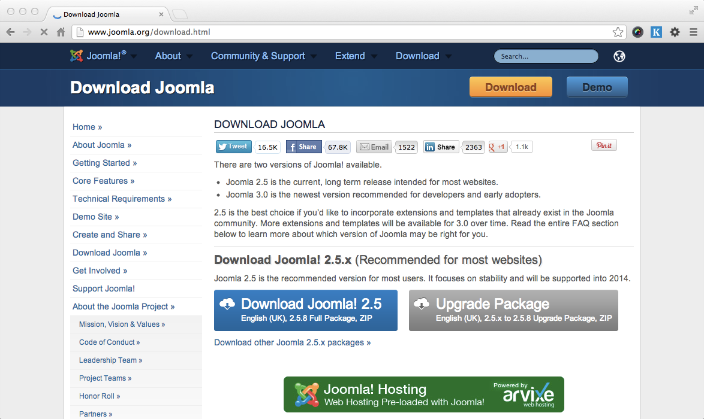
2.3.1 – Picture. Joomla! Download Page.
For this book, we are using Joomla! 2.5.8, as that is the latest version at time of writing this book. So, from the list of packages, click on one, for example ZIP beside 2.5.6 Full package. The file will be downloaded to your computer. Once downloaded, you can extract the file and see the folder for its contents. These files and folders need to be uploaded to your web server (local or remote).
Setting Database: We have learned that we need MySQL database server to install Joomla!. Before proceeding to actual installation of Joomla! we need to create a database for Joomla!. We can do it by using mysql command or through phpMyAdminweb interface. Let us create one database for ict4e site by using phpMyAdmin interface at localhost. For this, point your browser to http://localhost/phpmyadmin, and you will get the following screen:
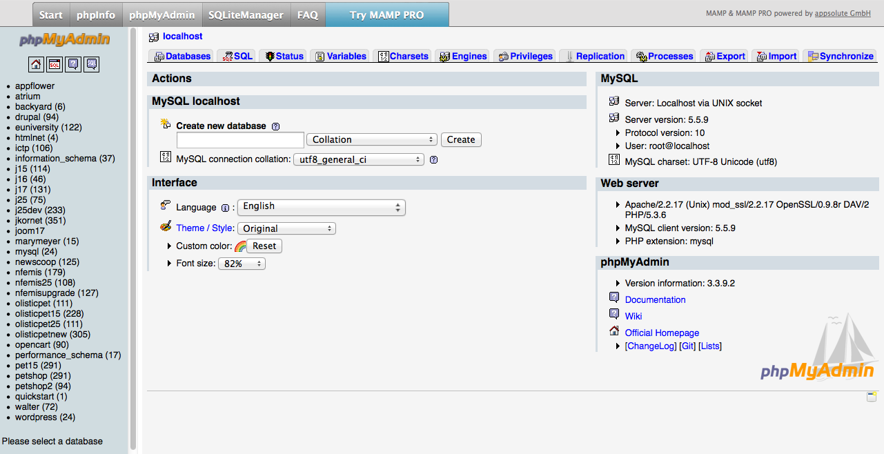
2.3.2 – Picture. PHP My Admin interface.

In the Create new database field type the name of database, i.e. j25multilang, and select utf8_general_ci in Collation dropdown list. Then click on Create button. This will create a database named ict4e. However, there will be no tables yet. We don’t need to create tables now, these will be created during Joomla! installation. What we need to know now is the database name and username for that database. As we are using localhost, username will be root and password also root (on MAMP, for WAMP password is blank). However, for production environment you need to know the database username and password exactly what is used there.
Uploading Installation Files: Once you have downloaded the installation files and extracted those, you need to upload those to the web server before starting installation. If you are using a local web server for development, like us, copy the files to your web server’s webroot. I am using MAMP on Mac OSX and web root is /Applications/MAMP/html-docs. If you use WAMP on Windows computer it is more likely c:\wamp\www. Under this web root, we will create a folder joomla25multilang and copy Joomla! installation files to this folder. Files and folders in this directory will look like the following screen shot.
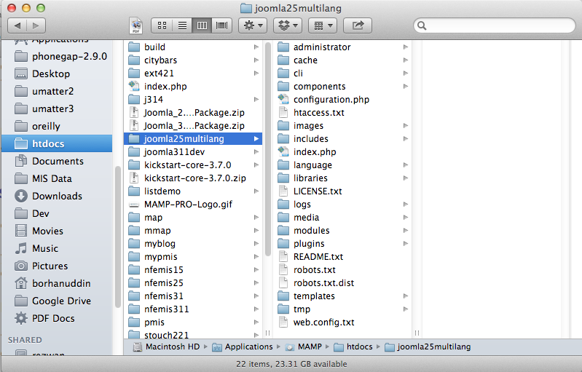
2.3.3 – Picture. Folders and Files for Joomla! Installation.

If you are using a remote web server, you have to use some FTP client like FileZilla. Connect to the FTP server and upload the files to the appropriate directory.
Starting JOOMLA 2.5 CMS. Installation:Let us start installation of Joomla! now. We are going to install Joomla! on our development environment, i.e. localhost. We can start Joomla! installation simply typing a URL in the web browser. Before that make sure that you have started the local web server (MAMP or WAMP) and Apache-MySQL services are running. Open your web browser and type http://localhost/joomla25multilang in the address bar. This will take you to Joomla! Installation wizard.Install Step 1: Language.First screen in Joomla! installation wizard is Choose Language. You will be given options to choose a language for the installation steps.
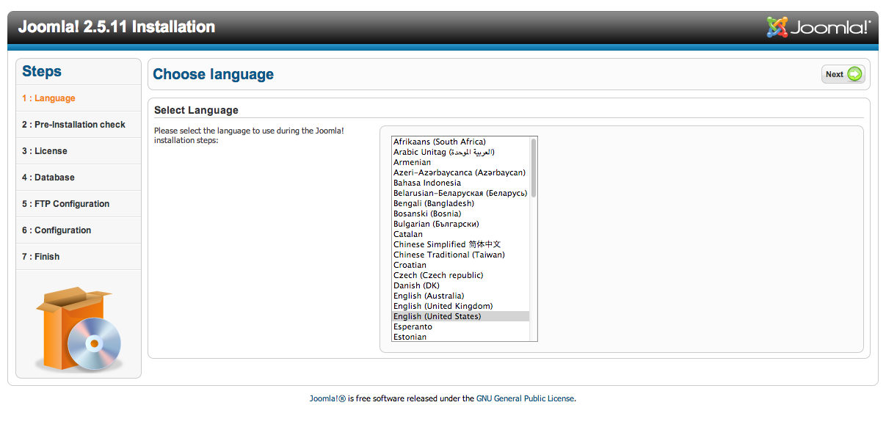
2.3.4 – Picture. Choose Language screen.

Select a language for installation steps, say English (United States) and click Next button.Install Step 2: Pre-installation check. Pre-installation checkscreen will be displayed.
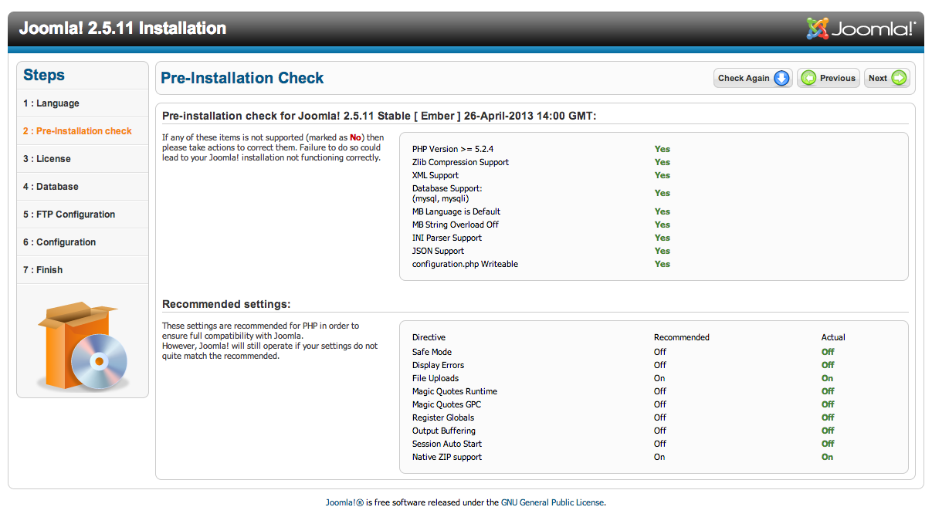
2.3.5 – Picture. Pre-installation check screen.

This screen has two sections:The First section shows you whether the system meets requirementsfor installing the Joomla! version you are installing.
Second section, shows the recommended settings and actualsettings found on the server. Any deviation from the recommended settings will be shown in red. If there is any item red in the first section, you cannot install Joomla!. However, items with red color in the second section(Recommended Settings) will still allow you to install Joomla! successfully. You may change some PHP settings and recheck the settings by clicking on Check Again button. To proceed with installation, click Next button.Install Step 3. License. Licensescreen will be displayed. This screen displays GNU GeneralPublic License.! [GNU General Public License for Joomla!] (images/01/Joomla__-Web_Installer_3.png)Read the license if you are not familiar with it. The license describesthe terms of use of Joomla!. To proceed with installation, click Nextbutton. Clicking Next means you have accepted the licensing terms.
Install Step 4. Database Settings. Database Settingsscreen will be displayed. You have to providedatabase setting information on this page.
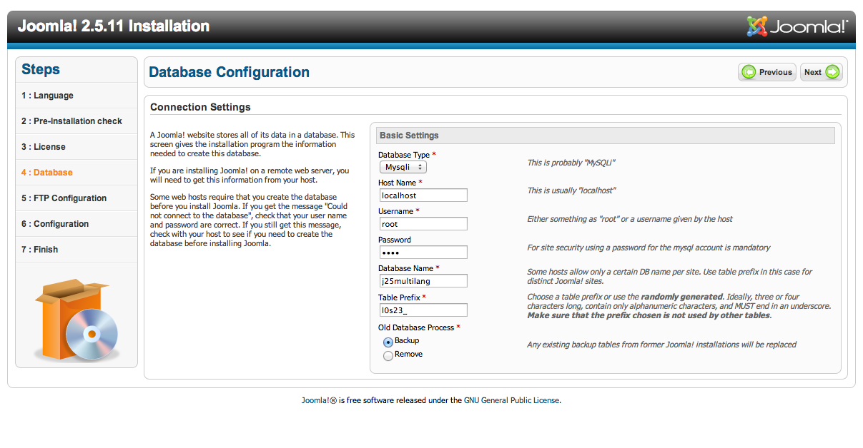
2.3.6 – Picture. Database Settings screen.
In the Basic Settings section, you have to provide the following information:
• Database Type: By default mysql is selected. You can also use mysql. For our database, select mysql.
• Host Name: This is MySQL server’s host name. It is usually localhost. If you are using remote server, this name may be different and can be obtained from the hosting provider.
• Username: This is username for connecting to database. The user should have permission to insert, update and delete records from the database. For our database, type root in this field.
• Password: This is the password for the above username. For our default installation of WAMP server, root user’s password remains blank. So keep it blank in WAMP. If you have changed that password, type that password in this field. I am using MAMP, so I’ll type root here.
• Database Name: Type the name of the database to be used for this Joomla! installation. We have created j25multilang database for this purpose, so type j25multilang in this field.
• Table Prefix: Type the prefix you want for Joomla! tables. Prefix is useful when you are sharing same database for multiple applications. This prefix identifies Joomla! tables. You can type any prefix in this box except back which is used for backed up tables in Joomla!. By default Joomla! 2.5 randomly generates a prefix for you and accepting that will be good choice in terms for security. Accept the default shown in this field. Once all these settings are configured, click on Next button to proceed with installation.
Install Step 5. FTP Configuration. FTP Configurationscreen will be shown. If you want to use FTP for uploading files to Joomla! website, you need to configure FTP settings in this screen.
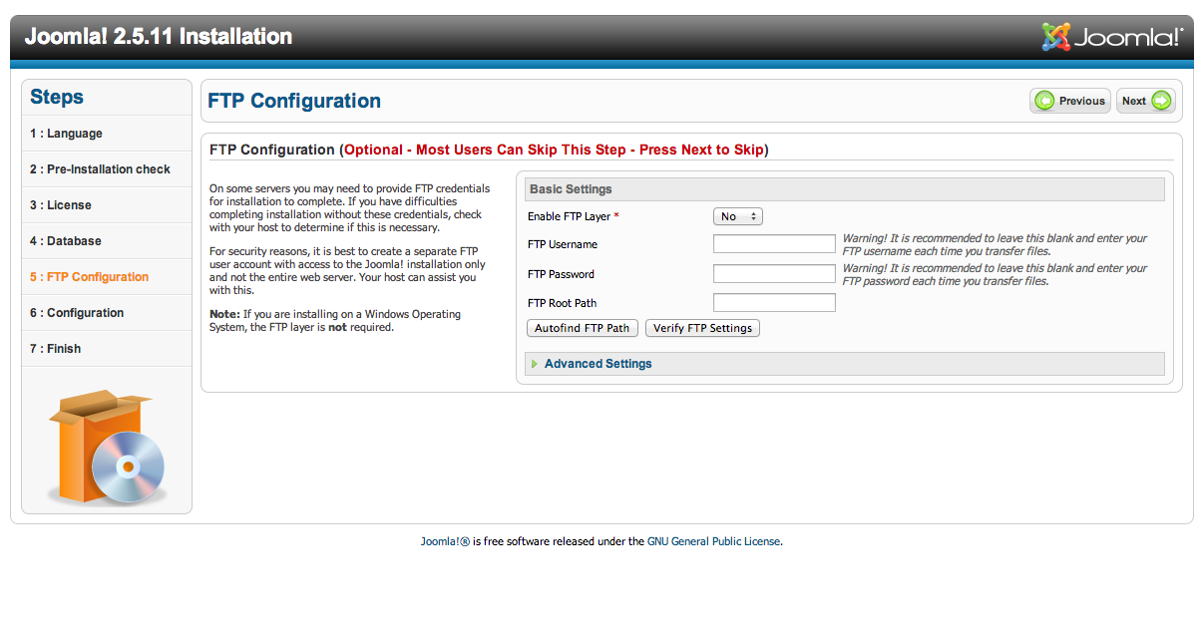
2.3.7 – Picture. FTP Configuration screen.
By default this is disabled. To enable it, select Yes. Then type FTP
User name, FTP Password for that user, and FTP Root Path.
In the Advanced Settings section, you can type FTP Host and FTP
Port. You can also configure whether FTP Password will be saved
or not. For our site, keep the defaults (i.e. selected No) and click on
Next button.Install Step 6. Main ConfigurationMain Configuration screen will be shown. There are mainly two sections: Site Name and Load Sample Data.
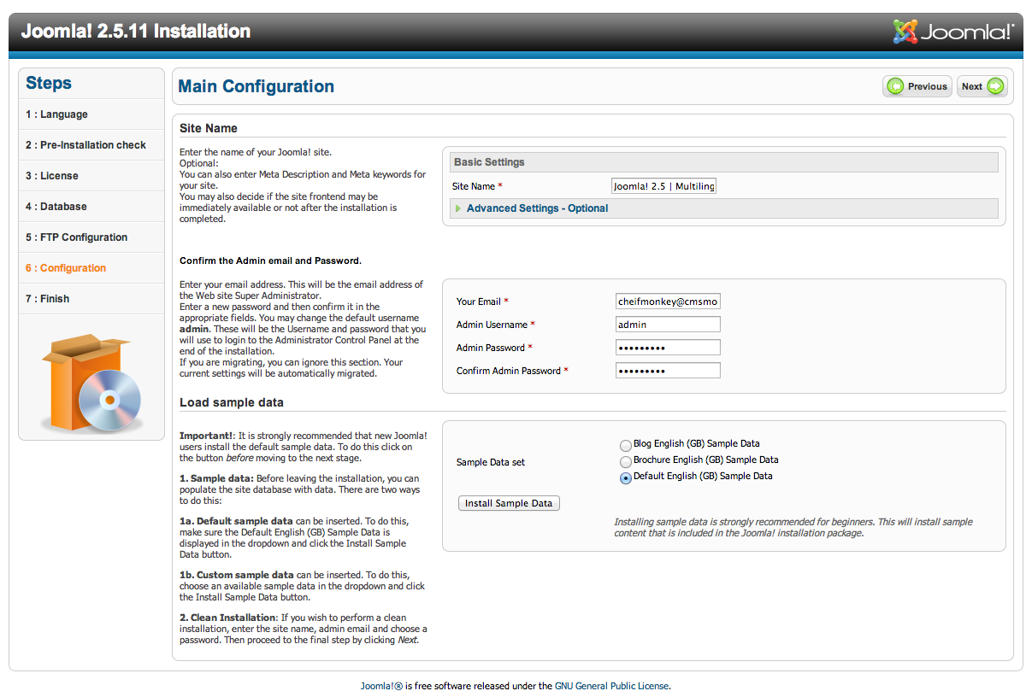
2.3.8 – Picture. Main Configuration screen.

In the Site Name box, type the name of your site. For example, Joomla! 2.5 | Mutilingual Site. In the next section, type administrator’s e-mail account in Your E-mail text field, then type password for the administrator account in the Admin Password text field. Then confirm it by retyping the password in Confirm Admin Password text field. By default, administrator username is admin. For security purpose, you may change to something else. In that case type your desired administrator account name in Admin Usernamefield. Joomla! comes with some sample data. Installing these sample data helps you understand how Joomla! works. You will get some predefined categories, articles, menus and modules. The articles accompanied with Joomla! 2.5 will help you understand how to use it. Therefore, it is recommended that if you are new to Joomla!, you install default sample data. For installing default sample data, select one sample data set - Blog,
Brochure or Default in Sample Data Set radio list and click Install Sample Data button. Within a few seconds Sample data installed successfully message will be displayed in place of Install Sample Data button. When installed sample data, click Next button.Install Step 7. Finish. Finishscreen will be displayed. Here you will see some warning (inred color) about removing installation directory.
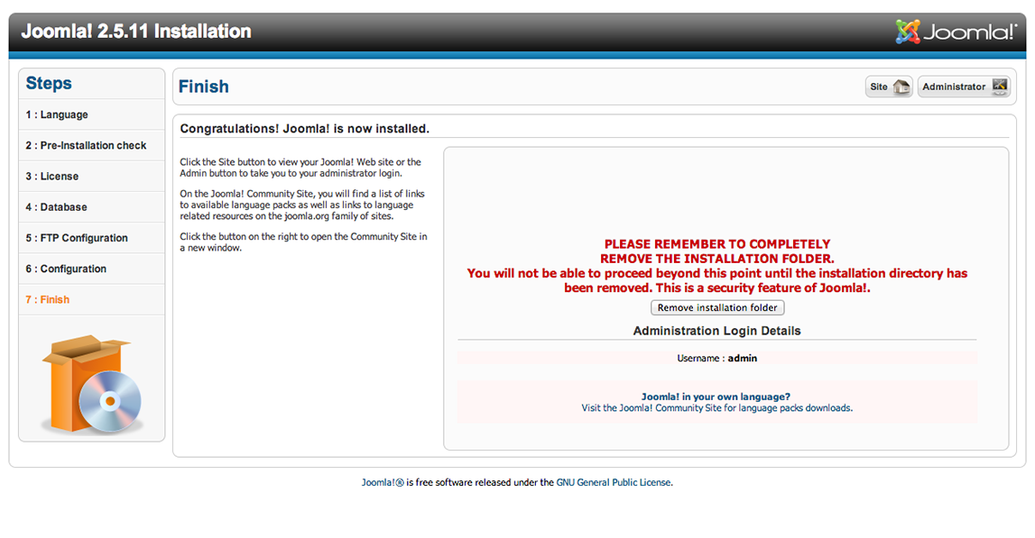
2.3.9 – Picture. Finish screen.

We will see a warning message. It advises us to remove the Joomla! installation directory named installation, and located under Joomla! installation root. Keeping this directory has a security risk, because anyone can point to this directory from his or her browser and start Joomla! installation again. Let us delete the whole directory by clicking Remove installation directory button. When done deleting, Installation folder successfully removed message will be displayed.
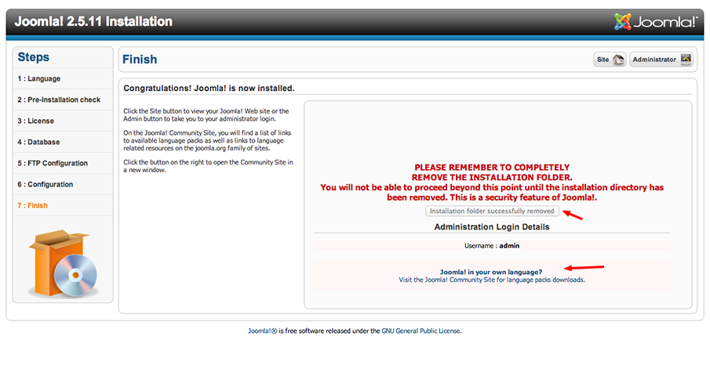
2.3.10 – Picture. Installation Folder Deleted Successfully.

On the top of the screen, we will also see two buttons – Site and Administration. By clicking on these we can go to website’s front-end or administration area. Also notice that administrative username is admin, and you need it to login to the administration panel.
Let us click on Site button now. Then we see the default installation of Joomla! 2.5.10. As we have installed the sample data, the frontend of the site looks like below:
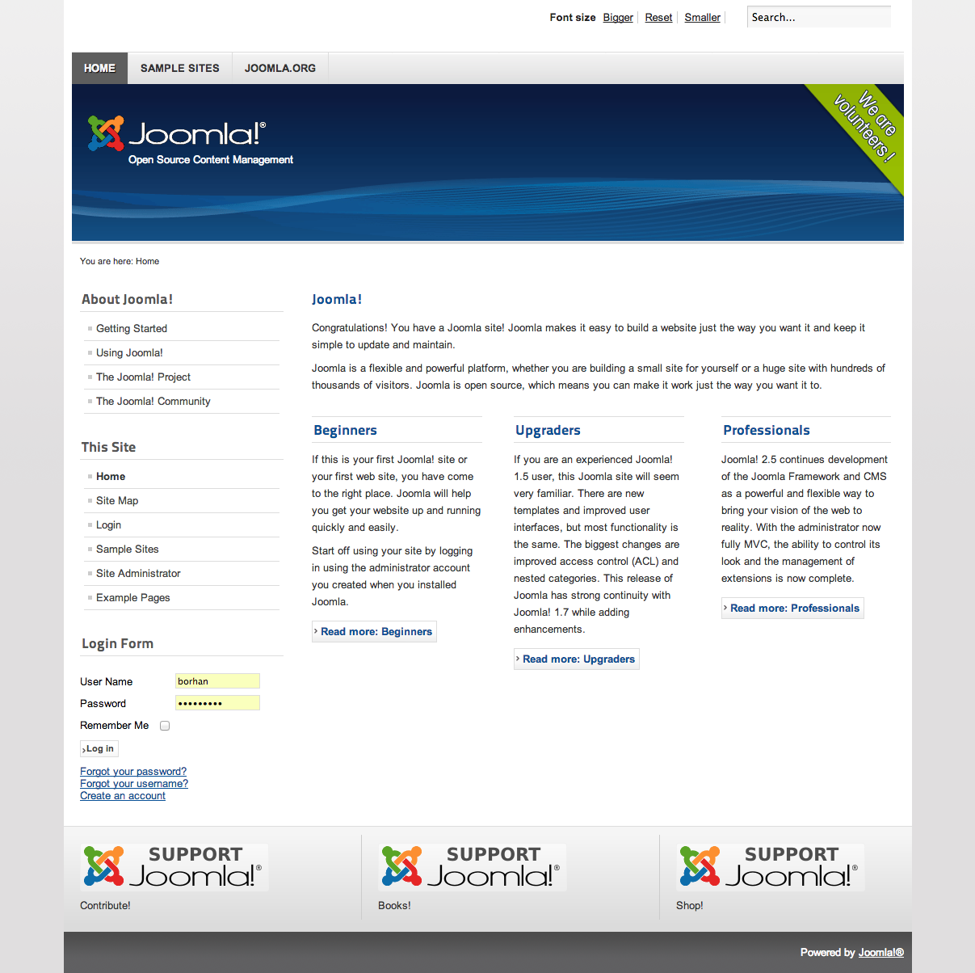
2.3.11 – Picture. Front-end of the Site with Default data.

You can now look into the administrative panel, too. Let us type http://localhost/hrs/administrator/ in our browser’s location bar. It will take us to administration section login screen:
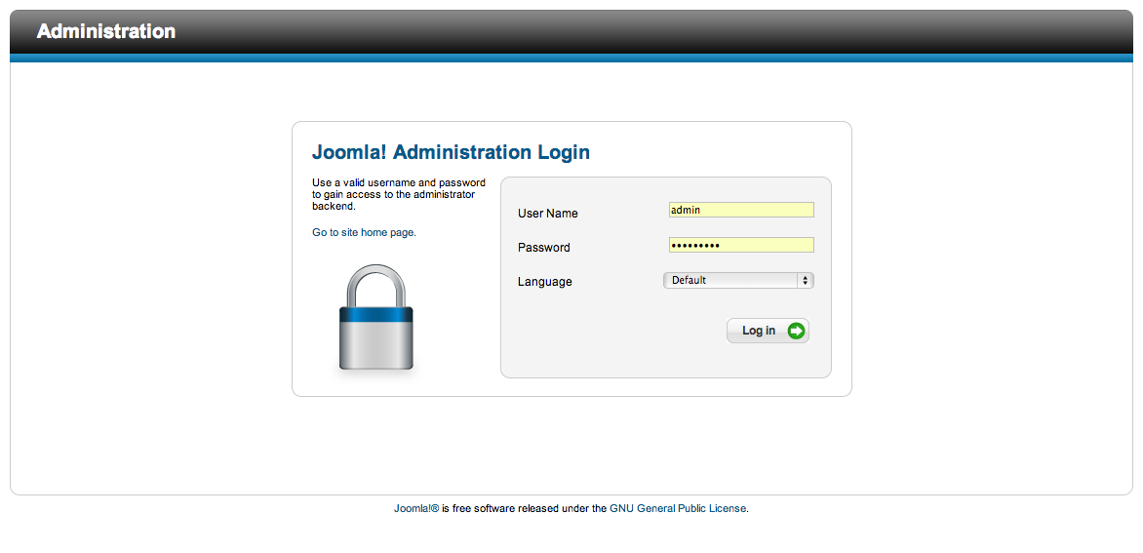
2.3.12 – Picture.Administration Panel Login Screen.

Now type administrative username admin and password that you have assigned during installation. You may select language, too. Then click Login button. On successful login, you will see Joomla! AdministrationPanel.
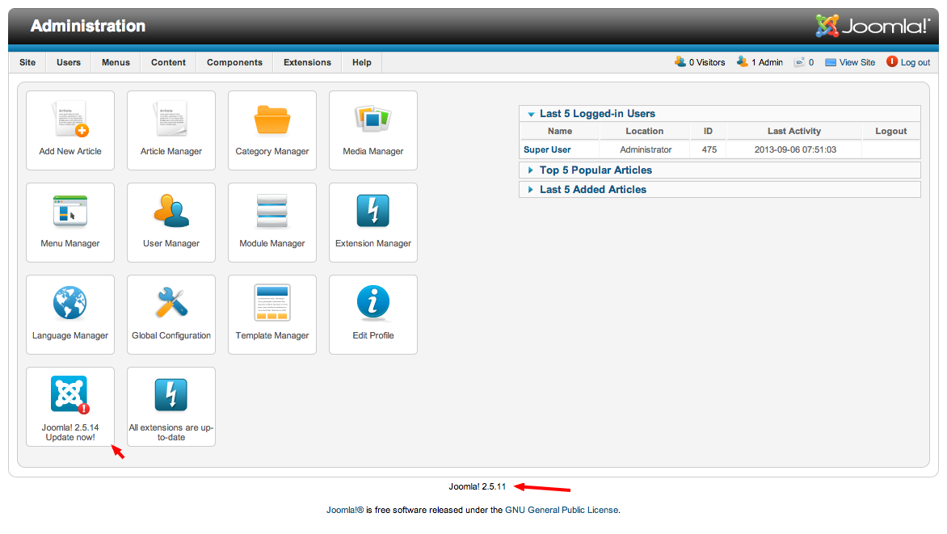
2.3.13 – Picture.Joomla! administration panel.

The Joomla! administration panel is the place from where we will configure our Joomla! site and manage its contents. At the bottom of the screen you will see the version number of the installed Joomla!. If you have installed a version different from the most recent version you will see an icon in control panel stating availability of recent version. To remain with the security bindings, you should update to the most recent version of Joomla!. Click on Joomla! 2.5.4 Update Now icon. That takes you to Joomla Update screen.
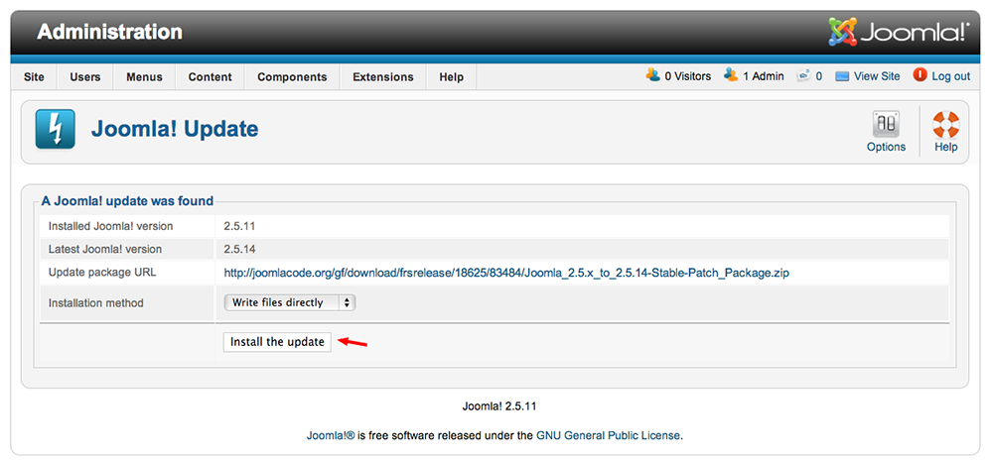
2.3.14 – Picture.Joomla Update screen.

From Joomla! Update screen you can update your Joomla! Installation to most recent version. This screen shows you installed Joomla version and latest Joomla! version. Click Install the update button to get updated. That downloads and installs the update. Depending on the speed of your internet connection, this may take some time. When done updating, you will see a message indicating that.
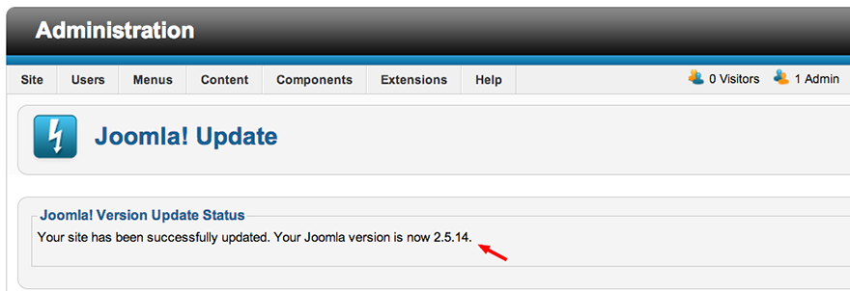
2.3.15 – Picture.Joomla Update Completion screen.

Now you have the most recent version of Joomla! 2.5 and you can proceed with further building the site.
In this chapter we have learned what Joomla! is, why we use Joomla!, what can be done with Joomla!, from where we can get a copy of Joomla!, and how we can setup Joomla!. For our example website, we have setup Joomla! and seen its front-end and backend. In the next chapter, we will learn how we can configure the site for our purpose.

2.4. Creating and configuring JOOMLA 2.5

- Login to your Joomla Dashboard.
- Roll your mouse over Menus, and click the menu you want to modify. Inmytests, I selected MainMenu:
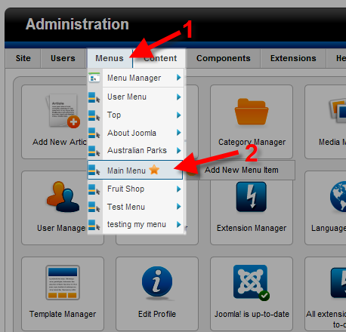
- You will see the menus listed in order of how they display on the page. Use the blue arrows to re-order or modify the menu location. As a test, I am moving the Example Pages link to the top.
Here is the default menu order, notice the location of the Example Pages link:
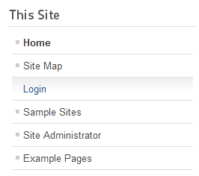
Now, I will click the arrow next to Example Pages, until it is all the way on top. Each time you click the arrow, you will see a message stating "Ordering successfully saved.":
2.3.16 – Picture.Menus part.
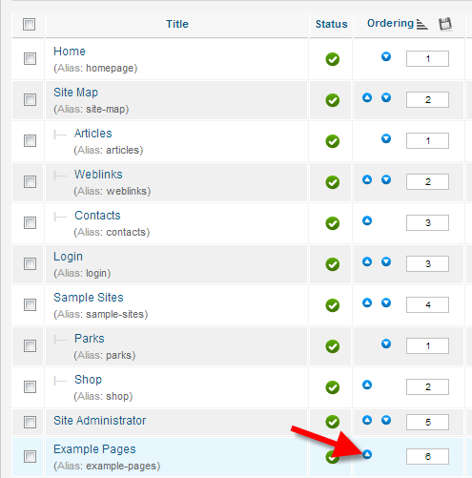
Once you have moved it to the top, refresh your website, and you will see the menu order has changed:
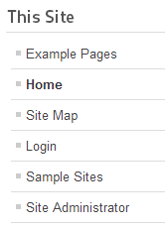
2.3.17 – Picture.Menu order.
Congratulations, now you know how to Re-order the menu's for Joomla, from the dashboard! An Introduction to Joomla 2.5 Menus With your Joomla hosting, menus provide the basic site navigation for your website. They allow you to link visitors to other parts of your website.Whatwebsitevisitorssee.
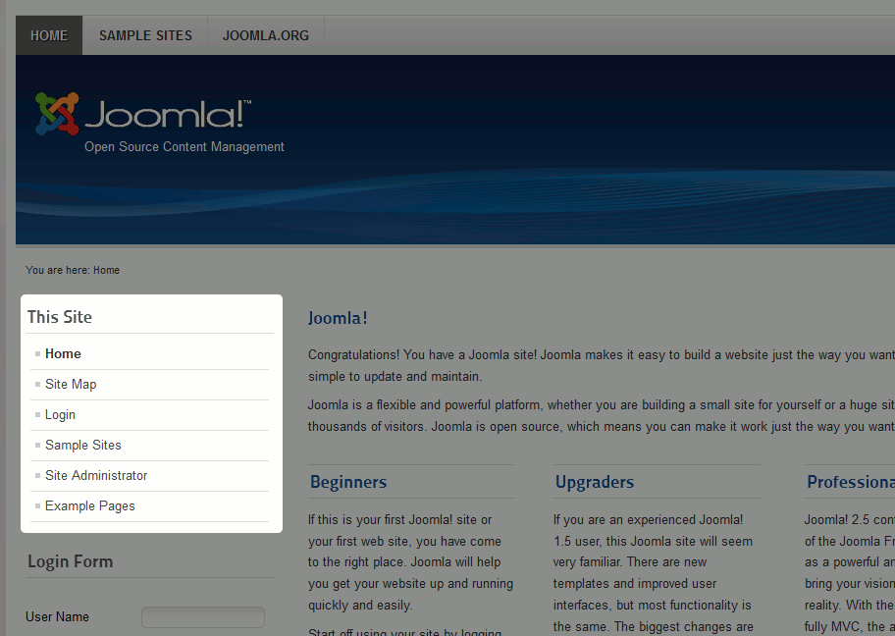
2.3.18 – Picture.Home page.

What is displayed in the JoomlaDashboard
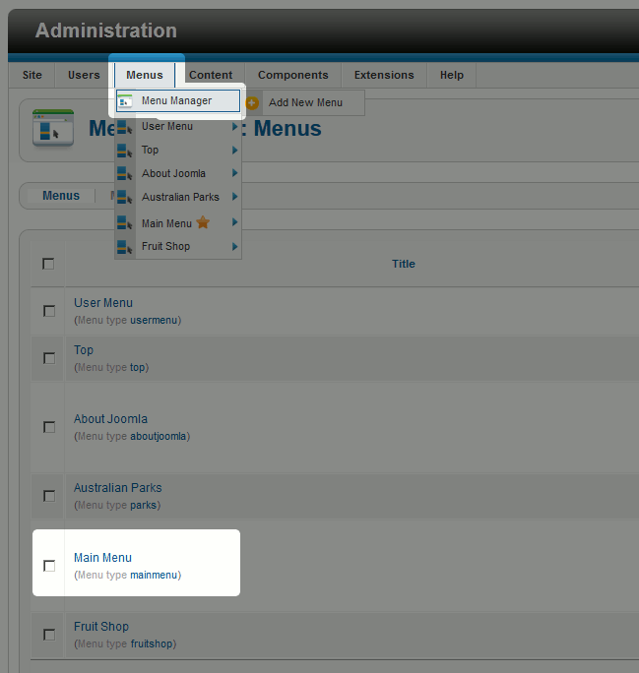
2.3.19 – Picture.Main menu.
Each Menu contains one or more menu items. Menu items are the actual navigational links that users click on. When setting up menu items, there are quite a few options you have to choose from. The most popular menu items are links that point to either specific articles or to a listing of all articles in a category.

Whatwebsitevisitorssee
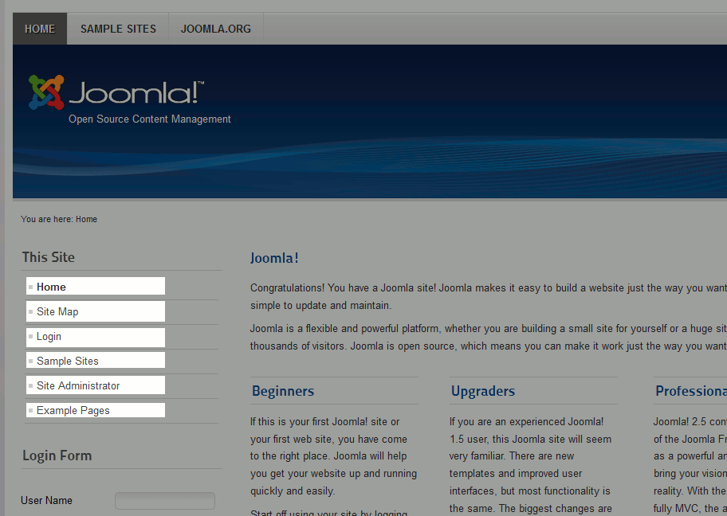
2.3.20 – Picture.Home page.
What is displayed in the JoomlaDashboard
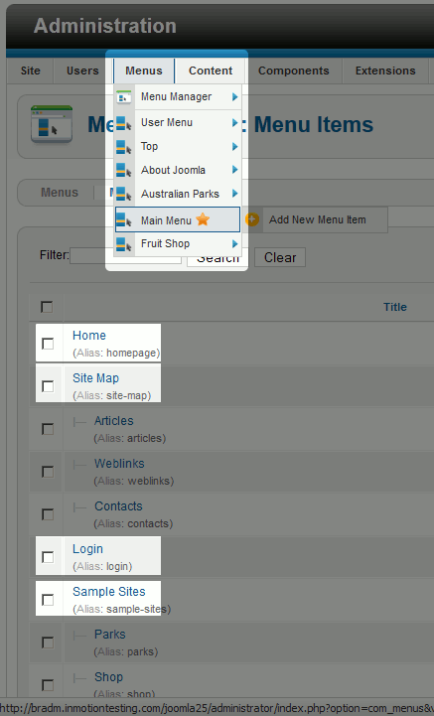
2.3.21 – Picture.Menu part.
Creating a menu does not automatically add the menu anywhere to your site. When you create a new Joomla 2.5 menu, a module for that menu is created. You then need to enable the menu's module and select the position in the template where the menu should go.
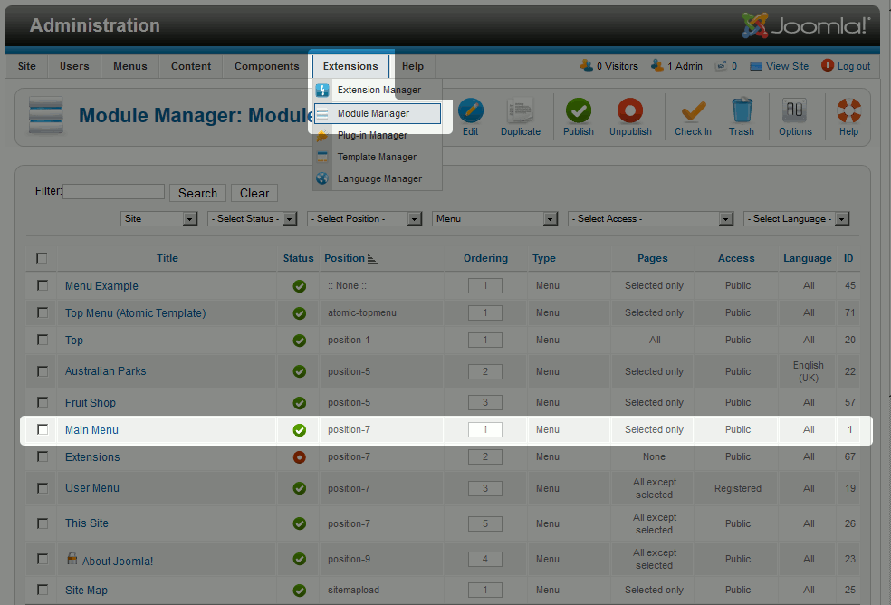

2.3.22 – Picture.Category.

How to create a new Menu and Menu Module in Joomla 2.5. In this tutorial, we will walk you through the steps of creating a new menu in Joomla 2.5. If you don't have any previous experience with Joomla 2.5 menus, we suggest taking a look first at An Introduction to Joomla 2.5 Menus.To create a Joomla 2.5 menu:
- LogintoyourJoomlaDashboard
- In the top menu under Menus, click Menu Manager
- Click the New button in the top right menu
- Type in a menu title, type, and description. Then click Save & Close in the top right menu
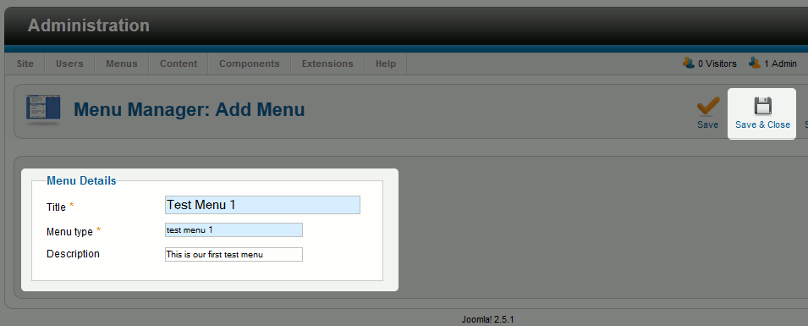
2.3.23 – Picture. Menu Manager.
Find and click Add a module for this menu type next to the menu you just created
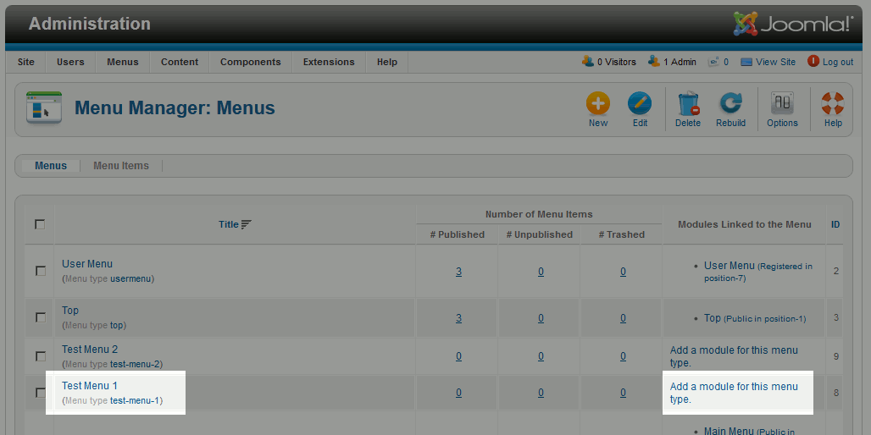
2.3.24 – Picture. Menu Manager.
Type in a Title, choose a Position for the menu, and then click Save & Close
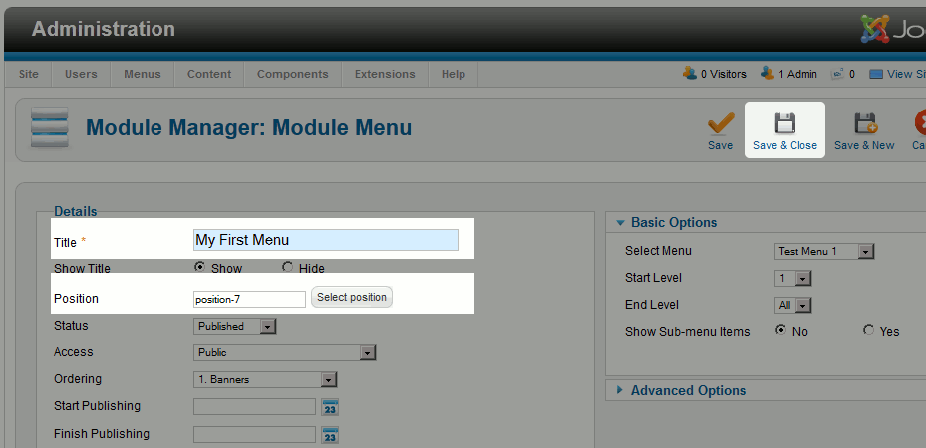
2.3.25 – Picture.Module menu.

Joomla 2.5 Menu Items - Category List vs. Category Blog. n a previous article, we created a new Joomla 2.5 menu item that links to a category. When we selected the menu type, we chose Category List. You may have noticed that there was a Category Blog option as well.CategoryList
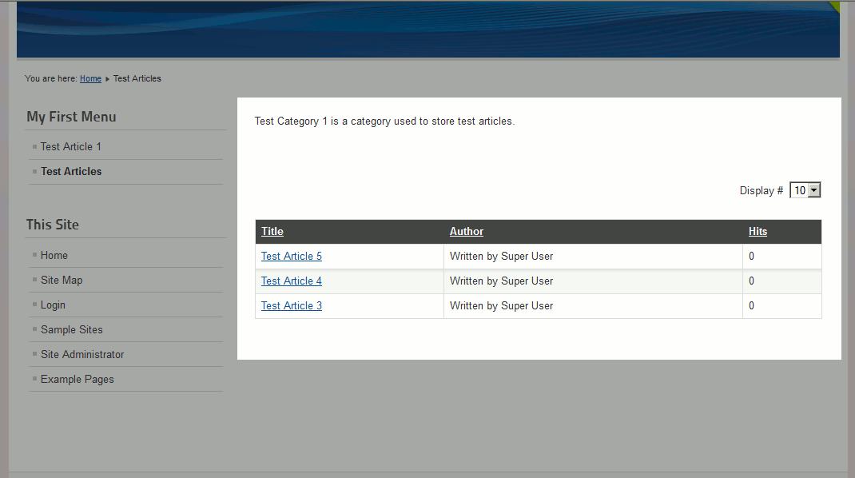
2.3.26 – Picture.Category list.
A Category List menu items links to a page that simply "lists" all of the articles belonging to that category.Category Blog
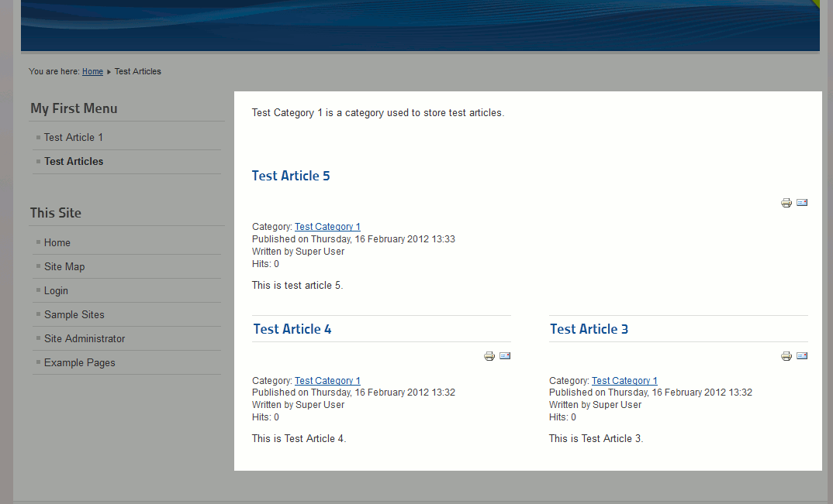
2.3.27 – Picture.Category Blog.
A Category Blog menu item links to a page that looks more like a traditional blog. Instead of just a listing of articles, the article are shown in a "preview" type mode where it shows a preview of the article's content as well as information such as who wrote it and when. Joomla 2.5 Menu Items - List All Categories. When creating new menu items in Joomla 2.5, one of the available options is a List All Categories menu type. Creating a List All Categories menu item will create a link, that when clicked, will bring users to a page that list all categories within a specific parent category (which you can select).
How to create a List All Categories menu item in Joomla 2.5:
- LogintoyourJoomlaadmin
- In the top menu, hover over Menus, hover over the menu you want to create the menu item for, and then click Add New Menu Item
- Next to Menu Item Type, click Select and then click List All Categories
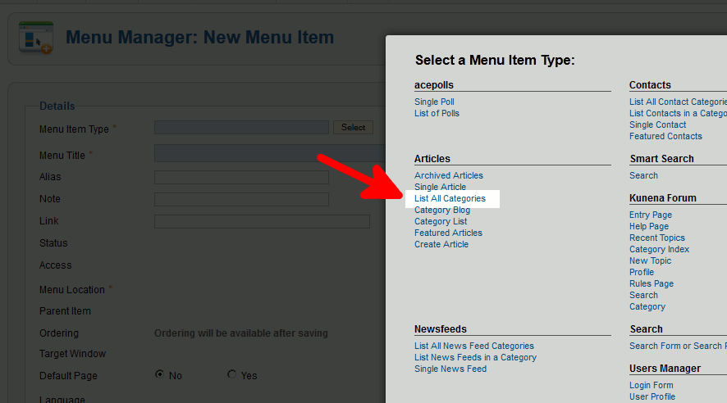
2.3.28 – Picture.Click Save in the top right menu.
Visit your Joomla 2.5 website, find and click on your new link, and you will then see a listing of all categories within the top menu category you selected!
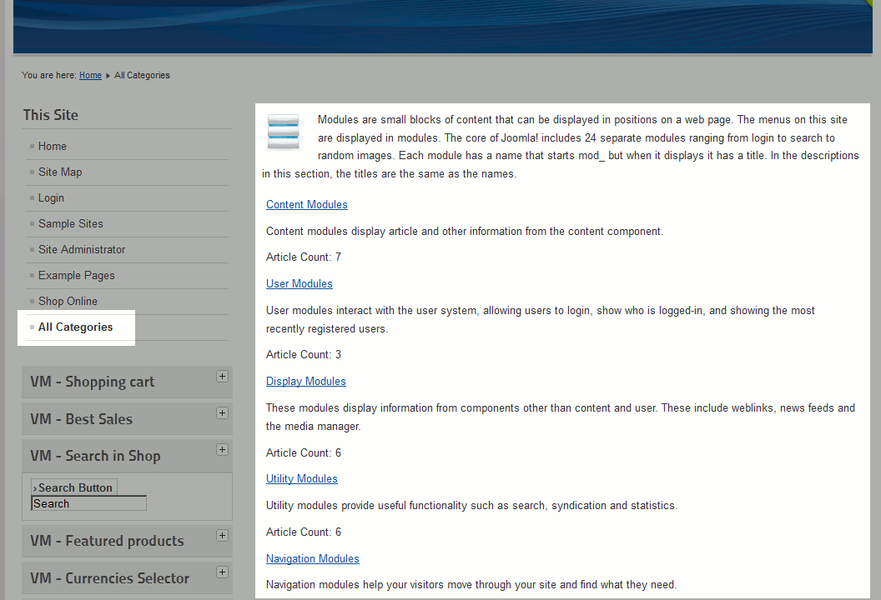
2.3.29 – Picture.All categories.

3. THE USER HANDBOOK OF WEBSITE “USCHOOL” ENGLISH LEARNING CENTER
3.1. Technical requirement of website “USCHOOL” English learning center

There must be some technical requirements in computer.
Hardware requirements:
- 2.2 GHz Intel Celeron Processor
- video memory at least 64 Mb
- Operation memory at least 512 Mb
- Free 500 Mb space in Hard Disk Drive
- 17 dym monitor
Software requirements:
- PC must be Windows or Linux Operation System
- PC has to have PHP 4 packet
- MySQL
- Web Sever (Apache)
- Web browser (Google Chrome, Mozilla, Opera)

3.2. Interface of website “USCHOOL” English learning center

Web site (USCHOOL) includes logo, basic menu (Home, About, Courses, Library, FAQ, Scholarship, Articles, Registration, Contact us), slider, left menu (News, Result of quiz, Competition, Conversation club, Movie club, Mnemonic club), Top teachers, Top groups, Top students.


3.2.1 – Picture.Home page.
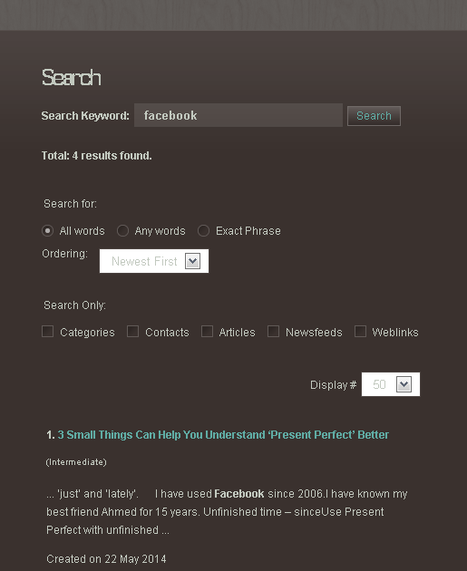
3.2.2 – Picture. Search page.
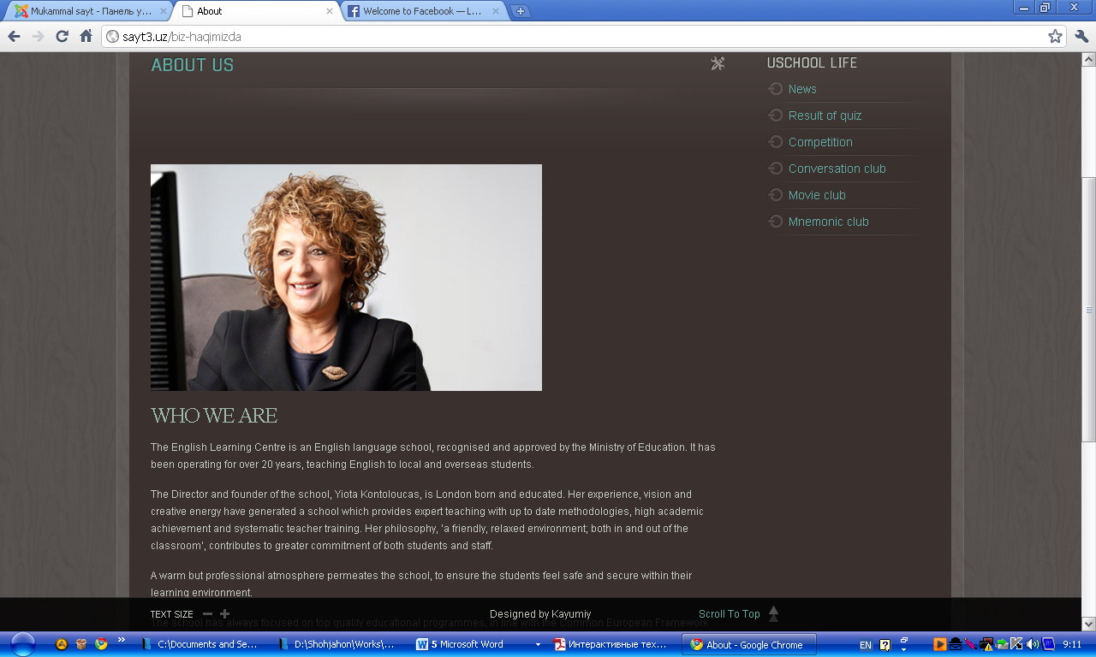
3.2.3 – Picture.About page.

3.2.4 – Picture.Courses page.
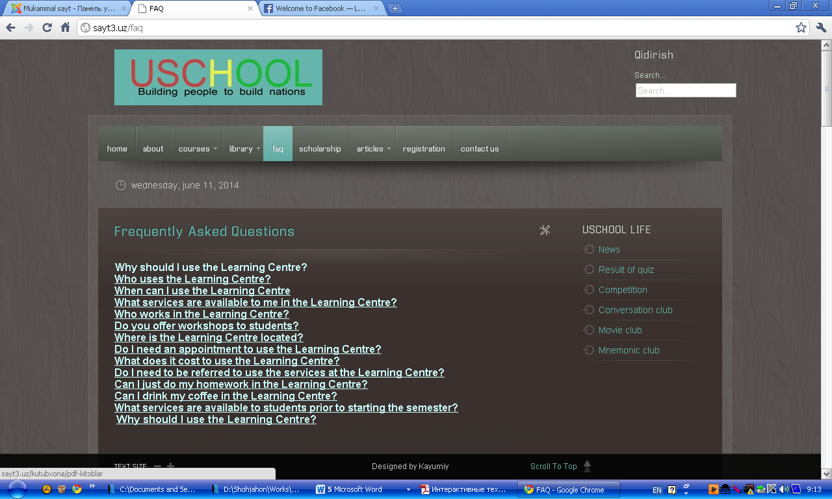
3.2.5 – Picture.FAQ page.

3.2.6 – Picture.Scholarship page.
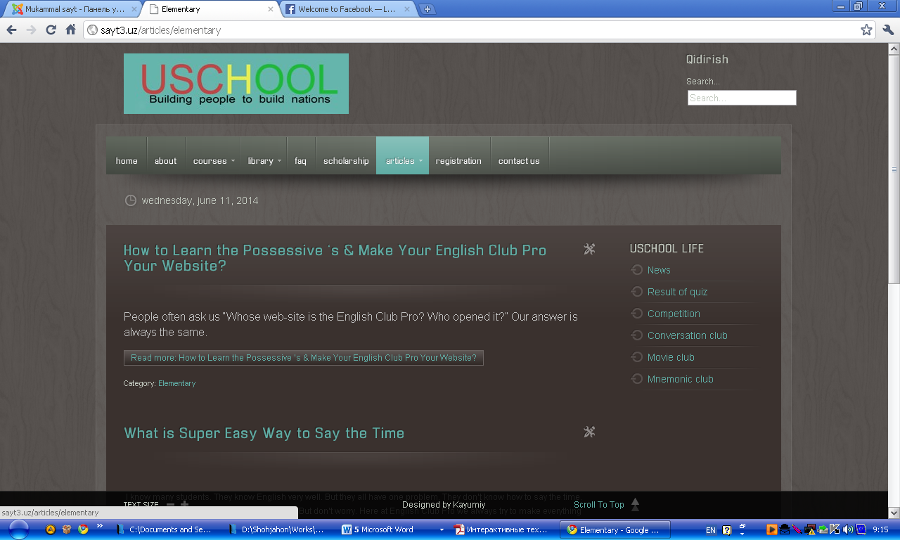
3.2.7 – Picture.Articles page.
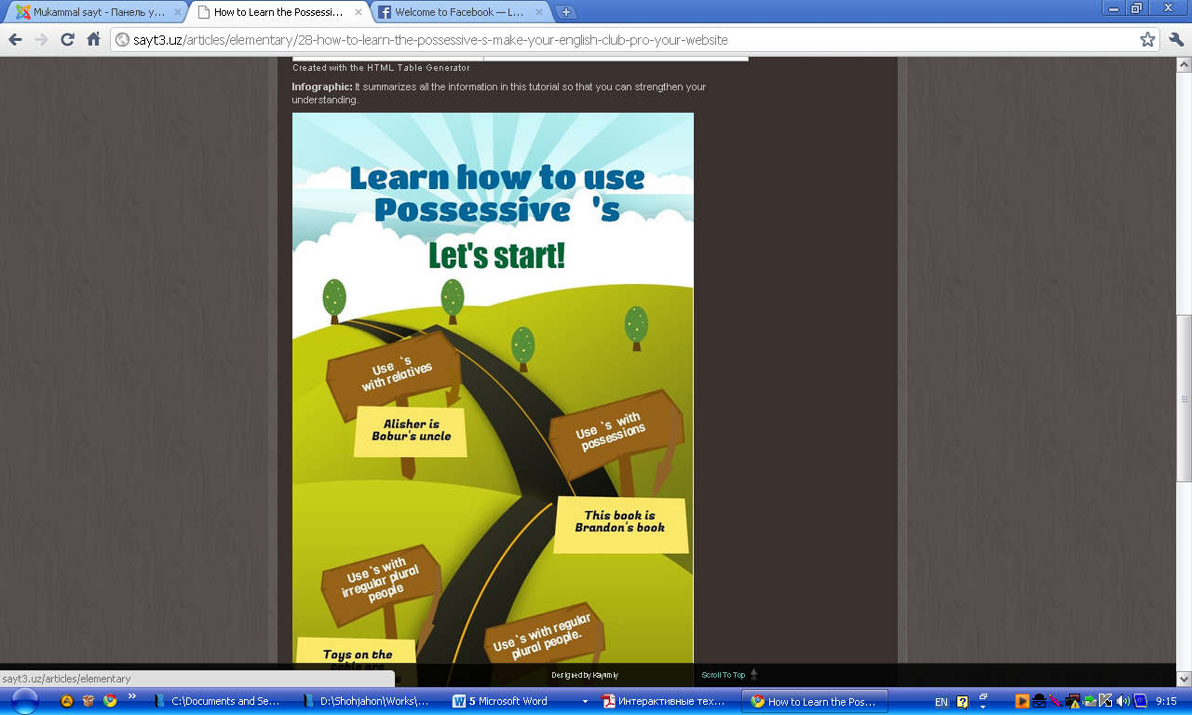
3.2.8 – Picture. Elementary articles page.
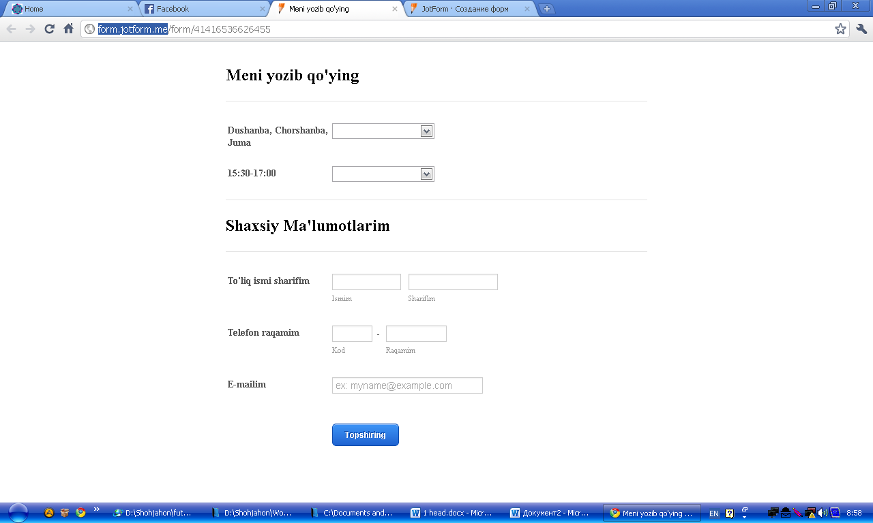
3.2.9 – Picture.Online registration page.
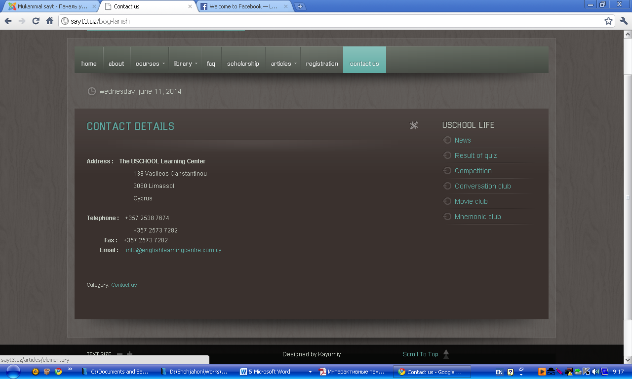
3.2.10 – Picture. Contact us page.

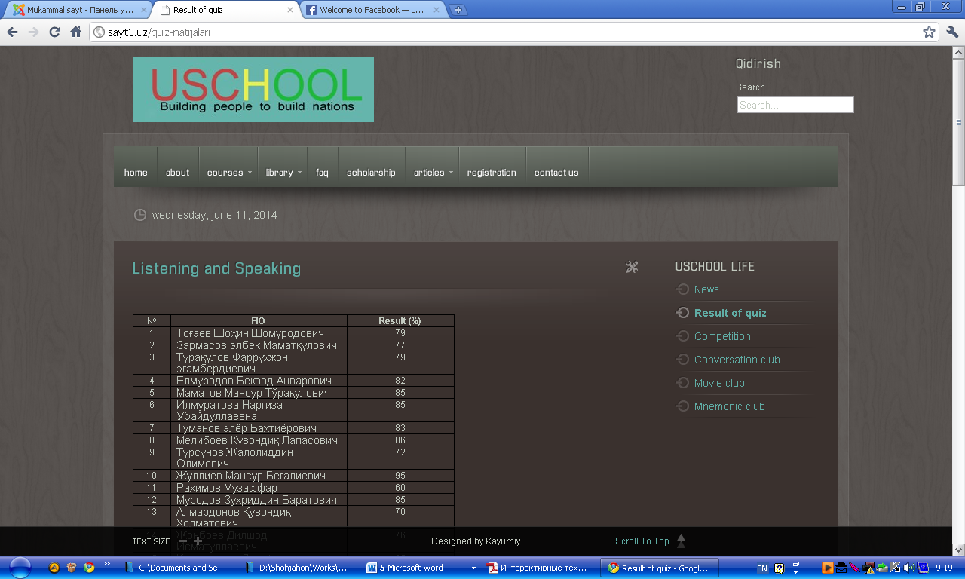
3.2.11 – Picture. Result of quiz page.
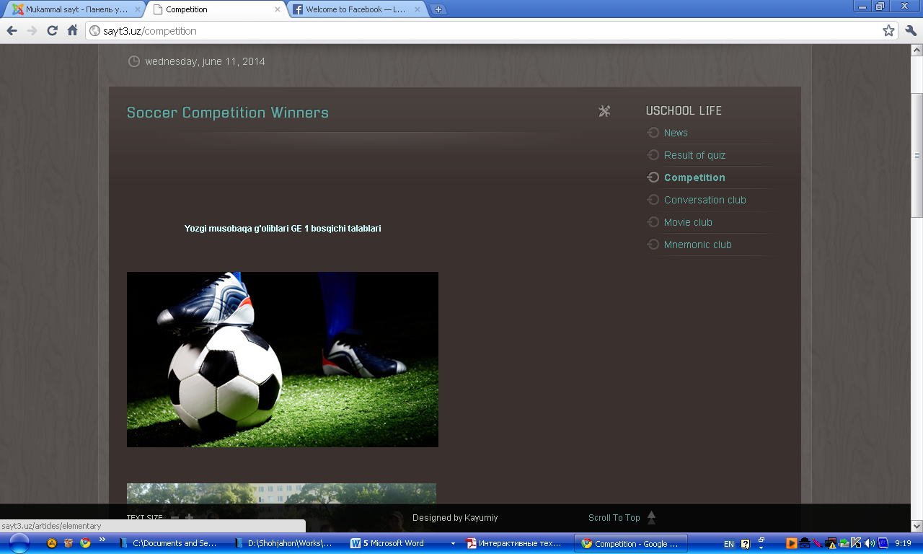
3.2.12 – Picture.Competition page.
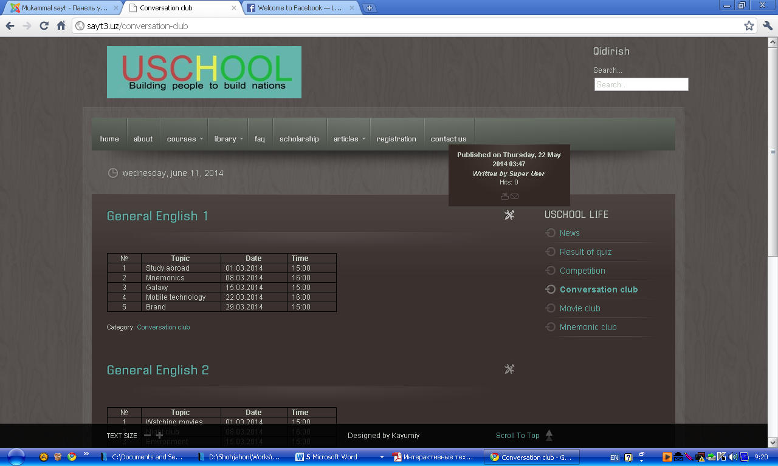
3.2.13 – Picture.Conversation page.
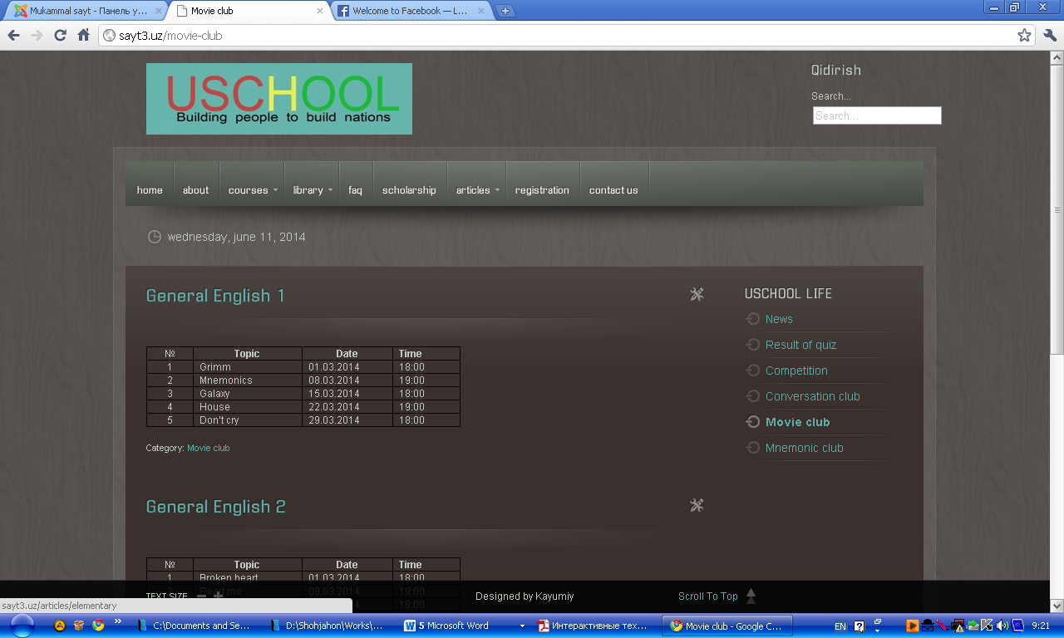
3.2.14 – Picture.Movie club page.
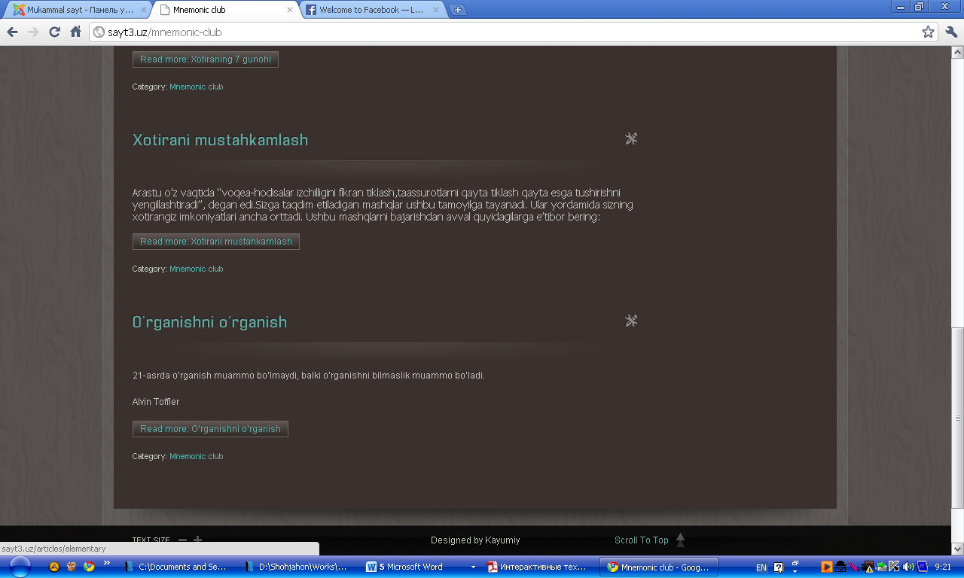
3.2.15 – Picture.Mnemonic club page.

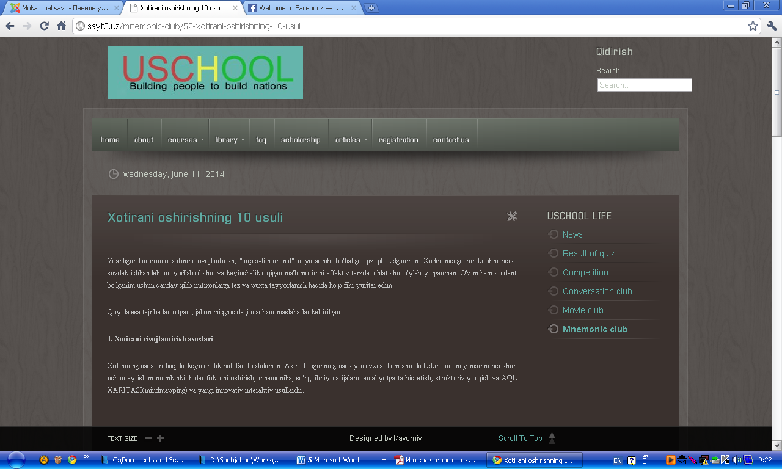
3.2.16 – Picture. Mnemonic article page
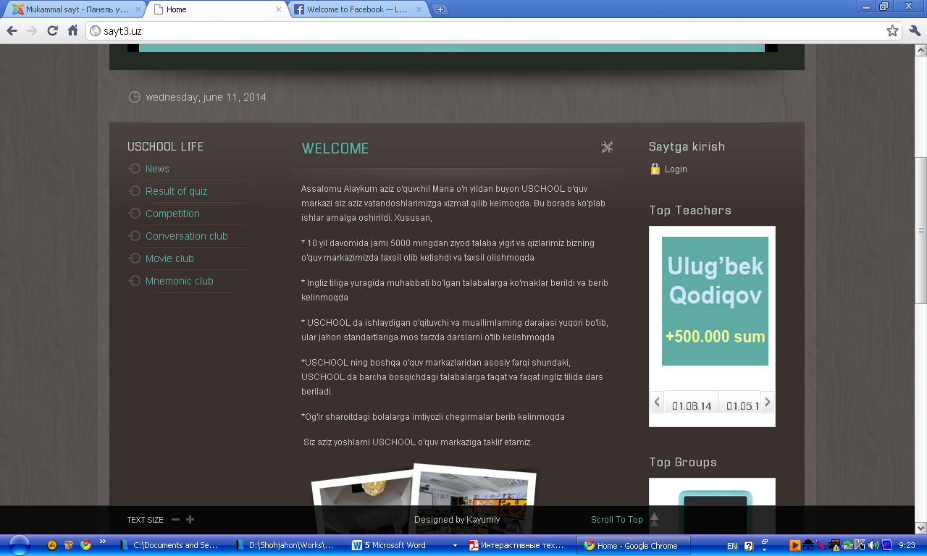
3.2.17 – Picture. Top teacher page.
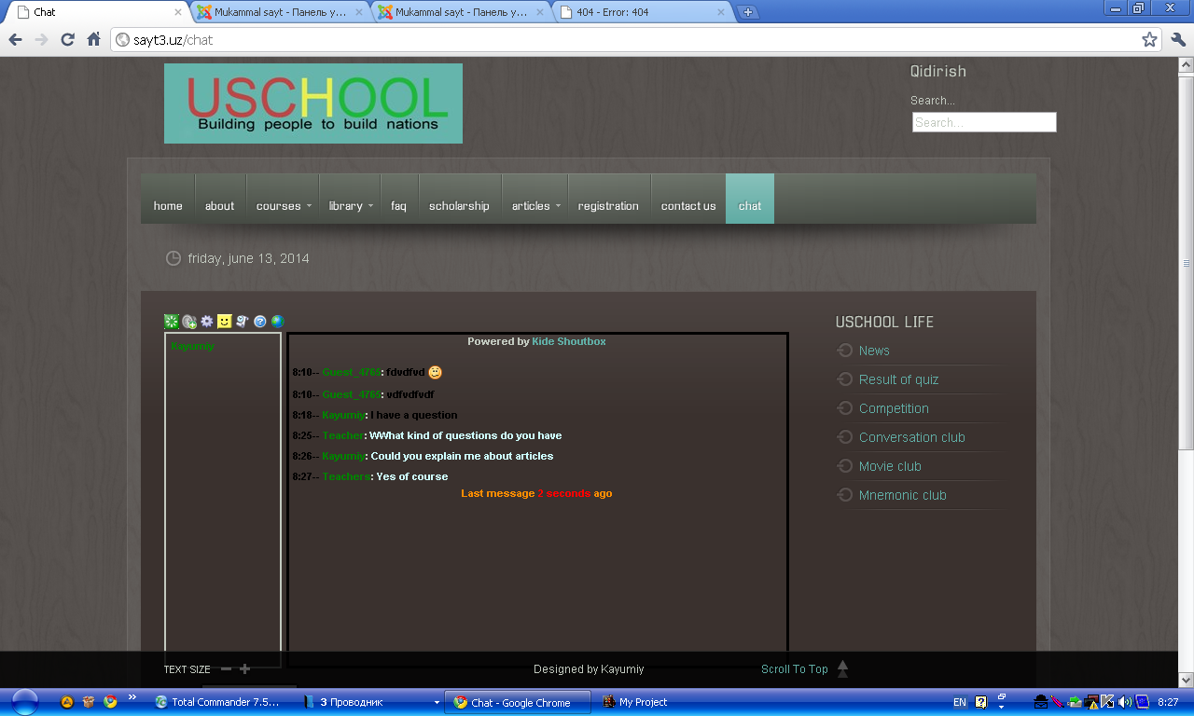
3.2.18 – Picture.Online chatpage.

4. SAFETY OF VITAL ACTIVITY
4.1. Rational organization of work place

The complexity of production processes and equipment changed the functions of the person in modern industry: increased responsibility of tasks; increased volume of information perceived by the working and the performance of the equipment. A person's work has become more difficult, increased load on the nervous system and increased physical load. In some cases, the man has become the least reliable link of the system «man-machine». There is a task of providing reliability and safety of persons at work. Solves this task ergonomics and engineering psychology.
Ergonomics (from the Greek work and norms - law) is the scientific discipline that studies the human in terms of its activities related to the use of machines. The goal of ergonomics - optimization of conditions of work in the system "man-machine". Ergonomics defines the requirements of the person to technology and to the conditions of its functioning. The ergonomics of the equipment is the most generalized index of properties and other characteristics of equipment.
The connection of the man with the environment and the parameters of the workplace. Working place, this is the area in which the committed work of the performer or group of performers. Jobs may be individual and collective, universal, specialized and special.
General requirements, which must be observed when designing jobs, the following:
• adequate working space for the person;
• optimum position of the body of the worker;
• sufficient physical, visual and auditory communication between man and machine;
• optimal allocation of working space in the room;
• the permissible level of action of factors of production conditions;
• the optimal placement of the information and the motor field;
• availability of means of protection from hazards.
Design should provide the zone of optimum and easy reach of the motor field of the workplace and the optimal area of the information field of the workplace. Angle of view in relation to the horizontal should be 30-40 degrees.
The choice of working arrangements should take into account the efforts expended by the man, the magnitude of the movements, the need for movement, the pace of operations. The choice of working postures should take into account the physiology of man and parameters of working places determined by the choice of the position of the body at work (standing, sitting, a variable).
Jobs for work «sitting» are organized in an easy job and middle severity, and the severe - working posture -"standing".
In the design of equipment and organization of a job it is necessary to foresee the possibility of regulating the individual elements, in order to ensure the optimum position of the operator.
The design of the equipment must ensure that it meets the anthropometric and bio mechanical characteristics of the individual on the basis of accounting change dynamics of the amount of heat when you move, the range of motion in joints.
For the account in the design of equipment anthropometric data should:
• determine the contingent of people for whom is designed equipment;
• select a group of anthropometric characteristics;
• install the percentage of working, which must meet the equipment;
• determine the boundaries of the interval size (efforts), which should be implemented in the hardware.
When designing the use anthropometric dimensions of the body, and take into account the differences in the sizes of the body of men and women, nationality, age, professional. To determine the boundaries of the intervals, which take account of the percentage of the population, the system is used pertseteley. Design of the equipment should provide the ability to use at least for 90% of consumers.
To work in a position "sitting" are used by various operating seats. Distinguish workers seat for long and short term use. General requirements for the seat of long use of the following: the seat should ensure position, minimizing the statistical work of muscles; create conditions the possibility of changes in working postures; not to obstruct the activities of the systems of the body; to ensure the free movement relative to the working surface, have adjustable parameters; have the floor upholstery. For short-term use is recommended hard chairs and a different type of stools.
In the conditions of growing mechanization and automation of production processes is of special significance means of display of the information about the object of management. Widespread use of the received information model, that is organized according to certain rules information about the status of the object of control.
The information models of the following requirements:
• the content of the information model should adequately display the object of management;
• information model should provide the best information balance;
• the shape and composition of the information of the model must be consistent with the labor process and possibilities of man for the reception of the information.
Practice makes it possible to outline the sequence of the development of an information model: definition of the objectives of the system, the sequence of their decisions and sources of information; drawing up a list of control objects and their characteristics; the distribution of objects on the degree of importance; the distribution of functions between automation and man; the choice of coding of objects and drawing up of the overall composition models; determination of Executive actions of man.
In the process of constructing information model are determined by the location of the media in the workplace, are selected dimensions of marks and the layout of. Displaying means are placed in the field of view of an observer with the account of optimum corners and observation areas. Dimensions signs monitoring are determined taking into account maximum accuracy and speed of perception of the information, as well as the brightness of the character, magnitude contrast, the use of color. Optimum brightness are considered to be the value at which the maximum contrast sensitivity. The value of it will be greater, the smaller the size of the object of discrimination. Optimal area size contrast is 60-90%.
In the work of the eyes is a place of a certain inertia, which requires taking into account the time of exposure of the optic signal and the time intervals for the sense of separate signals the following one after the other. In most cases, the exposure time of the signal should be no less than 50 MS. Each variety of indicators has its area of use: indicators backlit used for the display of high-quality information that requires an immediate response of the operator; gauges are used for the reading of the measured parameters; integral indicators for combining information immediately on several parameters.
The structure and dynamics of the controlled object are usually with the help of a chip. In some cases the scoreboard used to display information and perception of the team of operators.
In the design of the workplace should take into account the rules of the economy's movements: when using two hands of their motion should be simultaneous and balanced; movement should be smooth and rounded, rhythmic and customary for working. The design of the equipment shall take into account the rules relating to the speed and accuracy of workers ' struggles. For example, the most rapid movement to itself; in the horizontal plane of the hand speed more than in the vertical; the accuracy of movements better in a sitting position, than standing, etc. Controls, used in the workplace must comply with the General requirements of ergonomics: and direction of the management bodies must comply with the movement associated with him indicator; the compliance of the location of the management bodies of the sequence of work of the operator; ease of use; the creation of the bodies of the Board of mechanical resistance and etc. In addition, for each type of bodies of pressure corresponds to a specific area of use and the special requirements of the size, form, effort, etc.
The automated workplace of the operator-Communicator (the operator in the control room) in the General case are used:
- means of mapping the information of individual use (imaging units, signaling devices, and so on);
- means of control and input of information (remote the display, keyboard control, separate controls, and so on);
- devices of communication and transmission of information (modems, telegraphic and telephone sets):
- the device documentation and storage of information (printing devices, magnetic recording and so on);
- auxiliary equipment (means of office equipment, the storage media, the device of local lighting).
At the automated working place should be provided with information and constructive compatibility used by technical means, of anthropometric and physiological characteristics of the person.
At optimization of the procedures of interaction between operators of telecommunications workers with technical means in the conditions of automation ergonomic factors act as the main determining the probability-time characteristics and the intensity of the work. These factors are sensitive to variations of individual properties of the operator.
Working the furniture should be comfortable for the execution of planned operations. The design of the working furniture: table, chairs is of great importance for the creation of healthy environments and highly productive work. Working the furniture is designed with consideration of anthropometric data of a human, technical, aesthetic and economic factors.
In the complete set of the working furniture of great importance is the design of the production of a chair, as it depends on the attitude of the employee and, therefore, energy consumption and the degree of its strain. Operating the seat must have the required dimensions, the relevant anthropometric data of the person and be flexible. The most comfortable chairs and seats with adjustable back tilt and height of seat. Changing the height of the seat from the floor and back angle, you can find the most appropriate labor process and the individual characteristics of the employee.
As a rule, all the surface of the written and desktops should be at the level of the elbow in the position of a person. When choosing the height of the table should be considered a man sits during work or stands.
The inconvenient of the table height reduces the efficiency of work and causes rapid fatigue. The lack of sufficient space for the knees and feet cause constant irritation of the employee. Minimum operating table height should be not less than 725 mm. As practice shows, for the working medium height the height of the desktop is accepted 800 mm. For the employee of another growth you can change the height of the working chair, or the position of the boards so that the distance from the object processing before the eyes of the working height is equal to approximately 450 mm.
Accommodation of the technical means and the chair of the operator in the working zone should provide easy access to the main functional nodes and units of equipment for conducting technical diagnostics, preventive inspection and repair; the ability to quickly occupy and to leave the work area; the exception of accidental actuation means of control and input of information; comfortable working posture and position of rest. In addition, the scheme of accommodation should meet the requirements of integrity, compactness and technical and aesthetic expressiveness of the working postures.
The display must be placed on a table or stand so that the distance of observation on the screen does not exceed 700 mm (optimal distance of 450 - 500 mm). Display screen height must be located so that the angle between the center of the screen and horizontal line of sight was 200. Horizontal viewing angle of the screen should not exceed 600. The remote display to be placed on a desktop or stand so that the height of the keypad in relation to sex was 650 - 720 mm. When placing the remote control on a standard desktop height of 750 mm it is necessary to use the seat with height adjustable seat (450 - 380 mm) and the footrests.
Document (form) for entry operator data it is recommended to have at a distance of 450 - 500 mm from the eyes of the operator, predominantly on the left, with the angle between display screen and the document in the horizontal plane shall be 30 40 degrees. The tilt angle of the keyboard should be equal to 15 degrees.
Display screen, documents and keypad display should be located so that the difference of brightness surfaces, depending on their location relative to the source of light, not more than 1:10 (the recommended value 1:3). At nominal values of brightness of the image on the screen 50 - 100 CD/m2 illumination of the document should be 300 - 500 Lux.
Working place should be equipped in such a way that the movement of an employee would be the most efficient, least tedious.
The device documentation and other, rarely used by technical means, it is recommended to concentrate on the right from the operator in the zone of maximum reach and means of communication to the left, to free the right hand for the entries.

4.2. Emergencies

In theory SAFETY EMERGENCIES - is a set of events, the result of the onset of which is characterized by one or more of the following signsо
a) danger to life and health of a significant number of people;
b) the material violation of the ecological balance in the area of the emergency;
с) the failure of the life support systems and control, full or partial cessation of economic activities;
d) significant material and economic damage;
e) the need to involve large as the usually external to the area of emergency forces and means for the salvation of men and the elimination of consequences;
e) psychological discomfort for large groups of people.
It is characteristic that emergency arises outwardly suddenly, suddenly. Specification of definition of the emergency is achieved by introduction of quantitative measures of the dangers.The classification of emergencies.
For reasons of emergencies are of natural, man-made, man-made, environmental, and social. To the natural (natural) emergency situations are dangerous natural phenomena or processes that have extraordinary in nature and lead to a breach of everyday life more or less significant groups of the population, loss of life destruction of material values. These include earthquakes, floods, tsunamis, volcanic eruptions, mudflows, landslides, avalanches, hurricanes and Smart-Chi, massive forest and peat fires, snow and avalanches. The number of natural disasters are also droughts, long-term heavy rains, strong stable frosts, epidemics, epizootics, epidemics, mass distribution of pests of agriculture and forestry.
Natural disasters can happen: as a result of rapid movement of the substance earthquakes, landslides); in the release of within the earth's energy (volcanic activity earthquakes) at increasing the overall level of rivers lakes and seas floods tsunamis) under the influence of an unusually strong wind аhurricanes cyclones. Some natural disasters fires avalanches landslides, etc..may arise as a result of the actions of the people themselves but their consequences are always the result of the action of the forces of nature. For each natural disaster characterized by the presence of intrinsic in the affecting factors, adversely affecting human health.
Natural disasters are a tragedy of the entire state and especiallyо for those areas where they occur. As a result of natural disasters are affecting the economy of the country since the collapse of production of the enterprise the destruction of material values and most importantlyо there are losses among the peopleе killed their housing and property. In addition, natural disasters pose extremely adverse conditions of life for the population, which may be the cause of outbreaks of infectious diseases. The number of people affected by natural disasters can be considerable and the nature of the lesions is very diverse. Most people suffer from floods (40% of the total damage), hurricanes (20%), earthquakes and droughts (15%). About 10% of the total damage is on the other types of disasters.
A number of Soviet and foreign experts, citing data on the losses in major disasters assume that in the future in connection with the growth and concentration of population similar in the force of the disaster will be accompanied by an increase in the number of casualties in the tens of times.
Man-made emergency situations is considered a sudden failure of machines, mechanisms and units during their operationи accompanied by serious violations of the production processс the explosions the formation of fire radioactive chemical or biological infections of large territories a group of damage destruction of people. To technogenic emergencies are accidents at industrial facilities constructionе as well as on railм airо roadо pipeline and water transport as a result of which the firesа the destruction of civil and industrial buildingsа there was a danger of radioactive contaminationя chemical and bacterial contaminationт there was the spreading of the oil products and aggressive poisonous liquid on the surface of earth and water and there are other consequences endangering human health and the environment.
The nature of the consequences of technogenic catastrophes depends on the type of accident, its scale and characteristics of the enterprise, where the crash occurred (on the means of transport and the circumstances in which the accident occurred.
Anthropogenic emergency situations are the consequence of the erroneous actions of the personnel. This class of emergency can occur at the same objects that and man-made emergency situations. The difference consists only in the fact that man-made emergency situations is not connected with the human factor directly.
The emergency ecological character may include: intensive degradation of the soil and its pollution by heavy metals (cadmium, lead, mercury, chromium, etc.) and other harmful substances, polluting the atmosphere of harmful chemical substances noise electromagnetic fields acid rain the destruction of the ozone layer, etc.
To the social emergency relate the events taking place in the society robbery violence) ethnic conflicts accompanied by the use of force contradictions between the States with the use of weapons.

CONCLUSION
There are many types of sites, such as forums and other social websites, that are intended to facilitate interaction between people. In the strictest technical sense, these can be consideredinteractive websites. The term "interactive websites," however, is usually intended to refer towebsites in which the user and the site interact without a third party. Creating interactivewebsites means crafting an online user experience that involves only the user and the website, without the intervention of a third party.
The interactive website includes these following services:
- Online registration
- Registering for consultation
- Registering for placement test
- Registering for consultation
- Registering for Conversation club
- Registering for payment
- FAQ (Frequently Asked Questions). Students may know immediately what the need
- Online studying
- Video courses
- Online books (vocabulary, reading, listening, grammar)
In fact, these interactive services will have a beneficial effect on our lives.I have searched a lot during my graduation project:
- I learned USCHOOL English learning center in depth.
- I determined systems of USCHOOL which are needed to automate.
- I found some interactive websites for searching and analyzed advantages and disadvantages of these websites.
- I developed new ways and interactive level balance of the education websites.
- I looked for a lot of interactive and Single Page templates (CMS, Word Press)
- I created new modules for my website by using HTML, CSS and PHP codes.
- One USCHOOL worker and great English teacher have helped me to do my graduation project.
I have learned a lot of knowledge and experience during the graduation project. I realized that there is a lot to be said for using interactive technologies in education system.
Single Page Web Applications make a number of possibilities for us due to the fact that they are simple, convenient and unique.

REFERENCES

1. O’zbekistonRespublikasiPrizidentiI.A.Karimovning AKT sohasigategishli 2013-yil 27-iyun sanasida “O’zbekistonRespublikasimilliyaxborot-kommunikatsiyatiziminiyanadarivojlantirishchoratadbirlarito’g’risida”gi PQ-1989-sonli qarori.
2. I.A.Karimov. “Yuksakma'naviyat - engilmaskuch”, Toshkent «ma'naviyat», 2008.
3. Vasenin VA Russian Internet and new technologies in education Proc. at the Second Intern. Congreve. UNESCO's "Education and Science", Moscow, 2011.
4. Declaration and Recommendations of the Second UNESCO International Congress on Education and Informatics. M., 1999
5. Domrachev VG Retinskaya IV The classification of educational computer information technology / / Inform. technology. 2006. № 2.
6. Krivosheeev AO Development and use of computer training programs / / Inform. technology. 2013. № 2.
7. Edmonds, R. (2012, July). Distance teaching with a vision. Paper presented at the Biennial Conference of the Australian Society for Educational Technology, Melbourne.
8. Fulford, C, & Zhang, S. (2013). Perceptions of interaction: The critical predictor in distance education. American Journal of Distance Education,7 (3),8-21.
9. Gilbert, L, & Moore, D. R. (2009).Building interactivity into web courses: Tools for social and instructional interaction. Educational Technology,38 (3),29-35.
10. Hirumi, A., & Bermudez, A. (2012). Interactivity, distance education, and instructional systems design converge on the information superhighway. Journal of Research on Computing in Education, 29 (1), 1-16.
11. Horn, D. (2009). Distance education: Is interactivity compromised? Performance and Instruction, 33 (9), 12-15.
12. Hughes, C., &Hewson, L. (2012). Online interactions: Developing a neglected aspect of the virtual classroom. Educational Technology, 38 (4), 48-55.
13. Kimeldorf, M. (2011). Teaching online-Techniques and methods.Learning and Leading with Technology, 23 (1), 26-29.
14. Klesius, J., Homan, S., & Thompson, T. (2013). Distance education compared to traditional instruction: The students' view. International Journal of Instructional Media, 24 (3), 207-220.
15. McHenry, L., &Bozik, M. (2011). From a distance: Student voices from the interactive video classroom. TechTrends, 42 (6), 20-24.
16. http://www.underscorejs.org
17. http://www.backbonejs.org
18. http://www.jquery.org
19. http://www.w3school.org
20. http://www.readmorejs.org
21. http://www.getbootstrap.com
22. http://it-ebooks.info/
23. http://lex.uz/pages/GetAct.aspx?lact_id=304013

APPENDIX

<html xmlns="http://www.w3.org/1999/xhtml" xml:lang="en-gb" lang="en-gb" >
<head>
<base href="http://sayt3.uz/" />
<meta http-equiv="content-type" content="text/html; charset=utf-8" />
<meta name="generator" content="Joomla! - Open Source Content Management" />
<title>Home</title>
<link href="/?format=feed&amp;type=rss" rel="alternate" type="application/rss+xml" title="RSS 2.0" />
<link href="/?format=feed&amp;type=atom" rel="alternate" type="application/atom+xml" title="Atom 1.0" />
<link href="http://sayt3.uz/component/search/?format=opensearch" rel="search" title="Search Mukammalsayt" type="application/opensearchdescription+xml" />
<link rel="stylesheet" href="/libraries/gantry/css/gantry.css" type="text/css" />
<link rel="stylesheet" href="/libraries/gantry/css/grid-12.css" type="text/css" />
<link rel="stylesheet" href="/libraries/gantry/css/joomla.css" type="text/css" />
<link rel="stylesheet" href="/templates/rt_zephyr/css/joomla.css" type="text/css" />
<link rel="stylesheet" href="/templates/rt_zephyr/css/demo-styles.css" type="text/css" />
<link rel="stylesheet" href="/templates/rt_zephyr/css/template.css" type="text/css" />
<link rel="stylesheet" href="/templates/rt_zephyr/css/template-webkit.css" type="text/css" />
<link rel="stylesheet" href="/templates/rt_zephyr/css/overlays.css" type="text/css" />
<link rel="stylesheet" href="/templates/rt_zephyr/css/typography.css" type="text/css" />
<link rel="stylesheet" href="/templates/rt_zephyr/css/fusionmenu.css" type="text/css" />
<link rel="stylesheet" href="/modules/mod_cdlogin/tmpl/css/mod_cdlogin.css" type="text/css" />
<link rel="stylesheet" href="/plugins/system/cdscriptegrator/libraries/highslide/css/highslide.css" type="text/css" />
<link rel="stylesheet" href="/modules/mod_roktabs/tmpl/light/roktabs.css" type="text/css" />
<link rel="stylesheet" href="http://sayt3.uz/modules/mod_image_show_gk4/styles/gk_sj/style.css" type="text/css" />
<styletype="text/css">
body {background:#332823;}
.details-layout3 .rt-articleinfo, .tip-wrap {background-color:#332823;}
body, a:hover, #rt-popuplogin .inputbox {color:#C2C9BF;}
a, #rt-popuplogin .readon, #rt-popuplogin .readon .button, ul.roknewspager-numbers li.active {color:#60ACA4;}
#rt-header, #rt-header a:hover, #rt-header .title, #rt-header .inputbox, #rt-top, #rt-top a:hover, #rt-top .title, #rt-top .inputbox {color:#C2C9BF;}
#rt-header a, #rt-header .title span, #rt-header .readon span, #rt-header .readon .button, #rt-top a, #rt-top .title span, #rt-top .readon span, #rt-top .readon .button, #rt-header ul.roknewspager-numbers li.active, #rt-top ul.roknewspager-numbers li.active {color:#60ACA4;}
#rt-navigation {background-color:#5F665C;}
#rt-navigation, #rt-navigation .inputbox, .fusion-submenu-wrapper .readon .button, .fusion-submenu-wrapper .readon, #rt-navigation .fusion-submenu-wrapper .readon .button, #rt-navigation .fusion-submenu-wrapper .readon {color:#FFFFFF;}
.title1 .title, .title2 .title, .title1 .module-title .title span, .title2 .module-title .title span {color:#FFFFFF !important;}
#rt-navigation .module-content a, #rt-navigation .readon .button {color:#60ACA4;}
.menutopli.active.root> .item, .menutopli.active.root.f-mainparent-itemfocus> .item, .menutopli.root:hover> .item, .menutopli.root.f-mainparent-itemfocus> .item, .menu-type-splitmenu .menutopli.active> .item, .menu-type-splitmenu .menutopli:hover> .item, .menutop .fusion-submenu-wrapper, .title2 .module-title {background-color:#60ACA4;}
.menutopli.root> .item, .menutop li > .item {color:#FFFFFF;}
#rt-showcase, .title1 .module-title, .box7 .rt-block, .box10 .rt-block {background-color:#262A24;}
#rt-showcase, #rt-showcase a:hover, #rt-showcase .inputbox, #rt-showcase .created-date {color:#C2C9BF;}
.box7, .box7 .title, .box7 a:hover, .box10, .box10 .title, .box10 a:hover {color:#C2C9BF !important;}
#rt-showcase a, #rt-showcase .readon .button, #rt-showcase .title span, #rt-showcase ul.roknewspager-numbers li.active {color:#60ACA4;}
.box7 a, .box7 .title span, .box7 .roktabs-links li.active span, .box7 ul.roknewspager-numbers li.active, .box10 a, .box10 .title span, .box7 .button, .box10 .button, .box10 .roktabs-links li.active span, .box10 ul.roknewspager-numbers li.active {color:#60ACA4 !important;}
#rt-feature, .box8 .rt-block, .box11 .rt-block, .title3 .module-title {background-color:#3A312E;}
#rt-feature, #rt-feature a:hover, #rt-feature .inputbox {color:#C2C9BF;}
.box8, .box8 .title, .box8 a:hover, .box11, .box11 .title, .box11 a:hover, .title3 .module-title .title {color:#C2C9BF !important;}
#rt-feature a, #rt-feature .readon .button, #rt-feature .title span, #rt-feature ul.roknewspager-numbers li.active {color:#60ACA4;}
.box8 a, .box8 .title span, .box8 .button, .box8 .roktabs-links li.active span, .box8 ul.roknewspager-numbers li.active, .box11 a, .box11 .title span, .box11 .button, .box11 .roktabs-links li.active span, .box11 ul.roknewspager-numbers li.active, .title3 .module-title .title span {color:#60ACA4 !important;}
body #roksearch_results {background:#3A312E;}
.rt-main-inner {background-color:#3A312E;}
#rt-main, legend, #rokajaxsearch .inputbox, #rt-mainbody .inputbox, #rt-mainbodyinput#email, #rt-mainbodyinput#name, #rt-mainbodyinput#username, #rt-mainbodyinput#password, #rt-mainbody input#password2, #rt-mainbodyinput#passwd, #rt-main a:hover {color:#C2C9BF;}
.roktabs-links li.active span, .heading1, #rt-main .readon .button, #rt-main ul.roknewspager-numbers li.active {color:#60ACA4;}
#rt-bottom-surround, .box9 .rt-block, .box12 .rt-block {background-color:#262A24;}
#rt-bottom, #rt-bottom a:hover, #rt-bottom .title, #rt-bottom .inputbox, #rt-copyright, #rt-copyright a:hover, #rt-copyright .title, #rt-copyright .inputbox {color:#C2C9BF;}
.box9, .box9 .title, .box9 a:hover, .box12, .box12 .title, .box12 a:hover {color:#C2C9BF !important;}
#rt-bottom a, #rt-bottom .readon .button, #rt-bottom .title span, #rt-copyright a, #rt-copyright .title span, #rt-copyright .readon .button, #rt-bottom ul.roknewspager-numbers li.active {color:#60ACA4;}
.box9 a, .box9 .title span, .box9 .button, .box9 .roktabs-links li.active span, .box9 ul.roknewspager-numbers li.active, .box12 a, .box12 .title span, .box12 .button, .box12 .roktabs-links li.active span, .box12 ul.roknewspager-numbers li.active {color:#60ACA4 !important;}
#rt-footerbar {background-color:transparent;}
#rt-footer, #rt-footer .title, #rt-footer a:hover, #rt-footer .inputbox {color:#C2C9BF;}
#rt-footer a, #rt-footer .readon .button, #rt-footer .title span, #rt-footer ul.roknewspager-numbers li.active {color:#60ACA4;}
body.rt-normal .rt-articleinfo, body.rt-flipped .rt-articleinfo, body.rt-left .rt-articleinfo, body.rt-right .rt-articleinfo {color:#60ACA4;}
body #rt-logo {width:320px;height:86px;}
</style>
<script src="/media/system/js/mootools-core.js" type="text/javascript"></script>
<script src="/media/system/js/core.js" type="text/javascript"></script>
<script src="/media/system/js/caption.js" type="text/javascript"></script>
<script src="/media/system/js/mootools-more.js" type="text/javascript"></script>
<script src="/templates/rt_zephyr/js/gantry-articledetails-mt1.2.js" type="text/javascript"></script>
<script src="/libraries/gantry/js/gantry-totop.js" type="text/javascript"></script>
<script src="/libraries/gantry/js/gantry-smartload.js" type="text/javascript"></script>
<script src="/libraries/gantry/js/gantry-buildspans.js" type="text/javascript"></script>
<script src="/libraries/gantry/js/gantry-inputs.js" type="text/javascript"></script>
<script src="/templates/rt_zephyr/js/rt-fixedfooter.js" type="text/javascript"></script>
<script src="/templates/rt_zephyr/js/rt-rokstories-thumb-scroller.js" type="text/javascript"></script>
<script src="/modules/mod_roknavmenu/themes/fusion/js/fusion.js" type="text/javascript"></script>
<script src="/plugins/system/cdscriptegrator/libraries/highslide/js/highslide-full.min.js" type="text/javascript"></script>
<script src="/modules/mod_roktabs/tmpl/roktabs.js" type="text/javascript"></script>
<script src="http://sayt3.uz/modules/mod_image_show_gk4/styles/gk_sj/engine.js" type="text/javascript"></script>
<scripttype="text/javascript">
window.addEvent('load', function() {
<divid="rt-footer">
<div class="rt-grid-4 rt-alpha">
<divclass="rt-block">
<divid="rt-accessibility">
<div class="rt-desc">Text Size</div>
<divid="rt-buttons">
<a href="/?font-size=smaller" title="Decrease Text Size" class="small"><span class="button"></span></a>
<a href="/?font-size=larger" title="Increase Text Size" class="large"><span class="button"></span></a>
</div>
</div>
<divclass="clear"></div>
</div>
</div>
<divclass="rt-grid-4">
<divclass="clear"></div>
<span class="copytext">Designed by Kayumiy</span>
</div>
<div class="rt-grid-4 rt-omega">
<divclass="rt-block">
<a href="#" id="gantry-totop"><span class="totop-desc">Scroll To Top</span><span class="totop-icon"></span></a>
</div>
</div>
<divclass="clear"></div>
</div>
</div>
</div>
</div></body></html>

