MINISTRY FOR DEVELOPMENT OF INFORMATION TECHNOLOGIES AND COMMUNICATIONS
OF THE REPUBLIC OF UZBEKISTAN
TASHKENT UNIVERSITY OF INFORMATION TECHNOLOGIES

«Allowed to defense»
Head of the department «SAP»
________________
___________2015 г.

FINAL WORK

on the theme: « Software development of Warehouse Management System.»

Graduate _____________ Rustamov Sh. N.
(signature)

Consultant ____________ Khan I.V.
(signature)

Life safety and ecology consultant ____________ Abdullayeva S.M.
(signature)

Reviewer ____________ Reshitov E.S.
(signature)

Tashkent – 2015
MINISTRY FOR DEVELOPMENT OF INFORMATION TECHNOLOGIES AND COMMUNICATIONS
OF THE REPUBLIC OF UZBEKISTAN
TASHKENT UNIVERSITY OF INFORMATION TECHNOLOGIES
Faculty Software Engineering
Department Systematic Application Programming
Direction 5330200 "Software Engineering
«CLAIM»
Head of the department «SAP»
________________________
« ___ » ________ 2015 y.
TASK
for the final work of Rustamov Shakhriddin Nasirdinovich
1. The theme of work: « Software development of WMS system »
2. The theme approved by order of the University of « 20 » January 2015y. № 80-16
3. Completion of the finished work: 06.06.2015
4. Source data to work: http://rsdn.ru/article/patterns, "Generalized Model-View-Controller», Sergei R., 2007
Report of the Republic of Uzbekistan President dedicated to the socio-economic development in 2012 and the most important priorities of economic program for 2013, Karimov I.A., Publisher:Norma, 2012
5. Contents of the settlement explanatory note (list of questions to be development): Main features of warehouse management system in organizations where retail trade is considered.
1. The basic information about WMS, 2. The development of warehouse management system, 3. Life safety
6. List of graphic material: Tables, figures, user interfaces, presentation.
7. Date of task issue: 18.03.2015
Consultant _______________
signature
Task received _____________
Signature

8. Consultants for the individual sections of the final work
Section | Consultant | Signature, date
Section | Consultant | Task issued | Task received
Main part  Life safety and ecology | Khan I.V.  Abdullayeva S.M. | 18.03.2015 _____  04.05.2015 _____ | 18.03.2015 _____  04.05.2015 _____

9. Progress chart
№ | Name of the section of work | Term performance | Signature of the consultant
1 | Introduction | 18.03.2015
2 | Analysis of technologies of web applications development | 19.03.2015-01.04.2015
3 | Formation of problem statement | 01.04.2015
4 | ERD for the subsystem | 02.04.2015-26.04.2015
5 | Warehouse management system development | 27.04.2015-23.05.2015
6  7 | Writing of the chapters  Life safety and ecology | 04.05.2015-10.06.2015  12.06.2015-18.06.2015
8 | Preparation of presentation | 30.05.2015-06.06.2015

Graduate ________________ «______» ________________ 2015 y.
(signature)
Consultant ________________ «______» ________________ 2015 y.
(signature)

CONTENT
INTRODUCTION 6
CHAPTER 1. THE CONCEPT OF WMS SYSTEM AND ITS PURPOSE 9
1.1. Importance of WMS system and learning of the sequence of warehouse receipt and movement of resources within the organization 10
1.2. Introduction to the activity of the staff 15
1.3. Learning of organization's infrastructure for the implementation of the hardware 17
1.4. The required equipment and tools for the integration into the system 18
1.5. The main functions of WMS system 21
CHAPTER 2. DESIGNING AND CONSTRUCTION OF THE SYSTEM ARCHITECTURE 24
2.1 Utilized technologies 24
2.2 User interaction with the WMS 29
2.3 Tools for the implementation 44
2.4 Implementation of WMS 48
2.5 Application description 50
CHAPTER 3. LIFE SAFETY AND ECOLOGY 53
3.1. Ergonomics 53
3.2. Production influence of meteorological conditions on the human organism. 60
3.3. Model of the production processes in terms of ecology. 64
CONCLUSION 68
REFERENCES 69
APPENDIX 70

INTRODUCTION

Now modern information technologies are helping with permission of difficult solved tasks and are facilitating thus our life and work to give us the chance to develop the mental abilities, relieving us of monotonous, difficult and routine work.
The analysis of financial reports represents a basis and one of the major components in the economic analysis of financial and economic activity of the organization by both internal, and external users. For this reason the analysis of financial reports can be considered one of functions of business management or an informative type of administrative activity which purpose consists in creative studying, systematization, generalization and an assessment of information on use of economic resources and results of work of an economic entity for the purpose of the correct understanding of its development, identification of real opportunities, and also the contradictions and difficulties disturbing to economic growth, and eventually for increase of efficiency of its functioning.
By means of analytical procedures the most significant characteristics and aspects of activity of the enterprise come to light and forecasts of its future state then plans of production and market activity are made become, procedures of control of their execution are developed. The analysis is the leading link between the account and adoption of administrative decisions therefore is a key component of ensuring acritical development of an economic entity.
For business actual are questions of introduction in economic practice of information technologies and program systems for automation of the primary business activity making profit. Successful introduction of the computerized system of accounting accelerates information streams in some, and sometimes - and in tens times. Completeness, timeliness and reliability of the received information allows to make the correct and effective decisions at various levels of the enterprise. Thus, use of information systems in accounting has to lead to increase of efficiency of the final product of management - adoption of effective decisions for achievement of goals.
One of the priority directions of the state policy of Uzbekistan is to increase the level of implementation in practice of information and communication technologies, as well as the formation of a system of electronic document among the participants of the business process - public authorities and economic agents. President of Uzbekistan Islam Karimov said: "... it is necessary ... in the shortest time to reach the rank of advanced countries with a high level of information and communication technologies" [1].
In this regard, an actual task is full automation of accounting for what in the republic the strong, deeply thought over standard and legal base allowing to carry out the automated accounting of all operations made at the enterprise from the moment of education and in its follow-up activity is created.
A number of normative documents regulate further activity of the enterprise in the field of implementation of the automated accounting — these are Laws of the Republic of Uzbekistan: "About accounting" No. 279-I of 30.08.1996, "About the principles and guarantees of freedom of information" No. 439-II of 12.12.2002, "About informatization" No. 560-II of 11.12.2003, "About a digital signature" No. 562-II of 11.12.2003, "About electronic document flow" No. 611-II of 29.04.2004, "About electronic commerce" No. 613-II of 29.04.2004, "About information security in the automated banking system" No. ZRU-30 of 04.04.2006, and also changes and additions to them.
In this final work software development of Warehouse Management System will be considered. The subsystem of this complex serves for difficult calculations on the basis of the adjusted mechanism of business rules, providing the "deep" analysis of financial performance due to comparison of diverse data in any financial section and formations of financial statements according to national standards of accounting of the Republic of Uzbekistan.
Final work consists of introduction, 3 heads and the conclusion.
In introduction relevance of work, and also definite purposes and tasks necessary for realization is proved.
The analysis of problem domain, technologies of creation of web applications are provided in 1 head.
Design stages and ways of realization are given in the 2nd head, processes of a subsystem are described.
Requirements for life safety and ecology are provided in the 3rd head.
In the conclusion the main practical and theoretical conclusions are brought to final work.

CHAPTER 1. THE CONCEPT OF WMS SYSTEM AND ITS PURPOSE

As we know, the warehouse management system - control system that provides the automation and optimization of all processes of warehouse work profile of the enterprise.
Today the offer on the market is replete with a variety of WMS solutions from Russian and Western developers. Nevertheless, we are faced with uncommon misconception about the purpose and functionality of the WMS. The reason is that there are two fundamentally different types of systems: accounting systems and technology.
WMS systems are designed to control process steps in the warehouse in real time. (In this case, the transactions are considered atomic operations-actions: take a box, put the box count box, etc.).
For the beginning, you need to implement a fully functional WMS-system specialist, you must first analyze a number of parameters, namely:
• that the product meets the objectives of the introduction;
• cost-effectiveness of implementation;
• the system architecture and its productivity;
• system functionality;
• the need and ability to work in real time;
• the cost and ease of use of the system;
• developer experience and expertise of the team.
The purpose of WMS system
• active management of the warehouse;
• an increase in the rate of goods collection;
• accurate information about the location of goods in a warehouse;
• efficient management of goods with limited shelf life;
• receive a tool to improve the efficiency and development of processes for handling goods in a warehouse;
• optimizing the use of storage space.
At the stage of implementation of the system is recorded description of the physical characteristics storage, loading equipment, the parameters of all the equipment used and the rules of working with him.
All incoming goods are marked with bar codes. Conducting technological warehouse operations under the control of the system is made on the basis of the barcode, storage and loading equipment. Loading machinery and warehouse workers equipped with wireless terminals IO data, which is a portable computer, communicating with the master system via radio. The system can use any of the existing types of codes or labels printed with the internal barcode.
When the inventory experts with the help of the terminal to collect data (TSD) read bar codes that are automatically stored in the database devices.
The system takes into account all the requirements for storage conditions in the distribution of storage locations for incoming goods to the warehouse. For example, can be taken into account humidity, temperature, shelf life, manufacturers, implementation time, suppliers, compatibility rules and any other options. WMS automatically selects the storage location for the received goods and generates jobs for warehouse workers. Jobs come on the screen radio terminals in the form of staged elementary commands for each individual employee.

  - Importance of WMS system and learning of the sequence of warehouse receipt and movement of resources within the organization
Since an organization, i.e. pharmacy "GIYOH" has a warehouse, which is engaged in the sale and movement of large amounts of goods. So pharmacy needs active management of their warehouse, accurate information about the location of the goods in the warehouse, as well as in the effective management of products that have limited shelf life. The pharmacy has about 1500 names of drugs.
In total, there are 3 pharmacies: it is the main pharmacy, where the warehouse itself and 2 branches in different parts of the city.
For the owner of the system, it is important to purchase a warehouse management system (WMS system) smoothly and successfully worked on his stock, and solve important problems for a warehouse management. Other criteria associated with excess multifunctional software for a specific customer is not important.
Do not be limited to a total inventory of existing system functionality for warehouse management and inventory management (WMS). It is necessary to identify the main types of situation, business process and its technological features. When choosing a WMS should ask the developer "step by step" to describe the ways of their realization in the considered WMS system and to determine what corresponds to the tasks that require improvement, how much it will cost and compare that data with other WMS system.
This is the basic and most important criterion in choosing a WMS system!
Here are some examples for the evaluation of various criteria.
Characteristics automation. System WMS - warehouse management:
• consider the type of activity: manufacturing, trade, custody, distribution center.
• The product line: virtually unlimited.
• Identification technology: Bar code technology and RFID technology RFID.
• Attachment mnogourovnevaya- thing, boxes, pallets, packing.
• Special storage conditions: automatically maintains a predetermined storage mode.
• Zoning of warehouse: any number of docks (zones) shipping and receiving, flexible management of the warehouse and redevelopment areas.
• Number of incoming invoices processed (acceptances) per shift - is determined only by the number of staff involved in the reception.
• Admission: pallets, boxes, single package, oversized cargo.
• Location: In accordance with the algorithm to optimize warehouse or arbitrary.
• Correction: a correction to the partial accommodation.
• Applicable equipment: Radio terminals, TSD, forklifts, stackers, conveyor, RFID - readers.
• Consideration of expiration dates, batch certificates: account expiration dates, party registration, printing of certificates, bar coding, printing label- at any time; Several barcode both on-site storage, and the product.
• Estimated logic placement: Search empty cell, suppliers, arbitrary, different logic.
• Selection item: forklifts, stackers, the kits or sets the selection of goods, selection of standard methods (algorithmic), an arbitrary manner.
• Preparation of documents, reports, operational information: at any given time. Data is always ready.
Estimated generation logic jobs in the selection of goods: FIFO / LIFO, maximum / minimum shelf life, by warehouses (logical areas).
Deposit cells: similar goods or other name assortment updating the program automatically calculates the minimum stock in those days.
• Inventory: at any time, the warehouse as a whole, or any portion of.
• Compatibility: any combination of the corporate program.
When assessing the benefits, it is important to know:
How to increase turnover, the capacity and effectiveness of warehouse in the same areas? How will the speed of shipping and receiving goods? What will regulation work in the warehouse on time? How many people and what qualifications will be served after the automation of the warehouse? Do piecework payment of wages on the type, quantity and quality of work performed or the billing of services rendered in the current time mode? How much is the maintenance of the system after the end of the warranty period? How easy operation and configuration of the system when used alone without the involvement of the developer, etc.?
When evaluating business processes need to be considered, for example, such features:
• When you automate warehouse food, cosmetics and pharmaceutical goods immediately upon receipt of the goods must be specified consignment for shelf life and storage conditions. This is due to the optimum placement of the product, its safety, terms of shipment and storage, and simple usability.
• When working with a large nomenclature is necessary to evaluate the system to operate smoothly and stops. To understand how long it will remain a document with the positions, for example, of the 1,500 titles and its rate of saving. Or how you can quickly determine the location of the goods, in what ways and by what criteria, etc.
• When selecting a WMS you ask how to deal with the goods - by the numbers (the piece) or the parties immediately interested in - and in which the different possible packing of simultaneous consideration of one and the same product.
Can be any product placement with automatic latching it in stock?
• Do not "rigid" binding product to a specific cell or a "hard" passage from one zone to another warehouse in sequence?
• Whether or not the correction has produced the distribution?
• Or a practical situation - to be loaded into the machine: produced goods more than is necessary, and stayed over. How to take into account this situation?
Warehouse - detached structured region of space intended for receiving, storing, processing and internal release of the goods. The system can account one physical warehouse. If operating system on multiple physical or logical warehouses, you must create multiple databases of information with a possible exchange of information between a duplicate.
Pharmacy accept new batch of goods 4 times a week. The suppliers are pharmaceutical companies with Bukhara, Samarkand and Tashkent.
1) The arrival of the goods entering into the database:
1.1) If the item does not exist in the database
1.2) If the item already exists in the database
2) When you receive the goods in a warehouse of the central pharmacy, the storekeeper should accept the goods in a warehouse. To do this, the administrator needs to scan the bar scanner one or all of the bar codes of the drug, driving goods warehouse application to goods entered synchronized with the central application, that is to check for the database. If you have a product you need to enter the amount and update the database, and in the absence of, enter the name, quantity and price of the new drug.
3) Leave the goods (from the warehouse to the branches).
4) Leave the goods produced at the time of distribution of goods to the branches. Before you load the goods in the car, an employee of the pharmacy must scan the barcode or enter the name of the product in the system, specify the number and the branch for its reception.
5) Acceptance of the goods to the branches.
6) Once the goods were brought into the branch, the administrator sends a list of desired goods through storage application on the application of the branches where the branch officer shall confirm the delivery of the system.
7) The implementation of the product.
8) If the seller is selling medicines scans the bar code enters the number, indicates the type of payment and records the sale of goods. (If customers are asking for drugs that are not available in the range, then the seller should mention in the name of the drug). As well as the sale of goods in duty the seller should mention the type of payment "in debt" and enter the personal data of the debtor, taking into account the fact that the debtor will pay the price of the drug at a certain date.
9) Synchronization sale and submission of application for the acquisition.
10) In a certain period of time, the application will automatically synchronize the data from the central pharmacy to the founders, at any time able to view the current position of the branches (product availability, ie the intensity of the sales monitoring). While reducing the particular drug, the system will alert the seller to the seller of the branch could apply for the purchase of a certain drug.
11) Sending a written-off (delayed) of goods in the warehouse.
12) Before sending the delayed goods in the warehouse, the seller has to scan or enter the name of the drugs with their number in order to remove from the list of goods sold and notify the warehouse.
13) Reception of the written off (delayed) of goods in the warehouse.
14) Upon receipt of the delayed goods warehouse shall confirm their receipt.
15) Reporting.
16) After the monitoring data will form a report based on the statistics for further action (specified price and quantity of the goods balance, etc.).

  - Introduction to the activity of the staff
In pharmacy, there are about 20 workers, given the vendors, accountants, drivers, cashier, administrator, etc.
Prior to the development of WMS system should scrutinize the activities of the staff, especially the activities of the administrator and sellers, they play an important role in the system.
As adopted in the warehouse for a new party after synchronization on the availability of goods in the database is sent to the other branches, where traders will take into account all the nuances associated with the invoice.
Since the warehouse management system is one of business-critical, then the presence of one or more experts on its maintenance and operational issues - the need. In some customers such functions take on different staff IT - divisions, while others are dedicated professionals, but the need for training does not disappear.
The number of staff involved in education or training, a program with a clear timetable for the day, as well as testing (certification) professionals with the issuance of a certificate confirming - the important nuances that need to clarify and work out at the earliest stages. You also need to understand that is not always included in the course's original proposal. If so, it will be taken for preparing money.
On the part of the supplier WMS, learning customer's technical personnel are usually involved a specialized resource that has the proper experience and qualifications. The process of learning is optimal to hold office supplier, in a specially designed room, equipped with projector, test equipment (radios, access points, printers, labels, etc.), and installed a system allowing to show concrete situations.
To understand the seriousness of the supplier, on the first stage of the negotiations can be specified exactly who conducts training, and a proven track record (how many trained professionals who have successfully passed certification) to his credit, a handout given to students, and how they are tested (certification).
Training key users makes sense to produce directly in the warehouse, which has been completed all preparatory work, carried out the marking, and to ensure the operation of the infrastructure. Just prepare yourself for the fact that the training should be done with the job, and requires the full involvement of employees in the process. Availability of instructions, cards, prompts, and other handouts - a serious advantage. Employees should not receive the material only in oral form. Do not forget that after the receipt of a key user of necessary knowledge, he must ensure their transfer to other employees, and monitor the quality of work on the site.
Even if the training is present the entire warehouse staff, persons responsible for the correct transfer of experience must still be determined. Education - a process not a one-time, and are attended by a supplier - a temporary measure, which has its beginning and end. Further regulation of this process - an important task, which has a direct bearing on the security business. Unfortunately, personnel departments often do not pay enough attention to this fact that leads to a deterioration of the staff when staff rotation and distortion of the initial data received from the staff of the supplier WMS.
Then follow the steps of the pilot operation, as well as warranty and technical support to the functioning of WMS - system.
Do not dwell on how to choose a WMS supplier for the project. Such information can now be found on the Internet from the lots of information resources. We only note that, as to the issue it should be approached responsibly. This is due to the extensive range of companies operating in the Russian market WMS. According to experts, in this segment there are more than 50 Russian and foreign organizations. Unfortunately, not every supplier WMS solutions ready today to offer a full range of services, in other words - the project "turnkey", as well as extensive project experience and appropriate qualifications.
In addition, despite the fact that many potential users find all WMS - system identical in functionality and purpose, it should be understood that the warehouse management systems have their own classification. At the very least, they can be divided into the basic level solutions, so-called "box" system with a given set of functions, and adaptable, allowing to adapt to the business processes of the customer, both at the time of introduction, and in the long term due to the possibility of expanding up to configure their functionality. From this must also depend on the choice in favor of a company-integrator, which will automate the warehouse. In the case where it is planned to introduce a professional adaptable solution would be logical option if the project will the company with experience with this particular class WMS - systems.

  - Learning of organization's infrastructure for the implementation of the hardware
To implement the hardware to the pharmacy, I learned the infrastructure area where the organization had to take into account the power supply as it is stable. It was also necessary to explore the Internet connection, how well we will select the network topology to integrate all the hardware for the system.
Assessment and forecast of development of infrastructure should be based not only on an analysis of the status and security, but also to assess the demand for infrastructure, forward-looking assessment of the possible provision of infrastructure. Because of the above, it is appropriate to determine the effectiveness of infrastructure and its functional effects.
Therefore, a comprehensive assessment is a prerequisite of formation mechanism of management of development of infrastructure that will ensure the comparability of the planning of infrastructure development, the optimization of the settlement system with the needs of the territory and the investment plans of enterprises operating in the territory.
I suggested that the evaluation of the development of infrastructures must be a comprehensive pharmacy, based on the overlapping links between them in order to identify deficiencies in the activity of one of the satisfactory operation of the other, and then develop and implement proposals to optimize their activities.
And also use the Balanced Scorecard to assess the efficiency of interaction in the context of infrastructure development of pharmaceutical business.

  - The required equipment and tools for the integration into the system
To date, the practice of warehouses and distribution centers use a lot of modern methods and technologies for the picking of orders. Best practices and technology, or a combination of different methods with technology for the picking of orders that is optimal for each business is highly dependent on the type of activities and products, which are selected in order.
The main characteristics to determine the best method and equipment for the picking of orders are:
• the total number of orders for shipment of the day (or shift)
• the number of rows (lines) in one order
• the number of unique commodity codes (SKU) in order
• presence or absence of further processing of the goods prior to shipment to the customer (marking, repacking - operation "value added)
• types of shipments - the piece, whole boxes or entire pallets.
The main objective pursued by the organization, implementing in their warehouses and distribution centers, modern technology-picking orders - increase productivity, reduce time-picking orders and increase in accuracy-picking. Very often, these goals conflict with each other c - with requirements for performance-picking quality may suffer (configuration error), or in the case of high quality requirements picking - picking of time will increase significantly and control, and consequently - the performance drop.
Performance-picking goods orders is measured in the number of selection tests - elementary operations Picking a unique product in the necessary amount for one line (line-picking) in the order. For the piece-picking efficiency varies in an amount of picking of lines per hour Picking integer boxes productivity measured in the number of selected boxes per hour or the number of lines in the selection tests per hour. When picking of whole pallet unit of measurement is the number of pallets that were selected per hour.
The pharmacy most of the goods sold has its own bar code. But even products without the mark can get it in stock at the time of posting. Further, products (for example, it may be an ampoule, herbs and powders) are also prepared with a bar code label. Bar coding of goods introduced in the company is not for inventory purposes, and to simplify the sales - probably all seen in supermarkets goods laid out with trucks and scanned at the box office with special scanners. But this fact (total bar coding of all things) helped me to solve the main problem - the recognition of the goods on the shelf warehouse (or on the trading floor, it does not matter) and its accounting. For this purpose, usually a special device with a proud name - data collection terminal.
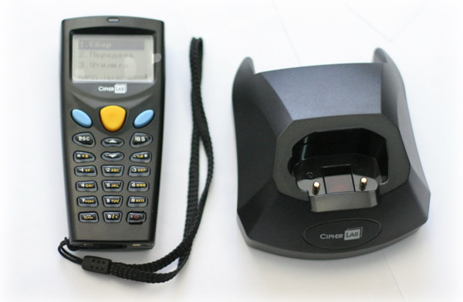

Figure 1.1. Terminal
Choosing among these devices is very huge variety of characteristics. Basically terminals differ in data collection capabilities:
• Scanning linear barcodes (usually all possible formats, as well as the color and the inverted mirror).
• Recognition of two-dimensional barcodes.
• Reading the radio tags.
But also, there are a number of other characteristics that are worth paying attention to:
• Features screen (affects the quantity and quality of output information to a user)
• The battery life (it will be unpleasant to interrupt an inventory of a dead battery)
• Memory capacity (the number of database records that the terminal can collect before sending)
• Connectivity (via dock via bluetooth or wi-fi)
• Protected against external impacts (impact strength, heat resistance - important for dusty warehouses or refrigeration)
• Price
Since initially only wanted to try an inventory of such devices, and if you would be comfortable - will be allocated money for mass adoption in all divisions, the most important criterion I chose a low price. As a result of searching and comparisons I chose CipherLab 8001L.
Labels marked all the goods and storage. Each identifier corresponds to a database record WMS, which account relevant characteristics of the product and storage areas that can uniquely identify them by a tag read information.
For the identification of goods and storage locations using mobile data terminals with integrated scanner that can read encoded information and display terminal information associated with the corresponding object.
Data on goods (products directories, applications for entry and release of goods from the warehouse) are loaded from the customer's accounting system in the WMS. Employee warehouse, equipped with mobile data terminals, perform operations with the help acceptance, shipment and product placement. By WiFi-connection data on transactions sent to the server, and then come into the accounting system of the customer (in the same way can be carried out and accounting for equipment at the plant).
Efficiency and automatic mode of transactions in the system achieved using wireless standard WiFi, which is always effective for quick connection. Despite, the fact which you device. Therefore, people are choosing WiFi technology to connect to the Internet.
In the data collection terminals and server systems. When performing commodity automatically or on request printed forms accounting and document storage.

  - The main functions of WMS system
The main function of the WMS system must be automation of the account of receipt, transfer and sale of storage resources. Increase the intensity of the sale of goods based on monitoring data.
WMS or Warehouse Management System is a technological system, which means that the problems to be solved with the help of WMS, beyond the treatment of goods, movement, inventory, etc. Full WMS-system controls all warehouse processes, from shipping and receiving of goods to strategies placement and slotting optimization of holding dynamic inventory, etc. The key task of WMS - analysis and selection of the optimal embodiment of the storage process.
Over the years, the practice of warehouse automation, we faced various challenges, specific industry requirements, types of warehouses - and now we can say that for certain types of warehouses WMS implementation is impractical with a great degree of probability:
• You work with the same type of goods, with a simple circuit inside the warehouse processing (pipe rolling).
• Your warehouse - a warehouse of goods and materials, which is not "earn", and is only required for the storage of goods. Implementation of WMS in the warehouses of this kind is possible, but will not lead to tangible benefits and you are unlikely to see a return on investment (ROI) for the project.
You should think about the warehouse automation via WMS, if:
• important for you to keep track of the results of the stock in real time.
• For you it is important analyst for storage and movement of goods flow.
• In front of you is a question of structuring and optimization of storage space.
• You use the address storage in a warehouse and you want to optimize warehouse processes through the development of algorithms for selection, placement, quality control
• On your stock using bar-coding technology, RFID
• Using technology warehouse processing: cross-docking, voice selection, distribution of shopping, etc.
Remember, your warehouse - link chain logistics and WMS systematic tool to improve the efficiency of its operation. The warehouse management system - not a panacea for all problems, and like any software product has its own set of technological and functional characteristics.
Selecting a WMS should be based on an analysis of the current situation and identify existing problems, development of business plans and the specific processing flow of goods.
The classical understanding of the design phase WMS provides for the inclusion in the functional system of the elements and tools that will continue to be used to monitor the performance of all warehouse. However, the main objective of the design phase is largely, the result of a comparison of the planned (designed feature set), and the expectations of the customer on the future of the system. Usually, the client does not have a clear idea of the data and how will be processed in the system, the user will get a result, so at the design stage it makes sense to not only build on the existing business processes, But how to analyze them, to structure and make such adjustments which further ensure the transparency of the final result for the head and understandable algorithm of actions in the system for the user.
An important part of the design phase is to review the required set of features warehouse management system, in the process of development of the organization and in the context of replicating the experience to other customer sites. We will understand this idea in more detail. At various warehouses, even within the same organization may change the requirements for warehouse management system. For example, there are a number of standard-specific warehouse processes marking the incoming flow, the formation of standard loading units, and identification of shipment account. All these functions can be implemented on a single stock. But for the second storage may be necessary for additional functions beyond the standard kit supplied for the first request. For example, you need to take a standard box of acceptance of quality control, despite the fact that all other processes have to repeat the functionality of the first warehouse. Feature configurable systems and systemic approach to the development, implementation can solve such a problem by, let's say, putting more "ticks" in the front of the relevant units. Fast, low cost, manageable. Where do these units appear in the system? Additional features warehouse management system are laid at the design stage.
Ideally, the design phase is to provide such flexibility, for which the company can respond quickly to changing market conditions and business conditions, the power to create reserves and finding new opportunities for development.
Of course, changes can take place at any stage in the beginning of the project during its implementation, at the final stage, in the course of commercial operation of the system. It is important to assess the costs of such changes, as time (a significant increase in terms of implementation) and financial. Implementation of WMS parameterized avoids surges total cost of ownership, and in the presence of trained staff in the company acquires a certain independence in terms of service WMS.

CHAPTER 2. DESIGNING AND CONSTRUCTION OF THE SYSTEM ARCHITECTURE

The main function of the system architecture is to establish a common infrastructure, or the foundation, for a building other components of a system. The infrastructure is then used and re-used by other components of a system that rely on communication and other resources through high-level architecture.
Making the right decisions at the right time is the chief responsibility of a software architect. Specifically the architect must evaluate various design options in light of overall system objectives and constraints. Each architectural decision has its benefits and costs, and since it is not possible to achieve all quality attributes that one may desire, an architect must make tradeoffs between available options.
Before we start describing utilized technologies and user interaction with the WMS, we have to know basics of software architecture. For any developer software architecture refers to the high level structures of a software system, the discipline of creating such structures, and the documentation of these structures. Software architecture choices include specific structural options from possibilities in the design of software.

2.1 Utilized technologies
Before looking at the question of what is a web application. There are two approaches for designing a web application in JAVA. First is Servlet approach and non Servlet approach. I used Servlet API 3.1, because of several reasons.
The main features of Servlet API 3.1 are:
Non-blocking I/O - Servlet 3.0 allowed asynchronous request processing but only traditional I/O was permitted. This can restrict scalability of your applications. Non-blocking I/O allow to build scalable applications. TOTD #188 provide more details about how non-blocking I/O can be done using Servlet 3.1.
HTTP protocol upgrade mechanism - Section 14.42 in the HTTP 1.1 specification (RFC 2616) defines an upgrade mechanism that allows to transition from HTTP 1.1 to some other, incompatible protocol. The capabilities and nature of the application-layer communication after the protocol change is entirely dependent upon the new protocol chosen. After an upgrade is negotiated between the client and the server, the subsequent requests use the new chosen protocol for message exchanges.
- ServletResponse.reset clears any data that exists in the buffer as well as the status code, headers. In addition, Servlet 3.1 will also clears the state of calling getServletOutputStream or getWriter.
- ServletResponse.setCharacterEncoding: Sets the character encoding (MIME charset) of the response being sent to the client, for example, to UTF-8.
- Relative protocol URL can be specified in HttpServletResponse.sendRedirect. This will allow a URL to be specified without a scheme. That means instead of specifying "http://anotherhost.com/foo/bar.jsp" as a redirect address, "//anotherhost.com/foo/bar.jsp" can be specified. In this case the scheme of the corresponding request will be used.
- Clarification in HttpServletRequest.getPart and .getParts without multipart configuration.
- Clarification that ServletContainerInitializer is independent of metadata-complete and is instantiated per web application.
JDBC
As JDBC is the uniform interface to all databases, it is enough to study of it to write appendices, which will work with MySQL. Actually if properly to use JDBC, written by you on Java of the appendix will be able to work with any DBMS. If you have an access to other databases, except MySQL, can check fidelity of this statement, having started examples of this chapter with other database.
H2
H2 is an embedded database system is a database management system (DBMS) which is tightly integrated with an application software that requires access to stored data, such that the database system is “hidden” from the application’s end-user and requires little or no ongoing maintenance.
The main features of H2 are:
- Very fast, open source, JDBC API
- mbedded and server modes; in-memory databases
- Browser based Console application
- Small footprint: around 1.5 MB jar file size
Thymeleaf
Thymeleaf offers a set of Spring integrations that allows to use it as a full-featured substitute for JSP in Spring MVC applications.
These integrations will allows to:
- Make the mapped methods in Spring MVC @Controller objects forward to templates managed by Thymeleaf, exactly like you do with JSPs.
- Use Spring Expression Language (Spring EL) instead of OGNL in templates.
- Create forms in templates that are completely integrated with form-backing beans and result bindings, including the use of property editors, conversion services and validation error handling.
- Display internationalization messages from messages files managed by Spring (through the usual MessageSource objects).
Spring Framework
Spring Framework or just Spring — a universal framework with an open source code for a Java-platform. In spite of the fact that Spring Framework didn't provide any concrete model of programming, it became widespread in Java-community mainly as alternative and replacement of the Enterprise JavaBeans model. Spring Framework provides big freedom to Java-developers in design, besides, it provides well documentary and cures of the problems easy in use arising at an application creation of corporate scale.
Meanwhile, features of a kernel of Spring Framework are applicable in any Java-application, and there is a set of expansions and improvements for creation of web applications on Java Enterprise to a platform. For these reasons of Spring acquired great popularity and admits developers as strategically important framework.
Spring MVC
The Spring Framework is an application framework and inversion of control container for the Java platform. The framework's core features can be used by any Java application, but there are extensions for building web applications on top of the Java EE platform. Although the framework does not impose any specific programming model, it has become popular in the Java community as an alternative to, replacement for, or even addition to the Enterprise JavaBeans (EJB) model. The Spring Framework is open source.
The Spring web MVC framework provides model-view-controller architecture and ready components that can be used to develop flexible and loosely coupled web applications. The MVC pattern results in separating the different aspects of the application (input logic, business logic, and UI logic), while providing a loose coupling between these elements.
- The Model encapsulates the application data and in general they will consist of POJO.
- The View is responsible for rendering the model data and in general it generates HTML output that the client's browser can interpret.
- The Controller is responsible for processing user requests and building appropriate model and passes it to the view for rendering.
Spring Data
The goal of Spring Data repository abstraction is to significantly reduce the amount of boilerplate code required to implement data access layers for various persistence stores. The central interface in Spring Data repository abstraction is Repository. It takes the domain class to manage as well as the id type of the domain class as type arguments. This interface acts primarily as a marker interface to capture the types to work with and to help to discover interfaces that extend this one. The CrudRepository provides sophisticated CRUD functionality for the entity class that is being managed.
Spring JDBC
Spring JDBC Framework takes care of all the low-level details starting from opening the connection, prepare and execute the SQL statement, process exceptions, handle transactions and finally close the connection. Spring JDBC provides several approaches and correspondingly different classes to interface with the database. I'm going to take classic and the most popular approach which makes use of JdbcTemplate class of the framework. This is the central framework class that manages all the database communication and exception handling.
Spring Test
Spring test is just as with other application styles, it is extremely important to unit test any code written as part of a batch job as well. The Spring core documentation covers how to unit and integration test with Spring in great detail, so it won't be repeated here. It is important, however, to think about how to 'end to end' test a batch job, which is what this chapter will focus on. The spring-batch-test project includes classes that will help facilitate this end-to-end test approach.
MyBatis
MyBatis does not realize JPA bake, and is alternative of JPA. The main difference of MyBatis from Hibernate — this is made a maping of objects. Hibernate maps tables DB on essence, giving us access to data. For data acquisition of Hibernate generates SQL inquiries, the generated inquiries are good from time— to time, and then they eat a heap of time, become bulky and not operated. MyBatis maps not on tables, and on SQL inquiries, the developer is responsible for formation of inquiries and only on it will depend as the appendix will quickly work.
JUnit
JUnit is a unit-testing framework for the Java programming language. JUnit has been important in the development of test-driven development, and is one of a family of unit testing framework which is collectively known as xUnit that originated with SUnit.
JUnit is linked as a JAR at compile-time; the framework resides under package junit.framework for JUnit 3.8 and earlier, and under package org.junit for JUnit 4 and later.

2.2 User interaction with the WMS
Figure 2.1. Use Case diagram
In the course of the analysis of subject domain the actors interacting with system were revealed: Storekeeper, Seller.
Each role includes the following functions:
1. The pharmaceutical account which in turn shares on:
a. Accounting of receipt
b. Return of goods on a warehouse
c. Sale
d. Message on confirmation
e. Message on not confirmation
2. The warehouse account which in turn shares on:
a. Acceptance of goods
b. Revaluation of the existing goods
c. Acceptance of the returned goods
d. Acceptance of forward goods
3. Distribution which in turn shares on:
a. Demands
b. Application
c. Viewing
d. To delete
e. Distribution of goods
f. Inquiry of confirmation
At the request of the customer was functionality on automatic generation of demands for delivery of goods which quantity reaches a minimum in realization points is provided. Considering the automation fact this action is carried out by the System, and in this case she acts as the actor.
As we see in the first chart, the pharmaceutical account works with functions for the accounting of receipt, return of goods on a warehouse, sale, the message on confirmation and the message on not confirmation.
In the second chart, the warehouse account works with functions for acceptance of goods, revaluation of the existing goods, acceptance of the returned goods and acceptance of forward goods.
Figure 2.2.Use Case diagram
In the third chart, a class distribution works with functions for demands, application, viewing, removal, of course distribution of goods and inquiry of confirmation.
And each chart there is a functionality of monitoring that the owner of a warehouse could check movements of any sort, or operations, in working hours of system. This most it is the chart expresses the uniqueness.
At the request of the customer was functionality on automatic generation of demands for delivery of goods which quantity reaches a minimum in realization points is provided. Considering the automation fact this action is carried out by the System, and in this case she acts as the actor.
Each chart of precedents describes, the system how correctly works that from this will melt it is known, with what classes the developer should work.
Figure 2.3.ERD diagram
Concerning a database, we have a model essence communication, which was based on the binary system account. It is essence of communication expresses universality since all economic operations were performed through conducting. Here you can look at the table of conducting, and then understand this table works with what attributes.
This chart comprises 8 interacting tables:
1. Conducting: credit account, credit outer, debit account, debit oauter, operation, price, quantity, sale and secondary key.
2. Medicine: name, medical name, production, price and secondary key.
3. Party: date of receipt, expiration date, price, quantity, quantity of increments and secondary key.
4. Revaluation: date, old price, new price and secondary key.
5. Account: description and primary key.
6. Outer: description and primary key.
7. Medicine type: name and primary key.
8. Operation: description, primary key and two binary keys.
In each program there has to be the database, and that it is possible to get confused very strongly. Not to get confused I thought up this universal database based on system of binary accounts. Before starting to write the chart of sequence it is necessary to check correctness of essence of communications of a database carefully. Now it is possible to decide on classes with what the developer will work.
Figure 2.4. Sequence diagram of Goods reception from suppliers
In the course of function performance of" Goods reception from suppliers" the classes given on the scheme sequence are involved: store keeper, goods, shipment, business transaction, steering, account, reappraisal. Sequence of the events occurring in system in the course of performance of function it is possible to break into the following steps:
• At the first stage Actor sends inquiry to the class goods through a web the interface by data input.
• Further the class goods having processed inquiry addresses to the class shipment.
• Further the class shipment having processed inquiry returns the answer to the class store keeper.
• Further the class store keeper having processed inquiry addresses to the class business transaction.
• Further the class business transaction having processed inquiry addresses to the class steering.
• Further the class steering having processed inquiry returns the answer to the class store keeper.
• Further the class store keeper having processed inquiry addresses to the class account.
• Further the class account having processed inquiry returns the answer to the class store keeper.
• Further the class store keeper having processed inquiry addresses to the class reappraisal.
• Further the class reappraisal having processed inquiry returns the answer to the class store keeper.
Figure 2.5. Sequence diagram of Goods distribution to warehouse
In the course of function performance of" Goods distribution to warehouse" the classes given on the scheme sequence are involved: store keeper, goods, shipment, business transaction, steering, account, reappraisal. Sequence of the events occurring in system in the course of performance of function it is possible to break into the following steps:
• In the second stage Actor sends inquiry to the class goods through a web the interface by data input.
• Further the class goods having processed inquiry addresses to the class shipment.
• Further the class shipment having processed inquiry returns the answer to the class store keeper.
• Further the class store keeper having processed inquiry addresses to the class business transaction.
• Further the class business transaction having processed inquiry addresses to the class steering.
• Further the class steering having processed inquiry returns the answer to the class store keeper.
• Further the class store keeper having processed inquiry addresses to the class account.
• Further the class account having processed inquiry returns the answer to the class store keeper.
• Further the class store keeper having processed inquiry addresses to the class reappraisal.
• Further the class reappraisal having processed inquiry returns the answer to the class store keeper.
Figure 2.6. Sequence diagram of Goods reception from warehouse
In the course of function performance of" Goods reception from warehouse" the classes given on the scheme sequence are involved: seller, goods, shipment, business transaction, steering, account, reappraisal. Sequence of the events occurring in system in the course of performance of function it is possible to break into the following steps:
• At the third stage Actor sends inquiry to the class goods through a web the interface by data input.
• Further the class goods having processed inquiry addresses to the class shipment.
• Further the class shipment having processed inquiry returns the answer to the class seller.
• Further the class seller having processed inquiry addresses to the class business transaction.
• Further the class business transaction having processed inquiry addresses to the class steering.
• Further the class steering having processed inquiry returns the answer to the class seller.
• Further the class seller having processed inquiry addresses to the class account.
• Further the class account having processed inquiry returns the answer to the class seller.
• Further the class seller having processed inquiry addresses to the class reappraisal.
• Further the class reappraisal having processed inquiry returns the answer to the class seller.
Figure 2.7. Sequence diagram of Selling
In the course of function performance of" Selling" the classes given on the scheme sequence are involved: seller, goods, shipment, business transaction, payment, steering, account, reappraisal and lend. Sequence of the events occurring in system in the course of performance of function it is possible to break into the following steps:
• At the fourth stage Actor sends inquiry to the class goods through a web the interface by data input.
• Further the class goods having processed inquiry addresses to the class shipment.
• Further the class shipment having processed inquiry returns the answer to the class seller.
• Further the class seller having processed inquiry addresses to the class business transaction.
• Further the class business transaction having processed inquiry addresses to the class payment.
• Further the class payment having processed inquiry addresses to the class business transaction.
• Further the class payment having processed inquiry addresses to the class steering.
• Further the class steering having processed inquiry returns the answer to the class seller.
• Further the class seller having processed inquiry addresses, to the class account.
• Further the class account having processed inquiry returns the answer to the class seller.
• Further the class seller having processed inquiry addresses to the class reappraisal.
• Further the class reappraisal having processed inquiry returns the answer to the class seller.
• Further the class seller having processed inquiry addresses to lend.
• Further the class lend transaction having processed inquiry returns the answer to the class seller.
Figure 2.8. Sequence diagram of Application filling
In the course of function performance of" Application filling" the classes given on the scheme sequence are involved: seller, goods, application, account. Sequence of the events occurring in system in the course of performance of function it is possible to break into the following steps:
• At the fifth stage Actor sends inquiry to the class goods through a web the interface by data input.
• Further the class goods having processed inquiry addresses to the class application.
• Further the class application having processed inquiry returns the answer to the class seller.
• Further the class seller having processed inquiry addresses to the class account.
• Further the class account having processed inquiry returns the answer to the class seller.
Figure 2.9. Sequence diagram of Goods writing off
In the course of function performance of" Goods writing off" the classes given on the scheme sequence are involved: store keeper, goods, shipment, business transaction, steering, account. Sequence of the events occurring in system in the course of performance of function it is possible to break into the following steps:
• At the sixth stage Actor sends inquiry to the class goods through a web the interface by data input.
• Further the class goods having processed inquiry returns the answer to the class shipment.
• Further the class shipment having processed inquiry returns the answer to the class store keeper.
• Further the class store keeper having processed inquiry addresses to the class business transaction.
• Further the class business transaction having processed inquiry addresses to the class steering.
• Further the class steering having processed inquiry returns the answer to the class store keeper.
• Further the class store keeper having processed inquiry addresses to the class account.
• Further the class account having processed inquiry returns the answer to the class store keeper.
Figure 2.10. Sequence diagram of Report organizing
In the course of function performance of" Report organizing" the classes given on the scheme sequence are involved: seller, history, report, saldo, account. Sequence of the events occurring in system in the course of performance of function it is possible to break into the following steps:
• At the seventh stage Actor sends inquiry to the class report through a web the interface by data input.
• Further the class report having processed inquiry addresses to the class account.
• Further the class account having processed inquiry addresses to the class saldo.
• Further the class saldo having processed inquiry addresses to the class history.
• Further the class history having processed inquiry addresses to the class saldo.
• Further the class saldo having processed inquiry addresses to the class report.
• Further the class report having processed inquiry returns the answer to the class seller.
After I defined all charts of sequence, it is necessary to start the following stage.
Figure 2.11. Class diagram
The object model represents a set of the classes comprising business logic according to the functional purpose revealed at creation of the charts sequence. The class business of logic contains all operations connected by processing of objects defined on the charts sequence and operation over tables necessary for functioning business of logic.
The scheme of the chart of classes is given in drawing below.
Figure 2.12. Class diagram
Where the class "Business transaction" is connected with the class "Payment" and with the class "Steering" it is one business of the logician.
Figure 2.13. Class diagram
Where the class "Report" is connected with the class "Account", with the class "Saldo" and with the class "History" it is another business of the logician.
Figure 2.14. Class diagram
All connected classes which have the interaction, will quickly work. And these classes "Seller", "Storekeeper", "Reappraisal" and "Lend" have no interrelation.

2.3 Tools for the implementation

IntelliJ IDEA 14
As the release of the integrated environment of applications programming of IntelliJ IDEA 14 is available to us. The system is delivered in the form of the free version "Community Edition" which is cut down on functionality and the full-function commercial version "Ultimate Edition" for which active developers of open projects have opportunity to obtain the free license. Source texts of the Community-version extend a framework of the license Apache 2.0. Binary assemblies are prepared for Linux, OS X and Windows.
Community the version of the IntelliJ IDEA environment supports tools for carrying out testing of TestNG and JUnit, the monitoring system of CVS, Subversion, Mercurial and Git versions, means of assembly of Maven and Ant, the Java, Java ME, Scala, Clojure, Groovy and Dart programming languages. Applications programming for the mobile Android platform is supported. The module of visual design of the Swing UI Designer GUI interface, the XML editor, the editor of regular expressions, system of check of a correctness of a code, the monitoring system behind performance of tasks and addition for import and export of projects from Eclipse is a part. Integration tools with systems of tracking of errors of JIRA, Trac, Redmine, Pivotal Tracker, GitHub, YouTrack, Lighthouse are available.
The commercial version "Ultimate Edition" differs in existence of support of additional programming languages (for example, PHP, Ruby, Python, JavaScript, HTML, CSS, SQL), support of the Java EE technologies, possibility of work with frameworks (Rails, Google Web Toolkit, Spring and Hibernate), integration tools with Perforce, Microsoft Team Foundation Server and Rational ClearCase.
Main innovations:
• The built-in decompiler of Java-classes allowing to analyse interiors of Java-libraries for which there are no source texts is integrated;
• Possibilities of a debugger are expanded: in the course of debugging in the editor display of the current values of variables is provided, the option of display of the referring objects (Show Referring Objects) is added, support a lambda expressions is added to dialogue of calculation of expressions (Evaluate);
• Means of inspection are expanded with the possibility of the analysis of a new code which is automatically forming summaries of @NotNull, @Nullable and @Contract for Java-libraries on the basis of a baytkod;
• In the editor of a code adaptive processing of behavior of the Backspace key, automatic detection of style of a code, support of Scratch-files, the improved system of simultaneous allocation of several blocks, an option for copying in the HTML/RTF formats (Copy as HTML/RTF), a set of small improvements is added;
• Means of the help of coding when using new releases of earlier supported frameworks are updated, support of frameworks of Thymeleaf and PhoneGap/Cordova/Ionic is added;

PostgreSQL
PostgreSQL is full-fledged SQL DBMS with the big list of opportunities and a huge number of people worldwide which use and develop this DBMS. Unlike one more free DBMS: MySQL which development initially was guided by a web, development of PostgreSQL was guided by use in difficult appendices. For this reason emphasis was always placed on reliability, existence of the developed functionality and a sootvetstveniye to standards. Thus, of course, PostgreSQL can be used in the same way and in web applications where this DBMS shows permanently excellent results, at the best scalability and a nastraivayemost.
PostgreSQL is a cross-platform product and works not only in the wide range of dialects of UNIX (Linux, FreeBSD, Solaris, etc.), but also at the Microsoft Windows platform.
For work with PostgreSQL there is a set of interfaces and libraries of interaction from other programming languages: Java (JDBC), ODBC, Perl, Python, Ruby, C, C ++, PHP, Lisp, Scheme and Qt.
PostgreSQL is intensively developed (usually new release leaves once a year, and within a year there are subversions) and well supported by community. You can always receive both free and paid technical support, having addressed in one of lists of mailing, to subscribe on which it is possible on the site PostgreSQL.
The team of the PostgreSQL developers is guided by compliance to standards. Its realization of SQL completely conforms ANSI-SQL 92/99 to standards. It has full support of the enclosed inquiries (including a choice from FROM), reading level only of the recorded data and the serialized transactions. And as PostgreSQL has completely relational system catalog supporting a set of schemes of databases, its catalog is also available by means of the information scheme according to the SQL standard.
Means of ensuring of integrity of data include compound primary keys, external keys with support of a ban and cascading of changes/removals, check of restrictions (constraints), restrictions of uniqueness and restriction on nonempty values.
PostgreSQL also includes a set of expansions and improvements. Among conveniences there are autoincremental fields on the basis of sequences, and LIMIT/OFFSET designs allowing to return a resultant set only partially. PostgreSQL supports compound, unique and functional indexes for which construction (storage) methods of a B-tree, a R-tree, hashing, or GiST can be used.
Indexing of GiST (Generalized Search Tree) represents the system uniting a big set of various algorithms of sorting and search including B-trees, B +-trees, R-trees, trees of the partial sums, the ranged B +-trees, and others. It also provides the interface providing both creation of the user types of data, and the expanded methods of inquiries allowing to carry out search in them. I.e. GiST gives the chance to define that you store as you store it and how you will carry out search. These opportunities significantly exceed the means given by standard algorithms like a B-tree or a R-tree.
GiST forms the basis for many open projects which use PostgreSQL, such as OpenFTS and PostGIS. OpenFTS (Open Source Full Text Search engine) provides on-line indexing of data and ranging on importance searching on a database. PostGIS is the project adding support of geographical objects to PostgreSQL, and allowing to use it in geographical information systems (GIS) similar to ESRI SDE or Oracle's Spatial extension.
Other improvements include tabular inheritance, system of rules, and database events. Tabular inheritance gives to creation of tables the object-oriented bias allowing to inherit at creation of a database new tables from old, considering from as basic classes. Moreover, PostgeSQL supports both single, and multiple inheritance.
The system of rules which is also called by system of rewriting of inquiries allows to create rules which set certain operations over the set tables or representations, and dynamically to transform them to other operations in the course of performance when developing a database.
Events of a database is a system of interaction between processes in which messages and events can be transferred between clients by means of use of the LISTEN and NOTIFY teams. It allows to build both simple schemes of interaction like "point-to-point", and more difficult schemes of processing of events. Notices can be initiated by triggers or the stored procedures, and clients of PostgreSQL can trace database events, such as changes, removals and entering of data into tables, in process of their approach.

2.4 Implementation of WMS
Implementation of the system was developing by IntelliJ IDEA 14.
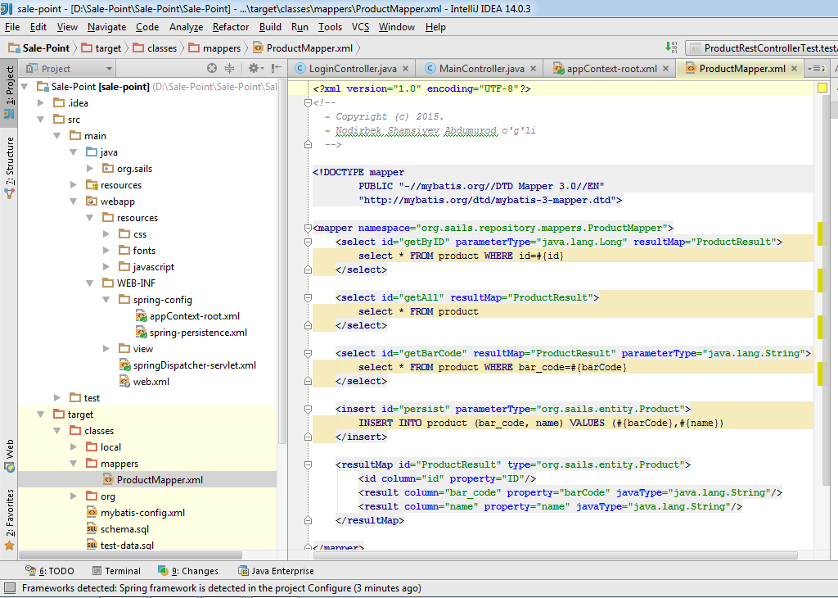
Figure 2.15. ProductMapper.xml
For using requests I used mappers, to not to be confused. It provides to parse result of requests to my entity classes.
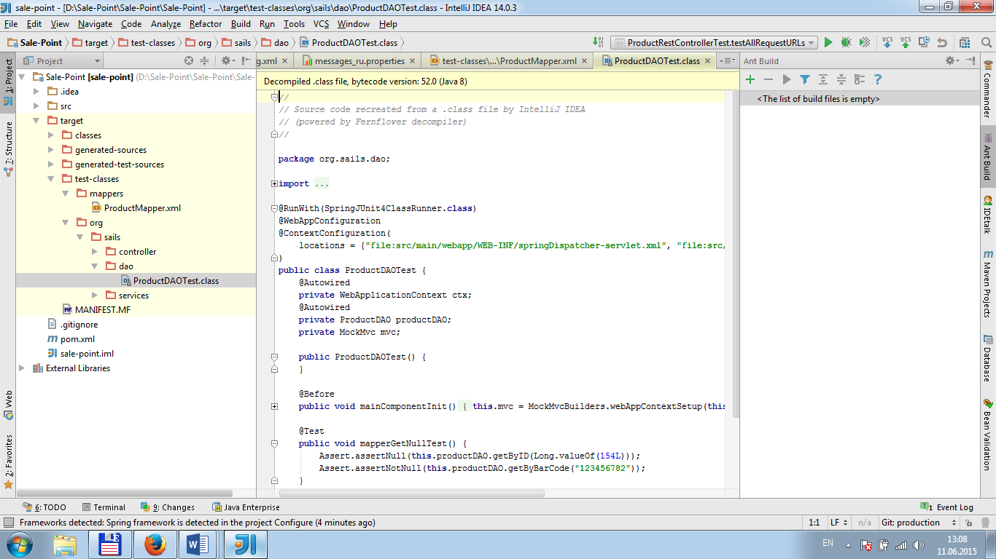
Figure 2.16. ProductDAOTest.class
In this screenshot I used DAO, because I needed to encapsulate data source. Since my soft don’t need to depend on database.
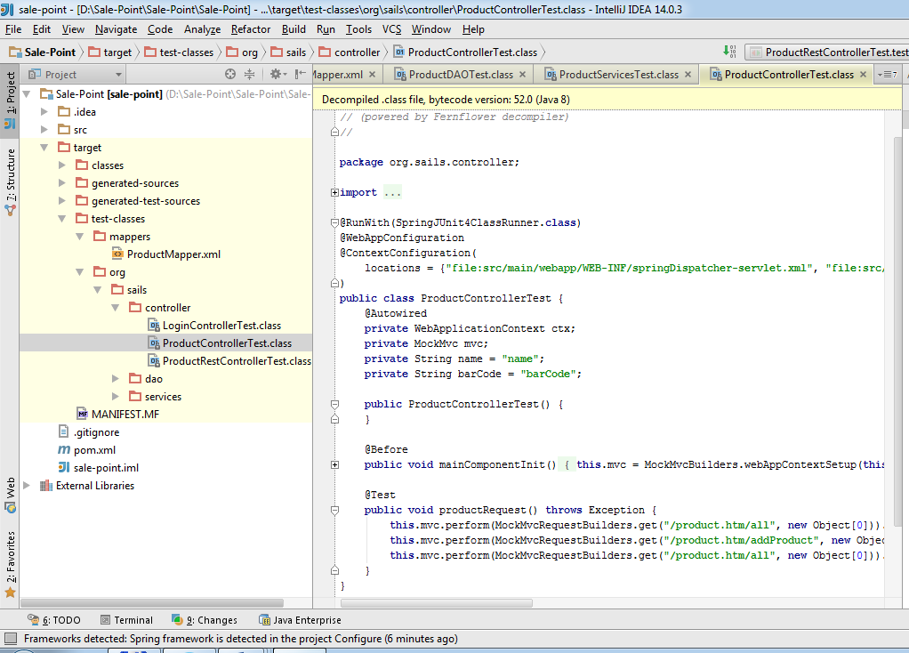
Figure 2.17. ProductControllerTest.class
Classes ProductControllerTest.class were used to make unit tests to check whole functionality.

2.5 Application description
The welcome page of our system is authorization page. It is shown in the Figure 2.6.1. According to the role of registered user, whether user will register or not. The WMS requires “founder”, “seller”, “storekeeper” role to get access in it.
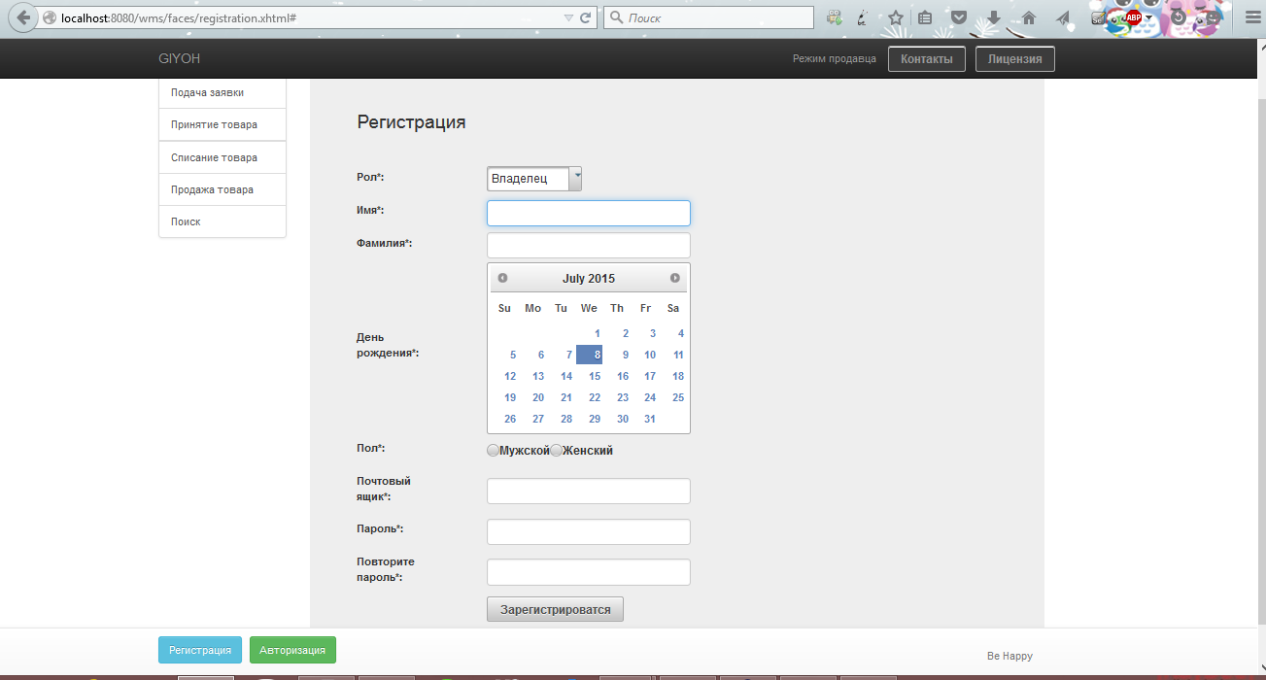
Figure 2.18. Registration page

This is the main page of “Authorization page” that consists of two rows:
- Login
- Password
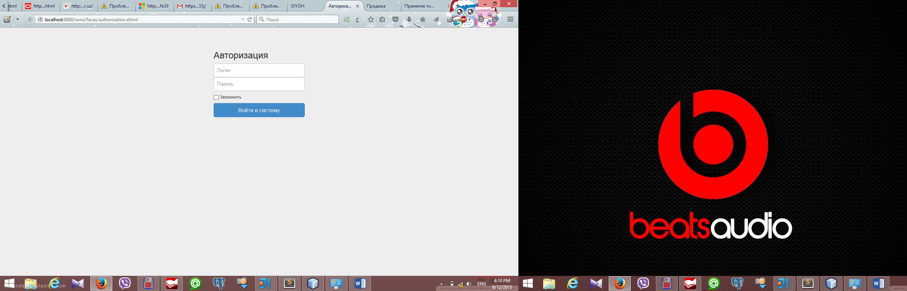
- Figure 2.19. Authorization page
It is shown in the Figure 2.6.2. According to the role of authorized user. The WMS requires user’s role to get start to get into the system.
In this page, you can see sellers application, where seller sells goods to customer.
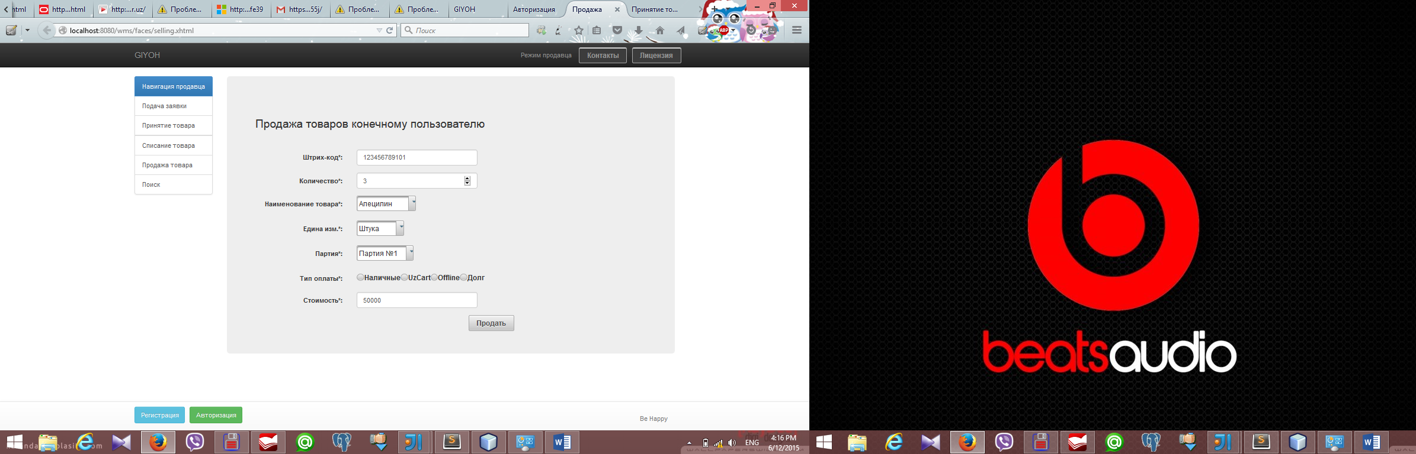
Figure 2.20. Page of selling to customers
Pointing in each row seller can choose bar code of any drug, defining count, name, measure, choice of shipment and price of course. Finally make a payment.
In this page, you can take a look at storekeeper’s application . You can see what kind of issue is going to be in this page. This is goods reception from suppliers.
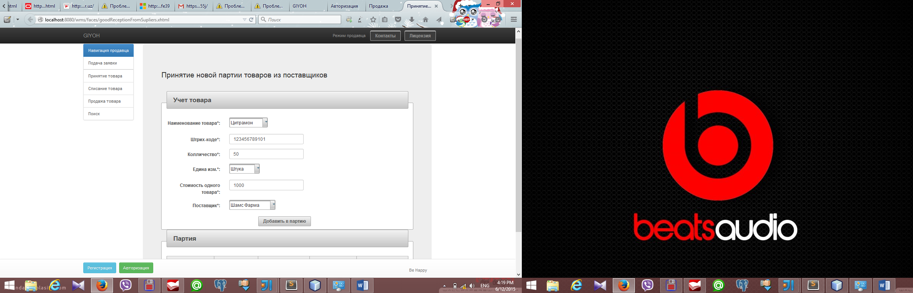
Figure 2.21. Goods reception from suppliers
When storekeeper starts an operation Goods reception from suppliers, storekeeper have to account name of goods, bar code, count of these goods, unit of measure , price of this shipment, suppliers address and add to shipment.

CHAPTER 3. LIFE SAFETY AND ECOLOGY

3.1. Ergonomics
Ergonomics (from Greek ergon - work and nomos - law) - a scientific discipline that studies human beings in its activities related to the use of machines. The goal of ergonomics - the optimization of working conditions in the "man-machine" (SChM). Ergonomics pertains to technology and human conditions of its operation. Ergonomic engineering is the most general indicator of the properties and other indicators of technology.
Ergonomics - the science of how people with their different physical characteristics and ways of functioning interact with the operating environment (equipment and machines they use). The goal of ergonomics is to provide comfort, efficiency and safety in the use of computers at the stage of development of keyboards, computer boards, furniture and others working to eliminate physical discomfort and health problems in the workplace. Due to the fact that more and more people are spending a lot of time in front of computer screens, scientists from many fields including anatomy, psychology and the environment, are involved in the study right from the point of view of ergonomics, work environment.
Most furniture manufacturers do not take into account the individual characteristics of the human body in the design of computer workstations. Construction ergonomically equipped places may require additional expenses. If your budget allows, buy ergonomically designed furniture such as chairs, shelves and tables that can be tailored to your individual physical data.
The objectives of ergonomics as an applied discipline are:
• Design the system "man-machine" that is, the distribution of functions between man and machine;
• design of the workspace so that the physical environment consistent with the characteristics of a person;
• designing environment in accordance with the requirements of the operator;
• Design work situations (working hours, rest breaks, etc.).
Psychology, as it follows from the above, is almost an integral part of ergonomics, the crucial problem of the organization of the system "man-machine" by:
• the distribution of functions between man and machine;
• analysis of the functions performed by a person in the "man-machine";
• Information system design, selection of a sensitive channel;
• design of controls;
• the design of workplaces;
• providing facilities maintenance vehicles;
• recruitment and training.
Accounting, ergonomic requirements must be implemented at all stages of the project, and includes:
• Development defining the goals and objectives of employment, its physiological characteristics, demands on man and technology.
• Analysis and specification of purpose, principles of operation and design technology, its characteristics for the purposes of employment.
• The distribution of functions between man and technology on the basis of quality assessment tasks man and machine and the overall efficiency of the system.
• Establishment of a sequence of operations performed by a man and a determination of the amount and form of presentation of information.
• Orientation assessment, time and accuracy requirements for human activities.
Based on the cited papers is determined by: the composition of experts, their function and organization of work, the composition of displays, controls, jobs and controls; arrangement of displays and controls, posting jobs in production areas.
Relationship with the environment and the working environment.
Workplace - this is the area in which work activity is performed performer or group of performers. Jobs can be individual or collective, universal, specialized and specific.
General requirements to be met in the design of workplaces, the following:
• Adequate working space for human rights;
• optimal working posture;
• adequate physical, visual and auditory communication between man and machine;
• Optimal placement of the workplace in the room;
• acceptable level of the factors of production conditions, the optimal placement of information and motor field;
• a means of protection against occupational hazards.
The construction zone should provide easy access and optimal motor field of the workplace and the optimal coverage of the information field workplace. Viewing angle to the horizontal should be 30-40 °.
Selecting the operating position must take into account the efforts expended by a person, the magnitude of movements, the need for movement, the tempo of operations. Selection of working postures should take into account human physiology, and workplace settings determined by the choice of body position at work (sitting, standing, alternately).
Jobs for work "sitting" are organized under light to moderate work, and with a heavy - working posture - "standing."
The design of the equipment and the work area must be such as to permit the regulation of individual elements to ensure optimum working position.
Equipment design should ensure that it complies anthropometric and biomechanical characteristics of a person on the basis of consideration of the dynamics change the size of heat when it is moved, the range of motion in the joints.
To take into account in the design of equipment anthropometric data should:
• determine which people, which is intended for equipment;
• select a group of anthropometric characteristics;
• establish the percentage of employees who must meet the equipment;
• determine the boundaries of the interval size (forces) to be implemented in hardware.
In the design used anthropometric dimensions of the body, and take into account differences in body size between men and women, national, age, professional. To determine the boundaries of intervals, which take into account the percentage of the population uses a system pertseteley. Construction equipment must allow for at least 90% of consumers.
For operation in the "sitting" used various working seat. Distinguish workers seat. Long and short-term use. General requirements for the seats durable following: sitting posture should provide that reduces the statistical work of muscles, to create the conditions for the possibility of changing the working posture, no hindrances in the systems of the body, to ensure the free movement relative to the work surface, have adjustable parameters, have a semi-soft upholstery. For short-term use is recommended hard chairs and stools of various types.
With the increasing mechanization and automation of production processes are particularly important means of displaying information about the object. The widespread use of received information model, that is organized according to specific rules about the state of the control object. For information models must meet the following requirements:
• The content of the information model should be adequate to display the object management;
• Information Model should provide an optimal balance of information;
• Shape and composition information model must be consistent with the work process and the possibilities of man to receive the information.
Practice allows you to map out the sequence of the development of the information model: the definition of the tasks of the system, the sequence of their solutions and sources of information, an inventory control objects and their attributes, the distribution of objects in order of importance, the distribution of functions between automatic and man, the choice of a coding system objects and the drawing up of the overall composition of the model; definition of executive actions of man.
In the process of designing the information model defined location of the media in the workplace, selected label dimensions and layout. Display means are placed in the field of view with the optimum angles and observation areas. Dimensions are determined by observation of signs with the maximum accuracy and speed of perception and brightness character, the values of contrast, the use of color. Considered optimum brightness values, which provide maximum contrast sensitivity. Its value will be greater, the smaller the size of the object of discrimination. The optimum region the contrast value is equal to 60-90%.
In my eyes there is a certain inertia, which requires taking into account the exposure time and the visual signal timing for a sense of separateness signals one after the other. In most cases, the exposure time signal must be at least 50 ms. Each species has its own area of indicators used: Backlit indicators are used to display high-quality information that requires immediate attention of the operator, dial indicators are used to read measured values, integral indicators for combining information about several parameters.
The structure and dynamics of the managed object is usually represented by a chip. In some cases, a display for displaying information and the perception of its team of operators.
In the design of the workplace should be considered rules of economics movement: the work of the two arms of the movement must be simultaneous and symmetrical, the movement should be smooth and rounded, rhythmic and familiar to the employee. Equipment design should take into account the rules on speed and accuracy of movement of workers. For example, the most rapid movement to itself, in the horizontal speed of the hands more than the vertical, the accuracy of motion in the sitting position rather than standing up etc. The controls used in the workplace, must comply with the general requirements ergonogetiki: the direction of motion controls should correspond to the movement of the associated indicator, matching the location of the control sequence of the operator's ease of use, the creation of government agencies in the mechanical resistance, etc. Besides, for each type of pressure corresponds to a different area of use and the special requirements for size, shape, force, etc.
On the workstation operator-communicator (the operator in the control room) are generally used:
- Display means for individual use (imaging units, signaling devices, etc.);
- Controls and input (remote display, keyboard control, individual controls, and so on);
- Device information and communication (modem, telegraph and telephones)
- Documenting and storage device information (printing apparatus, recording, etc.);
- Auxiliary equipment (office equipment, storage for media, local lighting devices).
At the workstation must be provided information and structural compatibility of the technical means of anthropometric and psycho-physiological characteristics of the person.
If your work area should be taken into account not only the factors that reflect the experience, level of training, individual and personal property of the operators, signalers, but the factors that characterize the compliance forms, methods of presentation and data entry capabilities psychophysiological person.
When optimizing the procedures of interaction operators, signalers with the technical means in terms of automation ergonomic factors are the principal causing probability characteristics and hard work. These factors are sensitive to variations in the properties of the individual personality of the operator.
Workshop furniture should be comfortable to perform the planned work operations. The construction work of furniture: table, chair is essential for a healthy environment and a high-efficiency work. Workshop furniture is constructed taking into account the anthropometric data of human, technical, aesthetic, and economic factors.
Included working furniture has important industrial design chair as it determines the position worker and therefore energy consumption and the degree of fatigue. Operating the seat should have the required dimensions corresponding anthropometric rights and be mobile. The most comfortable seats and chairs with adjustable back tilt and height of the seat. By varying the height of the seat from the floor and back angle, you can find a position that most closely matches the labor process and the individual characteristics of the employee.
As a rule, all the surfaces of written and desktops should be at elbow height at working man's position. When you select a table height should be considered a man sitting during work or cost.
Inconvenient table height reduces efficiency and causes rapid fatigue. The lack of sufficient space for knees and feet causes constant irritation of the employee. Minimum working height of the table should be at least 725 mm. Practice shows that the average height for the working height of the desktop received 800 mm. For another employee growth can change the height of a chair or working status of its steps so that the distance from the object to the processing of eye working height was equal to about 450 mm.
Accommodation facilities and the operator's seat in the work area to provide convenient access to the major functional units and units of equipment for technical diagnostics, maintenance inspection and repair, and the ability to quickly take up and leave the work area, with the exception of accidental actuation of the controls and data entry; convenient posture and pose recreation. In addition, the layout must meet the requirements of integrity, and compactness of the technical and aesthetic expression of the working posture.
The display should be placed on a desk or table so that the viewing distance to the screen does not exceed 700 mm (optimal length 450 - 500 mm). Display adjustment should be located so that the angle between the center line of the screen and the horizontal view was 200. The horizontal viewing angle of the screen should not exceed 600. Remote display must be placed on a table or stand, so that the keypad height relative to the floor was 650 - 720 mm. When placing the console on a standard table height of 750 mm is necessary to use a chair with adjustable seat height (450 - 380 mm) and a footrest.
Document (blank) for operator input of data is recommended to have a distance 450 - 500 mm from the eyes of the operator, especially the left, the angle between the display screen and the document in the horizontal plane 40 should be 30 °. Angle of the keyboard should be equal to 15 °.
Screen display and keyboard instruments display panel should be arranged to drop the brightness of surfaces, independent of their location relative to the light source does not exceed 1:10 (recommended value
1: 3). At nominal values of the brightness of the screen image 50 - 100 cd/m2 luminance of the document should be 300 - 500 lux.
The workplace should be equipped in such a way that the movement of the worker would be the most rational, less tedious.
Device documentation and other infrequently used technical tools is recommended to have the right of an operator in the zone of maximum reach and means of communication to the left to release the right hand to take notes.

3.2. Production influence of meteorological conditions on the human organism.
Classification of the working environment and its effects on the body.
Production climate (weather conditions) - the climate of the internal environment of production facilities is determined by the current on the human body by a combination of temperature, humidity and air velocity and temperature of the surrounding surfaces.
Production depends on the climate zone and climate season, the nature of technological process and type of equipment used, the size and number of working places, heating and venter conditions. However, despite the variety of micro-climatic conditions can be divided into four groups.
1. The microclimate of industrial premises in which production technology is not associated with significant heat generation. The microclimate of the premises mainly depends on the climate, the terrain, heat and vender. There can only be a slight overheating on hot days in summer and cool winter with insufficient heating.
2. The microclimate of industrial premises with significant heat generation. These include boilers, forging, open-hearth and blast furnaces , sugar factories and workshops. In hot shops impact on the climate has warmed heat and hot surfaces.
3. The microclimate of industrial premises with an artificial cooling. These include various refrigerators.
4. The microclimate of the open atmosphere, depending on the
climate conditions (eg, agricultural, road and construction works).
One of the most important conditions for the normal life of a person in the performance of professional duties is to maintain thermal organism balance with significant fluctuations of various parameters of the working environment, rendering -governmental influence on the state of the heat exchange between the individual and the environment.
Heat transfer functions, adjustable thermoregulatory centers and cortex provide the optimum ratio of heat generation and heat transfer processes depending on the specific conditions. The main role in the heat exchange processes in humans belong physiological regulation of the heat output.
Under normal climatic conditions, heat transfer is mainly due to radiation, approximately 45% of the removed body heat convection - 30% and evaporation - 25%.
At low ambient temperature increases the proportion of convection-. Under conditions of high ambient temperature decreases heat loss by convection and radiation, but due to increased evaporation. At temperatures equal to body temperature, heat transfer by radiation and convection practically disappears and becomes the only way to heat the evaporation of sweat.
Low temperatures and increased air mobility help to increase heat loss by convection.
Role of humidity at low air temperatures significantly less. At the same time it is believed that at low temperatures, high humidity environment increases heat loss from the body due to intensive water vapor absorption of the radiation energy of man. However, a large increase in heat loss occurs through direct wetting of the body surface and clothing. In a production environment, where the air temperature and surrounding surfaces below the temperature of the skin, heat is carried out mainly by convection and radiation. If the air temperature and the temperature of the surrounding surfaces is equal to or above the skin, occurs due to the evaporation of moisture from body surface and from the upper respiratory tract, if the air is not saturated with water vapor.
A significant expression of individual factors in the production of climate may be the cause physiological changes in the body of workers, and in some cases may cause pathological conditions and diseases.
Integral indicator of the thermal state is human body temperature. The degree thermoregulatory functions of the body and its thermal state can be judged as to change temperature, skin and heat balance. Indirect indicators of the thermal state - and the reaction cardiovascular system (heart rate, blood pressure and minute volume of blood). Violation of thermoregulation because of the constant overheating or overcooling of the human body causes a number of diseases.
Under the conditions of excess heat energy restriction or even complete elimination of certain ways heat can lead to a violation of thermoregulation in which possible overheating of the body, that is. E. Increased body temperature, increased heart rate, sweating and with a strong degree of overheating - thermal impact - ataxia, weakness, drop in blood pressure, loss of consciousness.
As a result of violations of water-salt balance can develop convulsive disease, which manifests itself in the form of tonic convulsions of limbs, weakness, headaches, and others.
When working outdoors during intensive direct irradiation of the head can occur sun hit, accompanied by headache, vision, vomiting, cramps, but body temperature remains normal.
Effects of infrared radiation on the body is both general and local reactions. Stronger reaction by irradiation of long-wave radiation, so when the same intensity portability time is shorter than the short-wave radiation. Due to the great depth of penetration into the tissues of the body portion of the spectrum short-wave infrared radiation has a more pronounced effect on the overall human body.
Under the influence of infrared study of the human body there are biochemical changes and changes in the functional state of the central nervous system, enhances the secretory activity of the stomach, and salivary glands.
Cold discomfort (convection and radiation) is in the human thermoregulatory changes to limit heat loss and increase heat production. The decrease is due to vasoconstriction in peripheral tissues.
Under the influence of low and low temperatures may develop air refrigeration (swelling, itching, and burning of the skin), frostbite, myositis, neuritis. Long-term cooling promotes the development of diseases of the peripheral nervous and muscular systems, joints: radiculitis, neuritis, myositis, rheumatoid diseases. Frequent and strong cooling may occur neurotrophic changes.
Normalization of the working environment and prevention of adverse effects.
All norms of microclimate of industrial premises regulate the rate of production of the microclimate. They determined the air temperature, its relative humidity, air velocity, and optimal allowable intensity exposure to the work area taking into account the season of the year and severity of work.
In production areas where it is impossible to install allowable microclimate necessary to include measures to protect workers from possible overheating and cooling.
The main way of improvement of working conditions in hot shops is to change the process, aimed at limiting the sources of heat and reduction of contact time working with climate, and the effective use ventilation, streamlining the work and rest, drinking regime, work wear.
The most effective means of improving weather conditions and is automation of all processes associated with the heating of the products.
Significantly reduces heat radiation and convection and radiant flow of heat into the working area insulation, reflective screens, water curtains.
A significant factor in increasing activity working hot shops is compliance of work and leisure, reduced working hours, additional breaks, rest rooms.
For personal overheating prevention is essential rational drinking regimen. When (more than 3.5 kg per shift) and significant exposure time infrared radiation - 50% and - used salted (0,3% NaCl) carbonated water with the addition of potassium and vitamins. At lower salt consumption filled food. In the southern parts of the country are used in hot shops protein-vitamin drink, green tea with added vitamins and other.
In the prevention of overheating play an important role of personal protective equipment (overalls of cloth and staple fabrics, fiber, helmets, felt hats, etc..).
To avoid falling into the cold air production areas should be equipped with air curtains at the entrance lobbies, or gateways. If the building can not use an air and radiant heating. When working outdoors in cold climates suit breaks for heating in specially equipped rooms warm. An important role is also played by clothing, shoes, gloves (wool, fur, artificial tissue with heat features, heated clothing, etc..). Termination of work in the open air at low temperatures is made on the basis of the decision of local authorities.

3.3. Model of the production processes in terms of ecology.
Any manufacturing process is a certain system is organically linked with the external environment. This manufacturing system receives from the environment feedstock materials, energy, and sends it to the finished products and various waste. Operation of the system is carried out thanks to the flow of energy supplied from the outside (electric, solar, etc.) or generated internally by physical and chemical processes. For wastes include all substances and materials, thermal emission, physical and biological agents which fall into the external environment and is not further participate in the delivery of products or energy.
If we use the concepts of thermodynamics, then, like all systems, processes, in principle, divided into three categories: non-closed (open), closed and isolated. The vast majority of real-world processes fall into the category of unclosed. It is considered as closed systems in which there is no exchange of matter with the environment. Technology analogue closed-loop system can serve as a process in which there are no residues of chemicals - solid, liquid and gaseous emissions. For example, the final assembly of products made of finished parts. In this exchange with the external environment feedstock and finished products not taken into account, although the products can also be considered as a deferred departure. Theoretically possible and isolated processes, which do not give any material or energy waste.
In general, all the processes can be considered in terms of their environmental compliance. Regarding such can be considered environmentally friendly manufacturing processes and production, whose impact on the environment in the framework of a certain proportion does not violate the normal functioning of natural ecosystems. Environmentally unfriendly process technologies provide increased human impacts and have a negative impact on the environment.
It may be any environmentally unfriendly process. Thus, a closed process technology with no removal of chemical substances into the environment, can not be considered harmless if it is accompanied by harmful physical effects: thermal emissions, noise, electromagnetic fields, etc.
Environmentally friendly production processes can be estimated by using the method of primary balance, which is based on the conservation laws: the mass of all the resources used (raw materials, fuel, water, etc.) will eventually equal to the mass of finished products and industrial wastes. Consider the scheme of material flow in the production of various degrees of isolation. The following notations:
R -current resources (feedstock, basic and auxiliary materials, semi-finished products);
W -current waste (chemicals and energy), polluting and carrying away some of the mineral resources;
Wy - trapped waste stream;
F - the flow of finished products.
Non-closed production process meets the following equation logistics balance:
R = P + W = (R - Wy) + W. (1)
The parentheses in the equation indicates the unity of the flow (and waste). "Waste production" can be assessed at a rate of Kothi = W / R. Accordingly, the ratio of non-waste Kb = F / R.
The closed production cycle comes to a complete processing and recycling of the waste stream Wy, which returns to the sphere of production. It flows Wi Wy are quantified, and the flow of finished products P corresponds to an R.
In a number of mathematical models are considered environmentally friendly production methods with various schemes of input, intermediate and output streams. As characteristics of the flow received not only mass flow agent and its concentration, temperature, pressure, flow of heat and other physical parameters related to each other balance equations. Methods of modeling of production processes are useful in solving problems of optimization technologies for environmental criteria.
Greening and reduced environmental capacity manufacturing involve reducing gross introduction into the environment of man-made emissions. Make it completely waste-free production impossible. The problem is not limited to, to eliminate everything environmentally negative effects of production processes. To put such a task equivalent to the intention to invent a perpetual motion machine. Conditionally zero waste can only be the individual stages of the technological cycle of production. However, there are theories of non-waste processes and certain provisions relating to this issue.
Thus, according to the definition adopted at the seminar of the European Economic Commission on low-waste technology (Tashkent, 1984), "non-waste technology - it is a method of production (process, enterprise, territorial and production complex), under which the most rational and comprehensive raw materials used, and energy in a series of "raw materials - Production - Consumption - secondary raw materials * so that any impact on the environment does not violate its normal functioning."
Sometimes, especially in foreign literature, used the term "clean production", which refers to technology strategy that prevents environmental pollution to a minimum and lowers the risk for people and the environment. With regard to the process - is the rational use of raw materials and energy, elimination of toxic raw materials, reduction of the number and degree of toxicity of all emissions and waste generated during the manufacturing process. In terms of production Cleaner production means reducing its environmental impact throughout the product's life cycle from raw material extraction to disposal (or disposal) after use. Cleaner production is achieved through improved technology, the use of know-how and / or improvement of the organization of production. Note that these definitions do not imply the possibility of a complete non-waste production.

CONCLUSION
The purpose of this work is software development of Warehouse Management System. The user should be able to enter, view and edit the raw data.
Within this work the following results were received:
- Study of problem domain
- Formulation of the problem statement
- Basics of structure of web applications development are covered
- Analyze technologies of web applications development
- The analysis of the problems that appear while reporting are forming
- Development of algorithm
- Develop and implement a block diagram of the database
- The user's manual of system is created
Result of all work is software development Warehouse Management System that allows to calculate almost all operations which was done by employees of pharmacy and clear profit, to manage the financial flows of pharmacy for its different activities, to increase its quality for managing with different types of goods.

REFERENCES
1. Report of the Republic of Uzbekistan President dedicated to the socio-economic development in 2012 and the most important priorities of economic program for 2013, Karimov I.A., Publisher:Norma, 2012
2. Management accounting, Vahrushina M.A., Publisher: Omega-L, 2003, 570 p.
3. "Techniques of object-oriented design. Design Patterns ", E. Gamma, R. Helm, R. Johnson, J.. Vlissides, Publisher: Williams,2004, 546 p.
4. Database systems. Full course, Garcia-Molina G, Ullman.J, Widom J,Publisher: Williams, 2004, 636 p.
5. Automated information technologies in the economy, Titorenko E.D.,
Publisher: Unity, 2006, 463 p.
6. http://rsdn.ru/article/patterns, "Generalized Model-View-Controller», Sergei R., 2007
7. http://abc.vvsu.ru/Books/ecolog_tocsicolog, «Environmental Toxicology», Ivanenko N.V.,2008
8. Fire safety, Sobur S.V., Publisger: Kalan, 2011, 304 p.
9. Databases and UML. Design, Mueller R.J., Publisher: Lory, 2002, 442 p.
10. A SAS Institute White Paper «Standard scenario development of Web-based applications",Chip Kelly, Publisher: The power to know, 2012, 16 p.
11. http://scitelclibrary.ru, "Review of modern WEB technologies build server-side applications", Kryukov D.,2013
12. http://opengroup.org/projects, Determination of a service-oriented architecture
13. Basis of accounting, Bogachenko V.M., Publisher: Feniks, 2013, 334p.
14. Accounting, Gulyamova F.G., Publisher: Norma, 2013, 128 p.
15. Collection of national accounting standards, Gulyamova F.G., Publisher: Norma, 2014, 432 p.

APPENDIX
LoginControllerTest.class
//
// Source code recreated from a .class file by IntelliJ IDEA
// (powered by Fernflower decompiler)
//
package org.sails.controller;
import org.junit.Before;
import org.junit.Test;
import org.junit.runner.RunWith;
import org.springframework.beans.factory.annotation.Autowired;
import org.springframework.test.context.ContextConfiguration;
import org.springframework.test.context.junit4.SpringJUnit4ClassRunner;
import org.springframework.test.context.web.WebAppConfiguration;
import org.springframework.test.web.servlet.MockMvc;
import org.springframework.test.web.servlet.request.MockMvcRequestBuilders;
import org.springframework.test.web.servlet.result.MockMvcResultHandlers;
import org.springframework.test.web.servlet.result.MockMvcResultMatchers;
import org.springframework.test.web.servlet.setup.MockMvcBuilders;
import org.springframework.web.context.WebApplicationContext;
@RunWith(SpringJUnit4ClassRunner.class)
@WebAppConfiguration
@ContextConfiguration(
locations = {"file:src/main/webapp/WEB-INF/springDispatcher-servlet.xml", "file:src/main/webapp/WEB-INF/spring-config/appContext-root.xml"}
)
public class LoginControllerTest {
@Autowired
private WebApplicationContext ctx;
private MockMvc mvc;
public LoginControllerTest() {
}
@Before
public void mainComponentInit() {
this.mvc = MockMvcBuilders.webAppContextSetup(this.ctx).build();
}
@Test
public void loginRequest() throws Exception {
this.mvc.perform(MockMvcRequestBuilders.get("/login.htm", new Object[0])).andExpect(MockMvcResultMatchers.status().isOk()).andExpect(MockMvcResultMatchers.content().encoding("UTF-8")).andDo(MockMvcResultHandlers.print());
}
}

ProductControllerTest.class

package org.sails.controller;
import org.junit.Before;
import org.junit.Test;
import org.junit.runner.RunWith;
import org.springframework.beans.factory.annotation.Autowired;
import org.springframework.test.context.ContextConfiguration;
import org.springframework.test.context.junit4.SpringJUnit4ClassRunner;
import org.springframework.test.context.web.WebAppConfiguration;
import org.springframework.test.web.servlet.MockMvc;
import org.springframework.test.web.servlet.request.MockMvcRequestBuilders;
import org.springframework.test.web.servlet.result.MockMvcResultHandlers;
import org.springframework.test.web.servlet.result.MockMvcResultMatchers;
import org.springframework.test.web.servlet.setup.MockMvcBuilders;
import org.springframework.web.context.WebApplicationContext;
@RunWith(SpringJUnit4ClassRunner.class)
@WebAppConfiguration
@ContextConfiguration(
locations = {"file:src/main/webapp/WEB-INF/springDispatcher-servlet.xml", "file:src/main/webapp/WEB-INF/spring-config/appContext-root.xml"}
)
public class ProductControllerTest {
@Autowired
private WebApplicationContext ctx;
private MockMvc mvc;
private String name = "name";
private String barCode = "barCode";
public ProductControllerTest() {
}
@Before
public void mainComponentInit() {
this.mvc = MockMvcBuilders.webAppContextSetup(this.ctx).build();
}
@Test
public void productRequest() throws Exception {
this.mvc.perform(MockMvcRequestBuilders.get("/product.htm/all", new Object[0])).andExpect(MockMvcResultMatchers.status().isOk()).andExpect(MockMvcResultMatchers.content().encoding("UTF-8")).andDo(MockMvcResultHandlers.print());
this.mvc.perform(MockMvcRequestBuilders.get("/product.htm/addProduct", new Object[0])).andExpect(MockMvcResultMatchers.status().isOk()).andExpect(MockMvcResultMatchers.content().encoding("UTF-8")).andDo(MockMvcResultHandlers.print());
this.mvc.perform(MockMvcRequestBuilders.get("/product.htm/all", new Object[0])).andExpect(MockMvcResultMatchers.status().isOk()).andExpect(MockMvcResultMatchers.content().encoding("UTF-8")).andDo(MockMvcResultHandlers.print());
}
}

ProductRestController.class

//
// Source code recreated from a .class file by IntelliJ IDEA
// (powered by Fernflower decompiler)
//
package org.sails.controller;
import org.junit.Assert;
import org.junit.Before;
import org.junit.Test;
import org.junit.runner.RunWith;
import org.mockito.Mock;
import org.mockito.Mockito;
import org.mockito.MockitoAnnotations;
import org.sails.entity.Product;
import org.springframework.beans.factory.annotation.Autowired;
import org.springframework.http.MediaType;
import org.springframework.test.context.ContextConfiguration;
import org.springframework.test.context.junit4.SpringJUnit4ClassRunner;
import org.springframework.test.context.web.WebAppConfiguration;
import org.springframework.test.web.servlet.MockMvc;
import org.springframework.test.web.servlet.request.MockMvcRequestBuilders;
import org.springframework.test.web.servlet.result.MockMvcResultHandlers;
import org.springframework.test.web.servlet.result.MockMvcResultMatchers;
import org.springframework.test.web.servlet.setup.MockMvcBuilders;
import org.springframework.web.context.WebApplicationContext;
@RunWith(SpringJUnit4ClassRunner.class)
@WebAppConfiguration
@ContextConfiguration(
locations = {"file:src/main/webapp/WEB-INF/springDispatcher-servlet.xml", "file:src/main/webapp/WEB-INF/spring-config/appContext-root.xml"}
)
public class ProductRestControllerTest {
@Autowired
private WebApplicationContext ctx;
@Mock
Product product;
private MockMvc mvc;
public ProductRestControllerTest() {
}
@Before
public void mainComponentInit() {
this.mvc = MockMvcBuilders.webAppContextSetup(this.ctx).build();
MockitoAnnotations.initMocks(this);
Mockito.when(this.product.getBarCode()).thenReturn("1123123");
}
@Test
public void testAllRequestURLs() throws Exception {
this.mvc.perform(MockMvcRequestBuilders.get("/product.htm/json/ID/{ID}", new Object[]{"1"})).andExpect(MockMvcResultMatchers.status().isOk()).andExpect(MockMvcResultMatchers.content().contentType(MediaType.APPLICATION_JSON)).andDo(MockMvcResultHandlers.print());
this.mvc.perform(MockMvcRequestBuilders.get("/product.htm/json/ID/{ID}", new Object[]{"12237777777123123"})).andExpect(MockMvcResultMatchers.status().isNotFound());
this.mvc.perform(MockMvcRequestBuilders.get("/product.htm/json/barCode/{barCode}", new Object[]{"123456782"})).andExpect(MockMvcResultMatchers.status().isOk()).andExpect(MockMvcResultMatchers.content().contentType(MediaType.APPLICATION_JSON)).andDo(MockMvcResultHandlers.print());
this.mvc.perform(MockMvcRequestBuilders.get("/product.htm/json/barCode/{barCode}", new Object[]{"1111111111111111111111111"})).andExpect(MockMvcResultMatchers.status().isNotFound());
this.mvc.perform(MockMvcRequestBuilders.get("/product.htm/json/all", new Object[0])).andExpect(MockMvcResultMatchers.status().isOk()).andExpect(MockMvcResultMatchers.content().contentType(MediaType.APPLICATION_JSON)).andDo(MockMvcResultHandlers.print());
this.mvc.perform(MockMvcRequestBuilders.get("/product.htm/json/string", new Object[0])).andExpect(MockMvcResultMatchers.status().isOk()).andExpect(MockMvcResultMatchers.content().contentType(MediaType.APPLICATION_JSON)).andDo(MockMvcResultHandlers.print());
Assert.assertEquals("1123123", this.product.getBarCode());
}
}

