

The Republic of Uzbekistan
The Ministry of Higher and Special
Secondary Education
Bukhara State University
Social-economic faculty
Economic Education and Tourism Department
Permitted to defend
Head of Department _______________ PhD H.R.KHAMROEV
«_____»_______________2015

DIPLOMA PAPER WORK

Title: The advance foreign experience of economical education and its application in the conditions of Uzbekistan”
Author: A graduate in Bukhara State University social-
economical faculty 5111000- “Professional
education” (economy) is Hamidov Rushan

Supervisor: B.N. Navro`z-Zoda
The date of defense The mark of S.A.C

«____»___________2015 ___________________
The conclusion of S.A.C

Bukhara – 2015.
The Republic of Uzbekistan
Ministry of Higher and Special Secondary Education
Bukhara State University
Social-economic faculty
Economic Education and Tourism Department
Speciality: Social-economical faculty 5111000- “Professional education” (economy)
“Confirmed”
Head of Department _____________
«____»____________2014

The title of diploma paper work: “The advance foreign experience of economical education and its application in the conditions of Uzbekistan”
1.Confirmed with the order of university ______________________
2.Completion date of bachelor thesis by author______________
3.The content of explanation letter__________________________
The list of questions related to the bachelor thesis:
4 The quantity of charts ( Important drafts with indicators)

5.Scientific advisors:
6.Supervisor B.N. Navro`z-Zoda
7.Date of the completion of task_________________________________________
8.Task is approved for performance______________________________________
Student’s signature________________________
The head of department’s signature________________

CONTENTS
Introduction ……………………………………………………………………..3
1-CHAPTER.Economical education’s essence and kinds………………………5
1.1. Economical education’s essence…………………………………………….5
1.2. Economical education’s kinds ………………………………………….…12
2-CHAPTER. Economical education’s leading foreign experience…………….20
2.1. USA economical education system ………………………………….….…20
2.2.China economical education system…………………………….………….31
3-CHAPTER.Eonomical education’s methods using and created new teaching models in condition of Bukhara…………………….……………………………39
3.1. Eonomical education is explained though view with Bukhara Tax college’s students…………………………………………………….……………………...39
3.2. Some created models which of teaching economical education..…………...43
Conclusions and Suggestions…………………….……………………………..47
References…………………………………………………………………….….52
Appendix ( it consists of twenty questions )………………….…………………55

Introduction
Theme’s climax. Uzbekistan was independent and it was very glad event, but we must solve very big problems and now we have solved many problems according to society has some solutions, our president has strived to reform economical system in community and he managed this very well. But my diploma paper work it is not about economical system’s problems it describe ”How we educate our children’s economical training”. It is very important in our society because nowadays there are many opportunties to developing or increasing own business. But there are many people in community and they want to live very well they would like to be richman, nevertheless some person obtain this chance because people have little economical knowledge. Because our ancestor had lived for seventy years colony’s USSR. This country had lived during in 1991 year and soviets wanted to build their community but it was riddle. There are not this country in the world but their economical training affected people conscious if we want to developing our country we must change humans mind we take shape new skills, new knowledge, new economical traininig because of economical training very important for developed our country economical power.
Diploma paper work’s purpose : foreign economical training application in our community and its created new teaching method.
Diploma paper work’s tasks. During the search following tasks are planed and solved:
- Economical education’s essence is describe by this text.
- Economical educastion’s kinds of expressing
- Economical educastion’s advance foreign experience have been learnt
- How is economical education explained by TAX college’s students.
- How we can be application to advance foreign experience for our condition.
- Advance foreign experience will get application in teaching system.
- Questionnaire – for learning economical education’s degree.
- Economical education’s technical model to be created
Diploma paper work’s main point is economical education
Diploma paper work’s subject is Economical educastion’s advance foreign experience.
Diploma paper work consists of introduction, three units, conclusion, suggestions and used infotmation base.
In introduction part explain subject’s culmination and expresse some facts this tema. Researching’s guest and chores are found, obtained results short describe this part and you can learn short information all of this diploma work in introduction part.
Firste CHAPTER explains “ Economical education theoretical bases” and this part is named “ Economical education’s gist and kinds” this unit describe economical education’s gist, means and kinds. All of information is depended on examples
Second CHAPTER is named “Economical education’s leading foreign experience” , this part express some developing and developed countries economical education system and advantages this knowledge. All of this part informations is depended on real instance .
The third CHAPTER it is about how this teme is learnt in our community students. TAX college student’s skills is learnt for my occupation period and this activity’s consequence was explained in this chapter. Some created teaching models is introduced this part
In Conclusion part expresses economical education teaching with depending sums and suggests
to sum up for introduction, this diploma paper work is filled with examples which of some great persons’ life and their great jobs. Our honourable president I. A. Karimov said “ human’s capability is the most strong, the most active, the most builder factor, it provides with going a head of reform of country and very big changes. In my mind we want to supple happy life in our citizens we must conclusion the president’s opinion and supporte new reforms.

1-CHAPTER.ECONOMICAL EDUCATION’S GIST AND KINDS
1.1.ECONOMICAL EDUCATION’S ESSENCE
Economical education---- Initially you seem this word is very simple. Many people can not seem how it is important in our educational system. I strive to explain this chapter economical education’s gist . If economical education is learned from word to word , you can see this expressed very complicated words’ bunch it depend on finance, tax, bank system, treasury , marketing and management’s system . All this types of trainings depend on each others this classification view:

- Draft ( this draft describes some economical criteria depending )
I think that economical education expressed why human can not rich? For instance: Economical education is base of rich . If you have some properties you will be richman those qualities are gathering of money , investment in something and charity for something. This property is learned when child was young.
In those properties are the most important gathering of money . this skill can help to child when he will be richman for future . if you do not learn gathering of money you have not any money . You can not invest for business and you will not be richman. Investment is the most important for you because you know gathering of money but if you do not invest, your money is loss value. You gather up money. After you investe it for business . If you will be bankrupt you must start all work again. Financial education is important part of economical education
Other property is charity for something you must make it to want yourself and charity also is learnet childhood periods. Economical traning is the most important for our life. We need for financial achivment because of we have to learn economical traning.
If we want to be richman we read and learn about economical education skills because : the most powerful force is financial skills , is not money .
Another example explain a person’s live how she had been rich and it show economical education’s gist:
Does school prepare children for the real world? "Study hard and get good grades and you will find a high-paying job with great benefits," my parents used to say. Their goal in life was to provide a college education for my older sister and me, so that we would have the greatest chance for success in life. When T finally earned my diploma in 1976-graduating with honors, and near the top of my class, in accounting from Florida State University-my parents had realized their goal. It was the crowning achievement of their lives. In accordance with the "Master Plan," I was hired by a "Big 8" accounting firm, and I looked forward to a long career and retirement at an early age.
My husband, Michael, followed a similar path. We both came from hard-working families, of modest means but with strong work ethics. Michael also graduated with honors, but he did it twice: first as an engineer and then from law school. He was quickly recruited by a prestigious Washington, D.C., law firm that specialized in patent law, and his future seemed bright, career path well-defined and early retirement guaranteed.
Although we have been successful in our careers, they have not turned out quite as we expected. We both have changed positions several times-for all the right reasons-but there are no pension plans vesting on our behalf. Our retirement funds are growing only through our individual contributions.
Michael and I have a wonderful marriage with three great children. As I write this, two are in college and one is just beginning high school. We have spent a fortune making sure our children have received the best education available.
One day in 1996, one of my children came home disillusioned with school. He was bored and tired of studying. "Why should I put time into studying subjects I will never use in real life?" he protested.
Without thinking, I responded, "Because if you don't get good grades, you won't get into college."
"Regardless of whether I go to college," he replied, "I'm going to be rich."
"If you don't graduate from college, you won't get a good job," I responded with a tinge of panic and motherly concern. "And if you don't have a good job, how do you plan to get rich?"
My son smirked and slowly shook his head with mild boredom. We have had this talk many times before. He lowered his head and rolled his eyes. My words of motherly wisdom were falling on deaf ears once again.
Though smart and strong-willed, he has always been a polite and respectful young man.
"Mom," he began. It was my turn to be lectured. "Get with the times! Look around; the richest people didn't get rich because of their educations. Look at Michael Jordan and Madonna. Even Bill Gates, who dropped out of Harvard, founded Microsoft; he is now the richest man in America, and he's still in his 30s. There is a baseball pitcher who makes more than $4 million a year even though he has been labeled `mentally challenged.' "
There was a long silence between us. It was dawning on me that I was giving my son the same advice my parents had given me. The world around us has changed, but the advice hasn't.
Getting a good education and making good grades no longer ensures success, and nobody seems to have noticed, except our children.
"Mom," he continued, "I don't want to work as hard as you and dad do. You make a lot of money, and we live in a huge house with lots of toys. If I follow your advice, I'll wind up like you, working harder and harder only to pay more taxes and wind up in debt. There is no job security anymore; I know all about downsizing and rightsizing. I also know that college graduates today earn less than you did when you graduated. Look at doctors. They don't make nearly as much money as they used to. I know I can't rely on Social Security or company pensions for retirement. I need new answers."
He was right. He needed new answers, and so did I. My parents' advice may have worked for people born before 1945, but it may be disastrous for those of us born into a rapidly changing world. No longer can I simply say to my children, "Go to school, get good grades, and look for a safe, secure job."
I knew I had to look for new ways to guide my children's education. I think it describe economical education’s essence because its gist depend on person’s mind and if we study this field we have to change our own consciouss and imagination.
In 1923 a group of our greatest leaders and richest businessmen held a meeting at the Edgewater Beach hotel in Chicago. Among them were Charles Schwab, head of the largest independent steel company; Samuel Instill, president of the world's largest utility; Howard Hopson, head of the largest gas company; Ivar Kreuger president of the International Match Co., one of the world's largest companies at that time; Leon Frazier, president of the Bank of International Settlements; Richard Whitney, president of the New York Stock Exchange; Arthur Cotton and Jesse Livermore, two of the biggest stock speculators; and Albert Fall, a member of President Harding's cabinet. Twenty five years later nine of them (those listed above) ended as follows. Schwab died penniless after living for five years on borrowed money. Instill died broke living in a foreign land. Kreuger and Cotton also died broke. Hopson went insane. Whitney and Albert Fall were just released from prison. Fraser and Livermore committed suicide.
I doubt if anyone can say what really happened to these men. If you look at the date, 1923, it was just before the 1929 market crash and the Great Depression, which I suspect had a great impact on these men and their lives. The point is this: Today we live in times of greater and faster change than these men did. I suspect there will be many booms and busts in the next 25 years that will parallel the ups and downs these men faced. I am concerned that too many people are focused too much on money and not their greatest wealth, which is their education. If people are prepared to be flexible, keep an open mind and learn, they will grow richer and richer through the changes. If they think money will solve problems, I am afraid those people will have a rough ride. Intelligence solves problems and produces money. Money without financial intelligence is money soon gone.
Most people fail to realize that in life, it's not how much money you make, it's how much money you keep. We have all heard stories of lottery winners who are poor, then suddenly rich, then poor again. They win millions and are soon back to where they started. Or stories of professional athletes, who, at the age of 24, are earning millions of dollars a year, and are sleeping under a bridge by age 34. In the paper this morning, as I write this, there is a story of a young basketball player who a year ago had millions. Today, he claims his friends, attorney and accountant took his money, and now he works at a car wash for minimum wage.
He is only 29. He was fired from the car wash because he refused to take off his championship ring as he was wiping off the cars, so his story made the newspaper. He is appealing his termination, claiming hardship and discrimination and that the ring is all he has left. He claims that if you take that away, he'll crumble.
In 1997, I know so many people who are becoming instant millionaires. It's the Roaring '20s one more time. And while I am glad people have been getting richer and richer, I only caution that in the long run, it's not how much you make, it's how much you keep, and how many generations you keep it.
So when people ask, "Where do I get started?" or "Tell me how to get rich quick," they often are greatly disappointed with my answer. I simply say to them what my rich dad said back to me when I was a little kid. "If you want to be rich, you need to be financially literate."
That idea was drummed into my head every time we were together. As I said, my educated dad stressed the importance of reading books, while my rich dad stressed the need to master financial literacy.
If you are going to build the Empire State Building, the first thing you need to do is dig a deep hole and pour a strong foundation. If you are going to build a home in the suburbs, all you need to do is pour a 6-inch slab of concrete. Most people, in their drive to get rich, are trying to build an Empire State Building on a 6-inch slab.
Our school system, having been created in the Agrarian Age, still believes in homes with no foundation. Dirt floors are still the rage. So kids graduate from school with virtually no financial foundation. They decide that the answer to their financial problems is to find a way to get rich quick. I think all questions are created financial problems and those problems are solved finalcial and education system. If we would want to solve this problem we must develop and learn economical education’s mean .
1.2. ECONOMICAL EDUCATION’S SORTS
This CHAPTER about economical education’s sorts without sorts we can not know about it and this describe what mean economical education sorts I think it consist of several kind the first financial education, tax education, charity education and other things the most important education I think that financial education be in our society many events depend on this system. If child do not know those knowledge, it will be very hard richman future .

Economical education

Tax
education
Charity
education
Financial
education

2-Draft ( this draft describe main three types economical education)
Financial education is increasingly important, and not just for investors. It is becoming essential for the average family trying to decide how to balance its budget, buy a home, fund the children’s education and ensure an income when the parents retire.
Of course people have always been responsible for managing their own finances on a day to day basis – spend on a holiday or save for new furniture; how much to put aside for a child’s education or to set them up in life – but recent developments have made financial education and awareness increasingly important for financial well-being.
For one thing, the growing sophistication of financial markets means consumers are not just choosing between interest rates on two different bank loans or savings plans, but are rather being offered a variety of complex financial instruments for borrowing and saving, with a large range of options. At the same time, the responsibility and risk for financial decisions that will have a major impact on an individual’s future life, notably pensions, are being shifted increasingly to workers and away from government and employers. As life expectancy is increasing, the pension question is particularly important as individuals will be enjoying longer periods of retirement.
Individuals will not be able to choose the right savings or investments for themselves, and may be at risk of fraud, if they are not financially literate.
But if individuals do become financially educated, they will be more likely to save and to challenge financial service providers to develop products that truly respond to their needs, and that should have positive effects on both investment levels and economic growth. Individuals are increasingly being asked to take on sole responsibility – and assume the burden of risk – for complex savings tasks which were previously at least shared with governments or employers, such as investing for a pension or for higher education for their children.
But how can individual workers or parents be expected to weigh the risks and make responsible choices in an ever more sophisticated financial market? This is true even in countries where consumers generally are familiar with financial instruments such as credit cards, mortgage loans and perhaps private saving to “top up” company pension plans. It is all the more difficult in emerging economies whose rapid development has given access to financial services to a large number of consumers, many of whom have only a limited experience with formal financial systems.
For emerging economies, financially educated consumers can help ensure that the financial sector makes an effective contribution to real economic growth and poverty reduction. But financial literacy is also crucial for more developed economies, to help ensure consumers save enough to provide an adequate income in retirement while avoiding high levels of debt that might result in bankruptcy and foreclosures.
The information available on consumer financial literacy is worrying for two reasons – not only do individuals generally lack an adequate financial background or understanding to navigate today’s complex market, but unfortunately they also generally believe that they are far more financially literate than is really the case.
This has become a cause for increasing concern for governments for a number of reasons. For one thing, increasing use of credit cards in OECD countries has led to an increase in personal bankruptcies – in 2003, almost one in 10 US households filed for bankruptcy and the number of private bankruptcies in Austria rose by 11%. And similar problems are arising in countries where credit is becoming more widespread – Korea has experienced large increases in consumer debt, while in Germany there has been an increase in private insolvencies, at least partly due to increased availability of credit. To help governments respond to these concerns, the OECD has taken the lead in examining financial literacy across member countries and suggesting how to improve it.
It has released the first major international study on financial education (entitled Improving Financial Literacy) as well as the world’s first practical guidelines on good practices in financial education and awareness.
These are addressed to all countries, developed and developing, that are interested in financial education and are designed to help them design and implement effective financial education programmes. These guidelines, in the form of a non-binding recommendation, are drawn from the experience of OECD countries on best practice in this area. They promote the role of all the main stakeholders in financial education: governments, financial institutions, employers, trade unions and consumer groups. The Recommendation calls for a number of actions to improve financial education (see Box), from basic savings and private debtmanagement to assessing whether your pension savings are adequate.
They also draw a clear distinction between public information provided by government and regulatory authorities, and that provided by private sector investment advisors such as banks and brokers.
These financial institutions clearly have a role in providing financial education, but it needs to be more clearly defined. One OECD recommendation that could help make choosing a savings plan less of a nightmare is that they should provide clear information and stop adding abstruse small print to their docu ments.
The G8 Finance Ministers’ meeting in St. Petersburg in June 2006 recognised the importance of financial education, welcomed “the on going work in the OECD on the Financial Education Project and call(ed) for further development of financial literacy guidelines based on bestpractices.”
Research conducted for the OECD’s study on financial education indicates that the level of financial literacy is low in most countries, including in developed countries. In Japan, for instance, 71% of adults surveyed knew nothing about investment in equities and bonds, while surveys in the US and Korea found that high school students failed a test designed to measure students’ ability to choose and manage a credit card or save for retirement.
Perhaps more worryingly, consumers often overestimate how much they know. In an Australian survey, 67% of those taking part claimed to understand the concept of compound interest but only 28% could find the correct answer to a problem using the concept. So before they can even start work on providing financial education to their citizens, governments need to persuade them it is needed.
The level of financial literacy tends to vary according to education and income levels, but the evidence shows that highly educated consumers with high incomes can be just as ignorant about financial issues as less educated, lower income consumers.
Countries are increasingly aware of the importance of financial education and are already providing a variety of financial education programmes, ranging from Web sites and pamphlets or brochures to training courses and media campaigns. They cover issues such as credit, insurance, investment and retirement saving.
But interesting consumers in financial education is no easy task. People taking part in a survey in Canada said they thought choosing the right investment for a retirement savings plan was more stressful than a visit to the dentist. Finding ways to measure whether financial education has achieved its aims, such as increased consumer awareness or changed behaviour, is not easy and is costly for governments, so not all programmes have been evaluated. But when programmes have been evaluated, they have been found to be effective.
Research in the United States shows that workers increase their participation in 401(k) retirement savings plans funded by employee and employer contributions when employers offer financial education programmes, whether in the form of brochures or seminars. Mortgage counselling before people take on their loan has been found to be effective in reducing the risk of mortgage delinquency. Consumers who attend oneon-one counselling sessions on their personal finances have lower debt and fewer delinquencies.
But while financial education is important, it is only one pillar of an adequate financial policy to improve financial literacy and access to financial services. Financial education can complement, but can never replace, other aspects of successful financial policy such as consumer protection and the regulation of financial institutions. Financial education should also go hand-in-hand with improving access to financial markets and services. Access to financial services is a significant issue in many emerging economies – as well as for significant groups in OECD countries, such as minorities or low income consumers who do not have bank accounts.
Finally, financial education might also need to be complemented by other approaches to ensure an improvement in consumer financial wellbeing. For example, some experts recommend that workers, when they become eligible, be automatically enrolled in defined contribution pension plans that include pre-determined contribution rates and investment allocations.
Governments are clearly aware of the need to improve financial literacy, but the OECD recommendations are only a first step. One key element for the future is persuading consumers that they need financial education and enabling them to access it. Also important is better financial education in schools. Today’s school-leavers need to be a lot more financially literate than even their parents were if they are to manage their personal finances successfully through life.
The role of financial institutions in providing financial education, not only to clients but also to their own staff, needs to be better defined and further promoted. More information is needed at both international and national levels on good programmes and practices and on ways to What more should be done?
If governments are to win consumers over to financial education, more needs to be learned about what their financial education needs are at various stages in their lives. How to deliver this education is also important – governments need to know how to attract the attention of people busy with jobs and families.
More work is clearly needed to develop ways of measuring the success of financial education programmes, and governments need to invest time and money in evaluating them. The OECD is deepening its work on financial education, particularly in the area of insurance and retirement saving. It will examine in more detail the important role of financial education in increasing consumers’ awareness and understanding of insurance issues, including the benefits of insurance coverage. It will also focus on the role of financial education in both defined benefit and defined contribution pension schemes and the development of appropriate guidelines on financial education for retirement savings.

.

2-CHAPTER. Economical education’s leading foreign experience
2.1 USA economical education system
“Philosophy of Economics” consists of inquiries concerning (a) rational choice, (b) the appraisal of economic outcomes, institutions and processes, and (c) the ontology of economic phenomena and the possibilities of acquiring knowledge of them. Although these inquiries overlap in many ways, it is useful to divide philosophy of economics in this way into three subject matters which can be regarded respectively as branches of action theory, ethics (or normative social and political philosophy), and philosophy of science. Economic theories of rationality, welfare, and social choice defend substantive philosophifor cal theses often informed by relevant philosophical literature and of evident interest to those interested in action theory, philosophical psychology, and social and political philosophy. Economics is of particular interest to those interested in epistemology and philosophy of science both because of its detailed peculiarities and because it possesses many of the overt features of the natural sciences, while its object consists of social phenomena.
The social philosophy and the social problems of almost any age can be phrased in terms of the relationship between the one and the many. This is nothing less than the problem of how the individual human being who in his physiological life lives and breathes and dies as an individual can also be a social creature who lives in a society of other human beings and has his actions determined in so very many ways by the pressures of that society.
Our problems of government, of social status, as well as of economic well-being, may all be embraced within this broad category of the relationship between the one and the many. Fortunately for ourselves, we live in an age and in a country in which the opportunity for self-expression by the individual citizen is as great as it has been at any point in history and in any civilization that has ever existed. At least this broad statement is true when applied to so many millions of us, as it may be in the United States of America and the Western world.
FREEDOM OF THE INDIVIDUAL
Since we live at such a pinnacle in the social development of the world, perhaps it would be useful to look back over the paths upon which our ancestors have led us, to see something of the manner in which these rights of the individual have been achieved. I think we may say that the individualism of the modern age is a product of the reaction against the rigidities of a medieval, authoritarian society. As various economic, political, and social developments of the medieval social system began to injure some individuals-at least in their own opinion-opposition to these authoritarian institutions arose.
Out of the opposition, developed the point of view which became the theory of the natural right of individuals. This doctrine was European in origin and European in its earliest expression. It gave rise to the governments which today we call democratic. In many respects, it became more solidly entrenched in the United Statesthan elsewhere in the world.
For us, it was doubly fortunate that the great continent of North America lay open to the exploitation of the white man. If we can by pass our treatment of the red men-that dark side of the settlement of North America-we can state that the abundant resources of this great continent gave freer rein to the tendencies leading toward an individualistic society than occurred, even in Europe, where these institutions had their birth.
In America, in an age in which the ownership of land seemed to be symbolic of freedom in almost all of its aspects, the great abundance of land became equated with economic and political opportunity. This became a country of fierce individualism, and as this individualism expressed itself in many ways through the centuries, the free institutions by which we like to be identified today developed. These institutions, nowhere more deeply established than among the millions who became the tillers of our soil, guarantee to individuals freedom before the law, freedom for self-expression, freedom of religion, and freedom in the many other ways which constitute our spiritual heritage.
RESTRICTION OF FREEDOM BY SOCIETY
For many decades this system of individualism worked exceedingly well. However, as time passed, difficulties began to appear, as they inevitably will. For one thing, when only individual selfinterest was considered, the vast resources of this continent in soil, minerals, and forests began to suffer seriously. Thoughtful persons began to be concerned for the economic future of a nation in which individuals, for their own private profit, could use and waste resources in ways that might make them unavailable for the use of future generations.
Furthermore, as the population of the country grew, and as additional facilities for communication and transportation were required, railways were built apparently for the sole profit of the builders. It was quite obvious to everyone else that the purpose of railways should be to serve the needs of a growing society. The difference was not at first realized. Since our society was so largely agrarian in this era, the dwellers upon the soil became the first and most serious sufferers from a policy of private development and management of these great transportation facilities. Yet, obviously the economic well-being of farmers and their very existence on the soil depended upon the availability of transportation which the railways provided.
How could the use and the abuse of transportation facilities be harmonized? Could people enjoy the benefits provided without suffering from the abuses which seemed to accompany the benefits?
As history tells us, the people on the farms were the first to decide that something had to be done about an intolerable situation. What the something should be was not clear, but nonetheless the agitation which eventually led to the development of what we now call the legal concept of a public utility had its origin in the protestations of farmers.
While these things were happening in the field of transportation and on the land, technological developments in industry were bringing about the growth of great monopolistic companies in steel and in other types of manufacturing. Competition became cut-throat between great companies, each of which had developed sufficient capacity to supply large markets, not only throughout the nation but throughout the world.
What was the underlying meaning of these events which were occurring in the latter half of the nineteenth century in America? In the first place, the processes of competition in the market place,as they had been visualized by some of the theorists of the late eighteenth and early nineteenth centuries, were obviously no longer working out in practice. Also, social pressures were building up to a high point demanding specific levels of service and performance from businesses which had become very large.
The pressures of the many were being brought to bear on the one. We continued to think of the one as only one even if it was a great firm employing thousands of persons. Neither did it seem to matter that such firms operated with capital raised from the contributions of many thousands of stockholders. The mass production and mass transportation provided by our great industries and railroads tended to mold the lives of the American people into corresponding patterns.
We became a nation which did not work or live as individuals. Individuals who wished to get ahead in the world had to do their climbing inside great organizations rather than independently. From a social point of view, great pressures arose not to be different from our neighbors and fellow employees.
Did this development of a changed attitude mean that the individual's freedom to be different was being stifled? Did it mean that creative imagination was being suppressed? Must we as human beings be as alike, think as alike, and act as alike as the proverbial peas in the pod? Is the individual farmer or businessman, or for that matter, the individual academic scholar, an outdated antique?
BALANCING FREEDOM AND RESTRICTION
If any of these questions point the way toward even a shred of truth about our past, can we now do anything about it? Whatever we may think about this question, the collective forces which have modified our social and economic life are here to stay. Transportation and communication have inevitably thrown us together more intimately than ever before in history. For that matter, this is not only true of the American people but it is true, and is a source of trouble, throughout the world.
This, then, leads us to the further question: Is freedom, as it was conceived by the founders of our country, any longer possible in a truly operational sense? Is freedom merely a word that we continue to use out of habit derived from the past? Can anything be done to carry forward into our future the values which we sense and cherish dearly from our past?
Clearly, what we would like to do is preserve the best from our past-the initiative, the opportunity for creativeness-and at the same time to coordinate these aspects of individual freedom with the stability and efficiency of social order maintained on a societywide scale. Is this possible without, as Hayek has said, permitting the social order to slip into authoritarianism?
Some persons, such as Hayek, believe that we cannot find a stable middle point between individualism, on the one hand, and an extreme authoritarianism, on the other. This point of view may, of course, be correct, but it seems to resemble too strongly a kind of black and white resolution of issues which is contrary to much that we find to be true in historical development. Rather, our task seems to be to recognize the difficulty, and to so direct our activities and modify our institutions that we prevent our society from being pushed into either extreme.
What we really want for ourselves is nothing less than the best of two worlds-the world of creative individualism, on the one hand, and the world of social efficiency and stability, on the other. Are they compatible? Can we create a kind of society in which we may achieve these two desirable objectives simultaneously? This is the problem of the one and the many in modern guise. The answer to it is assuredly not simple or easily given. Rather, each of us in his own zone of activity probably needs to work out a resolution of this dilemma for himself. The mode of harmonizing these two diverse tendencies may be quite different, both in kind and in degree, in different areas of our total life pattern.
In many respects, avoiding the standardizing tendencies of social pressure may not be important. The integrity of my personality is not damaged by the necessity to dress in conventional manner. In such cases, resistance is obviously foolish. In other areas-those which relate primarily to the mind and the spirit-preservation of full freedom for individual self-expression and for free play of his creative imagination is of the greatest importance. Just how this may work out is, of course, a matter which no one can predict. The very essence of individualism and of creative imagination is that they cannot be predicted precisely. All we know is that when they flourish they have been the source of the greatest progress which mankind has been able to make. We know that they are the pearls of great price in human affairs.
Our history shows us that we do not achieve this desirable condition merely by removing the barriers of an ancient order of society which has become restrictive. Rather, if we wish to have a free society composed of free and imaginative individuals, we have to achieve it by creating a social structure which will encourage variability and creativeness. We seem to have a great deal to learn and a great deal to achieve in this area.
Our educational system must do a very great deal more than condition students of any age, from first graders to Ph.D. candidates,to be mere repeaters of wisdom which they have learned from others. Rather, we must begin to instruct our children from the earliest age in the family and in the school system from beginning to end, in the joint responsibility of developing creative imagination and, at the same time, of maintaining a sense of personal responsibility for social order. In other words, what we need to learn is that, in the modern version, the problem is not the one versus the many, but the fulfillment of the one through the many. We speak today of the organization man, and we usually do so humorously, or even sarcastically. However, realistically, everyone of us must be an organization man. We must live our lives and earn our livings in larger social groupings which, in fact, are organizations if they function efficiently. We may scorn the organization man because he is sensitive to the characteristics of the social groups in which he is placed. He knows whom to flatter and whom to scold. He knows when to be subservient and when he can afford to be overbearing. He can pick the right persons to cultivate and to ignore. Not all of these types of behavior are admirable, but they are used because they work. Perhaps all of us-whether we are placed at the top, in the middle, or at the bottom of organizations-need to learn more about the operational characteristics of social groupings. If we did, possibly the undesirable aspects of the behavior of the organization man could not achieve success for him. Perhaps the real core of satisfactory functioning within organizations, as the individual might see it, is sufficient consideration of others in the organization that all may function smoothly in the performance of shared tasks.
Perhaps if all of us had better understanding of the psychological aspects of working together, which economic necessity dictates, our various organizations would offer less fertile fields for those smooth "operators" and unprincipled "climbers" whom we often call organization men.
The point I am trying to establish is that social pressures exist, and that the individual can be preserved as a viable and creative entity only within the structural frame of society and, in the last analysis, by society. That is, the functioning society really creates the individual with all of his potential for insight, imagination, and inventiveness.
To resist blindly the encroaching pressures of social control can conceivably be harmful to the full growth of the individual. What is needed in this respect is extremely hard to define and to achieve, namely a proper discrimination. We must strive to understand better both the individual and the society, for the two must certainly live and grow conjointly. To achieve this kind of understanding is a mark of individual self-fulfillment. At the same time it is proof that the individual is living within what must be classified as a good society.
I learn some American great person’s book and these books explain economical education in myy mind this idea is used our community following some experiences described:
Failure is not a single, cataclysmic event. We do not fail overnight. Failure is the inevitable result of an accumulation of poor thinking and poor choices. To put it more simply, failure is nothing more than a few errors in judgment repeated every day. Now why would someone make an error in judgment and then be so foolish as to repeat it every day? The answer is because he or she does not think that it matters. On their own, our daily acts do not seem that important. A minor oversight, a poor decision, or a wasted hour generally doesn't result in an instant and measurable impact. More often than not, we escape from any immediate consequences of our deeds. If we have not bothered to read a single book in the past ninety days, this lack of discipline does not seem to have any immediate impact on our lives. And since nothing drastic happened to us after the first ninety days, we repeat this error in judgment for another ninety days, and on and on it goes. Why? Because it doesn't seem to matter. And herein lies the great danger. Far worse than not reading the books is not even realizing that it matters! Those who eat too many of the wrong foods are contributing to a future health problem, but the joy of the moment overshadows the consequence of the future. It does not seem to matter. Those who smoke too much or drink too much go on making these poor choices year after year after year... because it doesn't seem to matter. But the pain and regret of these errors in judgment have only been delayed for a future time. Consequences are seldom instant; instead, they accumulate until the inevitable day of reckoning finally arrives and the price must be paid for our poor choices - choices that didn't seem to matter. Failure's most dangerous attribute is its subtlety. In the short term those little errors don't seem to make any difference. We do not seem to be failing. In fact, sometimes these accumulated errors in judgment occur throughout a period of great joy and prosperity in our lives. Since nothing terrible happens to us, since there are no instant consequences to capture our attention, we simply drift from one day to the next, repeating the errors, thinking the wrong thoughts, listening to the wrong voices and making the wrong choices. The sky did not fall in on us yesterday; therefore the act was probably harmless. Since it seemed to have no measurable consequence, it is probably safe to repeat. But we must become better educated than that! If at the end of the day when we made our first error in judgment the sky had fallen in on us, we undoubtedly would have taken immediate steps to ensure that the act would never be repeated again. Like the child who places his hand on a hot burner despite his parents' warnings, we would have had an instantaneous experience accompanying our error in judgment. Unfortunately, failure does not shout out its warnings as our parents once did. This is why it is imperative to refine our philosophy in order to be able to make better choices. With a powerful, personal philosophy guiding our every step, we become more aware of our errors in judgment and more aware that each error really does matter. Now here is the great news. Just like the formula for failure, the formula for success is easy to follow: It's a few simple disciplines practiced every day. Now here is an interesting question worth pondering: How can we change the errors in the formula for failure into the disciplines required in the formula for success? The answer is by making the future an important part of our current philosophy. Both success and failure involve future consequences, namely the inevitable rewards or unavoidable regrets resulting from past activities. If this is true, why don't more people take time to ponder the
future? The answer is simple: They are so caught up in the current moment that it doesn't seem to matter. The problems and the rewards of today are so absorbing to some human beings that they never pause long enough to think about tomorrow. But what if we did develop a new discipline to take just a few minutes every day to look a little further down the road? We would then be able to foresee the impending consequences of our current conduct. Armed with that valuable information, we would be able to take the necessary action to change our errors into new success- oriented disciplines. In other words, by disciplining ourselves to see the future in advance, we would be able to change our thinking, amend our errors and develop new habits to replace the old. One of the exciting things about the formula for success - A few simple disciplines practiced every day - is that the results are almost immediate. As we voluntarily change daily errors into daily disciplines, we experience positive results in a very short period of time. When we change our diet, our health improves noticeably in just a few weeks. When we start exercising, we feel a new vitality almost immediately. When we begin reading, we experience a growing awareness and a new level of self-confidence. Whatever new discipline we begin to practice daily will produce exciting results that will drive us to become even better at developing new disciplines. The real magic of new disciplines is that they will cause us to amend our thinking. If we were to start today to read the books, keep a journal, attend the classes, listen more and observe more, then today would be the first day of a new life leading to a better future. If we were to start today to try harder, and in every way make a conscious and consistent effort to change subtle and deadly errors into constructive and rewarding disciplines, we would never again settle for a life of existence - not once we have tasted the fruits of a life of substance! To Your Success.

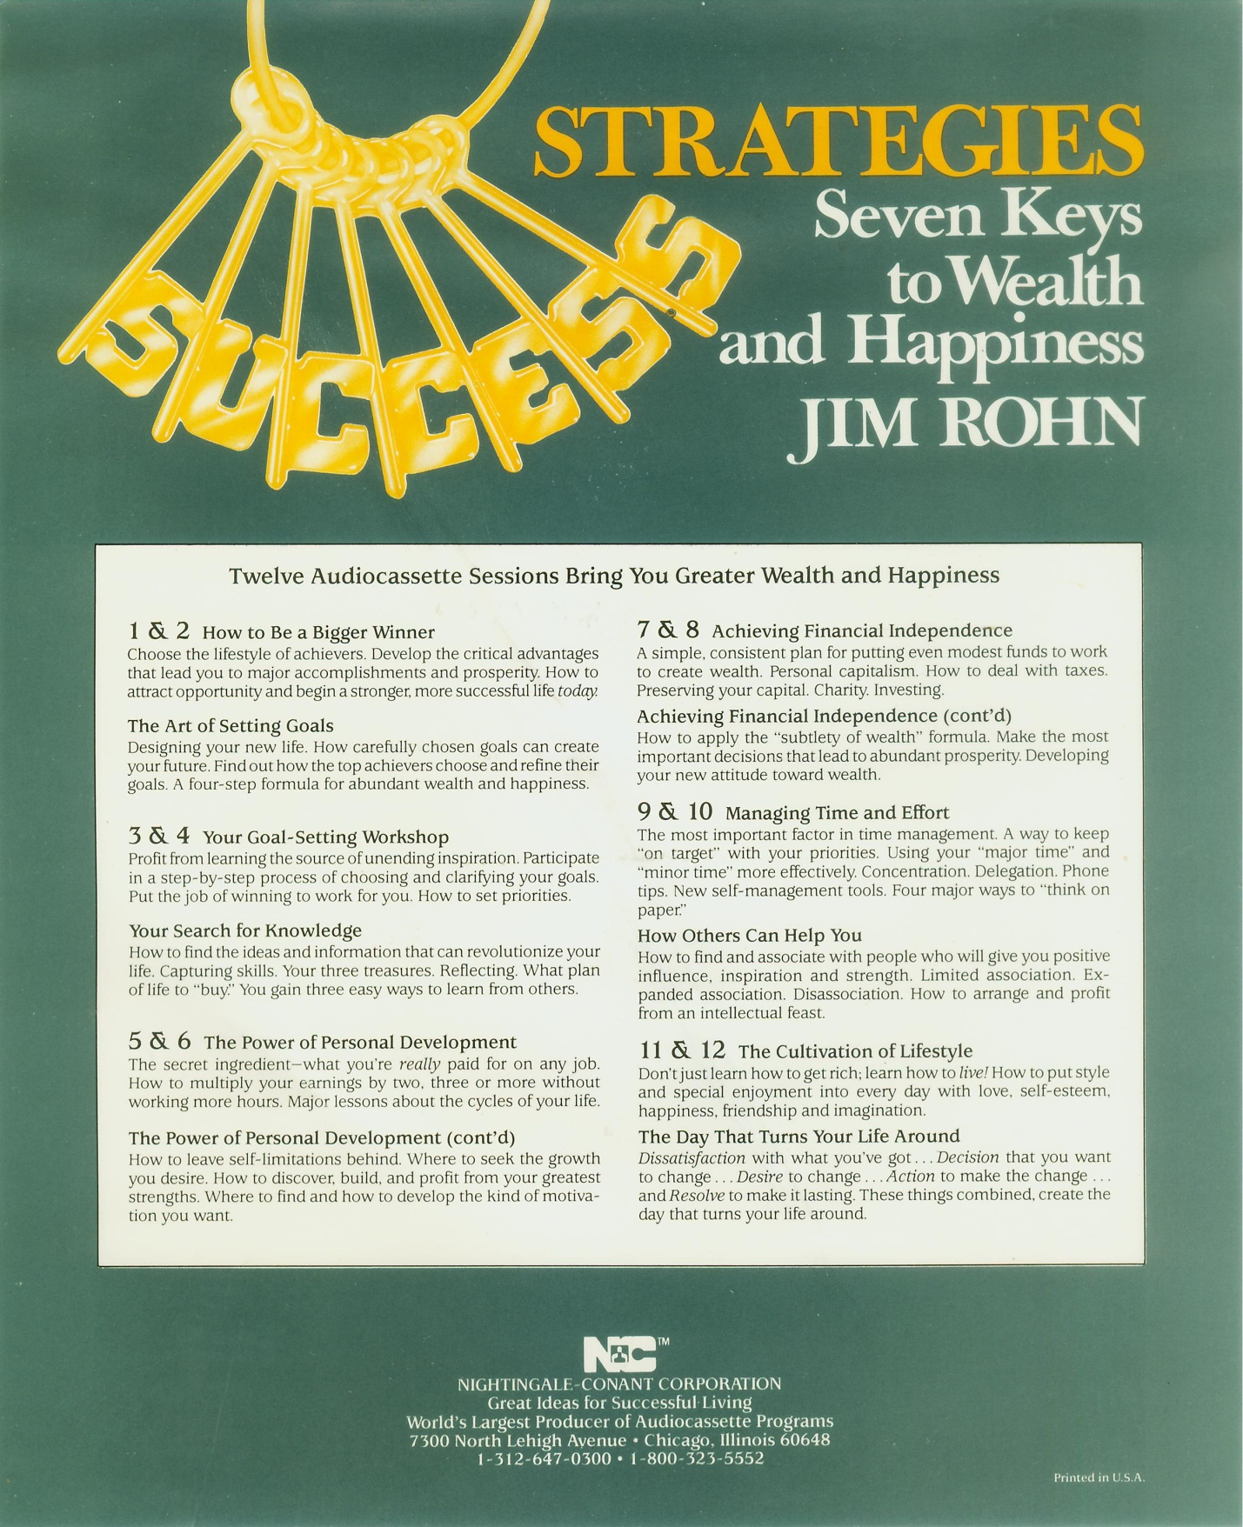
3-Draft (This picture is described Jim Rohn’s business philosophy)

2.2.China economical education system
Developing country’s economical education system.(China)
This section is about a developing country economical educational system I prefer to describe China’s economical traning because China is developing very fastly. The last for thirty years China’s economic had been changing and I think that it depend on economical system. In order to understand the Chinese culture, it is important that the three influential philosophies found in China be discussed. These three philosophies are:
1. Daoism
2. Confucianism
3. Buddhism.
Confucius called this time the Age of Grand Harmony. He believed that the key to harmony was education. The family, temples, schools, government all were tools by which moral ideals were passed on to the individual. He reinforced certain Chinese ethics such as (1) social and political concerns, (2) importance of family, (3) reverence for the elders (4) ritual and (5) the value of education.

4-draft (Chinese ethics such as (1) social and political concerns, (2) importance of family, (3) reverence for the elders (4) ritual and (5) the value of education.)
Lao Tzu
Daoism begins with the ancient philosopher Lao Tzu who said to have been born in China around 604 B.C.E. Most of what we know about Lao Tzu comes to us in the form of legends of which some are unbelievable while others are more realistic. One story states that he was a keeper of archives in western China and lived an unassuming life. At the end of his life he was disenchanted with his people's lack of interest in developing the natural goodness that he was advocating. He left for a life of meditation in what is now Tibet. At Hanako Gate a guard tried to convince him to return to China but failed. However, the guard did convince Lao Tzu to write his philosophy. Lao Tzu spent three days writing a 5000 character book which is now known as the Dao De Ching or The Way to Power.
This work is still regarded as the definitive text in Daoism.
In Daoism, the most essential concept is that of the dao. We can understand the dao in three ways. First, dao is the ultimate reality - it is so large and complicated it can not be understood. It is transcendent. Secondly, dao can be described as the way of the universe.
Later, Daoism divided into three different schools of which two are important for our understanding of this philosophy. According to Houston Smith in his book, Religions of the World, these two schools of thought can be classified as philosophical and religious Daoism. The major difference between these two schools is the idea of the dao itself. In philosophic daoism the dao is something to be controlled and expended wisely. This type of Daoism called School Daoism in China seeks wisdom in order to and conserve it rather than expend it on useless conflicts. It emphasizes the concept of wu wei which means inaction or pure effectiveness. Smith states: "Action in the mode of wu wei is action in which friction - in interpersonal relations, interphysic conflict and in relation to nature is
reduced to the minimum. On the other hand in religious Daoism, the dao is to be increased. In religious Daoism the idea of ch'i is important. It literally means breath but it also refers to energy. To receive more ch'i is to remove things that block it. This can be done by working in three ways: matter, movement and minds. From matter the idea of nutrition and medicinal herbs become important. The exercise t'ai chi and acupuncture relate to the concept of movement.
In the area of mind, Daoist mediation developed. Over time Daoism became
institutionalized into a religion. (Around the 2nd century CE. Lao Tzu became a "god." )
Buddha
Of the three philosophies discussed in the following lessons, the only one is not
inherently Chinese is Buddhism. Buddhism began in India around 560 BCE with the teaching of Siddhartha Gautama who upon his enlightenment was called the "the Buddha." which means the "awakened one." His teaching traveled into China along the famous silkroute around 200 C.E. For the next several hundred years Buddhism slowly developed in China through the work of Indian and Chinese monks that traveled to and from India with the Buddhist teachings. Over time Buddhism developed into a major religious philosophy in China with as many as eight different schools of Buddhism of which Ch'an (Zen meditation) and Pure Land ( chanting a Buddha's name) still exist today.
The basic belief of Buddhism is the Four Noble Truths and the Eightfold Path. The first noble truth is the admission that life is suffering. (Note the term suffering has a different connotation in the language of the Buddha. It means out of kilter or not quite right.) The second noble truth is that the cause of suffering is desire, greed ignorance and attachment. The Buddha gives a way to end suffering in the third noble truth which is to end desire, ignorance and attachment. The fourth noble truth tells how to end desire. This model is laid out in eight steps called the Eightfold Path. These guidelines are right understanding, right views, right speech, right effort, right livelihood, right behavior, right concentration and right meditation. Those three ways express how China is developing?
Few, if anyone, could have imagined in 1978 how much economic and social progress China would make in the next 30 years asa result of deciding to embark on its economic reforms and to introduce open-door policies. The purpose of China’s reform was said to be develop ‘socialism with Chinese characteristics’ (Deng Xiaoping, 1984). As a result of these reforms, China’s economy has been transformed. It has changed from an economy in which marketforces played virtually no role in organizing economic activity to one in which these forces play a major role. China has also gone from a position where it had virtually no foreign investment and a low-level of international trade and exchange to a position where it is a major global recipient of foreign investment and its trade and foreign exchanges are very high in comparison to its level of national production. A variety of indicators demonstrate that economic welfare in China has shown an upsurge in the last 30 years. However, in 1977, there was no sign that China was about to change its economic policies and the extent of its cooperation with the outside world. For example, examination of the documents of the Eleventh National Congress of the CCP (The Communist Party of China) held in 1997 reveal a commitment to past practices and policies (The Communist Party of China, 1977). It, therefore, seemed that without a change in political leadership, China would be stuck in its old economic groove, with well-worn philosophies and a negative outlook on the world.
Buddhism and Confucianism have had an impact on China for about two thousand years. In fact, Chinese culture is rooted in these two philosophies and their impact on Chinese life and economics is deep. According to Marx , the country’s philosophical traditions are a part of its being, while Gernet recognizes the contributions of Buddhism to Chinese culture, particularly its influence on many aspects of Chinese life, thought, literature, language, art and science . Ambler finds that "Confucianism has been guiding people´s behavior since Han Dynasty" (206BC-220AD). So Confucianism and Buddhism have affected and continue to affect the way Chinese people think and operate.
Unfortunately, the two philosophies were suppressed in the Cultural Revolution (1966-1976), but in recent years, Buddhism and Confucianism have been booming in China. In 2005, a nationwide survey about Chinese people´s religion and beliefs was carried out by Liu Zhongyu from the Research Center for Religion and Culture, East China Normal University. In this research, 5000 questionnaires were sent to people over the age of 16, about 91.2% of whom responded. The findings demonstrated that about 300 million people have different religious beliefs (Buddhism, Taoism, Catholicism, Christianity and Muslim, etc, Buddhism being the dominant part); indeed, 62% of the respondents aged between 16 and 39 claimed to have such beliefs Generally speaking, compared with two decades ago, people with faith are becoming younger and younger. The main reason given for religious belief is to meet spiritual needs, and Prof. Liu´s survey reveals that Chinese people have begun to emphasize spiritual life with the rise of living standards and the rapid lifestyle.
Nowadays, in different areas of public life, from government to business, religion is being promoted. For example, in a recent speech, President Hu Jintao suggested that religion, including Buddhism, can help ease tensions between the haves and the have-nots (Dexter 2008:51). In addition, there seems to be a growing trend towards worshipping Buddha and Confucius among Chinese business people, especially Chinese merchants, also known as Confucian merchants. The contrary trend appears with temple monks trying to connect Buddhism with business. For example, Shi Yongxin, the Abbot of Shaolin Temple (the origin of Chinese Buddhism) is called a CEO because he is the first person who has made the connection between traditional Chinese Buddhism and business. Abbot Shi runs many Shaolin gongfu schools inside China and abroad. Chen Xiaoxu, the former female Founding President of Beijing Shibang Advertising, became a Buddhist nun in February 2007. Shi Yongxin, Chen Xiaoxu and Confucian merchants all made people think a lot about the influence of Buddhism on business. These examples demonstrate the strong link between spiritual and material life in contemporary China.
Our survey, carried out in 2007, reflects the effects of Confucianism and Buddhism on Chinese business in China. Our larger aim was to find out what is happening in respect of English and international business in China, and to this end, a questionnaire was developed in English and Chinese which was given to employees in 59 companies by email or in paper form, in China. Companies were classified according to their location, international or national profile, products and the type of company, such as foreign, joint venture, state-owned, or private company. Some 550 questionnaires were given in Chinese and English versions. 297 questionnaires were received, 288 of which were considered valid.
The classification of the respondents was based on gender, age, nationality, academic background, profession and employer. The respondents who were employees in corporations or language school were all Chinese except three, who were Brazilian, and about 90% of these respondents were aged from 20 to 39. As for the position of the employees in the companies, the majority were technicians , followed by Management and Marketing, then Public Relations and Accounting . As for academic background, the largest number had Bachelor Degrees, while the smallest number held Doctorates. The remaining respondents divided themselves between those holding a Master's and those with no academic degree.
Below we present some results of our survey which reveal the influence of the two philosophies. These results have not been previously published. First of all, in relation to ways of communicating which were deemed to be effective by our population (Figure 1), we found that around 69.8% of the respondents answered building long-term connections (guanxi, 关系), while nearly 55.6% responded with paying attention to harmony. These results demonstrate how overwhelmingly important long-term connections and harmony are considered amongst this group.

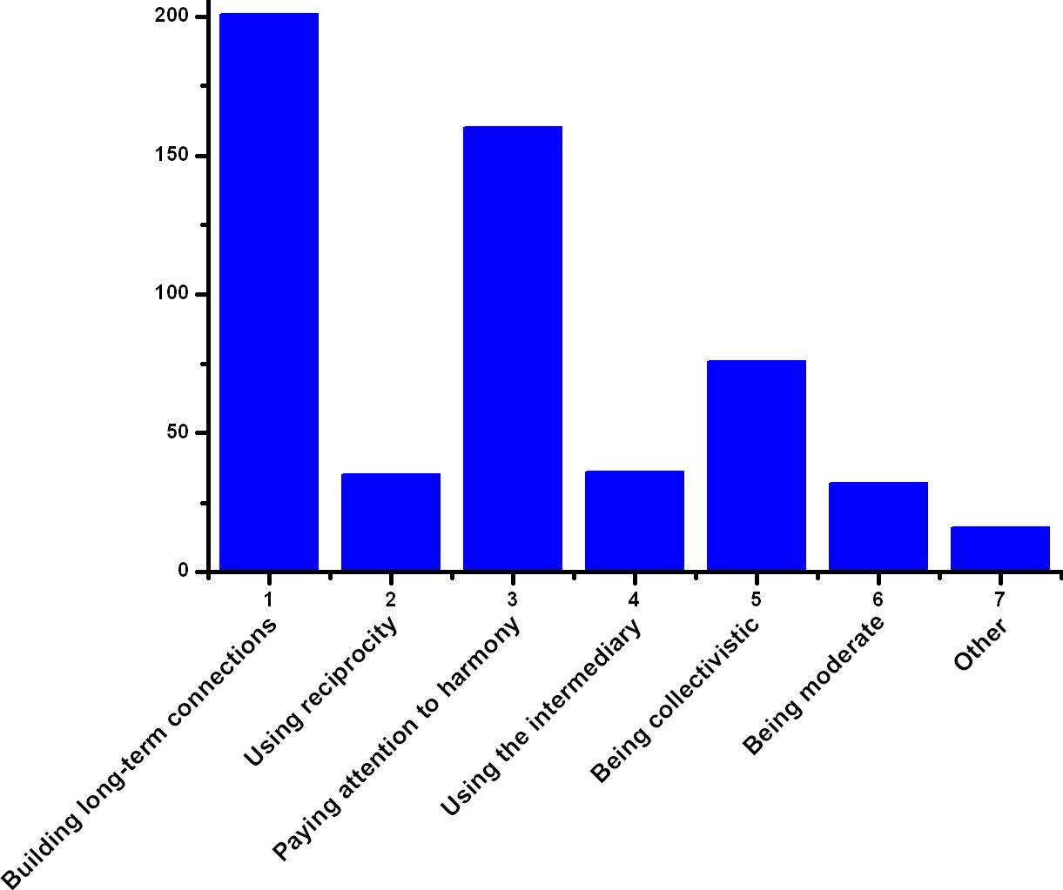
5-Draft .Effective ways of communicating
When questioned about the cultural values considered important for successful business in Chinese markets (Figure 2), our results revealed that 68.7% of the respondents selected interpersonal harmony, 62.6% considered trust, 50.8% included collectivism, and 46.5% chose guanxi (关系), followed by endurance, social status, thrift, face and others. These results demonstrate how much importance is attributed to the role of interpersonal harmony, trust, collectivism and guanxi (关系) in successful business in China.

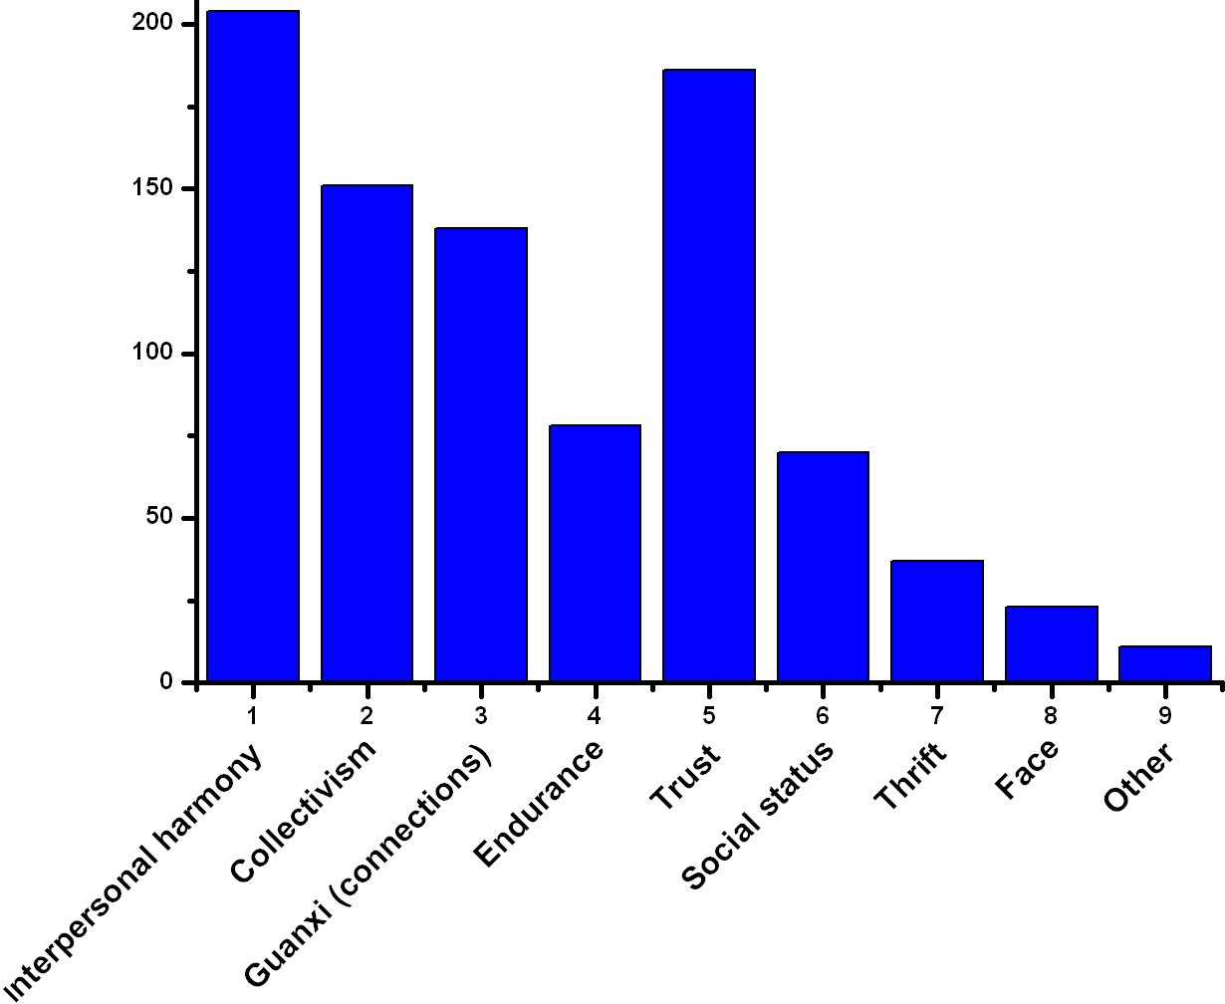
6-Draft . Important cultural values in the Chinese market

In response to the question about the contributions of Confucianism and Buddhism to business in China (Figure 3), the respondents considered tolerance (important Chinese cultural value) with 47.9% answers as the most important aspect, followed by the cooperative principle and politeness, loyalty and the win-win principle, showing the importance of these values in Chinese business. No matter where they are located, Chinese employees from foreign, joint-venture or state-owned companies, share the same cultural values and determine the way they deal with conflict management (Shi 2003). These cultural values make Chinese people work harder. Confucianism and Buddhism principles like harmony, the cooperative principle, politeness, the win-win principle, loyalty and endurance are exercised in the way they do their business.
I think those reasons explain why is China developing. I belive that depending on Chinaes economical education .

3-CHAPTER.Eonomical education’s methods using and created new teaching models in condition of Bukhara.
3.1. Eonomical education is explained though view with Bukhara Tax college’s students.
When I have been for practical training in Tax College I found some facts about essence of economical education. I asked that them to be explained financial training, charity training and tax education differents. This question was asked 25 students for answers.
This table explains their answer:
N | What do you think: are there any differents from tax, financial, charity educations eachother | Amount of group members | Percent %
A –group | Tax, financial, charity educations explain the same mean | 3 | 12
B-group | Tax and charity educations almost describe the same mean but financial education explain treatment of money | 12 | 48
C-group | Tax and financial educations describe the same means but charity on other hand | 2 | 8
D-group | Financial and charity educations explain the same means | 1 | 4
E-group | Financial, charity, tax trainings explain different means | 7 | 28
 | Total | 25 | 100

1- Table
We can find this table 25 student’s 48 % give us the same answer and they answer to supply “ Tax and charity educations almost describe the same mean but financial education explain treatment of money ”. I think this treatment is the best way for this question. Because really tax and charity is used the same purpose , state spend its money social protection and when you spend you money on charity organization in my opinion it is social protection too. Likewise they choose answer which of “ financial education explain treatment of money ”. this idea is very correct because this word use financial operation and all of banks use this thesis. It is clear a person and money treatment eachother, this thesis can be used.
But A- group chose following answer well ,,Tax, financial, charity educations explain the same mean” but this response is not right because this view explains all of them one mean. If we think tax and financial words do not have essence tax has special meaning it means that tax is collected by state and spend on other works but financial is corresponding for bank system. And they describe other type of words.
Our questionnaire of second question: economical education , tax education, charity education, what do you think which it is the most important for earning money?
This table explain following question’s respond
N |  |  | Amount | Percent %
1 |  | Tax education is the most important | 3 | 12
2 |  | Financial is the most important | 11 | 44
3 |  | Charity education is the most important | 2 | 8
4 |  | All of them are important | 9 | 36
 | Amount of students ( total) |  | 25 |  | 100%

2-Table
The table’s information said 11 students have chosen response which financial education is the most important. Some in great businessmens’ mind this idea the best idea for example ROBERT KIOSAKI who is businessman, teacher his book which this book is called ,, Poor Dad, Rich Dad “ the book has a phrase: the most poverful force is financial knowledge but it is not wealth.
The second bigger group said ,, All of them are important for earning money”
THE FIVE LAWS OF GOLD
I. Gold cometh gladly and in increasing quantity to any man who will put by not less than one-tenth of his earngs to create an estate for his future and that of his family.
II. Gold laboreth diligently and contentedly for the wise owner who finds for it profitable employment, multiplying even as the flocks of the field.
III. Gold clingeth to the protection of the cautious owner who invests it under the advice of men wise in its handling.
IV. Gold slippeth away from the man who invests it in businesses or purposes with which he is not familiar or which are not approved by those skilled in its keep.
V. Gold flees the man who would force it to impossible earnings or who followeth the alluring advice of tricksters and schemers or who trusts it to his own inexperience and romantic desires in investment.
There are 5 counsels about how to be wealth and all of advises consist of financial education.
The First Law of Gold
Gold cometh gladly and in increasing quantity to any man who will put by not less than one-tenth of his earnings to create an estate for his future and that of his family.
"Any man who will put by one-tenth of his earnings consistently and invest it wisely will surely create a valuable estate that will provide an income for him in the future and further guarantee safety for his family in case the gods call him to the world of darkness. This law always sayeth that gold cometh gladly to such a man. I can truly certify this in my own life. The more gold I accumulate, the more readily it comes to me and in increased quantities. The gold which I save earns more, even as yours will, and its earnings earn more, and this is the working out of the first law."
The Second Law of Gold
Gold laboreth diligently and contentedly for the wise owner who finds for it profitable employment, multiplying even as the flocks of the field.
"Gold, indeed, is a willing worker. It is ever eager to multiply when opportunity presents itself.
To every man who hath a store of gold set by, opportunity comes for its most profitable use. As the years pass, it multiplies itself in surprising fashion."
The Third Law of Gold
Gold clingeth to the protection of the cautious owner who invests it under the advice of men wise in its handling.
"Gold, indeed, clingeth to the cautious owner, even as it flees the careless owner. The man who seeks the advice of men wise in handling gold soon learneth not to jeopardize his treasure, but to preserve in safety and to enjoy in contentment its consistent increase."
The Fourth Law of Gold
Gold slippeth away from the man who invests it in businesses or purposes with which he is not familiar or which are not approved by those skilled in its keep.
To the man who hath gold, yet is not skilled in its handling, many uses for it appear most profitable. Too often these are fraught with danger of loss, and if properly analyzed by wise men, show small possibility of profit. Therefore, the inexperienced owner of gold who trusts to his own judgment and invests it in business or purposes with which he is not familiar, too often finds his judgment imperfect, 82and pays with his treasure for his inexperience. Wise, indeed is he who investeth his treasures under the advice of men skilled In the ways of gold."
The Fifth Law of Gold
Gold flees the man who would force it to impossible earnings or who followeth the alluring advice of tricksters and schemers or who trusts it to his own inexperience and romantic desires in investment.
"Fanciful propositions that thrill like adventure tales always come to the new owner of gold.
These appear to endow his treasure with magic powers that will enable it to make impossible earnings.
Yet heed ye the wise men for verily they know the risks that lurk behind every plan to make great wealth suddenly.
Following statements explain the laws of gold.

3.2. Some created models which of teaching economical education.
Theme . Economical education
Time- 2 hours
Lesson form | Lecture
Planing of Lesson | 1.Economical education’s gist and kinds.  2 .Financial education  3 .Tax and charity education.  4 .Economical education students’ view
Purpose of class: Students is given aboute economical education’s gist and kinds and this infotmation explained deeper by teacher
Teacher missions:  - Give information to economical education’s essence;  - Give information economical education’s sorts;  - Financial education;  - Tax education;  - Economical education in our country ;  - Developed country’s economical education system; | Lesson obtains following results:  - Teacher can explain about economical education’s essence;  - Students are taught about financial education by teacher  - Teacher shoved a film which explains economical training of USA ;  - Explained this information is used in our conditions.
Teaching method | Lecture
Teaching form | Frontal and working with group
Arguments of learning | Conspectus, searchlight, chalk, blackboard.
Class’s codition | Equipped audience.

3-Table
Teachnical map of lesson.
Time sections. | Teacher | Student
- Part  Introduction  ( for 10 minutes) | - Teacher advertises new subject and explain plans of theme.  - The group is made sections . | 1.1Listening and writing.  1.2 Remember and repeat
- Part  Main body  (For 60 minutes) | 2.1 Some questions are asked.  2.2 distributor drive away materials  2.3 a film is showed  2.4 teacher listens student’s ideas and correct mistakes. | 2.1 Mentioned and responded question.  Established table  2.2 Given information is written on notebook.  2.3 they are watched a video about theme  2.4 Studens give their own idea about theme.

4- table

7- draft . cllasters

Research question.
- Do you explain economical education’s essence?
- Do you count economical education’s sorts?
- Do you describe a county’s economical education which explained for lesson?
- How is advance foreign experience used in our society condition?

Conclusions and Suggestions
To sup up this Diploma paper work following results is obtained:
- Economical education is treatment and this treatment occours between people and money . We learn a developed country economical system.
- Some teaching methods is created
- Questionnaire is asked from Bukhara Tax colleges’ students.
- We learn a developed country economical system and their advance experience how much suit our economical education system ? this question is answered by work .
- There are three gists economical education’ types
- Financial training.
- Tax training.
- Charity taining
- Economical education of USA and China counties is learnt and find how its application ways in our community conditions
- Advice of Jim Rohn and Adam Jecson is explained in this paper work.
- There are three choices for reasons to invest: to be secure, to be comfortable, or to be rich.
- You can see a world with too much money, if you shift away from thinking of money as scarce.
- Investing is confusing to most people because there are many different goals, different products, and different techniques.
- Investing is a plan, not a particular product; getting attached to a particular investing procedure will only limit your options.
- You can plan to be rich or poor, and your financial plan will determine where you end up.
- Getting Rich is Automatic, if you have a good plan and stick to it.
- Finding the right plan takes some deep thought, careful consideration, and a good financial team.
- Deciding now what you’ll be when you grow up, and keep expanding the goals for your life.
- Whether you want to be secure, comfortable, or rich, your plan will have its own costs and expenses.
- Investing isn’t risky, if you can invest from the inside.
- Which side of the table you sit on, whether you are a business owner or an employee, will determine your level of success.
- There are several basic rules of investing. Knowing the type of income you’re working toward (earned, portfolio, or passive), converting your earned income into passive and portfolio, knowing that you (the investor) are the asset or liability, and having the ability to evaluate risk and reward.
- You can reduce the risk level of your investments by increasing your financial literacy, such as learning to read income statements.
- Some basics of financial literacy include focusing on cash flow, know the government rules (and that they can change), and that it takes two financial statements to see the whole picture (one from the payer, one from the payee).
- Mistakes can lead to good results, if you learn from them.

In conclusion part I write a story and we should learn many things
Some time ago I received a call from a colleague who asked if I would be the referee on the grading of an examination question. He was about to give a student a zero for his answer to a physics question, while the student claimed he should receive a perfect score and would if the system were not set up against the student: The instructor and the student agreed to submit this to an impartial arbiter, and I was selected.
I went to my colleague's office and read the examination question: "Show how it is possible to determine the height of a tall building with the aid of a barometer."
The student had answered: "Take a barometer to the top of the building, attach a long rope to it, lower the barometer to the street and then bring it up, measuring the length of the rope. The length of the rope is the height of the building."
I pointed out that the student really had a strong case for full credit since he had answered the question completely and correctly. On the other hand, if full credit was given, it could well contribute to a high grade for the student in his physics course. A high grade is supposed to certify competence in physics, but the answer did not confirm this. I suggested that the student have another try at answering the question. I was not surprised that my colleague agreed, but I was surprised that the student did.
I gave the student six minutes to answer the question with the warning that the answer should show some knowledge of physics. At the end of five minutes, he had not written anything. I asked if he wished to give up, but he said no. He had many answers to this problem; he was just thinking of the best one. I excused myself for interrupting him and asked him to please go on. In the next minute he dashed off his answer which read:
"Take the barometer to the top of the building and lean over the edge of the roof. Drop that barometer, timing its fall with a stopwatch. Then using the formula 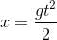, calculate the height of the building.
At this point I asked my colleague if he would give up. He conceded, and I gave the student almost full credit.
In leaving my colleague's office, I recalled that the student had said he had many other answers to the problem, so I asked him what they were. "Oh yes," said the student. "There are a great many ways of getting the height of a tall building with a barometer. For example, you could take the barometer out on a sunny day and measure the height of the barometer and the length of its shadow, and the length of the shadow of the building and by the use of a simple proportion, determine the height of the building."
-----"Fine," I asked. "And the others?"
-----"Yes," said the student. "There is a very basic measurement method that you will like. In this method you take the barometer and begin to walk up the stairs. As you climb the stairs, you mark off the length of the barometer along the wall. You then count the number of marks, and this will give you the height of the building in barometer units. A very direct method."
"Of course, if you want a more sophisticated method, you can tie the barometer to the end of a string, swing it as a pendulum, and determine the value of 'g' at the street level and at the top of the building. From the difference of the two values of 'g' the height of the building can be calculated."
Finally, he concluded, there are many other ways of solving the problem. "Probably the best," he said, "is to take the barometer to the basement and knock on the superintendent's door. When the superintendent answers, you speak to him as follows: "Mr. Superintendent, here I have a fine barometer. If you tell me the height of this building, I will give you this barometer."
At this point I asked the student if he really did know the conventional answer to this question. He admitted that he did, said that he was fed up with high school and college instructors trying to teach him how to think, using the "scientific method," and to explore the deep inner logic of the subject in a pedantic way, as is often done in the new mathematics, rather than teaching him the structure of the subject.

References.
- Karimov. I. 2014 yil yuqori o`sish sur`atlaari bilan rivojlanish, barcha mavjud imkoniyatlarni safarbar etish, o`zini oqlagan islohotlar strategiyasini izchil davom ettirish yili bo`ladi. T. O`zbekiston. 2013 y. ( 42 bet )
- Karimov I.A. 2012 yil vatanimiz taraqqiyotini yangi bosqichga ko’taradigan yil bo’ladi. (Page 53)T.: “O’zbekiston”, 2012 yil.
- Karimov I.А. Uyksak ma`naviyat – yengilmas kuch. – Т.:(page 23) «Ma`naviyat». 2008 y.
- B.N. Navro`z-Zoda , Iqtisodiy qobilyatning o’lchov mezonlari. ILMIY JURNAL “PSIXOLOGIYA” 2014 y
- Marx, E. (2001). Breaking through Culture Shock: What You Need to Succeed in International Business. London: Nicholas Brealey Publishing.( Page 56)
- Nyíri, P. & Saveliev, I. R. (page 98) (2002). Globalizing Chinese Migration: Trends in Europe and Asia. Aldershot: Ashgate Publishing.
- Rocha, T. & Maria, B.(2006) (page78). A comunidade de negócios chinesa em Portugal catalizadores da integração da China na economia global. Oeiras: Instituto Nacional de Administração.
- Shi, Yongpeng. (2003),(page56) Culture and Conflict Management in Foreign-invested Enterprises in China: an Intercultural Communication Perspective. Oxford: Peter Lang.
- ––– 2011. Individuals and Identity in Economics, Cambridge University Press.
- Davis, J., ed. 2006. (page21)Recent Developments in Economic Methodology, Cheltenham: Edward Edgar.
- Dyke, C. 1981. Philosophy of Economics, Englewood Cliffs, NJ: Prentice-Hall (pag76).
- Elster, J. 1985. Making Sense of Marx, Cambridge: Cambridge University Press, (page 23).
- Eichner, A. 1983. “Why Economics Is not yet a Science,” in A. Eichner, ed. Why Economics Is not yet a Science, Armonk, New York: M.E. Sharpe, (page42).
14. Rajabov O. Kichik biznes bandlikni ta`minlashning asosiy omilidir. XXI ASR.7Dekabr.http://www.21asr.uz/ozlidep/ozlidep-fraksiyasi/577-kichikbiznes.html.
15. Резник С.Д., Бобров В.А., Егорова Н.Ю.Менеджмент в домашнем хозяйстве . (2009), p31.
16. Роберт Поллак.Трансакционный подход к изучению семьи и домашнего хозяйства.THESIS.1994,вып.б./Robert A. Pollak. A Transactional Cost Approach to Families and Households // Journal of Economic Literature, June 1985, v.23, no.2, p.581-586. © American Economic Association, 1985 Перевод А.Л.Александровой. С.
17. Хайруллаев М.М. «Фаробий ва унинг фалсафий рисолалари»\ Ўзбекистон ССР Фанлар академияси академиги И.М.Мўминов таҳрири остида. Ўзбекистон ССР Фанлар академияси нашриёти, Тошкент – 1963 й, p31.
18 . Rocha, T. & Maria, B.(2006). A comunidade de negócios chinesa em Portugal catalizadores da integração da China na economia global. Oeiras: Instituto Nacional de Administração p.45-46.
19. Shi, Yongpeng. (2003), Culture and Conflict Management in Foreign-invested Enterprises in China: an Intercultural Communication Perspective. Oxford: Peter Lang, p.34.
20. Tu, W.M. (ed.) (1996). Confucian Traditions in East Asian Modernity: Moral Education and Economic Culture in Japan and the Four Mini-Dragons. Cambridge, Massachusetts & London: Harvard University Press.
21. Wang, G.W. (1991). China and the Chinese Overseas. Times Academic Press.
22. Wierzbicka, A. (1991). Trends in Linguistics: the Semantics of Human Interaction. Berlin & New York: Mouton de Gruyter.
23. Rocha, T. & Maria, B.(2006). A comunidade de negócios chinesa em Portugal catalizadores da integração da China na economia global. Oeiras: Instituto Nacional de Administração.
24.Shi, Yongpeng. (2003), Culture and Conflict Management in Foreign-invested Enterprises in China: an Intercultural Communication Perspective. Oxford: Peter Lang.
25.Tu, W.M. (ed.) (1996), p77. Confucian Traditions in East Asian Modernity: Moral Education and Economic Culture in Japan and the Four Mini-Dragons. Cambridge, Massachusetts & London: Harvard University Press.
26. Wang, G.W. p39(1991). China and the Chinese Overseas. Times Academic Press.
27.Wierzbicka, A. (1991), p98. Trends in Linguistics: the Semantics of Human Interaction. Berlin & New York: Mouton de Gruyter.
28.Hirschman, A. 1985. “Against Parsimony: Three Easy Ways of Complicating Some Categories of Economic Discourse”, Economics and Philosophy, 1: 7–8.
29.Hodgson, B. 2001. Economics as Moral Science, Heidelberg and New York: Springer p87.
30. Koslowski, P., ed. 1985. Economics and Philosophy, Tübingen: J.C.B. Mohr, 1985, p98.
31.Kregel, J. 1976. “Economic Methodology in the Face of Uncertainty: The Modeling Methods of Keynes and the Post-Keynesians”, Economic Journal, 86:
32. Love the Opportunity by Jim Rohn published 2005, p49. USA
33. George, D. p39, 2001. Preference Pollution: How Markets Creates Desires We Dislike, Ann Arbor: University of Michigan Press.
34.Gibbard, A. 1974. “A Pareto-Consistent Libertarian Claim”, Journal of Economic Theory, p31.
35. THE CASHFLOW QUADRANT ROBERT KIYOSAKI AND SHARON L. LECHTER pubpished 2012, New-York, p 66
36. Think and grow rich by Napoleon Xill published 2005 p.130. USA
37. Rich Dad Poor Dad by Robert Kiyosaki, published 2005 Missuri, p78 .
38 .www. lex. uz
39.www.stat.uz
40.Ziyonet Axborot Ta`lim tarmog`i.www.ziyonet.uz
41. http://www.quickmba.com
42. www.huaxia.com

Appendix
For Learnt economical education

