The Ministry of Higher and Secondary Special Education of the Republic of Uzbekistan

The Uzbek State World Languages University Institute for English Language Teacher Education
English Philology Faculty Interactive Methods of Language Teaching Department

Qualification Paper
Theme: Use of stylistic devices in the works of Charles Dickens (“Oliver Twist”) and Gafur Gulam (“Shum bola”)
Done by: Abdullayeva Munira, 4 Scientific advisor: Muratova E.D. Reviewer: Umarova M.A.

TASHKENT-2012
Use of stylistic devices in the works of Charles Dickens (“Oliver Twist”) and
Gafur Gulam (“Shuin bola”)
Content
Introduction 2
Chapter I Great names in world literature 7
§1.1 Basic facts of Charles Dickens and Gafur Gulam’s biographies 7
§1.2 Specific features of Charles Dickens and Gafur Gulam’s creative works 16
Chapter II The importance of stylistic devices in fiction 30
§2.1 Stylistic devices and their role in literature 30
§2.2 The special role of stylistic devices in the works of Charles Dickens “Oliver Twist” and Gafur Gulam “Shum bola” 33
Final Conclusion 42
List of Literature 44
Annex 47
Introduction.
“Without knowing any foreign languages we cannot acquire great knowledge and history of other countries”
(Islam Abduganievich Karimov)
Our President was right when he mentioned the importance of language learning. A language is a key which helps people to recognize the truth and acquire the needed knowledge. By knowing any foreign language people take a chance to know more and live in a right way. It’s never enough for a person knowing only his/her native tongue if he/she wishes to know more about the whole world. Of course, we cannot imagine language learning without literature. Every new language learner starts reading small anecdotes, fairy-tales and stories which are the main parts of magic literature. Connecting language learning and reading literature is an effective way of conducting lessons. No doubt, such lessons are more enjoyable and interesting.
Recent years our government paid great attention to language learning. In our universities English is taught as a first and a second language, foreign language teachers, native speakers are involved in this process. Special literature courses are held in order to enhance the students’ knowledge of English. We have to claim that all those courses are extremely interesting and make us think critically and enjoy the beauty of world literature. From a small story to a big fiction work which we read during the classes give us great experience of human beings. During four years we had special literature classes which were different from other subjects for being interesting, exciting and enjoyable. For the sake of great love for literature we also decided to do a research paper on literature. The theme of our qualification paper is “Use of stylistic devices in the works of Charles Dickens (“Oliver Twist”) and Gafur Gulam (“Shum bola,”)” Given the above , the topicality of our research is obvious.
We all know that Charles Dickens was a well-known English novelist who mostly wrote about humanism. His biography and creative work were studied all around the world. Most of his humanistic works were translated into many languages and there are also a great number of Charles Dickens’s readers in Uzbekistan. Some of his works which had been screened as movies are shown on TV on special holidays and the International Children’s Day.
Gafur .Gulam was a well-known Uzbek novelist and poet. Similar to Dickens he also wrote about humanism and human mercy. He was a very productive writer and his works made him famous in Central Asia. During World War II he wrote so many encouraging poems and articles for soldiers who were fight time for their motherland and their families who were waiting for them at home. All his books were sold so quickly because they could show the real life of Uzbek nation. He described everything in such a way that readers not only read the books but also lived the life of characters and felt their troubles or happiness at the same time.
Dickens’ books are widely read all around the world. In most of his works he used different types of stylistic devices which can be used at stylistics classes as examples. If we observe any book on stylistics we may notice that most of the examples are taken from Dickens’s works. Those sentences don’t lose their power even when they are translated into the Uzbek or Russian languages. Sometimes even one sentence can make the student be impressed by the meaning and find the book from which the statement is written there. We may say that Dickens also was such a writer who could capture readers’ attention in the first sight. Of course, we admi re the works of Western writers but we have to assume one thing that we al so have so many writers and poets whose creative work is not less great in quality in comparison with Western countries. One of them is Gafur Gulam whom we are going to speak about. If you search for any information about G.Gulam through
з
internet, probably you will not find anything valuable because not so much information is given in foreign languages. Any foreign person who is interested in Uzbek literature cannot find the needed information. By saying so we are not going to say that no any research paper was done on G.Gulam. Of course, there are so many research papers on his biography and creative work but they are not translated into different languages which make Uzbek literature unknown to the world. It’s great shame for Uzbeks to claim this painful feet. By doing this research paper we try to make foreign people aware of Uzbek Literature.
The aim of this research paper is to mainly focus on the analysis of stylistic devices in the works of Charles Dickens and Gafur Gulam. To achieve our goal we set: up three tasks.
- To analyze the role of stylistic devices in fiction.
- To compare creative works of Charles Dickens and Gafur Gulam.
- To analyze use of stylistic devices in the works of Charles Dickens and Gafur Gulam.
An every theoretical statement which is pronounced in the classroom should come with an example. Otherwise, the theory remains vague for the language learners. At lessons on stylistics we may need sentences in which stylistic devices are actively used. With the help of our research paper students wall easily find examples of stylistic devices in the works of Charles Dickens and Gafur Gulam. there are two advantages of doing this research paper. First of all, foreign people will have a good chance to know more about Uzbek writer Gafur Gulam.
Secondly, the teachers who conduct lessons on stylistics may use examples which are given in our research paper.
In our research paper we use comparative method which is based on certain amount of information about creative works and stylistic analysis of Charles Dickens and Gafur Gulam’s works. By comparing both of these writers we will be able to see clear differences and similarities of Ch. Dickens and G.Gulam.
While collecting the data for this research paper we had to meet with scholars who did researches on G.Gulam. We have to assume that those researchers we met were so glad because according to their experience up to present moment research papers were done only in the Uzbek and Russian languages but not in English.
“We also had so many great writers says Nosir Fozilov (Professor, 83 years old) “whose works could change the world. However; the art of translation is not so developed in our literature. We could not show the power of our literature. We have to be ashamed of that.”
In our opinion, Nosir Fozilov was right when he said so. By saying this we don’t want to blame all Uzbek translators on this issue. Young translators may translate world literature into the Uzbek language perfectly well but translating from Uzbek into different languages is a bit problematic question.
Bahrom Giyosov (Professor of Namangan State University) also expressed his opinion on translation problems:
“I think, translation is one of the most difficult things in literature. Great knowledge of a language and working experience are required from every translator. Sometimes we read the books recommended by our friends and admire the world literature. Very often it happens that you don’t find anything valuable after reading the book. And this is not because of the book and the author but a big mistake of a bad translator. You should not translate anything until you are sure about the quality of your translated work. Translating is creating a new world but not destroy.”
Theoretical value of our research paper is a comparative analysis of stylistic devices used by Charles Dickens and Gafur Gulam in their popular novels “Oliver Twist” and “Shum bola” respectively.
The practical value of our research paper is that in future teachers of literature, stylistics and researchers can find the needed information from this research.
5
Especially, the examples which are given in the Chapter IT can be used in the classroom at lessons on stylistics.
The structure of the work is traditional . Our research paper consists of introduction, two chapters, conclusion, list of literature and annex. In the first chapter, we mainly focus on biography and creative works of Charles Dickens and Gafur Gulam. All the information which is written in our research paper is based 011 the facts about writers and our own thoughts. The second chapter is devoted to stylistic analysis of their creative works (“Oliver Twist” and “Shunt bold”). In this chapter we mainly focus on revealing the importance of using styli stic devices in fiction. Finally, we come to the essential part of our research paper. In this part we analyze the use of stylistic devices in the works of Charles Dickens and Gafur Gulam. In conclusion we summarize the results of our research paper.
б

Chapter I Great names in World Literature.

§1.1 Some basic features of Charles Dickens and Gafur Gulam’s biographies.
Charles John Huffman Dickens was bom on 7 February, 1812 in Portsmouth, Hampshire, England in the family of Elizabeth Barrow and John Dickens a clerk in the Navy Pay Office. Charles had an elder brother Frances, known as Fanny, and younger siblings Alfred Allen, Letitia Mary, Harriet, and Frederick William known as Fred, Alfred Lamert, and Augustus Newnham.
When Dickens’ father was transferred to Chatham in Kent County, the family settled into the proper place of a larger home with two live-in servants—one being Mary Weller who was young Charles’ nursemaid. Dickens was a big reader of such authors as Henry Fielding, Daniel Defoe, and Oliver Goldsmith. When he was not attending school of William Giles where he was a suitable pupil, he and his siblings played games of make-believe, gave reading of poetry, sang songs, and created theatrical productions that would spark a permanent love of the theatre in Dickens. But household everyday expenditure was rising and in 1824, John Dickens was imprisoned for debt. All of the family went with him except for Charles because he was sent off to work at Warren’s Shoe Blacking Factory to help support the family, pasting labels on boxes. He lived in a boarding house and walked to work every day and visited his father on Sundays.
The quiet days of his childhood were over and he was rudely introduced to the world of the working poor, where child labor was uncontrolled and few if any adults secure a kind word for many abandoned or orphaned children. Many of his future characters like Oliver Twist, David Copperfield, and Philip Pirrip would be based on his own experiences. The appalling working conditions, long hours and poor pay typical of the time were harsh, but the worst part of the experience w^{r}as that when his father was released his mother insisted he continue to work there.
While he felt betrayed by and resented her for many years to come, his father arranged for him to attend the Wellington Flouse Academy in London as a day
s
pupil from 1824-1827, perhaps saving him from, a life of factory work and setting him on the road to becoming a writer.
While collecting the data for this research paper we have observed so many books which were devoted to the biography of Charles Dickens. By gathering the ideas of those research papers we may conclude that despite of his tough life he could handle with all his problems by himself. Adverse years of being an orphan and no having a permanent shelter could not bent his personality . During the years of working as a servant he could understand the toughness of the world. Despite of his unfinished education he could read various pieces of literature and at the same time he also tried to write small stories. Step by step he could see that all his writings were becoming polished, clear and understandable. While working in a post office he was supposed to deliver all necessary⁷ things to receivers. Working as a postman gave him a great chance to be in the center of literature works and news. Because of that all the time he could read one of them and be aware of needed information. Of course, the time which Dickens lived also influenced his works. In his time, Victorian period, people were treated according to their status they had. Dickens could see arrogant noble families and not leading any valuable knowledge. In Dickens’ opinion, those people belonged to the group of people who always cared about money and prosperity. It was so ridiculous for them to think about human soul and heart. Only great amount of money and unnecessary parties could catch their attention. Dickens did not like this process and always he had a painful trouble in his heart. He usually mocked at that society for being stupid. All those occasions made him work hard on literature seriously. He found a job in one small publishing house even it was not so well-paid job. However; then he could satisfy all his needs with his small creative works. He had not so much money but then he had power to say something to public. Dickens was an inborn clever and intelligent person. The books he read worked for the improvement of his knowledge. This could prove that English literature was going to have a great
novelist. Below given information shows Charles Dickens working as an amateur writer.
“In 1827 the Dickens were expelled from their home in Somers Town for unpaid rent dues and Charles had to leave school. He obtained a job as a clerk in the law firm of Ellis and В lack more. He soon learned shorthand writing and became a court reporter for the Doctors Commons. He spent much of his spare time reading in the British Museum’s library and studying acting. In 1830 he met and fell in love with Maria Beadnell, though her father sent her to finish school in Paris a few years later. In 1833, his first story of many, “A Dinner at Poplar Walk” was published in the Monthly Magazine. He also had some sketches published in the Morning Chronicle which ill 1834 he began reporting for and adopted the pseudonym ‘Boz’. At this time Dickens moved out on his own to live as a bachelor at Fumival’s Inn, Holborn. His father was arrested again for debts and Charles bailed him out, and for many years later both his parents and some of his siblings turned to him for financial assistance.”’
Dickens could not hold his tongue looking at the unintelligence of people around him. Like other people he could not sit in one place and praise other arrogant people. Fairness in Dickens character made him reveal all those corruption matters and tell the truth to the public. Unfortunally, he could say those things to people directly. Then he had to use humor in his works. His target was the person who got bribery and committed a crime while living in the society pretending to be an honest person. All those features which we counted were characteristics of some noble families. In Dickens’ opinion, the members of noble families had to be genius, kind and intelligent at the same time. Of course, this made him take a pen and put all his thoughts, troubles and pains to the paper. As we mentioned this earlier he did it with the help of humor. His works were widely spread among the people because all of them revealed negative points of the society and helpless, poor nation could laugh at stupid wealthy people. No doubt, rich people did not like his writings and tried to stop him by threatening him for several times. According to the scholars’ opinion, we may conclude that for quite a few times he had been tried to be killed but he was so lucky a person to stay alive. Despite of being poisoned for two times and treated badly he never stopped. He kept going forward. His strong personality can be a real model for those people who consider themselves as real men. We would compare Dickens to a diamond which is so rare in our life as his thoughts and attitudes were so unusual in comparison to other people. As Shakespeare wrote once: “Our life is a theatre and we play own roles in it.” Different from Shakespeare Dickens did not want to live as an actor observing all those people who were living machines. He felt sorry for them but it was too late for Dickens to make any change in those peoples’ life. That’s why all the time he persuaded the nation to pay the main attention to education of young children. All the time he convinced other people to think about educational system of schools and their development. Dickens blamed parents, teachers and weak politicians for children’s bad behavior and fragile education. Below given information shows his courage to say something sharp to public without hesitating and feeling any fear.
“Master Humphrey’s Clock concluded, Dickens started in 1842 on his first visit to America—an episode hitherto without parallel in English literary history, for he was received everywhere with popular acclamation as the representative of a grand triumph of the English language and imagination, without regard to distinctions of nationality. He offended the American public grievously by a few words of frank description and a few quotations of the advertisement columns of American papers illustrating the essential barbarity of the old slave system (American Notes). Dickens was soon pining for home—no English writer is more essentially and insularly English in inspiration and aspiration than he is. He still brooded over the perverseness of America on the copyright question, and in his next book he took
the opportunity of uttering a few of his impressions about the objectionable sides of American democracy, the result being that “all Yankee-doodle-dom blazed up like one universal soda bottle,” as Carlyle said. Martin Clzuzzlewit (1843—1844) is important as closing his great character period. His seve original, as the French would say, was by this time to a considerable extent exhausted, and he had to depend more upon artistic elaboration, upon satires, upon tours de force of description, upon romantic and ingenious contrivances. But all these resources combined proved unequal to his powers as an original observer of popular types, until he reinforced himself by autobiographic reminiscence, as in David Copperfield and Great Expectations, the two great books remaining to his later career.”
A1 least Dickens understood that it was impossible stand against to already grown up people because it was too difficult for them to change their skeptical ideas. It’s obvious from the psychology that when people get older the more they lose their interest in something new. Only some of them can be hardly persuaded. Dickens understood these things very well at that time and decided to pay more attention to education of young children. He deeply knew that once young generation could be the real nation of English. Dickens never stopped writing for a minute. He was keen on travelling and by doing this he gained a great chance to be close to the nation and know more. Once he wrote: “When do people read the books? Of course, they read when they see their troubles in it. A real book cannot be without pain and trouble of people.” In our opinion, he was right when he stated so. If we look at the books which were highly appreciated by people, we see that Dickens revealed and showed the difficulties and soreness of ordinary people. Dickens did not separate any person according to their nation. In his opinion, a real man had to love everybody regardless of the color, language, and religion. While
traveling around Europe and United States of America he visited many countries and got a good chance to be aware of interesting and exciting events.
“At the end of March 1850 started the new two penny broadsheet called Household Words, which Dickens planned to use for presentation of letters between himself and his readers, and as a means of collecting around him and hopeful the talents of the younger generation. No one was better able than he for this work, whether we consider his complete freedom from fictional resentment or his mystic gift of exciting young authors. Next the somewhat boring and illogical Bleak House (1852), Hard Times (1854)—an anti-Manchester School region, which Ruskin regarded as’Dickens’s best work—was the first long story written for Household Words. About this time Dickens made his final home at Gad’s Hill, near Rochester, and put the finishing touch to another long novel published upon the old plan, Little Dorr it (1855’—1857). The plot and characters ruin each other in this shapeless production. A Tale of Two Cities, commenced in All the Year Round (the successor of Household Words) in 1859, is much better: the main characters are powerful; the story actually tragic, and the atmosphere bright; but enormous labor was everywhere spent upon the construction of stylistic

з ...
ornament.” According to the information given above, we may conclude that Dickens kept touch with his readers in order to be closer with them and be aware of their, ordinary people’s delights and difficulties.
As Gyote once wrote “Every creation has its end.” As for many people we can use this quotation to Dickens as well. Despite of pain and grief destroying his nerves Dickens went on writing and making his readers glad with his extraordinary and amazing works. Below we present information about his last living days which is presented by scholar Samuel Robinson.
“In March and April 1870 Dickens was mixing in the best society; he dined with the prince at Lord Houghton’s and was twice at court, once at a long deferred private interview with the queen, who had given him a presentation copy of her Leaves from a Journal of our Life in the Highlands with the inscription “From one of the humblest of authors to one of the greatest “; and who now begged him on his persistent refusal of any other title to accept the nominal distinction of a privy councilor. He took for four months the Milner Gibson’s’ house at 5 Hyde Park Place, opposite the Marble Arch, where he gave a brilliant reception on the 7th of April. His last public appearance was made at the Royal Academy banquet early in May.” ⁴
Gafur Gulam was born in Tashkent, on 3th of March, 1903. He learned how to read and write from his father Gulom aka and mother Toshbibi aya. Despite of being from a poor family Gafur could manage to acquire more knowledge than his friends. When he was 12 his father dies and Gafur took the responsibility of supporting his young sibling with money. His only hope was his sick mother but ruthless cancer took Toshbibi aya when he was 18 years old. Then it was too difficult for Gafur to support his family not only financially but also mentally. He felt so bad whenever his young brothers asked about their mother. However; nothing could bend his personality. From early ages he got experienced how to write small articles and essays. While working in several places he manages to learn the Russian language and consequently this helps him to work as a translator. Russian literature helps him to understand and see beauty, power, and magic of literature.
We cannot say that Gafur Gulam had a happy childhood. From his early life he was supposed to supply his family with money. He was the eldest child in his family and naturally all the responsibilities were on his shoulders. In one of his books he wrote so:
“After my father’s death my mother totally lost her control. She got sick because of endless series of troubles in her life. In order to find a piece of bread she did everything that she could do. For example, she washed our neighbors’ clothes and ironed and even cooked for them. However I cannot say that the money she took was enough for feeding us. Sometimes we went to bed without dinner and cold. You know, we did not like winter, mostly we liked summer. You may ask “why?” The reason is quite simple. In summer we could eat fruits and did not worry about food. Besides, we were so glad that our mother was not worried about warm clothes. But in winter our living condition became more difficult as we did not have any warm clothes for winter. It was difficult for me to see my mother and siblings trembling from cold weather.”⁵
Despite of living in bad condition my mother always challenged us to study hard. At school I always was the pupil who came the first and who left the last. The food for that were my bare feet. I had no shoes to wear however the willing to study kept me going to school. I never took out my feet under the desk because I was afraid that someone could see my bare feet and laugh at me. But this did not last so long. One day one of my teachers saw me in such condition and felt sorry about me. Next day he brought me his son’s old shoes and asked me to try on.
They were just my size. I wish you could see little Gafur’s joy. “
After the death of his parents poor Gafur had no any choice but to work in several places at the same time. Because of World War I Tashkent streets were full of hungry orphan children. At that time state governments produced a law about gathering all orphan children and take care of them. Many buildings were built for orphan children and Gafur Gulam with his young siblings also was settled in one of those special houses.
“I was fourteen years old when 1 started living and working in that orphanage. Because of being older than the rest children I was asked to take care of children and their food. We had a cook named Grisha and every day he brought us food. “Food, food, I brought you food” he used to cry. Several times I saw him crying at the comer of the room while we were eating our meals. Only at that time I could see real cruelty of war and being orphan.”
While working in the orphanage Gafur Gulam had to create small stories, fairy tales in order to keep the rest children peaceful and quiet. In the dark, endless nights of the winter children used to ask him to tell something new and interesting. We may say that exactly this occasion was the stimuli for him to take his first steps in literature.
“Every day I had to tell something new. Of course, it was a bit difficult for me as I often mixed up some stories and this caused irritation of my young listeners.
Then I decided to take notes and all my stories in it. Sometimes because of unexpected inspiration I wrote five or six small stories a day. ”⁶
From the above given sentences we may conclude that precisely at that moment he decided to be a writer and poet. His first poem “Dinamo” was published when he was sixteen years old. For the sake of his great love to literature he began to work in a small publishing house as a corrector.
“My job was not so difficult” wrote Gafur Gulam in his memories “I looked through the drafts which were brought by writers and amateurs and checked them for mistakes. Every moment of being at that small publishing house gave me power to write, write, and write. I wrote almost every day and day by day I could see that the numbers of my writings were raising and in three months I was able to gather such amount of writings that could be published as a whole book. My name
could be seen almost in every newspaper. With the help of the editor of the publishing house where I worked I published my first book which predicted the
_{e} n
rest of my life.”

§1.2 Specific features of Charles Dickens and Gafur Gulam’s creative works.
In this paragraph it is essential highlighting specific features of two writers’ creative works. It’s proved that all the time Charles Dickens creative work caused a hot discussion. The reason is obvious that many writers were interested in his writing style which cannot be seen in novels of other writers. When journalists asked him for reason of writing in such exciting and thrilling way he simply answered that because of his poor childhood he could see and understand some features of life which were not seen by other people. As we know he had very hard childhood which he showed in some of his works “Oliver Twist” and “David Copperfield'.” Dickens claims that a writer cannot create really touching things without passing them through. In his opinion, the writer who writes according to only his own thoughts fails in getting the reader’s attention because there is no any grief and trouble in it. In one of his interviews he claims that almost all of the heroes of his creative works are reflection of Charles Dickens himself, the author. The fact was mentioned by him in the interview which he gave to “The Times” daily newspaper.
“Whether I shall turn out to be the hero of my own life, or whether that station will be held by anybody else, these pages must show. To begin my life with the beginning of my life, I record that I was born (as I have been informed and believe)
on a Friday, at twelve o'clock at night. It was remarked that the clock began to
•8 strike, and I began to cry, simultaneously.”
The biography and creative work of Charles Dickens were studied even starting from his living days and after his death as well. We would like to count the names of some scholars who widely analysed Charles Dickens’s phenomenon and did research. They were Gilbert Keith Chesterton, John Forster, Andrew Lang, Elbert Hubbard, George Gissing, and George Orwell. The detailed information about those scholars who contributed to the study of Charles Dickens’ life and work presented below.
Gilbert Keith Chesterton, an English scholar wrote about Dickens “He was the voice in England of this humane intoxication and expansion, this encouraging of anybody to be anything.” Critic John Forster became his best friend, editor of many of his serializations, and official biographer after his death, publishing The Life of Charles Dickens. Scottish poet and author Andrew Lang included a letter to Dickens in his Letters to Dead Authors. Elbert Hubbard in his Little Journeys series follows in the footsteps of Dickens through his old haunts in London. George Gissing also respected his works and wrote several introductions for them, as well as his Charles Dickens: A Critical Study in which he writes: “Humor is the soul of his work. Like the soul of man, it permeates a living fabric which, but for its creative breath, could never have existed.” While George Orwell was at times a critic of Dickens, in his 1939 essay Charles Dickens he, like many others before, again brought to light the author still relevant today and worthy of continued study: “Nearly everyone, whatever his actual conduct may be, responds emotionally to the idea of human brotherhood. Dickens voiced a code which was and on the whole still is believed in, even by people who violate it. It is
difficult otherwise to explain why he could be both read by working people and buried in Westminster Abbey.”
Dickens in his memories about his childhood stated that whenever he had free time all his time he spent on reading. In “David Copperfield’ he wrote so:
“My father had left a small collection of books in a little room upstairs, to which I had access (for it adjoined my own) and which nobody else in our house ever troubled. From that blessed little room, Roderick Random, Peregrine Pickle, Humphrey Clinker, Tom Jones, the Vicar of Wakefield, Don Quixote, Gil Bias, and Robinson Crusoe, came out, a glorious host, to keep me company . They kept alive my fancy, and my hope of something beyond that place and time, - they, and the Arabian Nights, and the Tales of the Genii, - and did me no harm; for whatever harm w^{r}as in some of them was not there for me; I knew nothing of it. It astonishes me now, how I found time, in the midst of my poring and blunderings over heavier themes, to read those books as I did.”
Many scholars prove that Dickens had a special ability to write. If we look back, at the time of his childhood not only Dickens but also vast numbers of children were orphan and homeless. And the question appears: why the other children did not become famous writers? We can say that Dickens was gifted by the God with a particular capacity of writing. A famous scholar of English Literature, Sarah Gilbert also confirms our attitude towards Dickens.
“Was Charles Dickens a creative genius? His works are still renowned today, maybe which says something. Oliver Twist and Great Expectations are among his
most famous works, no doubt greatly influenced by his childhood and adolescence; he worked hard and was essentially orphaned.”¹³
His life wasn’t easy, at least by existing life principles. He had to labor as a young gentleman, due to his parents, particularly his father's, financial failures. So, his life was a rough one during his teenage years, living with relatives and working hard. And exactly these factors influenced his creative works which gained world admiration.
One can see how Dickens near obsession with the orphaned main character was not a coincidence. He gained vast personal experience as somewhat of an unwanted child. His mother did not want him to return from work as a young boy, and hence Charles Dickens felt betrayed and developed a lack of distrust for the femal e race. After reflecting on the selfishness of his mother, and the ineptitude of his father, Dickens was able to better understand the troubles of the orphaned childhood. He was able to show' this on the poor orphan in Oliver Twist.
Sometimes works of other great writers can give inspiration to write numbers of beautiful works which are commonly appreciated by ordinary people. One of them was Dostoyevsky who claimed for several times that he had greatly and seriously impressed by the works of Charles Dickens. The scholar Timofey v who studied life and creative works of Dostoyevsky stated that Dickens had a particular character in Dostoyevsky’s creative works. The data which is taken from Timofeyv’s memories can verify our statement.
“Being distinctive and even idiosyncratic, Dostoevsky's imagery cannot be comprehended without appreciating Dickens's role in his Russian contemporary's development of his unique style. For Dostoevsky's innovative use of language the most important element in Dickens's writing was the English novelist's using his visual imagination to express human feelings and relationships. One can appreciate
Dostoevsky's inimitable style and characterization more clearly by comparing his characters and plots with those in Dickens's works.”
While providing the information about acknowledgments of Dostoyevsky toward Dickens we thought it would be necessaiy to present the Russian writers own words about English writer.
“We understand Dickens in Russia, I am convinced, almost as well as the English, and maybe even all the subtleties; maybe even we love him no less than his own countrymen; and yet how typical, distinctive, and national Dickens is.”¹³
The literary and personal friendship between Dostoyevsky and Dickens was greatly appreciated both by writers and ordinary people. It’s proved that they often wrote to each other and exchanged their own experiences over literature. Of course, these occasions were not out of attention of scholars who worked on Charles Dickens and Dostoyevsky. Timofeyv, the scholar, who did research on Dostoyevsky, wrote about two great writers impact on each other.
“Dostoevsky grasped the power of the English writer's artistic vision; he called him a "great Christian," admiring especially Dickens's humbler characters. Moreover, the basis for Dostoevsky's assimilation of Dickens's style and vision was Dickens's treatment of the theme about the need for the reconstitution of society, and especially for the wealthy and powerful display of a greater humanism towards that society's less privileged. As David Gravis remarks, "Dostoevsky saw a poetic spirituality beyond Dickens's morality. As Dickens determined to be their voice in Great Britain, so Dostoevsky determined to be their voice in Russia.”
Before writing about original assimilation of Dickens's manner in Dostoevsky's works we should mention about the Russian writer’s interest in imitating Dickens's genius. The period 1850-60 was crucial in Dostoevsky's creative assimilation of the spirit and style of Dickens's works. Dostoevsky's creative progress was effectively broken up by four years of Siberian exile in Omsk "ostrog" (prison) between 1850 and 1854 and a further five years of relative separation from typical culture spent in the Semipalatinsk agreement. Even during this period of separation, we can notice his vivid interest in Dickens. In his book of remembrances and memoirs about Dostoevsky's life in prison, M. Nikitin presented the evidence; for example, M. Nikitin remarked that, "After his Siberian imprisonment in Semipalatinsk, Dostoevsky read Dickens's novels by candlelight while often on the edge of tears”
Dostoyevsky was a Great Russian writer, no doubt. Of course, this was a big admiration toward Dickens’ books being read by his dear friend. Even being in a prison Dostoyevsky never stopped reading his colleagues’ beautiful writings. One of the Russian scholars, Petr Martjanov gathered the information about Dostoyevsky’s life time while being in prison. According to Martjanov's memories, Dostoevsky in his Siberian break "refused to read the books by other writers except David Copperfield and The Posthumous Papers of Pickwick Club in translations by Irinarch Vvedensky"
A German scholar Hendrix Muller gave more brief and clear information about the friendship of these two great writers.
The main features of this period: These works mainly tell about the ordinary life of common people. More strong criticism expressed in them.
Fourth period: “Great Expectations ” and “Our Mutual Friend”
The main features of this period: In this period Dickens mainly focuses on the people who have great strength and patience.
Like Dickens Gafur Gulam also was a very productive writer. He also made a great contribution to the Uzbek literature. His creative work made him famous in his own country, because he could understand the sorrow and grief of ordinary people and supported them to go forth. There are millions of readers of Gafur Gulam and a great number of writers who took special and extraordinary lessons from a genius writer as Gafur Gulam.
During the war time Gafur Gulam gained the mercy and love of nation by his works which had given hope to poor nation who were suffering from stamina. For example, we may count some of them: “Dinamo” (Square ), “Tirik qo ’shiqlar” (Alive songs) “Qish va shoirlar” (Winter and Poets), “Non” (Bread), “Toshkent” (Tashkent), “Qutbda saylov” (Election), “Men Yahudiy” (I’m a Jewish ), “Oish” (Winter), “Xotin” (Woman).
Gafur Gualm’s poems “Bog(Garden), “Sog’inish” (Missing), “Kuz keldi”
( Autumn) showed the beautiful nature of Uzbekistan while some of his other poems “Senyetim emassan” (You are not an Orphan), “Sog’inish” (Missing), “Bahor taronalari ” (Songs of Spring) brought the unnoticeable signs of content days of future.
Gafur Gulam had a special ability to show the events in traditional way. We can see some features of them in several of his novels as “Netay” (No choice),
“Yodgor” (Yadgar), “Shum bola” (Noughty boy), and “Mening о ’g’rigina bolam ” (My thief Son)
In 1943 he became the first member, the first professor of Uzbekistan Academy of Sciences which predicted his entire life forever. During the years of working in the Academy he took a great chance to meet with well known writers as Chingiz Aytmatov, Tagor and so on.
Gafur Gulam not only wrote but translated well-known brilliant pieces of literature as “Othello” and “KingLear” from Russian into the Uzbek language.
The main theme of Gafur Gulam’s creative work was love of motherland and strong personality of people. Almost in all of his works he encouraged people to love their motherland and work for the development of the nation. Very often, in some aspects we can see some similarities between creative works of Gafur Gulam and Charles Dickens. Actually the same issues made the novelist write about hard working labor and poor living conditions. Like Dickens Gafur Gulam also mainly highlighted children’s poor education. In his opinion, not having the proper knowledge and education was a ground cause of Uzbek nation’s adversity.
While writing about Gafur Gulam it’s essential to write about the period that he lived. At that time, 45-55s of the XX century, Stalinism was ruling the government. Writers, poets, actors had to work according to the order of chief persons. All kind of creative works were checked very carefully and forbidden if they were not proper to the period of Stalinism. No any word against politicians could be said; otherwise the punishment could be very severe. Most of the Uzbek writers, who openly said something negative towards government’s cruel rules, were considered as “the enemies of the nation” and sentenced to propel to cold places as Siberia. Some of them could come back home, most of them died in the cold forests in Siberia. Of course, as many writers Gafur Gulam also was investigated for certain period of time. His home was all the time observed by the people who worked as spies. Gafur Gulam wrote so in his memories:
“I saw many of my friends’ death. Of course, that was too hard for me to tolerate to such unfairness but I had no other choice of having patience. I do claim that I wrote praising poems about Stalinism because I had to do so. Like other writers I also could say something negative about the government but I was too much worried about my family. I was their only hope...”
Of course, it’s hard for any writer or poet not to be able to write thoughts and ideas openly. But for the sake of continuation of our life sometimes we have to have more patience.
Earlier we have mentioned that Dickens and Dostoyevsky had close and personal relationship in their private life and creative work. Like Dickens Gafur Gulam also was impressed by the representative of a foreign literature. This was a Great Russian poet Maykovsky. Gafur Gulam in most of his memories mentioned the name of Mayakovsky as his spiritual master of poetry. In most of Gafur Gulam’s poems we may see great influence of Mayakovsky’s poetry. Gafur Gulam’s said about Mayakovsky’s poetry:
“He has very beautiful style of writing. Whenever you read his poems you feel that a great hope appears in you for the future life. Actually, we, writers and poets have to learn how to write from him as our duty is showing particular beauty of the world.”
From Gafur Gulam’s interest in Myakovsky’s creative work we may see that he was eager to leam something particular from the literature of other countries. This occasion could be seen in his creative work as well. Almost in all of his works he challenges the nation learn more and have appropriate education. As we know, for several years Gafur Gulam worked at the National University and the Pedagogical Institute. He taught thousands of students and now we can see many famous
writers and poets among them. The next generation of Uzbek writers and poets wrote about Gafur Gulam.
Said Akhmad (writer, the Hero of Uzbekistan):
“I think, I took my sense of humor from my teacher Gafur Gulam. I cannot compare him with someone as he was irreplaceable. I could see the great grief of a writer behind his smiling face. In my opinion, not every person can handle with the problems Gafur Gulam had.”
Omonulla Madayev (Professor of the National University) remembers some particular characteristics of Gafur Gulam:
“Each time while conducting the lesson I ask myself: Am I not repeating my teacher? And immediately I find the answer; I exactly use my teacher’s, Gafur Gulam’s methods of teaching literature. When I remember my years of being a student, firstly I see the smiling face of my teacher and his pleasant jokes. I think, he loved the students so much and was ready to give all the knowledge that he had. In my opinion, a real teacher should have a great love towards students as Gafur Gulam”
Tursunoy Sodiqova (writer and poetess):
“Whenever Gafur Gulam came to the lesson we, his students, with no patience asked him to tell us something very interesting and exciting. He was different from other teachers for his great sense of humor and strong personality. I assume, such kinds of writers are bom only once in hundred years. He is not dead for his readers and students as he continues living in his great books”
Summarizing the common features of these two great writers, it’s worth to remember the story of writing their most popular works. When a journalist asked Dickens about the motive of ^{u} Oliver Twist” without any hesitation he told him that he wrote about himself. Adverse years of poverty and bad living condition made him write novels which could reveal real life of orphan children. According to our studies there could be two reasons for him to write about crime. First of all, it is essential to tell some words about his troublesome childhood years. Oliver's poor condition was shown where Dickens first began his open criticism of the Poor Law Amendment Act of 1834. It was the passage of this law that actually gave Dickens the idea to write Oliver Twist, target being to mock at the New Poor Law. Dickens began this attack by describing the Poor Law Commission with scathing sarcasm: "The members of this board were very sage, deep, philosophical men; and when they came to turn their attention to the workhouse, they found out at once ... the poor people liked it! It was a regular place of public entertainment for the poorer
25
classes" - Dickens could not accept the arrogance and selfishness of politicians and wildly started to criticize them with the help of his simple but powerful pencil.
The second influence on Dickens in his creation of Oliver Twist may have been the emergence of crime novels in the early nineteenth century. Known as "Newgate Novels," these stories were filled with highwaymen, robbers, and murderers. The highwayman became an incredibly romantic figure at the time. Though Oliver Twist did not romanticize crime as many of the "Newgate Novels" did, this trend may have given him the freedom to freely write about characters and incidents that had previously been considered inappropriate for literary purposes.
Similar to Dickens Gafur Gulam had almost the same childhood and he also from his early ages had to do hard work in order to stay alive. Instead of describing his childhood “Shum bold'' we would like to quote a paragraph from his memories:
“I always had a dream to write my own childhood but I could not do it without help of my creation and imagination. Each time when I remembered my childhood I always found something interesting and immediately wrote that down. Day by day I had a clear picture of my novel and in 1936 I took a pen to write my childhood, my “Shum bola”
Conclusion
In the first chapter we have seen some basic facts about Charles Dickens and Gafur Gulam”s biographies and creative works. According to the research we did Charles Dickens and Gafur Gulam had almost the same childhood and besides we can see some similarities in their private life and creative works. For example, both of these writers were orphans and from the early ages had to work in order to help their families. Both of the writers wrote about children’s tough labor and bad living conditions. Dickens showed the terrible living conditions of children in his book, Oliver Twist while Gafur Gulam reveals such problems in his famous novel, Shum bola. Reading the books readers may find some characters which are alike in these two novels. For instance, when Oliver meets Fagin he seems to be a kind and generous person. Almost the same event happens with Qoravoy (Shum bola). He meets with a chief of a gang and the head of the gang makes him work with them as a new member of the gang. But soon both Oliver and Shum bola find out that the people around them are dangerous and hazardous criminals.
Above we counted several similarities of two novels but another question remains without an answer. It’s obvious that, Ch. Dickens and Gafur Gulam lived in different periods of time. But looking at the similarities of their work we may conclude that Gafur Gulam may have read some creative work by Charles Dickens and this could give him motivation to write Shum bola. On the other hand children’s problem is a social problem which is equally seen in each society, as England and Uzbekistan.

Chapter II The importance of stylistic devices in fictions.

§2.1 Stylistic devices and their role in literature.
It must be remembered that language is the creation of the people. The division of the language into literary and vernacular only means that there are, as it were, a rough unpolished tongue and one wrought by men of letters. (Maksim Gorki)
It’s obvious that stylistic devices play a great role in great pieces of works accomplished by masters of world literature. Using the proper stylistic devices any writer can show beauty, expressiveness, clear understanding, and implicit meaning in his/her creative work. We may say that almost all of the writers and poets actively use stylistic devices in their work. “Your writings can be so weak without any detail” once wrote Dostoyevsky by mentioning the importance of using stylistic devices in fictions. We totally agree with his statement as the writings which include no stylistic devices are boring and fatigue.
“Stylistics is a domain where meaning assumes paramount importance. This is so because the term “meaning” is not applied only to words, word-combinations,
• • 27
sentences but also to the manner of expression into which the matter is cast.”
In this part of our research paper it’s essential to mention the function of stylistic devices and explain their main role in literature.
“The linguistic term “meaning” has been defined in so many ways that there appears an urgent need to clarify it; particularly the view of the fact that is so many
lexical, grammatical and phonetic stylistic devices this category is treated differently. It has already been mentioned that a stylistic device is mainly realized when a twofold application of meaning is apparent.”
There are so many writers and poets in the history of literature who mostly used stylistic devices in their creative works, among them - Charles Dickens, Oscar Wilde, Dostoyevsky, and Leo Tolstoy. The main similarity in their creative works was that all of them gave full and detailed information of the event and characters to the readers. For instance, let’s take Dickens and Dostoyevsky, as an example: we can say that full description of the things, events, and people was an inseparable part of their writing style. In some places of their novels we may see that the authors spent ten or more pages for description of a single event or person. Not only in English and Russian literature but also in Uzbek literature most of the writers and poets actively used different types of stylistic devices in their creative works. For example, some of them are Abdulla Kadiry, Abdulla Kahhar, Said Akhmad, and so on. Let us take Abdulla Kadiry’s best novel “O’tgan kunlar”
(Days gone by) as an example. Up to present days there is no any novel which can compete with this masterpiece. The language of the novel is difficult to translate into foreign languages as it includes such beautiful words which may lose their beauty while being translated into other languages. And the same is with short stories by Abdulla Kahhor which are widely spread among the nation. Even now the expressions used in his creative work are commonly used by the ordinary people of Uzbekistan. In our opinion, it’s impossible to imagine a piece of literary work without the presence of stylistic devices. Stylistic devices have an important function in literature. This statement was proved by Chekhov so many years back. We don’t need a picture of a man who is greedy and voracious while reading his “Hamelion” as the author himself draws the picture of a man by the help of his majestic words.
“The divisions of linguistics study the style of language and explain the norms and usage of literary language in speech, in various types of written works, and in public affairs.”
“Stylistics deals with language in the broad sense of the term, which includes speech, but stylistics differs from other areas of linguistics in that it is concerned with language and society and with sociolinguistics. Stylistics studies the means of expressing the supplementary (stylistic) information that accompanies the content of speech. A related subject of study is the system of a language’s synonymic means and potentialities at all levels. Stylistics also studies the linguistic norms of past periods of language development. Historical stylistics deals with these topics and also seeks to identify shifts and nuances in style, although its primary aim is to trace the history of stylistic systems, the origin, formation, and development of stylistic variants within languages, and the history of the interactions among these variants.”
In brief, we would like to say that the function of stylistic devices in literature is so great. “Writers are such people who see the world in different colors” once wrote famous, well known writer of Central Asia, Chingiz Aytmatov. And of course, while creating any kind of literary work, writers or poets use stylistic devices to color their thoughts and ideas.

§2.2 The special role of stylistic devices in the works of Charles Dickens. “Oliver Twist” and Gafur Gulam “Shum bola”.
While analyzing two great works by Charles Dickens and Gafur Gulam respectively, it’s essential to mention that both these two writers actively used stylistic devices in their creative works. They used special words as an ornament to highlight specific features of their heroes and to give vivid descriptions of the events in their novels. We start our analysis of stylistic devices in “Oliver Twist” and try to show their importance in particular cases presented below.
Oliver Twist
Mr. Brownlows cup of satisfaction was so full at that moment however that he felt he could afford a drop or two of its content, even to sprinkle on the dust in the bypass of his little friend.
In this sentence the author uses the metaphor “A cup of satisfaction”, referring to the inner state of his character. It’s clear that there is no any measurement for human patience.
There were something so very agreeable in being so intimate with such a waistcoat; in being on such off hand terms so soon with such pair of whiskers that Bill was uncommonly pleased with himself.
In this sentence the writer uses the metonymy “a pair of whiskers” “A waistcoat” instead of a person himself, to underline his most distinguishing characteristics.
Nancy’s hand trembled as she was slipping through Bill’s arm, and felt herself escorted up the steps, preceded by a cocked hat and Babylonial collar.
In this sentence the writer uses metonymy “a cocked hat” “A Babylonian collar” for the same purpose as in the previous example. The origin of this word comes from history. In ancient Greek culture only rich people had special, “Babylonial” collars.
The round game table was boisterous and happy.
In this sentence we may see that the writer actively uses the metonymy “game table was boisterous and happy” show the people playing around the table. In real life table cannot be active and happy.
Oliver’s mother always stood on her gentility and she never stood on anything but her active little feet.
In this sentence Dickens shows the beauty of using zeugma in repeating the word “stood” twice to strengthen the stylistic devices. (Actually, according to this stylistic device verb should be used once but serve to two nouns) In the first sentence the word stood means “to keep the position” and in the second the meaning comes in its real verb form “standing, standing on something.”
“Bow to the Board, ” said Bumble. Oliver brushed away two or three tears that were lingering in his eyes; and seeing no board but the table fortunately bowed that.
This example has a pun in it. We can see the word “Board” used reffering two meanings. They are “Board”- piece of a table and “Board”- chiefs/heads of a gang group.
A plump, rosy cheeked, wholesome apple faced young woman.
A well-matched, fairly-balanced, give-and-take couple.
These examples illustrate epithet. In both of these sentences Dickens dynamically uses a group of adjectives.
I understand you are poor, and wish to earn money by nursing, my son, who has been so prematurely deprived of what can never be replaced.
In this sentence instead of giving the word mother Dickens uses a word combination “what can never be replaced”, which is periphrases. By doing this he wants to say that mother is someone who can never be replaced.
In went Mr. Brownlow.
A tone of most extraordinary comparison Nancy said in it.
The above two sentences demonstrate stylistic inversion. In both sentences word order is changed to make the meaning stronger.
There were real silver spoons to stir the tea with, and the real chine cups to
drink it out of, and plates in the same to hold the cakes and toast in.
Reading Dickens’ works we may notice that he uses parallel construction in many places of his novels. The above given sentence is an example of the sentence where parallel constructions are used.
“I am exactly the man to be placed in the superior position in such a case as that.
I am the rest of mankind in such a case as that. I can act with philosophy in such a case as that. ”
“What has my life been? Fag and grind, fag and grind. Turn the wheel, turn the wheel”
These two sentences display repetition of the same word combinations several times in order to emphasize the meaning.
“The heaviest rain, and snow, and sleet, could boast the advantage over him in only one respect”
Polysendeton is mainly used in poetry but sometimes we may see them in prose as well. In the above given sentence the word “and” plays the role of polesyndeton in order to highlight the meaning of the sentence.
Shum bola
Men qozonning qulog’idan ushlab chekkaga olib qo ’ymoqchi edim, ammo qo ’lim qizib tashlab yubordim.
Possible translation: I was going to take the pot off when I suddenly dropped it because it was too hot.
In the Uzbek sentence we see the use of metaphor. In the direct translation the word “quloq” means “ear” of the pot but English people do not use the word “ear” referring handles of the pot.
Yolg’onlarimdan adoyi tamom bo ’Igan Sariboy xontaxtaning oyog’ini quchoqlab yig ’lay boshladi.
In this sentence a metaphor is used. The word leg (oyoq) which defines a standing part of human’s body in this sentence refers to a part of the table.
Eh-he, arrangizning tishlari allaqachon zanglab qolgan ekan-ku!
Possible translation: The teeth of the saw were unable to cut any more.
In this sentence the writer uses the word teeth for showing cutting part of the axe. And this sentence can be a good example of a metaphor.
Kampir o’choq o’g’zida kuymalanib nimadirpishirar edi.
Possible translation: The old lady was preparing some food by the fire.
In Uzbek culture fire is built in different ways. If you observe carefully you may notice that it is in the shape of an open mouth. That’s why Gafur Gulam used the word og’iz as a metaphor.
Ariqning labida oyog’imni suvga tiqib ashula aytishni yaxshi ко ’rardim.
Possible translation: I used to sing a song sitting by the water.
In the Uzbek language the word “lab” means “lip” but this word cannot be used in English as a lip of the river. In the Uzbek language it is normal to use this expression and it can be a good example of a metaphor.
Omon meni ко’chatting boshida kutib turgan edi
Any kind of street cannot have its “head” but in the Uzbek language this expression is used as the beginning of the street. Gafur Gulam used this metaphor to show the beauty of a language.
Bog’dagi qiz qurmag’ur issiqqinayuzli edi.
Possible translation: The girl whom I saw was pretty enough.
In the Uzbek language the face of a girl cannot be hot but this expression is used to say that someone has a beautiful outlook. So in this sentence there is also a metaphor for showing the face of a beautiful girl.
В и sovuq xabar tez orada butun qishloqqa yoyildi.
Possible translation: This unpleasant news immediately spread all around the village.
In most cases the word “sovuq” which means “cold” is used to tell about something unpleasant. In this sentence the word “sovuq” used as an epithet.
Ushirin so’zlasa ham ichidagini bilish qiyin edi.
Possible translation: Even his words were so sweet; I was confused to believe in him.
We all know that words cannot be sweet in the direct meaning but they are so pleasant to accept as sweet candies. (Especially when someone praises the other person) This epithet proves that good words sound sweet.
Eh, hech bandani tirnoqqa zor qilmasin.
In this sentence we may see use of synecdoche as the word tirnoq (nail) refers to a child, baby. This expression cannot be used in English language directly with its straight meaning that’s why we translated it as baby.
Eshitgan quloq nima deydi, yer yutgur?
Possible translation: What other people may say?
In this sentence there is another synecdoche, when a part of body “quloq” is used instead of a person who suddenly becomes aware of a secret.
Endi masjidda qolishim xavfli bo ’lib qoldi, oramizda egri qo’l pay do bo ’Igan edi.
Possible translation: Then it was dangerous to stay at that mosque any more as there was a thief among us.
In this sentence the role of the synecdoche plays the word “egri qo’l” which means a thief in English language.
Besh qo’l barobar emas, bo’talogim. Chida, bolajonim, chida!
Possible translation: Not all people are the same. Have more patients, my boy!
In the Uzbek language the phrase “besh qo’l” (five fingers) is used to show a group of people who have different point of view which makes it difficult to understand each other. That’s the author used this synecdoche to demonstrate the group of people who had different in opinions.
Qushlar shodon kuylashar, soylar toshib oqardi.
In English culture it’s normal to say “bird is signing” but this cannot be used directly in daily life of Uzbek people. Birds don’t sing, they produce a special noise which is called “sayramoq” in Uzbek. In this sentience we can see active use of personification which is used by Gafur Gulam to show the beauty of bird’s singing.
Bu “sahovatda tengi yo’q kishi” bilan hech kirn gaplashishni istamasdi.
Possible translation: Nobody wanted to talk with such a “kind and generous ” person.
As we know irony is mostly used for showing the opposite meaning of a sentence. In this sentence the phrase “sahovatda tengi yo’q kishi” (“kind and generous”) for demonstrating the person who is greedy and voracious. In this sentence Gafur Gulam wanted to say that the person who is described as a “kind and generous” man was extremely greedy and cruel.
Conclusion
According to the analysis of stylistic devices in Charles Dickens and Gafur Gulam we may conclude that both of these writers actively used Stylistic devices in their creative works. For example, in most places of Oliver Twist the author uses metaphors, metonymy, similes, epithets and etc. Of course, all of them play a major role in the expressiveness of the novels. Like Dickens Gafur Gulam also actively uses stylistic devices. But different from Dickens he mainly uses synecdoche as a main tool of his writing style. The beauty of the words which present the hidden meaning of the novels make people read further without stopping. According to the analysis of stylistic devices we may conclude that Ch. Dickens and G.Gulam had a special ability to see the world in different ways which couldn’t be seen у other ordinary people. In some places of G.Gulam’s
Shum bola readers will be able to read very interesting things. For instance, Shum bola says that sinking sheep were as mice in milk. The author describes this situation in such a way that readers not only read the novel but also can see it.
Thus, both of these two writers created so great works and contributed a lot to the world literature.
Final Conclusion.
In the last part of our research we would like to share our little experience which we gained by working on this research paper. In the very beginning of the academic year we were given the list of topics for our research papers and each student could choose the proper topic for him/herself. Different from other students we decided to do our research paper on literature but not on methodology. The main reasons for choosing exactly this sphere were great influence of literary works and interest in the biography and creative works of well known writers. As we mentioned for several times the theme of our research paper is “Use of stylistic devices in the works of Charles Dickens Oliver Twist and Gafur Gulam Shum bola. Our task while doing this research was to analyze the use of stylistic devices in these two novels and compare biographies and creative works of Charles Dickens and Gafur Gulam. In the first chapter of the work we mainly focused on the biography and creative works of these two writers, Charles Dickens and Gafur Gulam. When we were investigating Dickens creative works we found a lots of interesting facts that could be remarkable for other readers as well. For example, the word scrooge which refers to a person who is insatiable and greedy was contributed to the world literature by Charles Dickens. Not only Charles Dickens but also Gafur Gulam made a deep impression on us. In order to have more clear idea about the writer we went Gafur Gulam’s home which now became a small museum. As we mentioned in the main parts of our research paper Gafur Gulam thought thousands of intelligent and clever students who nowadays work as writers and teach in the National University of Uzbekistan. When they were sharing their memories about Gafur Gulam we had a good chance to know some interesting facts that cannot be found in the text books.
While analyzing use of stylistic devices in Oliver Twist we could find so many historical and etymological facts about the language. However the analyses of Shum bola was more difficult and complicated than Dickens work as the examples had been given in Uzbek language and we had to translate them in order to analyze them.
According to the analysis of stylistic devices in Charles Dickens and Gafur Gulam we may conclude that both of these writers actively used Stylistic devices in their creative works. For example, in most places of Oliver Twist the author uses metaphors, metonymy, similes, epithets and etc. Of course, all of them play a major role in the expressiveness of the novels. Like Dickens Gafur Gulam also actively uses stylistic devices. But different from Dickens he mainly uses synecdoche as a main tool of his writing style. The beauty of the words which present the hidden meaning of the novels make people read further without stopping.
Working on this research paper gave us the great experience of doing analyzes in literature and expressing in proper way. “Well begun is half done” say English people as our research paper may go with this proverb. At the very end of our research paper we would like to mention one thing that literature is a gift which is given by God for keeping endless love and mercy among people.

The sources in English
- Ackroyd, Peter - Dickens. London, 1990
- Butt, John E. and Kathleen Tillotson - Dickens at Work. 1957, reprinted 1982
- M. Bakoyeva, E. Muratova, M. Ochilova - English Literature, Uzbek State World Languages University, 2010
- Chesterton G.K. - Charles Dickens. London, 1903, reprinted 1977
- Churchill, Reginald C. - Bibliography of Dickensian Criticism. London: Rutledge (1836-1974-75)
- Collins, Philip - Dickens and Crime. New York, 1962
- Collins, Philip - Dickens, the Critical Heritage. New York, 1971, on his critical reception in 1836-82
- Dexter, Walter - The Letters by Charles Dickens. 3 vol., London, 1938
- Fielding, K.J. - Speeches. London, 1960, pp. 124-127
- Fielding, K.J. - A Critical Introduction. London, revised edition 1966
- Ford, George H. - A Second Guide to Research. London, 1978, pp. 34-113
- Ford, George H. - Dickens and His Readers. London, 1955, reprinted 1976
- Ford, George H. and L. Lane (eds.) - The Dickens Critics. London, 1961, reprinted 1976
- Garis, Robert - The Dickens Theatre. London, 1965
- Gissing, George R. - Charles Dickens.A Critical Study. London, 1898, reissued 1976
- Johnson, Edgar - The Heart of Charles Dickens, As Revealed in His Letters to Angela Burdett-Coutts. New York, 1952, reprinted 1976
- Kaplan, Fred - Dickens: A Biography. London, 1988
- Miller, J. Hillis - Charles Dickens: The World of His Novels. London, 1958, reissued 1969
- Orwell, George - Dickens:In Critical Essays. Boston, 1946, pp. 7-56
- Wall, Stephen (ed.) - Charles Dickens: A Critical Anthology. London, 1970
- Wilson, Angus - The World of Charles Dickens. New York, 1970 The sources in Uzbek
- Ahmad, Said - Yo’qotganlarim va topganlarim “Sharq” nashryoti, Toshkent, 1999, 86-89
- Nosirov, Fozil - Ustozlarimga “Yangi asr avlodi” nashryoti, Toshkent, 2008, 53-57
- Madayev Omonulla - O’zbek adiblari “O’qituvchi” nashryoti, Toshkent,
2009, 112-113
- Sodiqova, Tursunoy - Dildagi nur “Yangi asr avlodi” nashryoti, Toshkent, 2011, 213-215

The sources in Russian
- Скуратовская JI. - “Творчество Диккенса. Москва, 1969
- Уилсон, Энгус - Мир Чарльза Диккенса. Москва, 1975
- Урнов М.В. - Неподражаемый Чарльз Диккенс, Москва, 1990. 204-257 Used websites
- http://www.fathom.com/course
- http://www.victorianweb.org
- http://www.dickenslive.com/
- http://www.dickens2012.org/
- http://dickensblog.typepad.com/
- http://Wikipedia.com/
- www.ziyonet.com
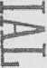



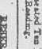

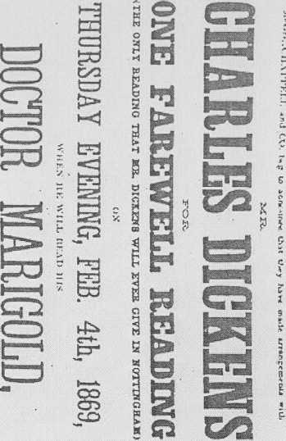

■fb
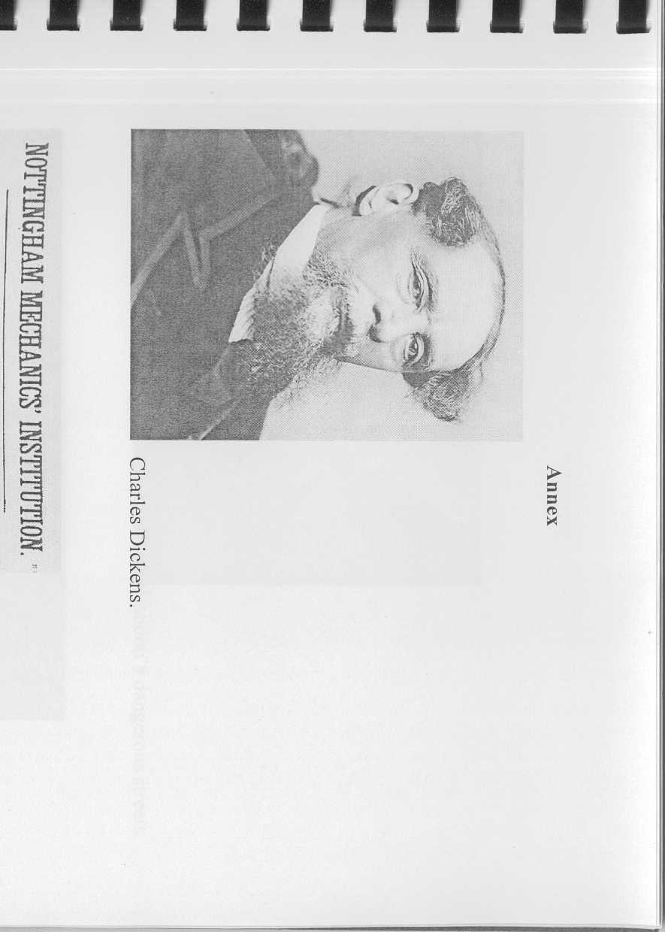

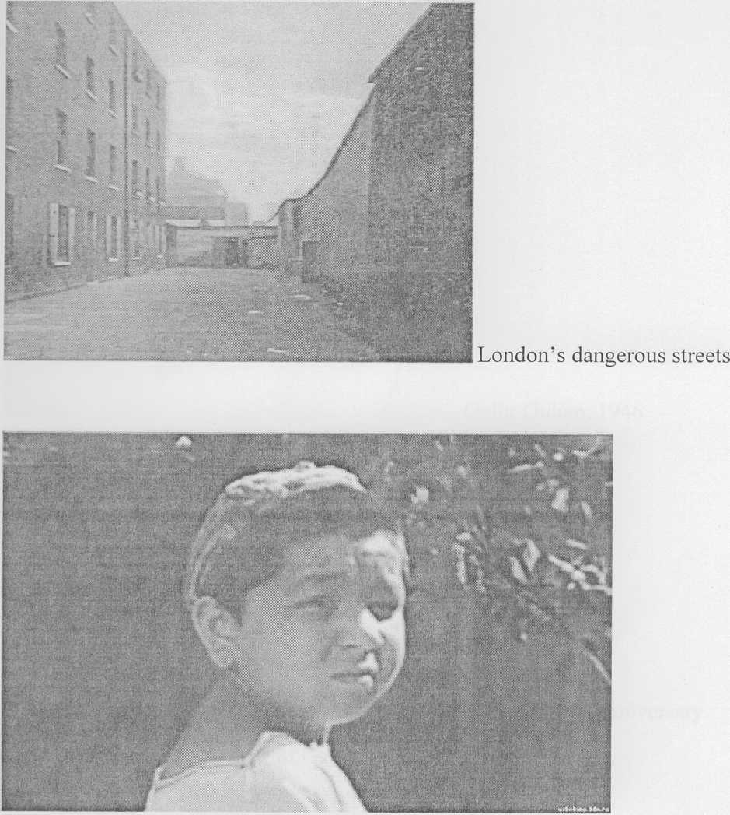
Abduraim Abduvahobov in the role of Qoravoy. 1977

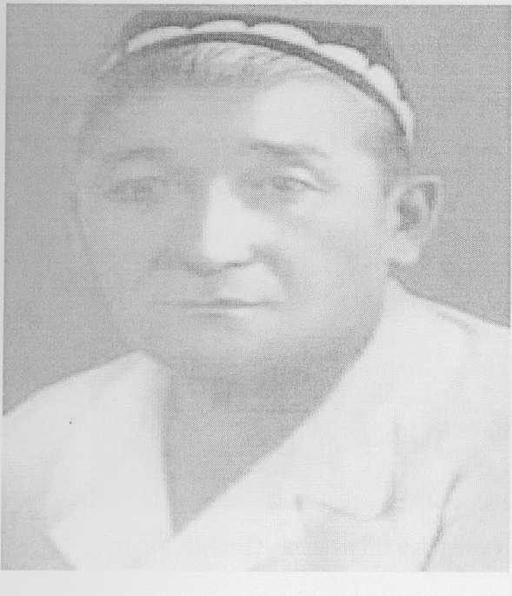
Gafur Gulam, 1946

Special stamp which was published for the anniversary of Gafur Gulam, 2003
jrti ri'mrrmwrrr
" о г о 1 kiston ш> зЧ
| ,^ 'Щь ;
I f- м
J. -*■ (mi
у ■ . | || |
I; |
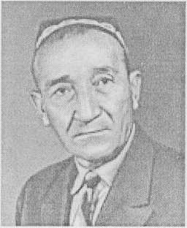
Gafur Gulam, 1956

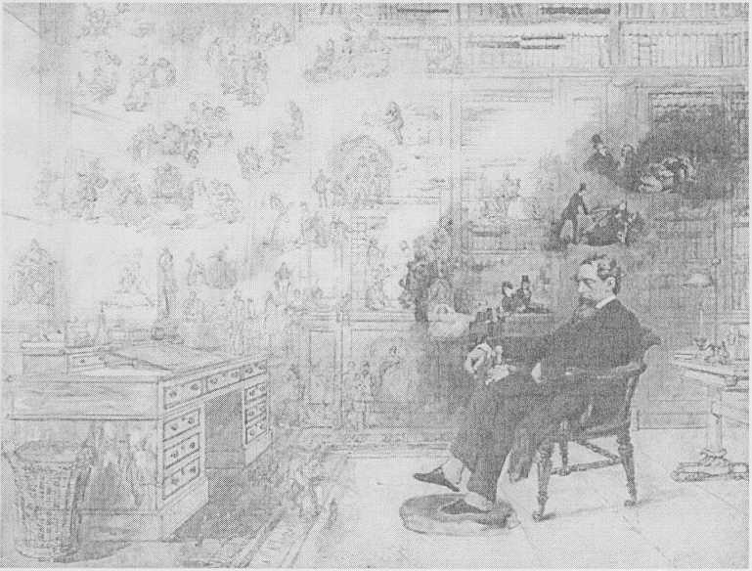
Charles Dickens in his cabinet by Moly Stevenson

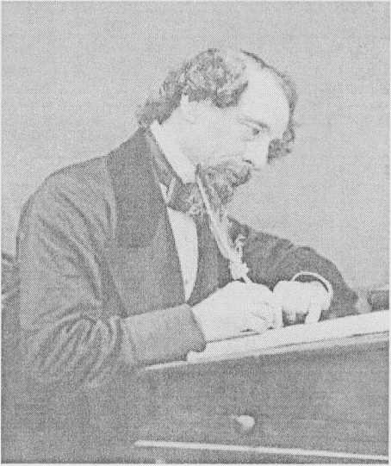

Charles Dickens, history of creation of Oliver Twist
а
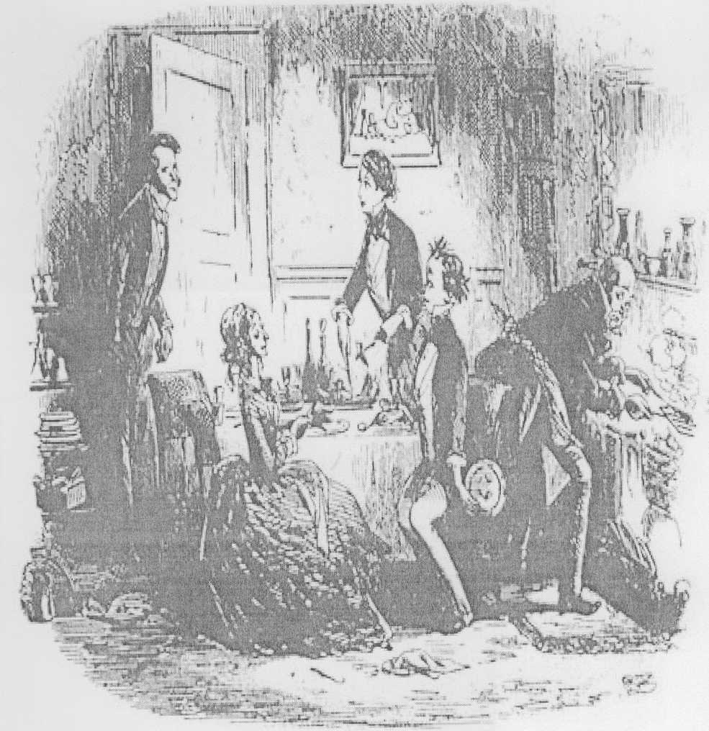

One of the famous painting made for Oliver Twist
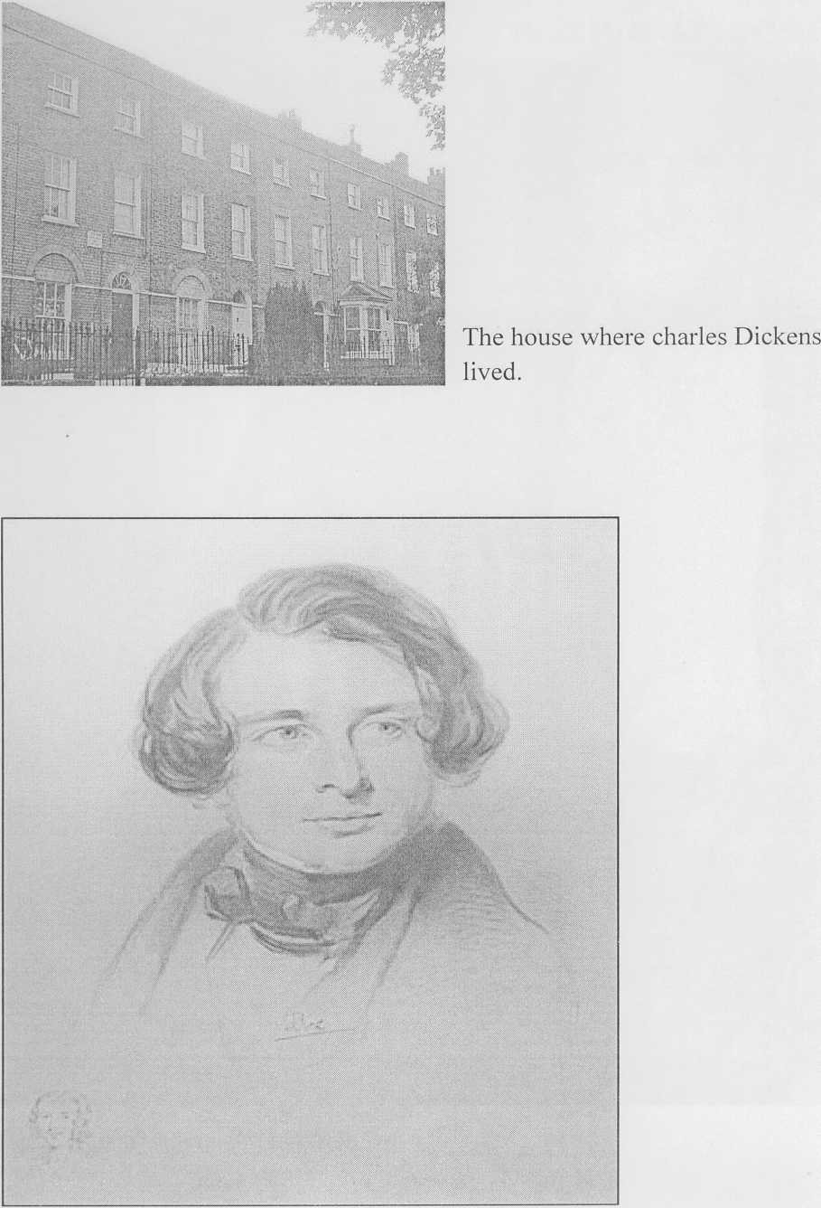
A portrait of Charles Dickens by Hoffman.

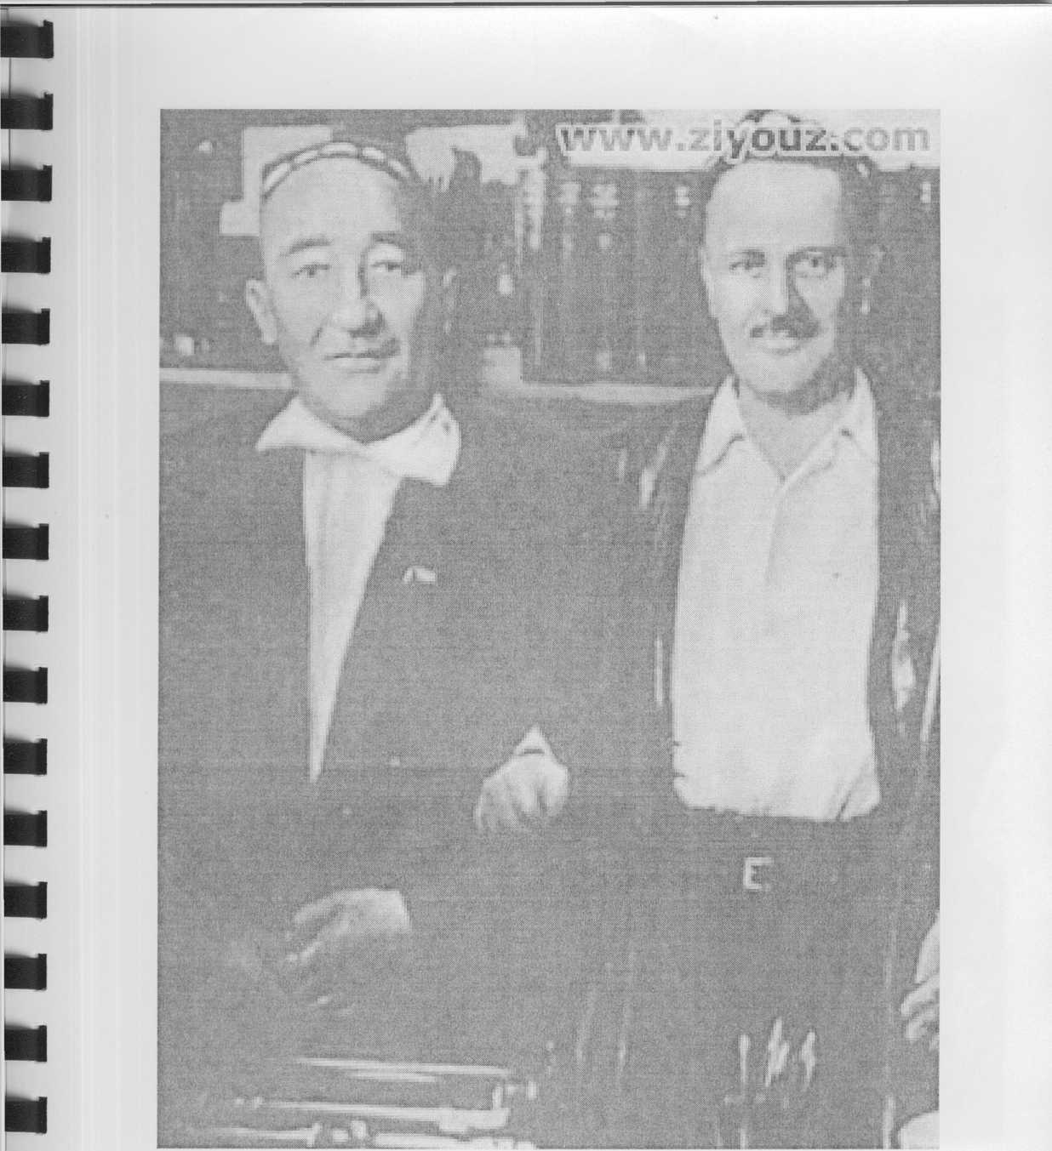
Gafur Gulam with one of his friends.

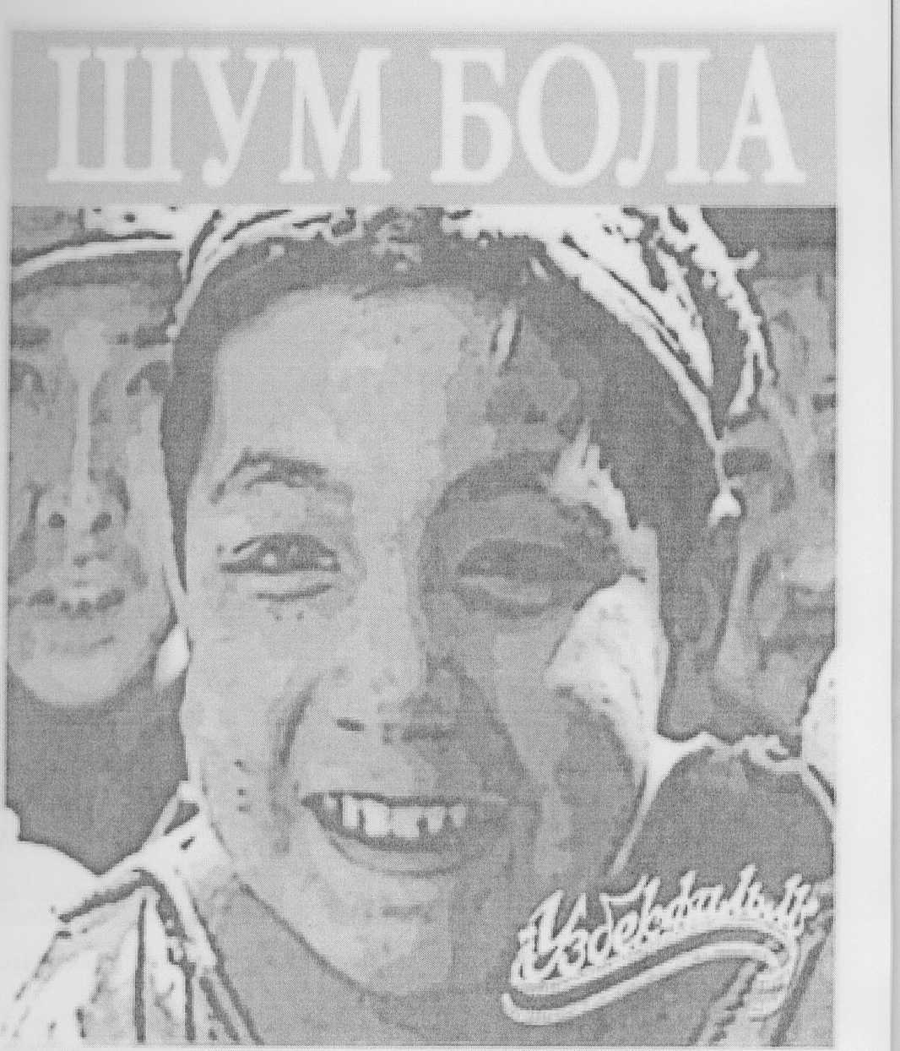
Special publication which was made for the film. 1977

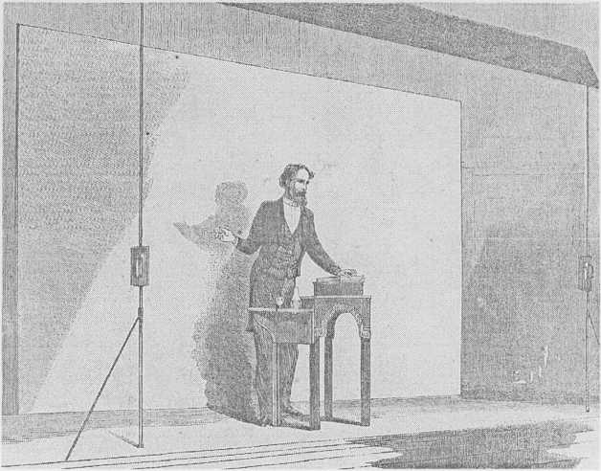
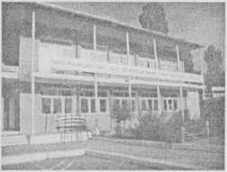

Charles Dickens. Lectures.
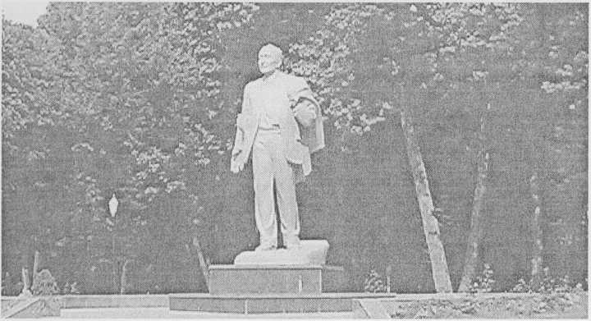
Gafur Gulam’s monument in Tashkent.

Teacher: Abdullayeva Munira Course: Literature Date: 03.05.2012
Topic: Charles Dickens and Gafur Gulam’s creative works. Use of stylistic devices and their role in literature.
Lesson Plan
Group :3 A Semester: S1-S2 Time: 80 minutes
Lesson Objective | As the result of this lesson students will have information about Charles Dickens and Gafur Gulam’s creative work.  Besides students will acquire some knowledge of using stylistic devices and their role in literature.
Content | - Introductory of a lesson.  - Main part  - Conclusion. Closing the lesson.
Language | English
Procedures and transitions | I Introductory of a lesson.  Greeting the students.  Teacher opens the lesson by showing two pictures of young boys, asks them to guess their names looking at their pictures.  Activity 1. After listening to possible answers instructor introduces the topic. Next, teacher asks some basic questions about the boys in the picture.

(For example, the authors of the book, the plot of the
novel, the main characters that can be read about,
end of the novel and etc.) All these activities can go
as speaking activity. (10 minutes)
II Main part.
Activity 2. After having a small talk about Ch.
Dickens and G. Gulam’s creative works students are
asked to pay attention to the next activity which goes
to reading. The instructor divides the students into
two groups and asks them to sit in the shape of a
circle. The teacher distributes the small pieces of
papers (handouts) that provide basic information
about the writers. Each group takes the separate
sheet of paper which provides the information about
the writers. According to teacher’s instruction
students should read the passages within 5 minutes
and prepare a small presentation for the opposite
group in 5 minutes. (Making a presentation 10
minutes.)
Activity 3. The teacher asks the students weather
they know anything about stylistic devices or not.
After listening to a few answers the teacher makes
some additions to their answers (if necessary) and
gives more information about stylistic devices. In
order to broaden their view on the arranged topic the
instructor gives special handouts which provide core
information about stylistic devices. (10 minutes)
In order to check their comprehension the instructor
asks some questions according to the passages. (5
minutes)

Activity 4. To check the students’ knowledge in practice the teacher gives some samples of sentences from “Oliver Twist” and “Shum bola” where stylistic devices are actively used. According to the instruction of the teacher the students should analyze the use of stylistic devices in those samples within 15 minutes.
Activity 5. This activity is aimed at improving students’ writing skills. In this activity the teacher asks the students to write a small paragraph describing the role of stylistic devices according to the knowledge acquired from the lesson. (“Role of stylistic devices in literature” 10 minutes) After writing the paragraph some of the volunteers are asked to read works. (5 minutes)
III Conclusion. Closing the lesson.
At the end of the lesson the teacher summarizes the discussion and asks students to look through all the covered topics and information once more.
Lesson Materials should be | Whiteboards, markers, pen, pencils, pictures, and hangouts.
Skills that improved during the class | Speaking, reading, writing
Literacy Framework | As the result of the lesson students will be able to improve their pronunciation, reading comprehension, and writing skills.
Differentiation | The differentiation of the lesson is that up present moment English and Uzbek writers were never studied together.

Used materials during the lesson.
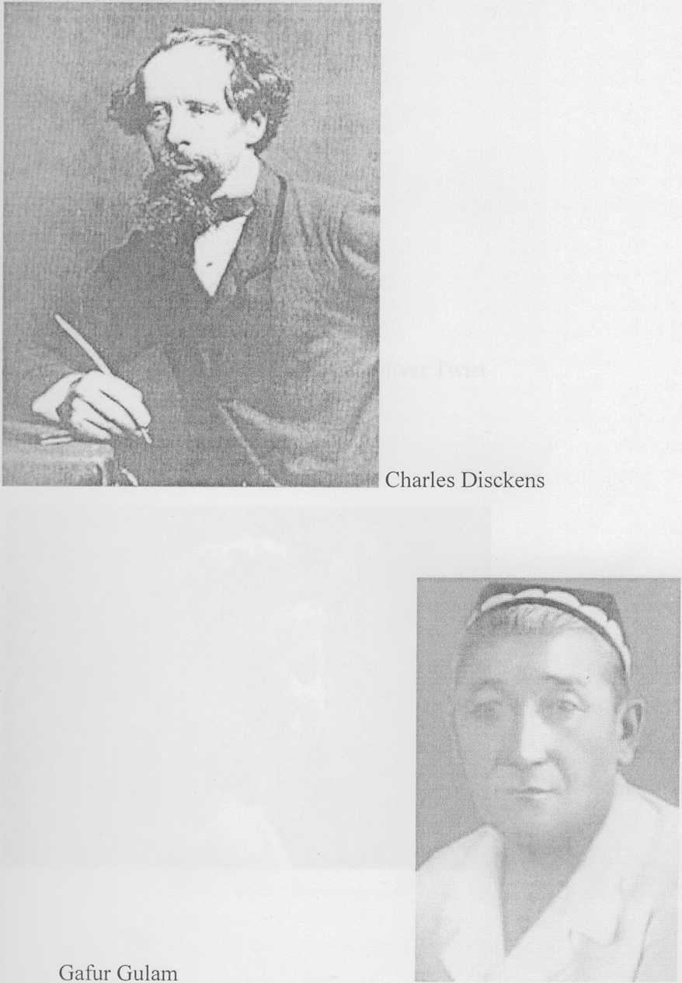

ш
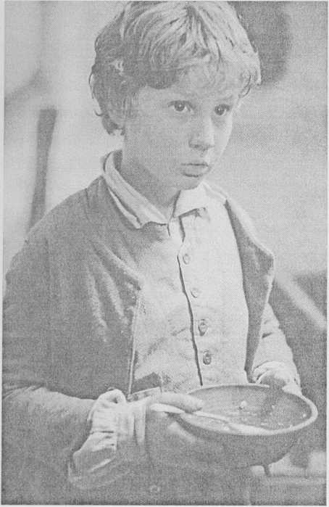
■
Oliver Twist
■
■
■
м
■

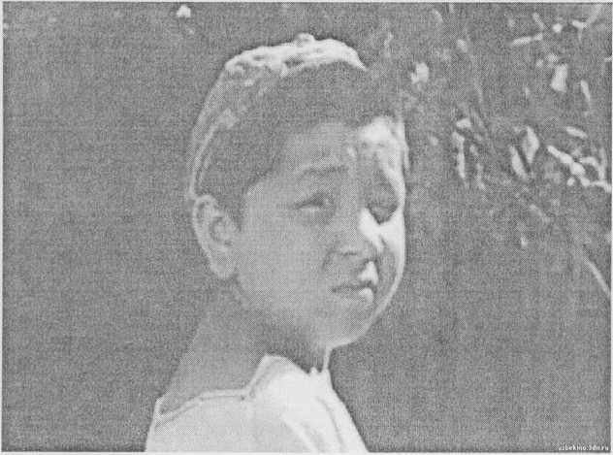
Shum bola

Many scholars prove that Dickens had a special ability to write. If we look back, at the time of his childhood not only Dickens but also vast numbers of children were orphan and homeless. And the question appears: why the other children did not become famous writers? We can say that Dickens was gifted by the God with a particular capacity of writing. A famous scholar of English Literature, Sarah Gilbert also confirms our attitude towards Dickens.
“Was Charles Dickens a creative genius? His works are still renowned today, maybe which says something. Oliver Twist and Great Expectations are among his most famous works, no doubt greatly influenced by his childhood and adolescence; he worked hard and was essentially orphaned.”
His life wasn't easy, at least by existing life principles. He had to labor as a young gentleman, due to his parents, particularly his father's, financial failures. So, his life was a rough one during his teenage years, living with relatives and working hard. And exactly these factors influenced his creative works which gained world admiration.
One can see how Dickens near obsession with the orphaned main character was not a coincidence. He gained vast personal experience as somewhat of an unwanted child. His mother did not want him to return from work as a young boy, and hence Charles Dickens felt betrayed and developed a lack of distrust for the female race. After reflecting on the selfishness of his mother, and the ineptitude of his father, Dickens was able to better understand the troubles of the orphaned childhood. He was able to show this on the poor orphan in Oliver Twist.
Sometimes works of other great writers can give inspiration to write numbers of beautiful works which are commonly appreciated by ordinary peopl e. One of them was Dostoyevsky who claimed for several times that he had greatly and seriously impressed by the works of Charles Dickens. The scholar Timofeyv who studied life and creative works of Dostoyevsky stated that Dickens had a particular character in Dostoyevsky’s creative works. The data which is taken from Timofeyv’s memories can verify our statement.
“Being distinctive and even idiosyncratic, Dostoevsky's imagery cannot be comprehended without appreciating Dickens's role in his Russian contemporary's development of his unique style. For Dostoevsky's innovative use of language the most important element in Dickens's writing was the English novelist's using his visual imagination to express human feelings and relationships. One can appreciate Dostoevsky's inimitable style and characterization more clearly by comparing his characters and plots with those in Dickens's works.”
While providing the information about acknowledgments of Dostoyevsky toward Dickens we thought it would be necessary to present the Russian writers own words about English writer.
“We understand Dickens in Russia, I am convinced, almost as well as the English, and maybe even all the subtleties; maybe even we love him no less than his own countrymen; and yet how typical, distinctive, and national Dickens is.”
The literary and personal friendship between Dostoyevsky and Dickens was greatly appreciated both by writers and ordinary people. It’s proved that they often wrote to each other and exchanged their own experiences over literature. Of course, these occasions were not out of attention of scholars who worked on Charles Dickens and
Dostoyevsky. Timofeyv, the scholar, who did research on Dostoyevsky, wrote about two great writers impact on each other.
'‘Dostoevsky grasped the power of the English writer's artistic vision; he called him a "great Christian," admiring especially Dickens's humbler characters. Moreover, the basis for Dostoevsky's assimilation of Dickens's style and vision was Dickens's treatment of the theme about the need for the reconstitution of society, and especially for the wealthy and powerful to display a greater humanitarianism towards that society's less privileged. As David Gravis remarks, "Dostoevsky saw a poetic spirituality beyond Dickens's morality. As Dickens determined to be their voice in Great Britain, so Dostoevsky determined to be their voice in Russia.”
Before writing about original assimilation of Dickens's manner in Dostoevsky's works we should mention about the Russian writer’s interest in imitating Dickens's genius. The period 1850-60 was crucial in Dostoevsky's creative assimilation of the spirit and style of Dickens's works. Dostoevsky's creative progress was effectively broken up by four years of Siberian exile in Omsk "ostrog” (prison) between 1850 and 1854 and a further five years of relative separation from typical culture spent in the Semipalatinsk agreement. Even during this period of separation, we can notice his vivid interest in Dickens. In his book of remembrances and memoirs about Dostoevsky's life in prison, M. Nikitin presented the evidence; for example, M. Nikitin remarked that, "after his Siberian imprisonment in Semipalatinsk, Dostoevsky read Dickens's novels by candlelight while often on the edge of tears”³¹
Dostoyevsky was a Great Russian writer, no doubt. Of course, this was a big admiration toward Dickens’ books being read by his dear friend. Even being in a prison Dostoyevsky never stopped reading his colleagues’ beautiful writings. One of the Russian scholars, Petr Martjanov gathered the information about Dostoyevsky’s life time while being in prison. According to Martjanov's memories, Dostoevsky in his Siberian break "refused to read the books by other writers except David Copperfield and The Posthumous Papers of Pickwick Club in translations by Irinarch Vvedensky".
A German scholar Hendrix Muller gave more brief and clear information about the friendship of these two great writers.
“E. A. Stakenshneyder, the owner of the literary salon in St. Petersburg, writing in her diary on 6 February, 1884, was briefer: "The favorite writer of Dostoevsky was Dickens."
Charles Dickens had a strong feeling for many things while growing up in a developed nation because he actually lived them. He grew up as a poor child that had to enter the work force at a young age. Dickens was treated differently as a poor child than those children who were wealthy, which led to the belief that everyone should be treated the same. He saw directly how bad the conditions were in these working environments, which led to many novels on the suffering of poor kids. His ideas were expressed through these novels as a social reformer.
(Adapted from www.wikipedia.com. Revised by Munira Abdullayeva)
Like Dickens Gafur Gulam also was very productive writer. He also made a great contribution to the Uzbek literature. His creative works made him famous in his own country, because they could understand the sorrow and grief of ordinary people and supported them to go forth. There are millions of readers of Gafur Gulam and great numbers of writers who took special and extraordinary lessons from a genius writer as Gafur Gulam.
During the war time Gafur Gulam gained the mercy and love of nation by his works which had given hope to poor nation who were suffering from stamina. For example, we may count some of them: “Dinamo” (Square ),
“Tirik qo ’shiqlar” (Alive songs) “Qish va shoirlar” (Winter and Poets), “Non” (Bread), “Toshkent ” (Tashkent),
“Qutbda saylov” (Election), “Men Yahudiy” (I’m a Jewish ), “Qish” (Winter), “Xotin” (Woman).
Gafur Gualm’s poems “Bog”’ (Garden), “Sog’inish” (Missing), "Km keldi” (Autumn) shoved beautiful nasture of Uzbekistan while some ofhis other poems “Senyetim emassan” (You are not an Orphan), "Sog’inish” (Missing), “Bahor taronalari” (Songs of Spring) brought the unnoticeable signs of content days of future.
Gafur Gulam had a special ability to show the events in traditional way. We can some features of them in several ofhis novels as “Netay” (No choice), “Yodgor” (Yadgar), “Shum bola” (Noughty boy) , and "Mening o’g’rigina bolam ” (My thief Son)
In 1943 he became the first member, the first professor of Uzbekistan Academy of Science which predicted his entire life forever. During the years of working in Academy he took a great chance to meet with well known writers as Chingiz Aytmatov, Tagor and so on.
Gafur Gulam not only wrote but translated well-known brilliant pieces of literature as "Othello" and “King Lear” from Russian into the Uzbek language.
The main theme of Gafur Gulam’s creative work was love of motherland and strong personality of people. Almost in all ofhis works he encouraged people to love their motherland and work for the development of the nation. Very often, in some aspects we can see some similarities between creative works of Gafur Gulam and Charles Dickens. Actually the same issues made the novelist write about hard working labor and poor living conditions. Like Dickens Gafur Gulam also mainly highlighted children’s poor education. In his opinion, not having the proper knowledge and education was aground cause of Uzbek nation’s adversity.
While writing about Gafur Gulam it’s essential to write about the period that he lived. At that time, 45-55s of XX century, Stalinism was ruling the government. Writers, poets, actors had to work according to the order of chief persons. All kind of creative works were checked very carefully and abolished if they were not proper to the period of Stalinism. No any word against politicians could be said; otherwise the punishment could be very severe. Most of the Uzbek writers, who openly said something negative towards government’s cruel rules, were considered as “the enemies of the nation” and sentenced to propel to cold places as Siberia. Some of them could come back home, most of them died in the cold forests of Siberia. Of course, as many writers Gafur Gulam also was investigated for certain period of time. His home was all the time observed by the people who worked as spies. Gafur Gulam wrote so in his memories:
"I saw many of my friends’ death. Of course, that was too hard for me to tolerate to such a unfairness but 1 had no other choice of having patient. I do claim that I wrote praising poems about Stalinism because I had to do so.
Like other writers I also could say something negative about the government but I was too much worried about my family. I was their only hope...”
Of course, it’s hard for any writer or poet not to be able to write thoughts and ideas openly. But for the sake of continuation of our life sometimes we have to have more patients.
Earlier we have mentioned that Dickens and Dostoyevsky had close and personal relationship in private life and creative works. Like Dickens Gafur Gulam also was impressed by the representative of foreign literature. This was a Great Russian poet Maykovsky. Gafur Gulam in most of his memories mentioned the name of Mayakovsky as his spiritual master of poetry. In most of the Gafur Gulam’s poems we may see great influence of Mayakovsky’s poetry. Below we can see Gafur Gulam’s thoughts and opinion about Mayakovsky’s poetry:
“He has very beautiful style of writing. Whenever you read his poems you feel that a great hope appears in your for the future life. Actually, we, writers and poets have to learn how to write from him as our duty is showing particular beauty of the world.”
From Gafur Gulam’s interest in Myakovsky’s creative work we may see that he was eager to learn something particular from the literature of other foreign countries. This occasion could be seen in his creative works as well. Almost in all of his works he challenges the nation learn more and have appropriate education.
(Adapted from www.ziyonet.com. Translated by Munira Abdullayeva)
The role of stylistic devices in fiction.
The role of word order stylistic devices
Syntactical stylistic devices are perceived as elaborate designs aimed at having a definite impact on the reader. It will be borne in mind that any stylistic device is meant to be understood a device and is calculated to produce a desired stylistic effect.
Aristotle stipulated that there should be a mixture of ordinary and unfamiliar words in the language of literature. Ordinary words made for clarity. Unfamiliar words (which included various stylistic devices) made the language shine, and avoided the appearance of meanness and the prosaic. Nevertheless language should be appropriate to context.
So arose the understanding that words were not good or bad in them, but only by virtue of their placing in a line. Languages like English allow considerable variety. Into He said shortly that she was not to go. The word however can be inserted correctly, if a little awkwardly, into all positions, giving not only rhythmic flexibility but nuances of meaning. But English writers have generally wanted more. If the standard word order in
English is subject, verb object, that order is not followed in these percentages of lines overall: Pope 32%, Milton 19%, Shelley 15%, Shakespeare and Tennyson 12%. Perhaps the commonest variation was hyperbaton, inversion of noun and adjective, chiasmus, hysteron-proteron, etc. For instance Milton could write:
I come to pluck your berries harsh and crude,
And with forced fingers rude (...) (Lycidas).
And Pope:
What dire offence from amorous causes springs (...) (The Rape of the Lock). Contemporary writings dislikes such inversions, but is not above pointing line endings in its own way — and perhaps less effectively, because line breaks are less apparent in spoken language :
so much depends upon a red wheel barrow...
(The Red Wheelbarrow: William Carlos Williams)
In short, the arrangement or juxtaposition of words creates its own poetic diction, and reflects society as much as anything else in the arts.
Below are presented in details the most widely applied stylistic devices that deal with the word order alternatives in different styles. The following stylistic devices are considered to be ‘The Winds Throwing Word Order’. This seems to be true indeed.
(Adapted from www.selfstudy.corn)
¹ The Times
⁸ Butt, John E. and Kathleen Tillotson - Dickens at Work. 1957, reprinted 1982, pp 95
¹² Gissing, George R. - Charles Dickens A Critical Study. London, 1898, reissued 1976, pp 117
²⁵ Chesterton G.K. - Charles Dickens. London, 1903, reprinted 1977, 83
²⁷ Galperin -Stylistics, Moscow, 1977, pp 14-19

Vann, J. Don. Victorian Novels in Serial. New York: Modern Language Association, 1985.
Ackroyd, Peter - Dickens. London, 1990, pp 45
Ackroyd, Peter - Dickens. London, 1990, pp 47
Collins, Philip -Dickens, the Critical Heritage. New York, 1971, pp 155
* Chesterton G.K. - Charles Dickens. London, 1903, reprinted 1977, pp 78 ⁵ Gissing, George R. - Charles Dickens.A Critical Study. London, 1898, reissued 1976, pp 116
Gissing, George R. - Charles Dickens.A Critical Study. London, 1898, reissued 1976, pp 116
Chesterton G.K. - Charles Dickens. London, 1903, reprinted 1977, pp 79
Ford, George H. - Dickens and His Readers. London, 1955, reprinted 1976, pp76
M. Bakoeva, E. Muratova, M. Ochilova - English Literture Uzbek State World Languages University, 2010, pp 131-134
Madayev, Omonulla - O’zbek adiblari “O’qituvchi” nashryoti, Toshkent, 2009, 112-113
Madayev Omonulla - O’zbekadiblari “O’qituvchi” nashryoti, Toshkent, 2009, i 12-113
Ahmad, Said - Yo’qotganlarim va topganlarim “Sharq” nashryoti, Toshkent, 1999, 86-89
Madayev, Omonulla - O’zbek adiblari “O’qituvchi” nashryoti, Toshkent, 2009, 112-113
Sodiqova, Tursunoy - Dildagi nur “Yangi asr avlodi” nashryoti, Toshkent, 2011, 213-215
Gulom, Gafur-Xotiralar, 1965, pp 54
Galperin - Stylistics, Moscow, 1977, pp 14-19
Galperin -Stylistics, Moscow, 1977, pp 14-19
Galperin -Stylistics, Moscow, 1977, pp 14-19

