
Ministry of Higher and Secondary Special Education of the Republic of Uzbekistan
The Uzbek State University of World Languages
English Faculty III
Qualification Paper
THEME: STIMULATING ACTIVE PARTICIPATION IN YOUNG LEARNERS’ CLASS
Admitted by Done by: Munis Khusanova, group 410
Scientific advisor: Saida Irgasheva
Anduraimova Y. Reviewer: Muhammedova Nilufar

Tashkent 2014

ABSTRACT
The current diploma thesis is aimed at comparing and discovering the most effective methods, techniques and approaches that stimulates active participation in young learners class (YLC). Besides that the implementation of various approaches in young learners’ class will alter the whole atmosphere and probably absorb learners’ attention into the lesson though in a fact children tend to have very short span of concentration.
The qualification paper consists of the secondary research as a theoretical part, which introduces the current situation in Education system in Uzbekistan, the role of motivation in language learning and various approaches applied by scientists and the primary research as a practical part which has been led by the researcher to evaluate and find out the most effective ones in the encouragement of young learners within three months.
A three-month survey has been conducted at the private, non-governmental language centre “Team”, located in Tashkent, Uzbekistan, which provides high-qualified education in language learning to adults and children as well. The survey was led with young learner aged between from 9 to 13 who come to learn English only once in a week in order to fulfill the primary part of the paper. As for the hypothesis questionnaires, observations, various activities, quizzes were applied to measure whether the hypothesis has been realistic or imagery.
Moreover, in a period of four weeks the researcher leads the lessons in a traditional way and for weeks non-traditionally in order to spot the difference and potency between them. The results illustrated in diagrams, charts, and tables have served as a key factor to show the usefulness and effectiveness of strategies utilized during the practicum by the researcher.
All in all, the current qualification paper comprises both theoretical and practical parts which have vital of importance in maintaining active participation in every young learners’ class.

CONTENT
Introduction 4
CHAPTER I – LITERATURE REVIEW 6
1.1 Situation in Uzbekistan 7
1.2 The role of motivation in language learning 12
1.3 The best techniques and approaches for teaching young learners 15
1.4 Wide range of activities 18
1.5 Young learners classroom: the role of teacher/learner and classroom environment 23
CHAPTER II – A. PROCEDURES AND PROCESS 29
2.1 Statement of Purpose 29
2.1.1 Purpose for conducting the study 29
2.1.2 The research questions and hypothesis 29
2.2 Method 30
2.2.1 The Subjects 30
2.3 Materials and Equipment 32
2.3.1 Materials 32
2.3.2 The equipment 40
2.4 Procedure 40
2.4.1 Variables of the Study 40
2.4.2 The Specific Steps in the Experimental Process 41
B. DATA COLLECTION 42
2.1 Analysis of Data 42
2.2 Data Collection 43
CHAPTER III – RESULTS AND DISCUSSION 46
3.1 Results of A Learner Needs Questionnaire 46
3.2 Results of Pre Mid-Term Test 50
3.3 Conducting Lessons and Experimenting Strategies 55
3.4 Results of Post Test 56
3.5 Results of Student Experience Feedback Form 61
3.6 Conclusion 65
3.7 Final Reflections 66
III – LIST OF USED LITERATURE 69
3.1 REFERENCE LIST 69
3.2 BIBLIOGRAPHY 76
List of table
Table 1 50
Table 2 51
Table 3 54
Table 4 55
Table 5 56
Table 6 59
List of Figures
Figure 1 45
Figure 2 46
Figure 3 47
Figure 4 48
Figure 5 52
Figure 6 57
Figure 7 60
Figure 8 61
Figure 9 62
APPENDICIES

Introduction

“When tasks are meaningful to students, when students have authority over their learning and when mistakes are considered as part of learning process, this would encourage students to display more on-task behaviors and would arose less anxiety, and therefore less disruptive behavior.”
Robert Kaplan
Motivation – is a strong hint that triggers a learner both internally and externally to perform well or vice-versa. Providing a right motive stimulates learners, while wrong one may lead to the apathy in education. That goes without saying that approaches and activities in the class should meet the needs of learners as the professor of Applied linguistics in Meikai University (past Director of the American Language Institute) Robert Kaplan stated in his scholarly journals. It is utterly true that methods and techniques applied in the class should bear clear purpose, sense and meaning to feel students satisfied. However, when it comes to children who are learning English as a second language, every minor detail of the lesson plan should be appropriate to their level, age and characteristics. As motivation is one of the essential factors in teaching, undoubtedly it requires plenty of investigation and practice from any teacher of foreign language.
Nowadays, a great deal of investigation is being held on this very topic because children learn from everything what they do and they are much curious to explore and discover. If their expectations meet satisfaction, they become enthusiastic to learn more. As concerns Uzbekistan, much of the attention is being paid on teaching English as a second language from the first grade in order to improve the quality of education system, to upsurge the number of foreign language barriers and to ameliorate the knowledge of foreign language among youth and children. According to these factors, teaching English to children seemed quite striking aspect of society. The researcher has become more interested in this field after learning more information throughout the university period and moreover, experience that she has been gaining since two year in teaching field, thus she never expected to enjoy the process of it. Nevertheless, the researcher set her heart on the topic “Stimulating active participation in young learners class seems to be very actual and practical.
The topic set the researcher in motion and she took quick look on the internet, at the encyclopedia and found many useful resources for qualification paper. These sources serve as tools of investigation and assessment. The researcher is quite sure that collecting more relevant and reliable date, will give a helping hand to dive deeply into the issue. Using periodicals for research like Forum which is published monthly tend to be a big collection of viewpoints of world’s English teachers, that is to say periodical Forum is rather common among ELT and teachers of different background and culture usually express their attitude towards the issue by posting articles on it. Throughout the qualification paper, the researcher is going to apply variable methods of stimulation. Furthermore, she expects to find out something new in teaching for sake of her future career in teaching.
All in all, the researcher hopes the topic ‘Stimulating active participation in young learners’ class” will be attention-grabbing topic both for me and for those who mainly teach foreign languages. I firmly believe it will be great technical report.

CHAPTER I – LITERATURE REVIEW

English has already earned the status of international and common language in the world and proudly stands in the UNO’s list of official languages. Teaching English in Young Learners class (TEYLC) is a rapidly growing field around the world, and English education is increasingly found at the primary levels. That goes without saying that the number of English language bearers is getting as wide as the ocean because in fact, everyday a dozen of students express their willingness to learn this particular language. A survey performed in a non-governmental, private language center “Team”, located in Tashkent, Uzbekistan, which supplies high-qualified education, has proved that the mean of daily appliers is about 10 for adults whereas this figure for young learners, aged between 9 and 12, stands at 4. Between these two groups of learners, the latter one appeal to the researcher as the most striking and interesting not only to work with but to carry a research on.
Despite being a student of university, working has already become an inseparable part of the researcher’s life providing many possibilities not only to gain experience in one particular field but to put the knowledge into practice as well. At the very beginning of teaching career, the idea to teach English in young learners’ class popped up in the researcher’s mind. In language centre “Team” in a short period of time a group of children who wish to learn English language were formed in order to experiment the best techniques and approaches that stimulates active participation in YLC. In a week, the gates of castle were opened and children welcomed the researcher with very nice attitude and mood. Although many people around regard teaching foreign language to children as much as difficult to handle with but the researcher has found this job quite enjoyable.
Features of young learners such as responsibility, thirst for acquisition of second language, habit of adhering to an appointed time and many others triggers the researcher to stay motivated and keep on teaching.

1.1 Situation in Uzbekistan
The significant development has occurred in education system of Uzbekistan. One of the noticeable changes might be observed in the usage of the term “a young learner”. By 2013 it had been interfered to school children, aged between 9 and 16, however nowadays the range of English learner has been extended exponentially, including the first graders too.
In fact, more than a decade ago, English used to be added as a secondary subject on the 5th grade to the school curriculum; however, these days English language has started being taught as the children set their heart on schooling. Enforcement of the law has brought many shifts to the education system. The most striking alter is that a special book named after “Kids English” has been designed by a group of EFL teachers based on Presidential Decree of December 2012, PD1875 and Common European Framework of Reference (CEFR) requirements.
On December 10, 2012 President of the Republic of Uzbekistan Islam Karimov signed a decree “On measures to further improve foreign language learning system”.
It is noted that in the framework of the Law of the Republic of Uzbekistan "On education" and the National Programme for Training in the country, a comprehensive foreign languages’ teaching system, aimed at creating harmoniously developed, highly educated, modern-thinking young generation, further integration of the country to the world community, has been created. During the years of independence, over 51.7 thousand teachers of foreign languages graduated from universities, English, German and French multimedia tutorials and textbooks for 5-9 grades of secondary schools, electronic resources for learning English in primary schools were created, more than 5000 secondary schools, professional colleges and academic lyceums were equipped with language laboratories.
However, analysis of the current system of organizing language learning shows that learning standards, curricula and textbooks do not fully meet the current requirements, particularly in the use of advanced information and media technologies. Education is mainly conducted in traditional methods. Further development of a continuum of foreign languages learning ​​at all levels of education; improving skills of teachers and provision of modern teaching materials are required.
According to the decree, starting from 2013/2014 school year foreign languages, mainly English, gradually throughout the country will be taught from the first year of schooling in the form of lesson-games and speaking games, continuing to learning the alphabet, reading and spelling in the second year (grade). Also it is envisaged that university modules, especially in technical and international areas, will be offered in English and other foreign languages at higher education institutions. The State Testing Centre, along with other relevant agencies, is tasked with preparing draft proposals on introducing foreign languages testing to the entrance examinations for all higher educational institutions.
In order to increase teaching standards in distant rural areas, the higher educational institutions are allowed targeted admission of people living in distant areas to foreign language programs on the condition that they will oblige themselves to work in the acquired specialty at their residence area for at least 5 years after graduation. The decree also envisages 30% salary increase for foreign language teachers in rural areas, 15% increase for those in other areas.
The National Teleradio Company, State Committee for communications, informatisation and telecommunication technologies, Agency for Press and Information of the Republic of Uzbekistan are tasked to prepare and broadcast language-learning programs, significantly increase access to international educational resources via “Ziyonet” educational network, promote publication of foreign language textbooks, magazines and other materials.
The Presidential Decree of December 2012 makes it clear the English will have to be taught according to communicative principles from Grade I. This will require not only a new curriculum with new materials, but new teachers and also massive re-training of existing teachers.
While the introduction of the national education standards into the education process has produced positive results, there remain problems with the curriculum and teacher supply.
Teacher supply: ‘At the beginning of the 2006-2007 school year, schools lacked a total of 1455 teachers of foreign languages.’ (from 2007/2008 UNDP Report Education in Uzbekistan: Matching Supply and Demand’, page 95) For this reason enrollment more students to English departments of the pre-service- based universities is impressive.
In 2007, the observers reported that, unsurprisingly, graduates’ methodology in schools reflected the curriculum and approach of their training in the universities: ‘They read text, write on the note books, teacher write on the b.b. they copy it … They learn present Simple Tense, new vocabulary of the lesson, teacher works on new words, pupils repeat in chorus’.
(4- PRESETT project team's site visit report, based on observation of one of schools in Tashkent)
The purpose of teaching English and including it as the most demandable subject into the curriculum of the education system of the Republic Uzbekistan is to develop learners’ communicative competence in the fast developing culture plant community. Communicative competence is the ability to use the gained knowledge, experience, skills in the spoken interaction. The Presidential Decree of December 2012 says that the minimal requirement in teaching English falls into two linguistic competencies (This term applies to mastering the combination of sounds, syntax and semantics):
- Language Competence
Phonetic Competence | Can pronounce all speech sounds accurately and precisely ;  Can stress the words correctly;  Can differentiate and use intonation in communicative approaches;
Lexical Competence | Can use lexicons in context;  Can use lexicons in communicative approaches;  Can differentiate and implement proper nouns;
Grammatical competence | Can use simple grammatical and syntactical structure in communicative cases;  Can link words and word phrases with conjunction “and”;  Can make sentences with the correct form of verbs and adverbs;  Can retell stories in correct order;

- Speech Competence3
Language skills |  | Competence
Listening |  | Can understand simple directions and respond properly;  Can understand sentences and questions;  Can understand nursery rhymes, stories and songs;  Can understand simple authentic speech in familiar contexts;
Speaking | Dialog | Can ask and give information;  Can ask for help;  Can lead simple question-answer dialogs;
Speaking | Monolog | Can talk about family, friends, acquaintances;  Can introduce himself;  Can talk about likes/dislikes;  Can make a short presentation about a familiar topic;
Reading |  | Can understand texts in familiar topics;  Can understand descriptive texts about people or place;  Can understand basic information in form of messages, e-mails;
Writing |  | Can write simple personal information (congratulation letters, notes, e-mails);  Can complete a form (name, address and etc)  Can write short rhymes and stories;

Each government keeps lifting the achievements of young learners by continuing to provide the highest quality curriculum. Raising the standards even higher in the critical areas of Literacy and Numeracy is one of the key priorities of this strategy. The changes that occurred in teaching English means English has already turned out to be an essential component in primary and pre-school education. In a fact, the early years of schooling are a critical period for the establishment and development of the skills, knowledge, behaviors, values and attitudes that provide the foundations for lifelong learning and sustain personal wellbeing. Young children are eager to learn therefore a teacher must continue to nurture the curiosity they bring to learning, focus on building confidence and ensuring success, and help instill in young learners a strong love of learning. Providing secure, positive and stimulating learning environments caters for each child’s abilities and foster high expectations. At the same time seeking to develop in young learners an independence of mind and work habits, a positive sense of self and a deep respect for others models the values a teacher seeks for students.

1.2 The role of motivation in language learning
No human being is unmotivated: all human behavior is an attempt to meet our needs; therefore, when we say that individual children are not motivated by a particular activity, all we are saying is that this activity, at this time, presented in this way, is not meeting their needs says Glasser, W. (1998), in his article The quality school: Managing students without coercion. According to him the children’s apathy does not mean that they have lost their drive to learn, but that learning this material in this manner does not satisfy them. Apathy is not the problem; it is a symptom of the problem, of the irrelevance of the task to their lives. There is no way to motivate children to do something that is futile says Louise Porter, PhD Child Psychologist and self-evidently, individuals are not motivated to become competent at everything. Therefore, we need to understand what motivates individuals to invest time, effort and skills in certain tasks and not others. Motivation – or a lack of it – is not an inherent part of children’s personality but also depends on the task and social setting. The author categorizes two aspects of motivating and depicts it in the following formula:
- Motivation = expectation of success
- x anticipated benefits of success
Observer states that children are not motivated by a particular activity; this formula tells us that one of these aspects must be missing and gives precise definition to each aspect:
Expectation of success: In order to develop an expectation that they can be successful on a task, children need to experience an optimal (not too high and not too low) degree of challenge, so that they are confident that they can meet demands. While some challenge is necessary to excite learning, children who experience less pressure to excel report enjoying tasks more and experiencing less tension while completing them. When children believe that the task is too difficult for them, they can experience anxiety (fear of failure), worrisome thoughts and physical symptoms of stress. This stress syndrome will reduce their motivation to invest energy in the tasks, compromise their learning and show itself in processes such as procrastination (avoidance) and attempts to escape task demands. In other words, children need to feel competent that they can achieve the demands. Nevertheless, although competence is necessary for children to be motivated to engage with an activity, on its own it is not sufficient to entice their engagement. A clear appreciation of how success will benefit them is also necessary.
Anticipated benefits of success: When children anticipate that success will benefit them (in terms of meeting their personal needs), they will place a value on being successful. Children who confidently expect success and freely adopt pro-educational values (as opposed to being compelled to do so through rewards and other forms of controlling discipline) are more likely to be willing to engage with educational tasks and to anticipate that doing so will benefit them in the future.
The personal needs that tasks must fulfill are:
• Children’s basic needs for physical and emotional safety;
• The emotional needs for self-esteem (which is contributed to by being Competent), for belonging, and for autonomy (self-directedness);
• The higher-level needs for fun and self-fulfillment.
Qualitative teaching and close partnerships between schools and parents will support each child to experience a successful educational journey through the early years of schooling. Parents should set proper expectations say Greer Middle School teachers in their article called “Seven proven ways to motivate children to do better in school”. Expect your child to succeed and opportunity for success improves greatly in a short period of time. Usually, children are aware keenly of theirs parent’s expectations and therefore their actions tailor to those views. Hence, it is crucial to have high expectations based on your child’s strength and weakness. The next thing that should be mentioned is giving a helping hand to a child to form goals. Knowing what they are expected to do stimulates each child to accomplish therefore researchers suggest to jot down goals as they are a visual reminder of what we need to do. Posting them in a prominent spot – such as a kitchen wall with a specific goal like “Connor will raise his math grade from a C to a B” triggers him to review for instance math rules every day, stay at school for a teacher for practice math tests to accomplish set goals. Moving further, authors consider the fact that showing your child that the school is important evokes an eagerness to be involved in schooling much better than ever and this includes maintaining a relationship with your child’s teacher, supporting the program at your child’s school, creating a suitable environment, keeping up with your child’s assignments and staying positive about school and schoolwork. As a consequence your child turns out to be more likely to want to learn and figuring out your child’s learning style that helps him to feel confident and natural – makes the most sense of the fourth stage that is supporting your child’s learning style. Teachers of the Greer Middle School say that encouragement has a bigger effect than praise on a child’s motivation. The main difference is that praised child relies on a teacher’s assessment while encouraged one forms positive assessment of herself. Consequently, encouragement makes motivation soar. The step 6 includes reinforcing learning at home and in the community by using imagination combined with creativity makes learning process not only alive but interesting for your child. Finally, encourage your child to be resilient say Sam Goldstein, Ph.D. neurologists and professor at the University of Utah who believes that encouraging resilience is one of the best thing parents can do for their children.

1.3 The best techniques and approaches for teaching young learners
There are several other ways in which we can help to generate high levels of motivation in young learner classrooms. Here are just a few of suggestions:
- Giving Praise
Most of us have been taught that rewards (including praise, stickers, school awards, student-of-the-day status, extra time on favorite activities, pocket money, and so on) will motivate children to do what we want them to do. In the case of motivation, we intend that rewards will motivate children to do the tasks we set them. On the one hand these rewards run four risks: to children’s self-esteem, to their intrinsic motivation, to their perfectionism, and to their orientation to learning and to challenge. That is, person praise lowers children’s subsequent evaluations of themselves and their work products, and leads to more negative emotional expression and helpless reactions to errors. Children who are praised become less persistent and more self-critical in the face of setbacks. On the other hand Young learners really respond well to praise when they have done something well, or made an effort to try something new or something that they find particularly challenging. If you can reward this then you will see motivation levels increase. One way to achieve this is through a Star chart. It is really simple and easy to set up. Draw up a chart with all your students’ names down one side. Explain to students how you are going to award stars and what you are going to award them for. At the end of each activity or task, or at relevant points during the class, mark a smiley face or a star on the chart for your special performers. Remember to reward with consistency, while taking time to support those who may not be able to achieve quite so well. Getting a star can really be a great motivator for younger learners – you’ll see the results in beaming faces and renewed efforts in future activities. Children are short-changed in the immediate rewards category. The best they can hope for is a stimulating environment that is socially comfortable and intellectually challenging. Many teachers work hard to provide an environment that is intellectually rich, fun, and emotionally supportive. Unfortunately many teachers are severely constrained by the structures of time, organization, and governance already described. School staff tries to reinforce the idea that learning is intrinsically worth-while and that the payoff has substantial material value. They do so primarily by dispensing symbols – grades, gold stars, praise and awards, eligibility for extracurricular activities. Not all students find these symbols intrinsically or extrinsically rewarding. Some students see little connection between their school experiences and their daily lives outside school. They cannot envision how what they do at school will result in economic rewards in the workplace. Praise and the other rewards encourage a performance rather than a mastery orientation to learning. Praise for high achievement causes children to choose safe tasks and avoid challenge; the children do not persist, experience less task enjoyment of learning, and manifest declining performance over time say Mueller and Dweck in their research. Thus, praise and rewards for high achievement fail to teach a motivation to become more skilful over time, but instead teach children to compare themselves to each other. Therefore, instead of judgments, children need feedback that provides specific information about what they have achieved and what their next goal may be. In contrast to the above effects, such informative feedback fosters considerate behavior, promotes a healthy self-esteem in children and sets a positive tone for the classroom. It helps children feel more competent and enhances their intrinsic motivation says Grol Nick, promotes a mastery orientation to learning and teaches them that they can turn failure into success by changing strategy, rather than causing them to give up on the grounds that they ‘can’t’ do it or ‘will never be any good at’ the task
- Reinforce and Repeat with Fun Activities
Young learners like familiarity, so if you find a popular game or activity that your youngsters enjoy, don’t be afraid to use it frequently. For example, you can use a game format to revise new vocabulary and/or grammar from the previous lesson. This will help to ensure that there is some continuation from lesson to lesson, and you will be able to see if students have learnt the work.
- Vary your material
Even though students do like familiar activities, it is still important to vary your material. After all, students will get bored with doing the same type of activity day in day out. So use a variety of different materials: TV/video programs for visual stimulation, games for active participation, an overhead projector to display something or tape recorder to tape your younger learners speaking English. Alternatively, use colorful images from the internet or use paints and coloring pens/pencils to get students doing interesting activities in English. Try to introduce new ways of doing things – in this way you will be able to re-present material or learning points that you have covered before in a way that seems new and exciting for your students.
- Be consistent in your Approach
At this age, students like secure surroundings – and routines can help the learning process. As with the idea in number 2 (above), think about ending your lessons with something which is familiar to them. This will let them know that the lesson is coming to an end – indeed it may give them that final push and lead to you leaving on a positive note. Some ideas that we have used before including finishing lessons with a song, or if they have been really well behaved and tried hard to learn what you have been teaching, you might choose to reward students with a favorite game. It is also important for you to be consistent. If the lesson aim has been achieved, let them know that you are pleased with their progress. Praise is a wonderful stimulator and can really help to encourage your young learners. Again, these are just a few ideas and later in the course you will find more, when we take a closer look at material for these students.

1.4 Wide range of activities
The lesson plans including activities should be designed to make a child’s early language learning experience positive and fun. As most teachers know, the biggest problem with teaching YL is holding the students’ interest while maintaining a credible level of academic input. It is relatively easy for most people to ‘entertain’ children, but that is not what the parents are paying comparatively large sums of money for us to do. Therefore choosing the range of interactive techniques which are appropriate to a learner’s age and level is vital of importance and bears multiple benefits both for a learner and educator. The instructor should be able to assess easily and quickly whether students have really mastered the material and the process of measuring students’ understanding in many cases is also practice for the material—often students do not actually learn the material until asked to make use of it in assessments. Finally, the very nature of these assessments drives interactivity and brings several benefits. Not all techniques mentioned below will have universal appeal, with factors such as your teaching style and personality influencing which choices may be right for you say Thomas A. Angelo and K. Patricia Cross in their article Classroom Assessment Techniques offer wide-range of activities in details such as:
Human Bingo – Students become acquainted at the start of a semester by performing a scavenger hunt you design as a handout: “find someone who dislikes carrots, someone who owns a German car, someone who has read a book about submarines, etc.”Role-Playing– Assign roles for a concept, students research their parts at home, and they act it out in class. Observers critique and ask questions.
Crossword Puzzle – Create a crossword puzzle as a handout for students to review terms, definitions, or concepts before a test. Some online websites will automate the puzzle creation.
Name Game – Students form circles in groups of 8-10 and one at a time state their name with an alliterative action: “I’m Jumping James!” Optimally, they should perform the action as well. They proceed around the circle, stating names and performing the actions, adding names one at a time, until the last person in the circle will have to say everyone’s name and perform all the actions.
Question and Answer Cards – Make index cards for every student in the class; half with questions about class content; half with the right answers. Shuffle the cards and have students find their appropriate partner by comparing questions and answers on their own cards.
Quick Division– Divide your class into two roughly equal segments for simultaneous, parallel tasks by invoking their date of birth: “if your birthday falls on an odd-numbered day, do task X…if your birthday is even, do task Y.” Other variations include males and females, months of birth, odd or even inches in their height (5’10” vs 5’11”).
Student Pictures – Ask students to bring their own pictures from home to illustrate a specific concept to their working groups.
Word of the Day – Select an important term and highlight it throughout the class session, working it into as many concepts as possible. Challenge students to do the same in their interactive activities.
Self-Assessment of Ways of Learning– Prepare a questionnaire for students that probes what kind of learning style they use, so the course can match visual/aural/tactile learning styles.
Hand Held Response Cards – Distribute (or ask students to create) standardized cards that can be held aloft as visual responses to instructor questions. Example: green card for true, red for false or hand - write a giant letter on each card to use in multiple choice questions.
Total Physical Response (TPR) – Students either stand or sit to indicate their binary answers, such as True/False, to the instructor’s questions.
The following activities have all proved very successful in a YLC environment during ELT career of the most teachers. Most of the activities can be used at any stage of a course, a few even with adults. The authors of the article “Young Learners Supplementary Activities Workshop” have included 4 major aspects in a criterion for an assessment of each activity:
- Educational benefits
- Potential problems
- Possible extensions
- Materials and management
and offers variety of activities with the assessment and analysis at the end of each:
Grab the Letter/Word (Originally suggested by Alex Chevrolle) This activity requires two teams. If it is possible to play boys against girls, it gives the game an edge. The game involves a little one-on-one running so it is a good idea to order the teams by height to ensure some fairness. Mixed-age classes usually mean some children are much bigger than others. The teacher sits at one end of the room with two identical parallel rows of mixed order, letter flashcards laid out on the floor and stretching to the opposite end of the room. One person (of approximate matched height) from each team stands in front of their respective row and the teacher calls out (for example) “I want an F!” The first person to bring the correct letter to the teacher wins a point for their team. Their teammates can of course help them, but not touch the flashcards. The game continues until there is only one pair of flashcards left. The game can be repeated if appropriate.
Educational benefits: This activity promotes listening and reading skills. The letter selected by the teacher has to be immediately recognized by sound and then quickly recognized in its written form.
Potential problems: Maintaining discipline during a high-energy, exciting game can sometimes be difficult. Minor injuries may occur during running (carpet burns, clashes of heads etc).
Possible extensions: Any target lexical items can be used. When used with items of food, the teacher can ask for several things like ordering at a fast food takeaway.
Materials and Management: A large classroom is useful for this activity. The destruction of the flashcards may occur during the game.
This can be resolved by having the students make their own pairs of flashcards immediately prior to the game using scrap pieces of A4/A5.
A tip here is to have lots of activities prepared and not make them too long – long enough for them to be interesting but not so long that students lose interest. Vary your tasks too. For example, don’t make them all ‘drawing’ activities. Students who don’t like drawing will soon latch on to the fact that in Ms. X’s lesson ‘all we do is drawing’. The dislike of the method of learning will quickly develop into dislike of the subject itself. But it is not all about having fun in the classroom. Having lots of activities up our sleeves is not going to work all by itself. Yes, teachers can reward students when they do well, and indeed they should. But there are more effective motivational strategies that teachers can employ to be successful at this level as well. So here are five key elements that will help to keep young learners interested in the lesson. Planning is crucial to successful motivation. When you are planning, think about what your young learners will be interested in doing. Where possible, use a young learner course book at a targeted age level for your class. Build your lesson around part of the book, but remember to think about what we have said regarding attention span. We need to understand and accept how quickly young learners will lose interest in what they are doing and how easily they may become distracted. Longman has produced some excellent rules on planning activities for young learners. They explain in really simple terms what each teacher needs to think about when planning activities for this age of learner. They are bullet pointed below:
- Tips from the Top Motivating Young Learners
- Planning for motivation
The secret of good motivation is planning. Remember the old saying: 'If you fail to plan, you should plan for failure. Plan for the learners' activities, not for the teacher's activities. Plan for an average of 5 minutes for each activity. Remember that children can't sit still being passive for more than two or three minutes. Activities where children are actively involved can be longer than five minutes. Be careful to sequence the activities so children do not become overexcited or excessively bored. Stirrers are activities that excite children. Any activities that involve singing or moving around the classroom will be stirrers. Settlers are activities that calm children down. Most 'paper and pencil' activities - writing, copying, coloring, and drawing - will be settlers. Don't imagine you can have a quiet classroom by using only settlers. The children will quickly become frustrated and de-motivated. Remember to balance head-up activities and head-down activities. Head-up activities are when children are looking at the teacher, the board or at other children. Head-down activities are when children have their eyes on a book or a piece of paper. Remember to balance individual, pair, small group and whole class activities. Children need to learn to operate in many different social situations. Finally, plan for time. Remember that in a large class, distributing papers, cards, colored pencils or books takes time. Think carefully about how you will organize these administrative things because they can turn a good plan into an unsuccessful lesson. Share your plans with the children. Tell them what they are going to do during each lesson. You will get better co-operation. Get planning right, this can go quite a long way to help us to become successful YL teachers.

1.5 Young learners classroom: the role of teacher/learner and classroom environment
Motivation is one of the most challenging areas when teaching young learners. After all, there’s nothing worse than going into a class full of people who don’t really want to be there. Unlike adults, younger learners are covert and probably they don’t have much to say about being in your classroom. Usually their parents will have placed them there. There may be some tacit agreement on the part of the young learner, in the choice that they have made but usually they have little say in the matter. Also, adults often have to pay for their place in your classroom, which gives them a higher level of motivation to ensure that their learning succeeds. Younger learners invariably do not. This has an impact on their motivation in class and hence their overall performance. One of the skills that teachers can bring into the classroom is that of successfully motivating students to learn. So it is important to take an active role in trying to improve the motivation levels of our younger learners groups. Teachers are the ones responsible for creating the right ‘motivational environment’ for our learners to grow and develop their knowledge of the language. In essence, teachers need to create a supportive classroom where students can feel comfortable. Teachers need to demonstrate that they are in control and can run the classroom effectively, utilizing appropriate discipline techniques.
“The nature of an each teacher’s behavior in the classroom is going to be crucial if they are:
a) an effective role model for our students
b) able to establish an effective rapport and group dynamic
c) enthusiastic and able to generate enthusiasm in our students towards learning”
To be motivated to learn says Alberto, P.A. young learners need both opportunities to learn and steady encouragement and support of their learning efforts. Because such motivation is unlikely to develop in a chaotic classroom, it is important that the teacher organize and manage the classroom as an effective learning environment and suggests to examine how we can best motivate our primary aged young learners, before moving on to look at how we can help to motivate our teenage learners.
“In my experience as a teacher of young learners, they need stimulation from the start of the lesson to the final minute. From the moment they enter the classroom, to the minute they leave, something needs to be happening.”⁹
This is partly because at this age (8-12 years) students tend not to be goal orientated. There is no ability to see the future or to understand whether their English is or is not improving. At this age level, young learners are generally unable to see past the activity they are engaged in, so as teachers we need to encourage immediate motivation. This motivation must come from the task as a class is doing at the present time. So it is crucial to incorporate a fun element into our lessons, so that learners at this level enjoy what they are doing. Young learners will enjoy being challenged within their ability range, but they will learn more if they are enjoying what they are doing. So remember to not let your students get bored. They need to be engaged and active.
According to Audrey MCIIvain ( www.english-adventure.net),“Teaching English To Very Young Learners”, stated that teachers shall explore some of the key characteristics, needs and strengths of the very young English learner and go on to examine the practical implications as these relate to our planning and teaching methodologies and supplies the following description for young learners:
“They learn very quickly. They have so much fun with learning. They have incredible energy. Everything is new to them. They are such active learners, processing new experiences, asking questions, trying things out, experimenting, practicing over and over until they master new skills (just watch them learning to ride a bicycle. They acquire their first language so easily ( The average British child knows 2000 English words at 4 and an amazing 4 – 5,000 at 5.).They are active language learners too. They do not merely repeat what they hear; rather, they are actively involved in formulating rules and trying out their hypotheses to 'puzzle it out' for themselves. They have fun with language may be viewed as 'practice play' and are enjoyed by the child for the inherent play potential of sounds, rhythms, rhymes, word structures and meanings. They ask questions all the time. Most lack self consciousness when they speak a new language”
Besides that the author mentions that the learner’s interests can help teachers to plan the topics to motivate and engage them. Usually very young children are interested in themselves, their families, food, pets, toys and the immediate environment therefore it is important to link the lessons with interest of learner.
The researcher turned towards many articles, books and many sources when the survey was going on regarding my diploma thesis. While reading she come together not only striking similarities in viewpoints in exploring the image of the child as an active and inquisitive young learner in YLC but have a difference of opinion as well that triggered the survey to go deeper to get more information.
Children have a natural eagerness to learn says Dweck, C.S. & Leggett, E.L. (1988), “A social-cognitive approach to motivation and personality”, and it is important that a teacher develops their creativity, nurture their curiosity and capitalize on their fascination with technology. Young learners in public schools are given every opportunity to achieve their best. Providing learning opportunities which encourage children to use their imagination and to investigate and actively explore their environment extends the ability of young learners to solve problems creatively by applying specific thinking skills appropriate to each task increase the use of different technologies as tools to stimulate inquiry and innovation and to broaden children’s understanding of the complex world in which they live strengthen approach to science and technology teaching through the review of science.
Stereotypes about difficulties that one may come up in teaching young learners is widely spread phenomenon and it triggers many teachers not to go in this direction. The only difference between young and adult learners is their age, that is to say youngsters are extrinsic learners who start learning process early while adults need some period of time to grasp the importance of languages for their future sake and become intrinsic ones. All children are individuals, unique in their abilities, from a rich diversity of backgrounds, beliefs and cultures. All children have the right to be treated with respect, positive regard and dignity. These early years of schooling are a time of rapid physical, social, emotional and intellectual growth. As children progress through these early years they gain more independence as learners and benefit from learning strategies that meet their individual needs. They develop a broader range of sоcial skills and become more aware of the world in which they live. These young learners, more than ever before, engage with information and communication technologies as powerful learning tools within and outside their classrooms. They are interested in and quickly become adept at applying new technologies. Children engage with their learning by questioning, explоring, investigating, analyzing, innovating and interacting. They are the ones who come with great expectations about hopes and express willingness to learn the language. For them ability to bear any language well is great proud and they have already become the zest of my life. A little bird says that young learners are usually forced to do something by their parents and language learning is not an exception either. Considering parents’ activity as a force would be wrong, absolutely.
The term climate refers to the learning atmosphere, attitudes, beliefs, values and norms of a school or educational class, as these affect children’s feelings about themselves, each other, their teacher and the subject matter. In order to motivate children, it will be essential that they are learning in a caring learning environment where they feel cared about and are encouraged to care about each other. Within such a setting, children will be more likely to take intellectual risks – and thus will learn more because they know that they will not be humiliated or punished for mistakes.
Every minute the world we live in changes. For young learners the rate of change is greater than ever before. How schools respond to these changes is the key to successful learning in the early years of schooling. Our approach needs to take account of the diverse backgrounds and environments of our young learners, the impact of technology and the connected global environment. It needs to acknowledge the significance of family and community in a child’s education and that every child is unique. This requires flexibility, creative problem solving, expert knowledge, quality teaching practice, understanding and innovation.

CHAPTER II – A. PROCEDURES AND PROCESS

2.1 Statement of Purpose

2.1.1 Purpose for conducting the study
Young learners should always have fun in learning therefore the lessons supposed to be vivid, dynamic and of course informative. The goal of my research was to go beyond the traditional ways of teaching, to develop new and modern approaches in teaching foreign language and consequently to introduce fresh and cranky ideas into the young learners’ class in order to stimulate active participation among young generation. Besides that, I demonstrated suitable methods of teaching English in the classes that accelerate and absorbed learners’ attention into the learning process where learners had a chance to practice four language skills such as speaking, listening, writing and learn pronunciation rules and new vocabulary as well. The objectives of the survey included the followings: to question EFL teachers about their teaching experience to compare how different ways of teaching work the best, to spot learners’ needs and in accordance with them to design well-organized lesson plans that serves as a tool to discover effectiveness of new approaches to increase young learners’ engagement in class activities.

2.1.2 The research questions and hypothesis
The researcher maintained a hypothesis that was implementation of appropriate activities to enhance learning process and it was achieved by the awareness of the study skills and various methodological approaches. By the end of the survey the following questions that spring into readers’ mind were expected to be clearly defined and answered based on real situation, facts and experience:
- Who is a young learner?
- What kind of problems might face teachers while teaching YL?
- What kind of techniques and approaches work the best to guarantee active participation in the class?
- What materials are available for teaching Grade 1-2 schoolchildren in Uzbekistan?
These days the questions stated above sound quite actual and challenging hence presenting different activities could help to develop the English learning process.

2.2 Method

2.2.1 The Subjects
Young learners, who took part in the research were schoolchildren aged between from nine to twelve, attended to language courses named after “Bravo” every Sunday. Estimated range of students in one group did not exaggerate 15, for this reason it was required to pilot new approaches and method in 2 groups are peculiarly enough. These children had been learning English for two years in school classes. They attended the third and fourth class and studied English as their hobby. In fact, they were chosen neither specially nor randomly, they were the one who expressed their willingness to learn English as a Foreign Language.
Some people are of the opinion that they are pushed by parent, however the researcher’s experience and eagerness of students contradicted those prejudgments and even the survey conducted at the end of practicum confirmed the researcher’s opinion.
The tables supplied below contain basic information about participants: their names, age, gender, nationality, the level of English and socio-economic status. The total number of participants is 26: 14 girls or 12 boys. The age of participants is from 9 to 12; all of them are Uzbeks. They study at school and their level of English is elementary. The participants were not taught English when they were first grade. Two year ago they started learning English at “Bravo English” courses in language centre “Team”.

№ | Name | Age | Gender  F/M | Nationality | Proficiency in a foreign language | Socio-economic status
1 | Munojat | 11 | F | Uzbek | Elementary | Pupil
2 | Muhsinaxon | 10 | F | Uzbek | Elementary | Pupil
3 | Muzaffar | 10 | M | Uzbek | Elementary | Pupil
4: | Abduazim | 9 | M | Uzbek | Elementary | Pupil
5 | Risolat | 9 | F | Uzbek | Elementary | Pupil
6 | Robiya | 10 | F | Uzbek | Elementary | Pupil
7 | Muhammadamin | 11 | M | Uzbek | Elementary | Pupil
8 | Ulug’bek | 9 | M | Uzbek | Elementary | Pupil
9 | Zumrad | 12 | F | Uzbek | Elementary | Pupil
10 | Saidanvar | 11 | M | Uzbek | Elementary | Pupil
11 | Isomuhammad | 11 | M | Uzbek | Elementary | Pupil
12 | Abdulaziz | 11 | M | Uzbek | Elementary | Pupil
13 | Hamidullo | 10 | M | Uzbek | Elementary | Pupil
14 | Ra’no | 10 | F | Uzbek | Elementary | Pupil
15 | Shohjahon | 12 | M | Uzbek | Elementary | Pupil
16 | Kamola | 9 | F | Uzbek | Elementary | Pupil
17 | Munavvar | 11 | F | Uzbek | Elementary | Pupil
18 | Muhlisa | 9 | F | Uzbek | Elementary | Pupil
19 | Muhammad | 9 | M | Uzbek | Elementary | Pupil
20 | Asliddin | 9 | M | Uzbek | Elementary | Pupil
21 | Surayyo | 9 | F | Uzbek | Elementary | Pupil
22 | Shohsanam | 10 | F | Uzbek | Elementary | Pupil
23 | Zilola | 12 | F | Uzbek | Elementary | Pupil
24 | Maftuna | 11 | F | Uzbek | Elementary | Pupil
25 | Bohodir | 9 | M | Uzbek | Elementary | Pupil
26 | Madina | 11 | F | Uzbek | Elementary | Pupil

2.3 Materials and Equipment

2.3.1 Materials
Almost all the materials for conducting the study were developed and adopted by the researcher. The materials consisted of questionnaires, lesson plans, songs, role-plays which includes drama techniques, video materials and handouts. The questionnaires were given in the beginning and the end of the research to get more detailed information about students’ needs, strengths, weaknesses and finally, achievements.
Questionnaire #1: “A Learner Needs Questionnaire” with the help of which the researcher obtained background data about students’ needs potentials, strengths, and weaknesses. Since the audience was young learners the questionnaire covered the personal aspects and preferences such as interests, hobbies, and future plans. Moreover, the questionnaire contained two multiple choice questions about the preferred activities in the lessons and language skills they like the best.
Questionnaire #2: “A Learner Achievement Questionnaire” with the help of which the researcher was able to get information as to how well the strategies used to develop active participation in the young learners class and which strategy they found out more effective and beneficial in the development and consolidation of participation.
Questionnaire #3: “Questionnaire for EFL teachers” was designed for teachers who had been working with kids for long periods of the time. The questionnaire was triggered to find out the effective ways and approaches that encourage children to participate actively. Obtained information was utilized to blueprint all the details that served as a basis for lesson planning.
The lesson plans and handouts were designed by the researcher in accordance with information and results obtained from questionnaire #1 and #2. The lesson contained various tasks to try the effectiveness of strategies such as songs, drama techniques, role-plays and so on. Along with lesson plans and questionnaires, video materials and pictures were utilized to help learners to move around in learning process.
The books have a vital of importance in teaching any foreign language. The selection of the books must be led in accordance with the learners’ characteristics in terms of age, interest, hobbies, learning style and so on. Range of activities were not enough to lead the lesson for this reason the researcher comprised several English books for kids which had been published abroad and in Uzbekistan.
Title of the book | Supplementary tools | How does the book encourage YL? | What is the role of a teacher?
Kids English | Teacher’s book  Parent’s book  Audio Materials | Pictures  Songs  Coloring exercises | Facilitator
Bravo English | Teacher’s Book  Pupils’ Book  Activity book  Audio Materials | Pictures  Games  Short funny dialogs  Coloring exercises | Controller
Bowen. M,&Ellis. P (2004)  Way Ahead | Teacher’s Book  Pupil’s Book  Practice Book  Work Book  Games application  Video/Audio Materials | Colorful pictures  Interesting fact  Dialog  Interesting Stories  Funny Songs | Facilitator

Table 1 researcher chose “Way Ahead” and “Bravo” course books in order to follow the activities covered in it. Although youngsters liked learning and playing with this course book, the researcher created her own lessons to bring more enthusiasm into the classes.
Despite certain anticipated problems the researcher created special lesson plans including a story, song project which could help me to reach my goal. Participants was engaged in enjoyable activities designed specifically for young learners, such as songs, tongue twisters, proverbs, riddles, chants, finger plays, and storytelling.
The purpose of using such techniques did not comprise only to make the lesson interesting but also to improve learners’ skills, enrich background knowledge in a certain language. In a fact effective incorporation of songs, chants, and poems into English lessons was good practice for teaching pronunciation, vocabulary, grammar, and all four skills. Children love stories. The purpose of this method was to explore the uses of storytelling to teach English to young learners. It gave the rationale for using stories as a meaningful context in which new language can be taught and as a source for cultural content. Demonstrations of storytelling techniques and activities for young learners were given in order to show participants how to integrate skills and teach vocabulary and grammar in fun and interesting contexts.
Young learners tend to have short attention spans and a lot of physical energy. In addition, children are very much linked to their surroundings and are more interested in the physical and the tangible activities. Their own understanding comes through hands and eyes and ears. The physical world is dominant at all times, hence firstly I made mind to use Total Physical Response (TPR) songs such as:

№ | Title of the TPR songs
1 | Head and shoulders, knees and toes
2 | 2-4-6-8-10 follow me
3 | Beginning the day / Days of the week chant
4 | Pinocchio
5 | Bingo
6 | Old Macdonald
7 | Brother come and dance with me

Table 2 During the practicum the researcher used the following songs and with the help of the she could involve learner to participate better that she expected earlier. Below there is a photo from the lesson:
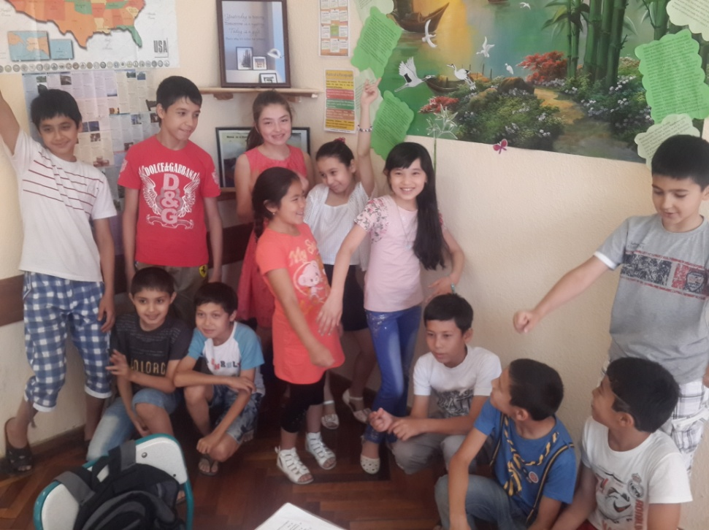

Photo 1: It can be seen from the picture that children were singing a song performed by Alexander Rybak “Fairytale”. They danced and acted some words out. Children liked this song very much and some parents of participants made the researcher aware that their children sang a song whole week at home.
№ | Title of the story | Authenticity | Audio material | Video material
1 | Three little pigs | Authentic | Available | Available on the internet
2 | The ugly duckling | Authentic | Available | Available on the internet
3 | The great fire of London | Authentic | Available | Available on the internet
4 | Jack and beanstalk | Authentic | Available | Available on the internet
5 | In the town | Authentic | Available | Available on the internet

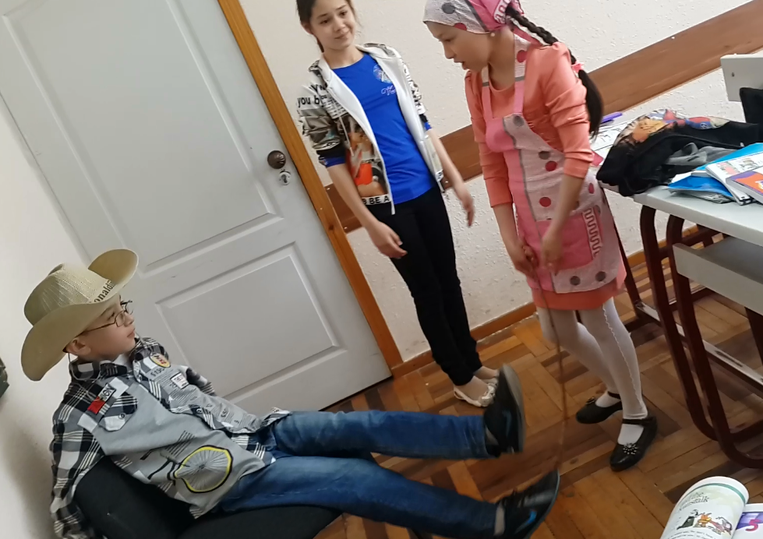
Table 3 contains only some list of stories that the researcher used during the survey. Among them “Jean and Beanstalk” was like the most by participant. Even they brought all necessary costumes and tools to act out the story. Below there is a photo evidence for role-play:

Photo 2
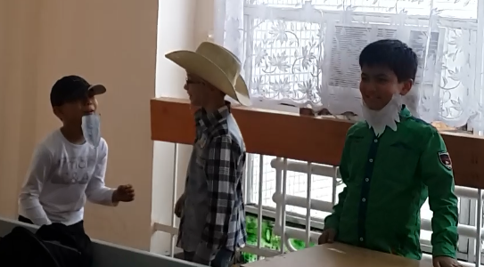

Photo 3 As can be seen from both photos learners did their best to bring authenticity to the classroom. Visual aids such as cowboy’s hat, beard, an apron and many other type clothes helped learners to understand the text better
List of energizers with procedure
№ | Title | Procedure | Designed to aid
1 | Introduction | Write information about yourself on the board, e.g. your name, occupation, where you live/work, how you get to work. Then ask the class questions, “What is my name?” etc. children answer using information on the board | Concentration  Co-ordination;  Relaxation;  Memory and listening skills;
2 | Where am I going to go? | Each child chooses a place to go and marks it in some way. One child begins, asking “Where am I going(to go)” staring at the school, the child then traces the route with a finger, saying, e.g. “I am going past the bank. Now I am going to past the bus station”. Other children guess: “Are you going to the science museum?” | Concentration;  Co-ordination;  Relaxation;  movement;  Memory and listening skills;
3 | What am I going to do on Monday? | Ask a child to come forward and ask the class “What am I going to do on Monday?” The child then draws a card out of the hat and hold it (without looking) above his/her head. The rest of the class gives clues (noises, little drawings on the board, words, and mimes). When the child has an idea of the answer s/he says “Stop” and makes a guess: “I am going to go to the circus”. | Concentration;  Co-ordination;  Relaxation;  Left to right eye movement;  Memory and listening skills;

(Bowen. M,&Ellis. P (2004) Way Ahead)
Having children involved in TPR songs, energizers and stories that were related to the lesson helped engage students in the learning process by introducing them to the context as well as to relevant vocabulary items. Students were more likely to feel interested and invested in the lesson and took better care of the materials. That means students draw different characters for a story or make puppets, masks, play-do sculptures, collaborated with the art teacher to make the visuals you need for you activities, contribute their own toys for the lesson (“Show and tell”).
The role of rewarding in young learners class has a vital of importance, therefore the researcher encouraged active students with certificates. Below, there are two excerpts:

Certificate №1
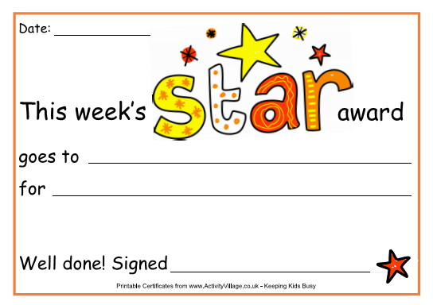

(Printable certificates from www. ActivitVillage.co.uk – Keeping kids busy)
Certificate №2
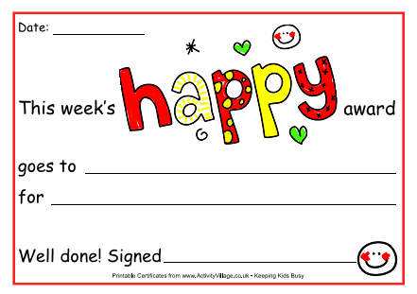

(Printable certificates from www. ActivitVillage.co.uk – Keeping kids busy)

2.3.2 The equipment

The role of environment that surrounds children is likely great; therefore classroom arrangement must be fine and apposite to the learners’ age and needs. The researcher was to use the following classroom equipment:
- Whiteboard
- Whiteboard marker
- Desks and chairs
- Recorder
- Laptop
- Speakers
Since the aim of the study was to find out the effective approaches to stimulate active participation in young learner class, other interactive tasks had to be implemented during the lessons, and the researcher would need to utilize some equipment and tools mentioned above. A laptop and speakers used to present video materials to students. For collecting and analyzing the date, she used a video recorder.

2.4 Procedure

2.4.1 Variables of the Study
Independent variable – activities and tasks, which serve to present how strategies work for the development of active participation, used in the experiment.
Dependent variable – effectiveness of the strategies for developing active participation which was affected by the independent variable.
Binary variable – observations that occur in one of two possible states, often labeled zero and one. E.g., “improved/not improved” and “completed task/failed to complete task.”
Moderator variable – factors which could influence on the appropriateness of the activities, tasks and in general, materials chosen in accordance with the subjects’ nationalities, ages and levels.
Control variable – the subjects’ prior experience in English, that is, things they had already known and taught about speaking aspect of English.
Latent variable – an underlying variable that cannot be observed. It is hypothesized to exist in order to explain other variables, such as specific behaviors, that can be observed.

2.4.2 The Specific Steps in the Experimental Process
When it comes to the procedure of the study, the foremost and significant thing that the researcher had to do was examining a set of strategies used by other scientists and selecting them to implement and evaluating their effectiveness. The following steps were taken in the experimental process:
Step 1: Teacher gave Questionnaire #1: “A Learner Needs Questionnaire” to students. The subjects were provided with this questionnaire in order to obtain general information about students’ levels, strengths, weaknesses, interests, hobbies, and future plans.
Step 2: Teacher gave Questionnaire #2 “Questionnaire for EFL teacher” to teachers who had been working with YL for at least a year. Intended audience was supplied with this questionnaire to obtain general information about teachers’ approaches, methods, and techniques in YLC.
Step 3: Teacher analyzed brought up information and carried out lesson designs which comprise four language skills throughout total physical response activities, songs, stories, crosswords, and many other interactions.
Step 4: Teacher commenced using different strategies with the subjects. The strategies would be sequenced logically, and implemented step-by-step.
Step 5: Teacher went on with her lessons following the sequenced strategies. She developed different lesson plans using various tasks and activities for each class.
Step 6: Teacher assessed students’ participation with various means of scorings like 5-star student cards, ratings, marking: 5*, +5, 5, and well-done certificates in each lesson. Each lesson teacher utilized different methods of assessing to encourage students to participate actively and spryly during the lessons.
Step 7: At the end of the study, the subjects were given Questionnaire #3: “A Learner Achievement Questionnaire” in order to identify which strategy tended to be effective for students, and served as a basis for the stimulating active participation in young learners’ class.

B. DATA COLLECTION

2.1 Analysis of Data
The research lasted nearly three months: staring from the September till December. During the interim specified above, 12 lessons were devoted to identify and set up range of approaches and techniques to bring away satisfaction to both teachers and students. After conducting an experiment and collecting certain amount of data expected from the study, the researcher analyzed all the findings according to some steps. First of all, the questionnaire was analyzed, and with the help of the general findings from this questionnaire the researcher went on conducting her study. The study went on by pre, while and post activities that let the pupils to take part in lesson actively. All the findings are going to be in the form of statistical information, charts, diagrams, graphs, etc in the next section. Moreover, the results will be demonstrated in numbers and percentages. The last questionnaire drew a conclusion of the study. In the next section of the current paper, so-called Data Collection, the process of collecting date will appear.

2.2 Data Collection
The conducted research was down to earth. In order to have crystal clear knowledge on motivating children the researchers devoted many precious hours to the library and internet reading/surfing and learning appropriate approaches to stimulate active participation in YLC. The survey was based on the researcher’s experience and teaching practice at the learning centre.
Initially the researcher commenced the survey by observation the class who she wanted to conducted the lessons with, in particular the purpose was to get acquainted with the audience, their behavior, attitude towards the lesson and teacher. The preferred and the foremost convenient place to take a seat for note taking in the class was the back of the class to escape the attention of students and teacher that might bring some disturbance and interruption to the lesson.
As it was mentioned in the prior section the second step in data collection was composed by pre and post questionnaires for students and a special questionnaire for teachers. Obtained data from learners and educators relieved to the researcher to develop further steps of the lesson plan. Moreover learners’ need, interest, and hobbies were taken into account while designing the lesson plan.
The implementation of the lesson plan was the forth step which was conducted by traditional ways: activities like turn by turn translation, retelling, jotting down new words from the blackboard were dominant and probably therefore the apathy of boredom such as yawning, doodling around were observed frequently.
Bringing new atmosphere and environment to the lesson that encourages students to have a zeal of time was the set goal of the qualification paper therefore the second lesson with young learners were absolutely not the same as the first one. The lesson started with the energizer which is called “We spy” (Process: One volunteer goes out of the room, the rest choose one object in the class. Let’s say their choice is blackboard. After that learners let that student in and all say “We spy with our little eye something that starts with a letter B”. When volunteer is close to the subject learner say “It is hot” if it vice versa then they say “It is cold”. The game goes on until the volunteer finds the name of the object). This energizer is tended to be one of interesting games to revise new words i.e. vocabulary of learners. The lesson followed by attendance/homework checking, new topic, activities on four language skills, assigning homework and was finished with memory game on vocabulary.
Lesson by lesson learners engagement grew higher and everybody in the class were active. However, it was not enough to prove the effectiveness of practical methods hence the researcher created two quizzes on assortment of stories. The former story was conducted on traditional ways mentioned above were utilized and no alternative ways were preferred. Consequently, learners’ results were quiet law. The latter story was presented differently first students read and underlines the main heroes of the story and draw pictures of each. Afterwards at the bottom of the paper learners wrote words of each hero and shared that data with each other. The next step was to present the information in form role plays, learners hung the picture of the character that they act out on their neck. As soon as the role play was over the researcher distributed tests and got expected high scores from the practicum.
All in all, in my humble opinion possibility to get high results are not something imagery but it is something that everyone can attain, as it does not depend on what kind of activities the educator used but how well each of us, teachers, deliver and apply either old or new method in realia.

CHAPTER III – RESULTS AND DISCUSSION
The researcher spent 3 months in order to collect adequate data to find the answers to the questions of the current research. As it has been stated in the previous section, the researcher organized pre and post questionnaires for students and tests to gather data. Results taken from those tools are going to be discussed in the current section of the paper and will appear in different means of diagrams, tables or charts below.

3.1 Results of A Learner Needs Questionnaire
The first thing that the researcher considered to do was to obtain crucial information to develop her further lesson plans via “A Learner Needs Questionnaire” and commenced the survey exactly with that questionnaire. The questionnaire was given and filled before starting a teaching process. It was comprised by 8 questions about the preferences, interests, future plans and hobbies of learner. First four diagrams below demonstrate information their future plans, preferred language skills and the answer to the question whether they are forced to learn language or not.

Figure №1 The researcher has included a question in order check whether children are forced to learn English or not because some of the people were of the opinion that children were pushed to do something. The result presented in the first pie- chart shows the absolutely contrasting answer. 100 % of learners answered that they were not pushed by dads and mums to learn English, and even some children attempted to answer fully:
“..Bir kuni manga oyijonim ingliz tilini o`rgangani boramiz, ruchka kitoblarini tayyorlab qo`y dedilar. Man hursan bo`ldim chunki mani qo`shnim ingliz tili zo`r biladi. Darsda Miss Munis bilan biz har xil o`yinla o`ynimiza, ashulala etamiz, mashqla qilamiz, manga yoqadi Bravo!”
Translation: “One day my mum asked me to prepare my books, note-books and pens as I was going to the English language course. I was really glad because my friend in the neighborhood knows English well. We play various games, sing songs, do exercises and I like “Bravo”!”
That means the initiative was demonstrated by their parents and the set of approaches applied by teacher during the classes hold them to be present at the all class.

Figure №2 As can be seen from the graph, spending the most years for language learning among children equaled to 3 years yet the percentage of learners made up the least number of children whilst the least years account for less than a year. However, the majority of subjects in the group had been learning English for a year.
It is widely believed that children are extrinsically motivated hence the process of learning which consists of only grammar rules and exercises may bring their interest down. Though, children, like every individual have their goals, aims, and future plans. The researcher asked learners to share about their future plans and diagram presented below illustrates their answers.

Figure №3 The researcher chose the most 4 frequent answers by learners. The biggest slice of the pie chart that is to say nearly as much as 50 percent of children were going to be doctors in the future. As for the imagery professions like Superman and Spiderman, were the least popular one, both share the equal amount of slice, 14 percent for each. And only a quarter of learner had a wish to become doctors in the future. Below, the researcher provides some excerpt from the answer sheet:
“Man kelajeda chelovek pauk bo`moqchiman. Shuning uchun ingliz tilini bilishim kere” – Abduazim, 9
Translation: “In the future I am going to be a Spiderman hence I am learning English”
“Man Miss Munisga o`xshab ingliz tili o`qituvchisi bo`laman. Chunki ulani hammamiz yaxshi ko`ramiz” – Risolat, 9
Translation: “In the future I am going to be a teacher like Miss Munis because we all like her.”
“Kelajeda man Amerikada o`qib kelib Oyimlaga o`xshagan doktor bo’laman. Lekin uladan zo`r doktor bo`laman chunki ula ingliz tilini bilmila” – Muhammadamin, 10
Translation: “In the future I am going to study in America. I want to be a doctor like my mother, but I will be a better doctor than her because I know English but she does not know. „
In a fact children’s future plans will alter as years go by till they understand what they want in realia, but happily they have real or imagery plans despite their age.

Figure №4 illustrates information about the skills that children like the most. One of the foremost and significant things to note was that speaking was the most popular language skill among children; under 25 percent children were willing to improve their speaking skills during the language classes. Another thing that stands out in the chart is that two input skills like Listening and Reading made up the second rank in list of favorite skills. On striking contrast writing was rated as the least preferred skill to train by children.
All in all “A Learner Needs Questionnaire” was the most important tool that assisted the researcher to focus on the main aspects while designing the lessons.
In accordance with the learners’ characteristics in terms of their age, needs, interests, the researcher developed lesson plans and implemented them in young learners’ classroom. In order to spot the difference between traditional and non-traditional methods of teaching, she led first two weeks of her lessons based on traditional approaches and the second two weeks were led by modern approaches.

3.2 Results of Pre Mid-Term Test
The researcher chose two different stories: “The Ugly Duckling” and “Jack and Beanstalk” both of them have the same level of English language. Initially she led the lesson traditionally as the most teachers do at school: learner translated the excerpts of the story turn by turn, and then they had a week to learn and retell the story. In a week teacher distributed pop-quiz and checked how well children understood the topic. The researcher did not have great expectations because learners did not feel the story itself and was not able to digest the context fully.
Below, table №1 demonstrates the initial results gained by young learners:

№ | Name | Dictation  25p | WH-questions  25p | Multiple-choice questions  25p | Retelling  25p | Total  Score  100p
1 | Munojat | 15 | 13 | 10 | 16 | 54
2 | Muhsinaxon | 16 | 14 | 15 | 17 | 62
3 | Muzaffar | 16 | 12 | 15 | 14 | 57
4 | Abduazim | 17 | 16 | 10 | 15 | 58
5 | Risolat | 18 | 15 | 10 | 17 | 60
6 | Robiya | 16 | 15 | 10 | 15 | 56
7 | Muhammadamin | 17 | 18 | 15 | 14 | 64
8 | Ulug’bek | 14 | 15 | 10 | 15 | 54
9 | Zumrad | 14 | 15 | 10 | 15 | 54
10 | Saidanvar | 19 | 18 | 15 | 17 | 69
11 | Isomuhammad | 19 | 17 | 15 | 17 | 68
12 | Abdulaziz | 11 | 10 | 5 | 13 | 39
13 | Hamidullo | 14 | 15 | 5 | 14 | 48
14 | Ra’no | 18 | 17 | 15 | 18 | 68
15 | Shohjahon | 19 | 19 | 15 | 17 | 70
16 | Kamola | 18 | 18 | 15 | 18 | 69
17 | Munavvar | 16 | 17 | 15 | 17 | 65
18 | Muhlisa | 15 | 14 | 10 | 18 | 57
19 | Muhammad | 9 | 8 | 5 | 12 | 34
20 | Asliddin | 10 | 11 | 10 | 14 | 45
21 | Surayyo | 17 | 18 | 15 | 16 | 66
22 | Shohsanam | 13 | 14 | 10 | 14 | 51
23 | Zilola | 18 | 17 | 15 | 17 | 67
24 | Maftuna | 14 | 13 | 10 | 14 | 51
25 | Bohodir | 18 | 19 | 15 | 16 | 68
26 | Madina | 18 | 17 | 10 | 16 | 61
Average: |  | 15.65 | 15.9 | 11.73 | 15.57 | 58.28

Table № 1 Pre-Test Scores: The pre-test comprised of 4 sections: dictation, WH-questions, multiple choice questions and retelling. Among the sections, WH questions were rather easier than the rest and the percentage for it was nearly 16 out of 25. As concerns multiple-choice questions, it was a bit difficult for participants and the average percent for it was 11.7. The highest score was 70 and it was obtained by one student only. The lowest score for Pre-Test was 34. The student who got the lowest score missed several lessons due to illness and it was difficult for him to catch up all covered topics.
№ | Frequency distribution | Score
1  2  3  4  5  6  7  8  9  10  11  12  13  14  15  16  17  18  19 | 1  1  1  1  2  3  1  2  1  1  1  1  1  1  1  1  3  1  1 | 34  39  45  48  51  54  56  57  58  60  61  62  64  65  66  67  68  69  70

Table №2 Pre-Test Frequency Distribution In a set of scores, the range is the number of points between the highest and lowest scores in set, plus 1. To find the range, subtract the lowest score from the highest score and add 1. For the set of scores in Table 2, the range is 37 (70-34+1=37)

Figure № 5 Frequency distribution diagram allowed the researcher to summarize data and see how many subjects behaved or performed in the same way. As we know the normal distribution should appear in the form of a smoothly-running bell-curve. However, from the graph we can see that the distribution of scores was somewhat negatively skewed. The reason why the distribution was negatively skewed could be clarified through central tendency, dispersion and percentage. In fact central tendency showed the most clustered scores and it was measured by three means which were: a mean, a mode and a median. Dispersion mostly focused on individual’s behavior and performance in the group via range and standard deviation. The range for the group was 37 and the standard deviation was 10. There were 2 peaks ((54:4)) and ((67:3)) which clearly showed that there were some sort of problems and therefore the diagram was bio modal. The mode for the graph was 54 as the total score of 4 learners collected this number. The median for the graph was 6 (56%) as 6 students who scored higher that of those 8 and 14 students scored lower. The mean for the pre-test results was 58. The central tendency and dispersion of the frequency distribution of the group were evaluated in the following ways:
Central tendency: a mean – 58, a mode – 54, and a median – 56.
Dispersion: Range: 37 (Table 2.)
The highest score - the lowest score + 1 = range: 70-34+1=37
Standard Deviation: 10, and it was calculated in the following way:
$$SD=\sqrt{\frac{Σ(X-{\overline{X)}}^{2}}{N}}$$
To calculate the standard deviation, the researcher began inside the formula and worked outward. First, she subtracted the mean from each score in the set. Then, squared each of these values and added them up. She divided the total by the number of scores, and the squares root of that total was the standard deviation.
№ | Name | Score | Mean | Difference | Difference Squared
1 | Munojat | 54 | --58 | -4 | 16
2 | Muhsinaxon | 62 | --58 | 4 | 16
3 | Muzaffar | 57 | --58 | -1 | 1
4 | Abduazim | 58 | --58 | 0 | 0
5 | Risolat | 60 | --58 | 2 | 4
6 | Robiya | 56 | --58 | -2 | 4
7 | Muhammadamin | 64 | --58 | 6 | 36
8 | Ulug’bek | 54 | --58 | -4 | 16
9 | Zumrad | 54 | --58 | -4 | 16
10 | Saidanvar | 69 | --58 | 11 | 121
11 | Isomuhammad | 68 | --58 | 10 | 100
12 | Abdulaziz | 39 | --58 | -19 | 361
13 | Hamidullo | 48 | --58 | -20 | 400
14 | Ra’no | 68 | --58 | 10 | 100
15 | Shohjahon | 70 | --58 | 12 | 144
16 | Kamola | 69 | --58 | 11 | 121
17 | Munavvar | 65 | --58 | 7 | 49
18 | Muhlisa | 57 | --58 | -1 | 1
19 | Muhammad | 34 | --58 | -24 | 576
20 | Asliddin | 45 | --58 | -13 | 169
21 | Surayyo | 66 | --58 | 8 | 64
22 | Shohsanam | 51 | --58 | -7 | 49
23 | Zilola | 67 | --58 | 9 | 81
24 | Maftuna | 51 | --58 | -7 | 49
25 | Bohodir | 68 | --58 | 10 | 100
26 | Madina | 61 | --58 | 3 | 9

Table № 3 Standard Deviation for Pre-Test Scores
The standard deviation was the average of the differences of all of the scores from the mean. In our case SD is 10.
$$SD=\sqrt{\frac{Σ(X-{\overline{X)}}^{2}}{N}}=\sqrt{\frac{2603}{26}}=\sqrt{100.12}≈10$$

3.3 Conducting Lessons and Experimenting Strategies
After analyzing the pre test results the researcher subsequently commenced teaching lessons through wide range of activities and tasks in order to compare how well various strategies stimulate active participation in the class and give a helping hand to learners to perform better in test. The lessons were designed by the researcher earlier, after conducting “A learner Needs Questionnaire”. Information about the strategies and approaches which the researcher utilized was provided in Research Plan of the current paper.
Besides that, the researcher observed each subjects because children needed individual approach and paid attention to subject’s level, progress and difficulties in the classroom participation and their performance during the lessons. The lessons were organized and conducted in accordance with student’ levels, strengths, weaknesses and needs.

3.4 Results of Post Test

№ | Name | Role Play 25p | Multiple choice questions  25p | WH- questions  25p | Dictation  25p | Total  Score  100p
1 | Munojat | 22 | 20 | 22 | 23 | 87
2 | Muhsinaxon | 22 | 20 | 22 | 23 | 87
3 | Muzaffar | 22 | 20 | 22 | 22 | 86
4 | Abduazim | 24 | 25 | 23 | 22 | 94
5 | Risolat | 24 | 25 | 24 | 22 | 95
6 | Robiya | 22 | 20 | 22 | 23 | 87
7 | Muhammadamin | 22 | 20 | 22 | 22 | 86
8 | Ulug’bek | 23 | 20 | 21 | 21 | 85
9 | Zumrad | 23 | 20 | 21 | 21 | 85
10 | Saidanvar | 23 | 25 | 23 | 23 | 91
11 | Isomuhammad | 22 | 25 | 24 | 23 | 91
12 | Abdulaziz | 21 | 20 | 19 | 20 | 80
13 | Hamidullo | 23 | 20 | 21 | 21 | 85
14 | Ra’no | 24 | 25 | 24 | 23 | 96
15 | Shohjahon | 23 | 25 | 24 | 23 | 95
16 | Kamola | 24 | 25 | 23 | 22 | 94
17 | Munavvar | 24 | 20 | 22 | 23 | 89
18 | Muhlisa | 23 | 20 | 21 | 22 | 86
19 | Muhammad | 21 | 20 | 19 | 20 | 80
20 | Asliddin | 23 | 20 | 21 | 21 | 85
21 | Surayyo | 23 | 25 | 23 | 22 | 93
22 | Shohsanam | 22 | 15 | 22 | 21 | 80
23 | Zilola | 24 | 25 | 24 | 23 | 96
24 | Maftuna | 22 | 20 | 22 | 22 | 86
25 | Bohodir | 23 | 20 | 23 | 22 | 88
26 | Madina | 23 | 20 | 23 | 23 | 89
Average: |  | 22.8 | 21.3 | 22.2 | 22.1 | 88.3

Table № 4 Post Test Scores: The pos-test consisted of 4 sections too: dictation, WH-questions, multiple choice questions and retelling. There was a great difference between pre-test and pos-test results. Among the sections, the highest score was achieved in role-play section. The participants organized their performance outstanding and pictures provided in the prior section confirmed their excellent presentation and the percentage for it stood at 22.8. In multiple-choice section participants gained the lowest score and it was 21.3. In the post-test the highest score was 96 and the lowest was 80.
№ | Frequency distribution | Scores
1 | 3 | 80
2 | 4 | 85
3 | 4 | 86
4 | 3 | 87
5 | 1 | 88
6 | 2 | 89
7 | 2 | 91
8 | 1 | 93
9 | 2 | 94
10 | 2 | 95
11 | 2 | 96

Table №5 Post Test Frequency Distribution: There was a substantial diversity between frequency distributions of pre and post tests as well. As can be seen from table5, there was a positive progress in students’ performance on test. Frequency distribution of post test was 4 with 85 and 86 score got by the majority of subjects and 2 with 94,95 and 96 that was the highest point in comparison with the pre-test 1 with 69 and 1 with 70.

Figure №6 It is apparent from the graph that the diagram was bio modal as there were two striking peaks as it was in the pre test but with very substantial positive difference in the scores, which means that the results and performance of the group improved sufficiently, positively and greatly. The results obtained from the test illustrate the effectiveness of the strategies that the researcher used during the lesson.
The distribution for the post test is somewhat positively skewed as the number of learner who got low scores than the mean is 14 and the figure for those who got higher stands at 12. The mean for the data in Table 4 is 88.3; the standard deviation was under 5. The mode for the graph was 85.5 as the total score of 8 learners collected this number. The median for the graph is 89%. The central tendency and dispersion of the frequency distribution of the group were evaluated in the following ways:
The central tendency and dispersion of the frequency distribution of the 1st group were calculated in the following ways:
Central tendency: a mean –88, a mode – 85.5, and a median –89.
Dispersion: Range: 17 (Table 8.)
The highest score - the lowest score + 1 = range: 96-80+1=17
Standard Deviation: 8 and it is calculated in the following way:

$$SD=\sqrt{\frac{Σ(X-{\overline{X)}}^{2}}{N}}$$
To calculate the standard deviation, the researcher began inside the formula and worked outward. First, she subtracted the mean from each score in the set. Then, squared each of these values and added them up. She divided the total by the number of scores, and the squares root of that total was the standard deviation.
№ | Name | Score | Mean | Difference | Difference Squared
1 | Munojat | 87 | --88 | -1 | 1
2 | Muhsinaxon | 87 | --88 | -1 | 1
3 | Muzaffar | 86 | --88 | -2 | 4
4 | Abduazim | 94 | --88 | 6 | 36
5 | Risolat | 95 | --88 | 7 | 49
6 | Robiya | 87 | --88 | -1 | 1
7 | Muhammadamin | 86 | --88 | -2 | 4
8 | Ulug’bek | 85 | --88 | -3 | 9
9 | Zumrad | 85 | --88 | -1 | 1
10 | Saidanvar | 91 | --88 | 3 | 9
11 | Isomuhammad | 91 | --88 | 3 | 9
12 | Abdulaziz | 80 | --88 | -8 | 64
13 | Hamidullo | 85 | --88 | -3 | 9
14 | Ra’no | 96 | --88 | 8 | 64
15 | Shohjahon | 95 | --88 | 7 | 49
16 | Kamola | 94 | --88 | 6 | 36
17 | Munavvar | 89 | --88 | 1 | 1
18 | Muhlisa | 86 | --88 | -2 | 4
19 | Muhammad | 80 | --88 | -8 | 64
20 | Asliddin | 85 | --88 | -3 | 9
21 | Surayyo | 93 | --88 | 5 | 25
22 | Shohsanam | 80 | --88 | -8 | 64
23 | Zilola | 96 | --88 | 8 | 64
24 | Maftuna | 86 | --88 | -2 | 4
25 | Bohodir | 88 | --88 | 0 | 0
26 | Madina | 89 | --88 | 1 | 1

Table № 6 Standard Deviation for Post-Test Scores
The standard deviation is the average of the differences of all of the scores from the mean. In our case SD is 5.
$$SD=\sqrt{\frac{Σ(X-{\overline{X)}}^{2}}{N}}=\sqrt{\frac{582}{26}}=\sqrt{22.3}≈5$$

3.5 Results of Student Experience Feedback Form
Finally, the researcher provided subjects with the post questionnaire in order to get feedback and learner’s attitudes towards the lessons. In addition the questionnaire provided essential information about the effective methods and approaches which were selected by youngsters and this form helped the researcher to find out which strategies were effective and useful for young learners. Almost 100% of subjects filled the feedback form. The researcher received the following data and results described in the figures 9, 10 and 11 below.
The researcher utilized several approaches to encourage children’s participation in the classroom and asked learners to decide the one they think crucial for their better performance.

Figure №7 Nearly as much as 58% of young learners liked certificates which were provided by the researcher for those who were active and dynamic in the class. The certificate was awarded only once in a month among all children who come to learn English (estimated number of “Bravo English” learner is up to 160-170) and the learners were awarded as “The Best Learner of the Month”. Such method of praising stirs up belief in learners to study harder and perform better in the class. The researcher observed the effectiveness of Certificates when she held out it to the passive student – Ulug’bek. After receiving his award, his attitude towards the lesson, teacher and his group mates altered positively. It was visible from his manner of behavior and the performance in the class.
In order to bring some changes to the class the researcher utilized another approach: she brought sweets and candies. Learners were given $1 for each correct answer and at the end of the lesson learners bought some sweets for the money they “earned” for participation. According to the results, this approach was not appreciated by large number of audience, as much as 8% learner liked this method. The same figure stands for Gifts. The researcher made the table of student with their scores lesson by lesson (See App), it was kind of rating and the first three top students used were given stationary or writing materials for those. The old approach that is scoring learners’ participation in the form of 5/+5/5* were still popular among kids.

Figure №8 Range of activities liked by learners In the “A Learners Needs Questionnaire” young children selected “Speaking skills” as the favorite among other language skills. Therefore the researcher included many nursery songs to the lesson plan. From the bar chart it becomes obvious that Songs were the most wanted activity for kids. Other type of activities such as Role-Plays, Crosswords, Puzzles and Stories were pre dominant favorite activities in the list. As for Proverbs and Tongue-twisters, they were least preferred activities. The last thing which was really interesting for the researcher was to find out which English: English at School or Bravo English is liked the most by learners. The diagram below provides the answer to the question:

Figure №9 Actually the post questionnaire was filled anonymously in order to get crystal clear feedback from learners. Therefore, the result illustrated in Figure №9 was the pure answer of learner. For the last question learners were provided 4 options: they could either select both or none of them. The majority number of learners in particular as much as 94 % chose Bravo English and for 6% English, taught both at school and language centre is interesting.
The researcher puts her trust on to see the positive change in selection of language course, the answers to the last question, in 2 or 3 year since lots of efforts and attempts directed to this sphere of education system.

3.6 Conclusion

The survey conducted by the researcher gave her a crystal clear about the difference of traditional and non-traditional classroom activities that helped her to stimulate active participation in young learners’ class.The lessons conducted with the various set of activities were efficient and learners were able to reach some proficiency in foreign language learning. Moreover, the current statistical study revealed that strategies which children liked and selected as the most effective ones were efficacious, advantageous and profitable to improve active participation in YLC. Furthermore the participant of the survey become more sociable and open with the researcher and till the end of the survey and even they suggested several energizer and activities which might be effective to stimulate them to take part in the class and confessed that they would like to have English lessons everyday instead of other subjects at the school.

3.7 Final Reflections

The research that lasted three month concentrated on discovering and implementing new and meanwhile old but seldom utilized methods and techniques to encourage not just learners, but young learner who needs individual approach, to participate actively in the classroom activities and perform better on test. Moreover, the survey dealt with answering 4 research questions that is very actual these days in Uzbekistan. Precisely the actuality of the topic and teaching young learner attracted the researcher very much.
At the very beginning of the survey, the researcher did not see any problem in teaching young learners because she was utilizing diverse set of approaches and techniques in her teaching career owing to the fact that she was studying at the university where PRESETT program had been implement widely. However, while analyzing learners’ environment deeper she came across some problem concerning 2 aspects like: motivation and participation and therefore she set her heart on learning more strategies and methods that stimulates active participation.
As soon as she determined the topic the sudden outburst of a wish to find and read more information correlated to the topic appeared in her mind. She surfed the internet day and night in fact internet provides infinite number of sources to read, besides that she visited one of the largest libraries in Tashkent named after “Alisher Navoiy” unfortunately a visit went to no purposes. Available material on the web triggered the researcher to plan the steps of qualification paper and the first and the most significant thing that the researcher concluded is that nothing can be made without good research plan. After planning each step of the survey she had a big picture about my survey but still it needed some fixations.
In order to correct the mistakes and have crystal clear plan, Literature Review part gave the researcher very good ideas, she has learnt even more than she expected. This section of the current paper was the most difficult part for the researcher; because she mixed all gather information and subsequently was lost. It was due to the planning was very weak. After spending long period of time on re-writing Literature Review, the researcher was able to move further section that was Research Plan. She made some changes to the outline of the research plan because this time she took into account all scholars and scientists ideas and tips.
When the survey was going on the researcher expected learner to like the activities and energizers which she comprised to the lesson plan, yet the learners did not react and the first two lessons were followed by passive participation this is due children were adopted to sit silently and no one even attempted to encourage them at schools. However, the atmosphere in the class commenced changing lesson by lesson and at the end they became very active. Young learner started singing songs loudly, acting out the role plays confidently and in some point professionally, participating actively in the classroom and all of these occurred due to the different approaches and methods suggested by scholars and scientists.
Overall, the researcher did her best, if she had an opportunity of changing or adding some extra elements which requires quite long period of time and lots of survey, she would conduct wider research than she did. She would not only work with those young learners who come to private language centre, but with those who study at schools as well.
Having learnt from research the researcher firmly recommends teachers working in this sphere to use more diverse set of activities and to treat every child with an individual approach.
The survey conducted by the researcher was the smallest part of the entire teaching system that goes without saying that there are many other issues, problems to investigate and study which are more crucial and need to be solved immediately. Being a good teacher or instructor or let’s say lecturer is not as hair raising profession, all of this requires from the one professional touch, goo knowledge, experience, lots of investigations, effort and researches.
In the future, the researcher is going to carry on teaching English as a Foreign Language to young learners and conduct more professional researches and hopefully she will get more satisfactory results and achieve success.

III – LIST OF USED LITERATURE

3.1 REFERENCE LIST

Alberto, P.A. & Troutman, A.C. (2003). Applied behavior analysis for teachers.(6th ed.) Upper Saddle River, NJ: Merrill Prentice Hall.
Governmental portal of the Republic of Uzbekistan, accessed 14/12/2012
Observation of lesson in school 142 Tashkent Chilanzar, 15.12.07
Узлуксиз таълим тизимининг чет тиллари буйича давлат таълим стандарти.
http://www.global-english.com/tipsfromthetop.htm
Thomas A. Angelo and K. Patricia Cross “Classroom Assessment Techniques” San Francisco, 2005.
Young Learners Supplementary Activities Workshop ian.oakes@englishfirst.com.cn
Berndt, T.J. & Miller, K.E. (1990). Expectancies, values, and achievement in junior high school. Journal of Educational Psychology, 82(2), 319-326.
Chan, L.K.S. (1988). The perceived competence of intellectually talented students. Gifted Child Quarterly, 32(3), 310-314.
Coleman, J.M. & Fults, B.A. (1982). Self-conceptand the gifted classroom: The role of social comparison. Gifted Child Quarterly, 26(3), 116-120.
Covington, M.V. & Müeller, K.J. (2001). Intrinsic versus extrinsic motivation: An approach/avoidance reformulation. Educational Psychology Review, 13(2), 157-176.
Craven, R.G. & Marsh, H.W. (1997). Threats togifted and talented students’ self-concepts in the big pond: Research results and educational implications. The Australasian Journal of Gifted Education, 6(2), 7-17.
Deci, E.L., Eghrari, H., Patrick, B.C. & Leone, D.R. (1994). Facilitating internalization: The self-determination theory perspective. Journal of Personality, 62, 119-142.
Deci, E.L., Koestner, R. & Ryan, R.M. (1999). A meta-analytic review of experiments examining the effects of extrinsic rewards on intrinsic motivation. Psychological Bulletin, 125(6), 627-668.
Porter, L. (2009). Motivating children. www.louiseporter.com.au 7
Deci, E.L., Koestner, R. & Ryan, R.M. (2001). Extrinsic rewards and intrinsic motivation in education: Reconsidered once again. Review of Educational Research, 71(1), 1-27.
Deci, E.L., Vallerand, R.J., Pelletier, L.G. & Ryan, R.M. (1991). Motivation and education: The self-determination perspective. Educational Psychologist, 26(3 & 4), 325-346.
DiCintio, M.J. & Gee, S. (1999). Control is the key: Unlocking the motivation of at-risk students. Psychology in the Schools, 36(3), 231-237.
Dweck, C.S. & Leggett, E.L. (1988). A social-cognitive approach to motivation and personality. Psychological Review, 95(2), 256-273.
Esposito, C. (1999). Learning in urban blight: School climate and its effect on the school performance of urban, minority, low-income children. School Psychology Review, 28(3), 365-377.
Feldhusen, J.F., Dai, D.Y. & Clinkenbeard, P.R. (2000). Dimensionsof competitive and cooperative learning among gifted learners. Journal for the Education of the Gifted, 23, (3), 328-342.
Glasser, W. (1998). The quality school: Managing students without coercion.(rev. ed.) New York: Harper Perennial.
Gordon, T. (1974). Teacher effectiveness training. New York: Peter H. Wyden.
Grolnick, W.S. (2003). The psychology of parental control: How well-meant parenting backfires.Mahwah, NJ: Lawrence Erlbaum.
Gross, M.U.M. (1997). How ability grouping turns big fish into little fish - or does it?: Of optical illusions and optimal environments. The Australasian Journal of Gifted Education, 6(2), 18-30.
Hoge, R.D. & Renzulli, J.S. (1993). Exploring the link between giftedness and self-concept. Review of Educational Research, 63(4), 449-465.
Jones, V.F. & Jones, L.S. (2004). Comprehensive classroom management: Creating communities of support and solving problems. (7th ed.) Boston, MA: Pearson Allyn and Bacon.
Kamins, M.L. & Dweck, C.S. (1999). Person versus process praiseand criticism: Implications for contingent self-worth and coping. Developmental Psychology, 35(3), 835-847.
Kaplan, A., Gheen, M. & Midgley, C. (2002). Classroom goal structure and student disruptive behaviour. British Journal of Educational Psychology, 72(2), 191-211.
Kohn, A. (1996). Beyond discipline: From compliance to community.Alexandria, VA: Association for Supervision and Curriculum Development.
LoCicero, K.A. & Ashby, J.S. (2000). Multidimensional perfectionism in middle school age gifted students: A comparison to peers from the general cohort. Roeper Review, 22(3), 182-185.
McEvoy, A. & Welker, R. (2000). Antisocial behavior, academic failure, and school climate: A critical review. Journal of Emotional and Behavioral Disroders, 8(3), 130-140.
Marchant, G.J., Paulson, S.E. & Rothlisberg, B.A. (2001). Relations of middle school students’ perceptions of family and school contexts with academic achievement. Psychology in the Schools, 38(6), 505-519.
Marsh, H.W. & Craven, R.G. (1998). The big fish little pond effect, optimal illusions, and misinterpretations: A response to Gross (1997). The Australasian Journal of Gifted Education, 7(1), 6-15.
Marsh, H.W., Chessor, D., Craven, R. & Roche,L. (1995). The effects of gifted and talented programs on academic self-concept: The big fish strikes again. American Educational Research Journal, 32(2), 285-319.
Milgram, N. & Toubiana, Y. (1999). Academic anxiety, academic procrastination, and parents involvement in students and their parents. British Journal of Educational Psychology, 69(3), 345-361.
Möller, J. (2005). Paradoxical effects of praiseand criticism: Social, dimensional and temporal comparisons. British Journal of Educational Psychology, 75(2), 275-295.
Porter, L. (2009). Motivating children. www.louiseporter.com.au 8
Moon, S.M., Swift, M. & Shallenberger, A. (2002). Perceptions of a self-contained class for fourth- and fifth-grade students with high to extreme levels of intellectual giftedness. Gifted Child Quarterly, 46(1), 64-79.
Mueller, C.M. & Dweck, C.S. (1998). Praise for intelligence can undermine children’s motivation and performance. Journal of Personality and Social Psychology, 75(1), 33-52.
Neumeister, K.L.S. (2004a). Understanding the relation between perfectionism and achievement motivation in gifted college students. Gifted Child Quarterly, 48(3), 219-231.
Neumeister, K.L.S. (2004b). Factors influencing the development of perfectionism in gifted college students. Gifted Child Quarterly, 48(4), 259-274.
Neumeister, K.L.S. & Finch, H. (2006). Perfectionism in high-ability students: Relational precursors and influences on achievement motivation. Gifted Child Quarterly, 50(3), 218-251.
Olszewski, P., Kulieke, M.J. & Willis, G. (1987).Changes in the self-perceptions of gifted students who participate in rigorous academic programs. Journal for the Education of the Gifted, 10(4). 287-303.
Parker, W. (1996). Psychological adjustmentin mathematically gifted students. Gifted Child Quarterly, 40(3), 154-161.
Parker, W. & Adkins, K.K. (1995). Perfectionism and the gifted. Roeper Review, 17(3), 173-176.
Rice, K.G., Ashby, J.S. & Preusser, K.J. (1996). Perfectionism, relationships with parents, and self-esteem. Individual Psychology, 52(3), 246-260.
Rogers, C.R. & Freiberg, H. (1994). Freedom to learn. (3rd ed.) New York: Merrill.
Rutter, M. (1983). School effects on pupil progress: Research findings and policy implications. Child Development, 54(1), 1-29.
Rutter, M. & Maughan, B. (2002). School effectiveness findings 1979-2002. Journal of School Psychology, 40(6), 451-475.
Ryan, R.M. & Deci, E.L. (1996). When paradigms clash: Comments on Cameron and Pierce’s claim that rewards do not undermine intrinsic motivation. Review of Educational Research, 66(1), 33-38.
Ryan, R.M. & Deci, E.L. (2000). Self-determination theory and the facilitation of intrinsic motivation, social development, and well-being. American Psychologist, 55(1), 68-78.
Schneider, B.H., Clegg, M.R., Byrne, B.M., Ledingham, J.E. & Crombie, G. (1989). Social relations of gifted children as a function of age and school program. Journal of Educational Psychology, 81(1), 48-56.
Siegle, D. & Schuler, P.A. (2000). Perfectionismdifferences in gifted middle school students. Roeper Review, 23(1) 39-44.
Silverman, W.K., La Greca, A.M. & Wasserstein, S. (1995). What do children worry about: Worries and their relation to anxiety. Child Development, 66(3), 671-686.
Sylva, K. (1994). School influences on children’s development. Journal of Child Psychology and Psychiatry and Related Disciplines, 35(1), 135-170.
Tollefson, N. (2000). Classroom applications of cognitive theories of motivation. Educational Psychology Review, 12(1), 63-83.
Vallerand, R.J., Gagné, F., Senécal, C. & Pelletier, L.G. (1994). A comparison of the school intrinsic motivation and perceived competence of gifted and regular students. Gifted Child Quarterly, 38(4), 172-175.
Wentzel, K.R. (1997). Student motivation in middle school: The role of perceived pedagogical caring. Journal of Educational Psychology, 89(3), 411-419.
Wood, K.J. & Care, E. (2002). The relationship between perfectionism and intelligence in a group of adolescents. The Australasian Journal of Gifted Education, 11(1) 22-29.
Wright, P.B. & Leroux, J.A. (1997). The self-concept of gifted adolescents in a congregated program. Gifted Child Quarterly, 41(3), 83-94.

3.2 BIBLIOGRAPHY

Bright Minds, Poor Grades: Understanding and Motivating Your Underachieving Child by Michael D. Whitley, Ph.D.
www.penguinputnam.com
Dreamers, Discoverers and Dynamos : How to Help the Child Who Is Bright, Bored and Having Problems in School by Lucy Jo Palladino, Ph.D.
www.randomhouse.com
Helping Students Develop Self-Motivation: ASource book for Parents and Educators by Donald R. Grossnickle National Association of Secondary School Principals
Homework Without Tears: A Parent’s Guidefor Motivating Children to do Homework andto Succeed in School.by Lee Canter and Lee Hausner, Ph.D.Harper Collins
www.harpercollins.com/hc
“Increasing Student Engagement andMotivation: From Time-on-Task Homework” by Cori Brewster and Jennifer Fager Northwest Regional Educational Laboratory
www.nwrel.org/request/oct00/textonly.html
“Motivating Kids to Read” Reading is Fundamental
www.rif.org/parents/motivate/default.mspx.
Motivated Minds: Raising Children to Love Learning by Deborah Stipek Ph.D. and Kathy Seal
www.henryholt.com
“Motivating Students” by Barbara Gross Davis University of Hawaii Honolulu Community College
http://honolulu.hawaii.edu/intranet/committees/FacDevCom/guidebk/teachtip/motiv.htm
“Motivating students to improve achievement” by Dr. Michael Whitley CNN.Com
http://archives.cnn.com/2001/COMMUNITY/08/29/whitley
“Questions and Answers about Resilience” by Sam Goldstein, Ph.D.
www.samgoldstein.com/articles/articles29.pdf
Raising Lifelong Learners: A Parents’ Guide by Lucy McCormick Calkins and Lydia Bellino
www.perseusbooksgroup.com
Seven Times Smarter : 50 Activities, Games, and Projects to Develop the Seven Intelligences of Your Child by Laurel Schmidt Three Rivers Press
www.randomhouse.com
Solve Your Child’s School-Related Problems by Michael Martin & Cynthia Waltman Greenwood HarperCollins Publishers, Inc.
www.harpercollins.com/hc
“The Parent’s Toolshop: The Universal Blueprint for Building a Healthy Family” Jodi Johnston Pawel Ambris Publishing
www.parentstoolshop.com
“Top Ten Ways to Motivate Students” by John Bishop National PTA
www.pta.org/parentinvolvement/helpchild/10motivate.asp

APPENDICIES

Appendix 1 Needs Analysis Questionnaire
Appendix 2 Post Questionnaire for Participants of Research
Appendix 3Questionnaire for EFL teachers
Appendix 4 Lesson Plans (1/2)
Appendix 5 Certificates
Appendix 6 Nursery Rhymes and Songs for Kids
Appendix 7 Sample of Test made by the Researcher
Appendix 8 Samples of Filled Questionnaire by learners

- NEEDS ANALYSIS QUESTIONNAIRE
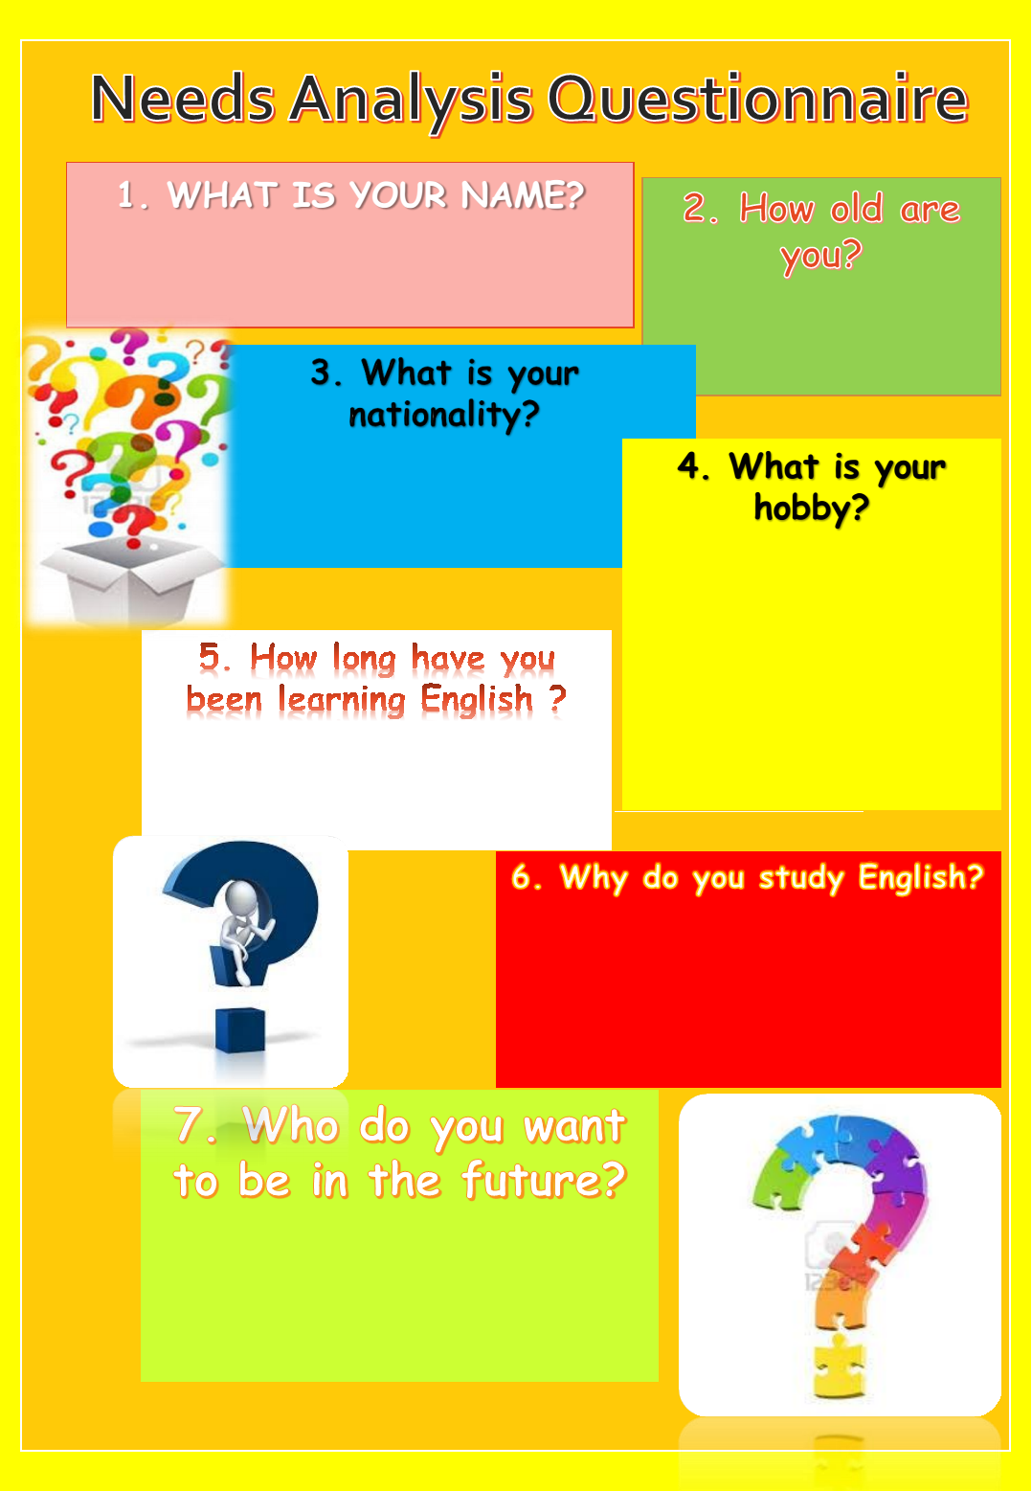
- POST- QUESTINONNAIRE FOR PARTICIPANTS OF RESEARCH

Section I: Personal Information
- Name:_______________________________________________________________
- Age:_________________________________________________________________
- Nationality:____________________________________________________________
- Socio-economic status: __________________________________________________

Section II: Preferences
№ | Questions | Answers
1 | Do you like English?
2 | Why do you like/ don’t like English?
3 | What is the purpose of learning English?
4 | Are you forced by your parents to attend English?
5 | Do you willingly come to learn English?
6 | Do you like your teacher?
7 | Why do you like her?
8 | Do you like your English courses?
9 | What do you do at the lessons?
10 | What do not you like to do at your lesson?

Section III: Multiple-choice questions/ Choose one
- Which of the skills do you like to practice at the lesson?
- Listening
- Speaking
- Reading
- Writing

- What activities do you like the best?
- Role-Plays
- Songs
- Proverbs
- Tongue-twisters
- Stories
- Crosswords
- Puzzles

- What is your favorite award?
- Certificate
- Sweets: Candies/Chocolates/Biscuits
- Gifts: Pens/pencils/erasers
- Marks: 5/+5/5*

- Which of them do you like the best?
- English at school
- Bravo English
- Neither of them

- Do you like doing your homework?
- Yes, I do
- No, I do not

- QUESTIONNAIRE FOR EFL TEACHERS

- Name______________________________________________________
- Age________________________________________________________
- Where do you study?__________________________________________
- Is your field of study correlated to the teaching system?_______________
If YES, can you describe the importance of methodological/pedagogical knowledge that you acquired at the university in teaching EFL? _____________________________________________________________________________________________________________________________________________________________________________________________________________________________________________________
If NO, how the one without pedagogical background can teach EFL?
_____________________________________________________________________________________________________________________________________________________________________________________________________________________________________________________

- Who is your audience?
- Young learners (9-12)
- Teenagers
- Adults
- If you have circled A, then can you define: Who is a young learner for you?
_________________________________________________________________________________________________________________________________________________________________________________________________________________________________________________________________________________________________________________________
- How long have you been working with young learners? ______________________________________________________________________________________________
- In accordance with your experience, what sorts of approaches encourage young learners the best? _____________________________________________________________________________________________________________________________________________________________________________________________________________________________________________________________________________________________________________________________________
- As an EFL teacher what do you prefer to start your lesson with? Why exactly that method? _____________________________________________________________________________________________________________________________________________________________________________________________________________________________________________________________________________________________________________________________________________________________________________________________________
- How long lasts your one lesson? _____________________________________________
- During the interim specified above, how many activities do you use? Can you describe each in a detail? _____________________________________________________________________________________________________________________________________________________________________________________________________________________________________________________________________________________________________________________
- What kind of features makes your lessons more interesting and motivating than that ones who are teaching at school? _____________________________________________________________________________________________________________________________________________________________________________________________________________________________________________________________________________________________________________________
- In your humble opinion what approaches should the best teacher apply in teaching? _____________________________________________________________________________________________________________________________________________________________________________________________________________________________________________________________________________________________________________________
- Please jot down the best 5 methods that really keep children motivated. __________________________________________________________________________________________________________________________________________________________________________________________________________________________________________________
- Please jot down the best 5 methods that subdue students’ interest. _______________________________________________________________________________________________________________________________________________________________________________________________________________________________________________________________________________________________________________
- What skills do you mostly focus on teaching?
- Listening
- Speaking
- Writing
- Reading
- Why exactly those skills? ___________________________________________________________________________________________________________________________________________________________________________________________________________________
- LESSON PLANS
  - LESSON PLAN №1

Teacher: Munis Khusanova
Course: Bravo English
Date: February 9,2014
Topic: At the restaurant
Number of Students: 14
Level of Students: Elementary
Student Interaction: Individual, Pair, Group
Language Focus: Vocabulary (restaurant) related to the topic.
Skills Trained: Speaking and Reading.
Objective: to introduce new vocabulary related to the topic and give learners a chance to practice the usage of this vocabulary based on activities.
Time: 45 min
Materials: Handouts with activities, foods word cards, one menu for two students, pictures of food, picture dictionaries and normal dictionaries for more confident pupils, speech bubbles
Assumption: the children will practice reading and speaking with enthusiasm
Anticipated problems: the pupils could feel less comfortable in role play activities
Procedure:
Opening (checking homework)
Time: 15 min
Materials: Handouts (given in the last lesson)
Stage 1
Check the written home assignments. If a pupil makes mistakes, ask other students to help him/her to correct mistakes and at the end give your comment on that mistake.
Stage 2
Put the following diagram on the board and write the words that students are supposed to learn around the diagram. Then ask each student to provide definitions for each word on the diagram.

Restaurant

Possible words: drink, eat, a waiter, a waitress, a guest, a room, a light, a chair, a sofa, a TV, a radio, a plate, a spoon, a fork, a knife, soup, a bread, meat, a fish, chicken, cheese, a mushroom, an onion, a cucumber, a tomato, a potato, a carrot, coffee, juice, a cup of tea, a glass of lemonade and so on.
Activity 1
Objective: to check students’ background knowledge with the help of some names of food and give them a chance to match the names of food with pictures.
Time: 5 min
Materials: Activity 1. Handout 1
Procedure:
Stage 1
Distribute Handout 1 and ask children to work in pairs. Allow 2 minutes to match pictures with words.
As soon as they finish, let each pair share their answer. At the end tell students that in the second stage they will make two sentences using words in Handout 1 individually.
Stage 2
Students work individually. When learners finish, check their sentences and correct mistakes.
Activity 2
Objective: to introduce new vocabulary related to the topic (restaurant, type of meal).
Time: 5 min
Materials: Activity 2. Handout 2
Procedure: Students work individually. Distribute handout 2 to each student and ask them to follow you. Explain the menu in detail with examples and try to involve student in conversation by questioning:
- What food do you prefer for main course?
- What type of food does the main course include?
- What would you like for desert?
After that, make sure that pupils know the translation of food provided in menu in their native language. Make a smooth move to the next activity by giving out handout 3.
Activity 3
Objective: to check students understanding (grouping)
Time: 5 min
Materials: Activity 3. Handout 3
Procedure: Divide the class into three groups and name them as: main course, desserts, and drinks. Allow students 5 minutes to write the food into the correct group. As they finish check the answer together, correct mistakes and if it is possible ask student to continue the list themselves.
Activity 4
Objective: to check students understanding (true/false statements)
Time: 5 min
Materials: Activity 4. Handout 4
Procedure: Distribute handout 4 and ask learners to do the task in pairs. As they finish, analyze their answers and if it is necessary you may provide explanations in Uzbek.
Activity 5
Objective: to give pupils a chance to practice new words.
Time: 5 min
Procedure: Ask the following question and summarize the lesson:
“What food do you like on this menu?”
Teaching Materials
Activity 1 Handout 1
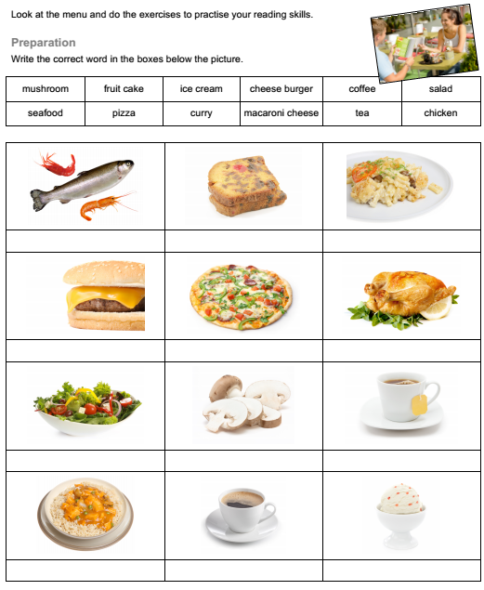


Activity 2 Handout 2

Activity 3 Handout 3
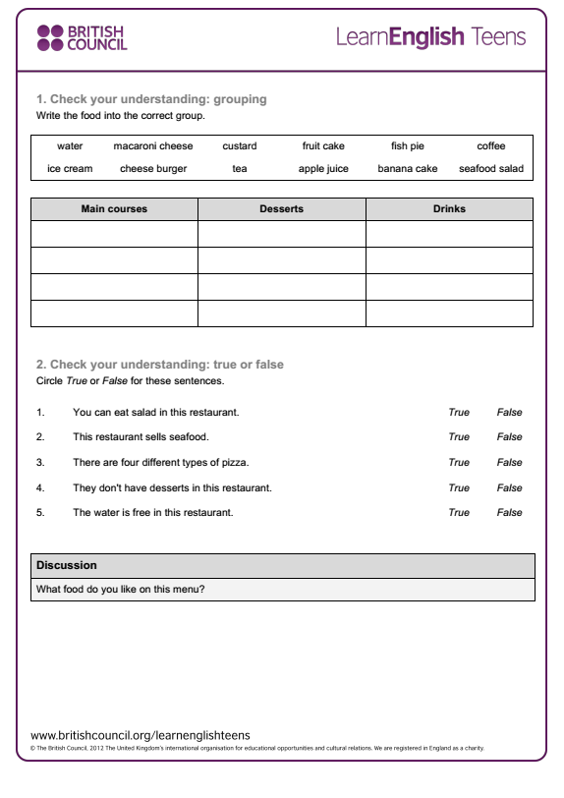
Activity 4 Handout 4

All material are taken and adopted from
www.britishcouncil.org/learnenglish

4.2 LESSON PLAN №2

Teacher: Munis Khusanova
Course: Bravo English
Date: February 23,2014
Topic: Animals living in the forest
Number of Students: 14
Level of Students: Elementary
Student Interaction: Individual, Pair, Group
Language Focus: Vocabulary related to the topic.
Skills Trained: Speaking and Reading.
Objective: to introduce new vocabulary related to the topic, give learners a chance to practice the usage of this vocabulary based on activities and check pupils’ comprehension of the story through context.
Aim: to practice listening for specific reason (food vocabulary)
Time: 45 min
Materials: Handouts with activities, flash cards with animals, animal and plant word cards, picture dictionaries and normal dictionaries for more confident pupils, speech bubbles.
Assumption: the children will practice reading and speaking with enthusiasm
Anticipated problems: the pupils could feel less comfortable in role play activities
Procedure:
Stage 1
Divide the pupils into three groups.
Motivation: Show the children a big sheet of paper stuck on the wall and let them guess the reason why it is on the wall. Each group makes their own guesses.
Piece by piece draw forest trees and let the children guess again what it is. (Forest)
Then ask the pupils to show their pictures of forest animals and stick them on the paper together with the children.
Let the children find in dictionaries the names of animals which they do not know and write them on the board as they say them.
Stage 2
Guessing game - the teacher - I can see a small animal. It has got four legs, long ears, short tail and brown color. What animal is it? The children: A rabbit.
Let some other pupils describe other animals from the poster themselves and let the rest of the class guess.
One child pretends to be one of the animals and others guess what animal he or she is.
Stage 3
We are going to listen to the next part of the story. Can you tell me what animal meets in the forest? Can you describe the wolf from the story? Have you ever seen any wolves? What do they eat?
Stage 4
Listen to the story and tell me then what the wolf says to a girl and what the girl takes to her grandma’s house.
Make some guesses before listening and write them on the board and after listening
check them with children.
Stage 5
Stick speech bubbles on the board and practice saying them with all children. Then let each group choose one character: wolves, mothers and LRRHs. Then each child from the mother’s group should read one sentence from the dialogue and other children should read their part all together.
Then read the narrator’s part yourself and encourage pupils to read the rest.
Summarize the text by checking pupils’ comprehension via tasks below:

Task 1 Circle family words
SISTER DOOR HOOD BROTHER MOTHER
FOREST GOOD UNCLE GRANDMA DAY
COUSIN VERY AUNT LITTLE WOLF
SISTER RED GRANDPA MUCH FATHER
VILLAGE DAD WHITE BEAUTIFUL NAME

Task 2 Find family words and write the correct words in the next blank
1 | B M U N C L E
2 | R A D D C M F
3 | O M A A O U A
4 | T D D T U M T
5 | H M H U S V H
6 | E E S S I S E
7 | R I A U N T R
8 | R G A N P D A

Task 3/ Underline the words you hear in the story
SISTER DOOR HOOD BROTHER MOTHER
FOREST GOOD UNCLE GRANDMA DAY
COUSIN VERY AUNT LITTLE WOLF
SISTER RED GRANDPA MUCH FATHER
VILLAGE DAD WHITE BEAUTIFUL NAME

Task 4
- write Uzbek/Russian meaning of these words:
LITTLE = .............................
RED = ..................................
RIDE = .........................when you ride a horse, you sit on it and control it
HOOD = ....................it is a part of your coat which covers your head
- complete the sentence:
This is the story of a little girl, her ................. and a big bad ............... .

Task 5/Organize following sentences. 4
1. Where does your grandma live?
2. She lives in a little old house in the middle of the forest.
3. Is it far?
4. No. It is very near here.
5. Mmm. Perhaps I can eat this little girl and her grandma.
6. Look over there. Can you see those nice flowers? Does your
grandma like flowers? You can go and get some for her.
7. Oh no, I can’t. I can’t leave the road.
8. But you can come back to the road later.

Task 6/ Match the following rhyming words:
1 | Red | Please
2 | Hood | Life
3 | Mouse | Head
4 | Knees | Tea
5 | Knife | Wood
6 | Bee | My
7 | Hat | House
8 | Eye | Cat

TAPESCRIPT
Little Red Riding Hood
Little Red Riding Hood, retold by Sue Arengo (1995)

This is the story of a little girl, her grandma and a big bad wolf. The little girl lived in a little white house. The house was in the village and the village was near a forest. She was a good little girl. Her mother and father loved her very much. Her grandma loved her very much too. The little girl’s grandma lived in a very old house in the middle of the forest. The Little girl often went to her grandma’s house. One Christmas, Grandma gave the little girl a beautiful red cloak with a hood. She wore the cloak all day on Christmas day and the next day too. She wore it all the time, some people gave her a new name. They called her "Little Red Riding Hood".
One day her mother said: “Mother Little Red Riding Hood, your Grandma is ill. Go to her house and take her this basket of bread and butter. Walk quickly to her house! Don’t stop and play! And don’t leave the road. Do you understand?”
LRRH: “Yes, Mother”
LRRH took the basket and ran into the forest. She walked very quickly. She did not stop and play. But soon after, she saw .....a WOLF!
Wolf: “Hello. How are you today?”
LRRH: “I’m very well, thank you. But my Grandma is ill. I’m taking this basket of bread and butter to her.”
Wolf: “Are you? That’s interesting.”
The wolf was very hungry. He looked at LRRH with his big hungry eyes.
Wolf: “Where does your grandma live?”
LRRH: “She lives in a little old house in the middle of the forest.”
Wolf: “Is it far?”
LRRH: “No. It is very near here.”
Wolf: “Mmm. Perhaps I can eat this little girl and her grandma. Look over there. Can you see those nice flowers? Does your grandma like flowers? You can go and get some for her.”
LRRH: “Oh no, I can’t. I can’t leave the road.”
Wolf: “But you can come back to the road later.”
LRRH: “Yes ... that’s true. I can. Oh, all right.”
So she walked through the trees to the flowers. Now the bad wolf ran quickly to
Grandma’s house. He went to the door and knocked.
Grandma: “Who is it?”
Wolf: “It’s me, Grandma! It’s LRRH”
Grandma: “Open the door and come in, dear.”
Wolf: “Where are you Grandma?”
Grandma: “I’m up the stairs in bed, dear. I am ill today and I can’t get up.”
Wolf: “I’ve got some nice bread and butter for you.”
He went up the stairs and ran into Grandma’s bedroom. Then he jumped onto the bed and opened his big mouth and ate her! The wolf put on one of Grandma’s nightdresses, and got into her bed and waited. He waited for LRRH. LRRH got lots of beautiful flowers in the forest. Then suddenly she remembered her grandma.
LRRH: “Oh, dear! I am going to be late!”
She ran back to the road, and soon she came to her grandma’s house. She stopped when she saw the open door. And she went in.
LRRH: “That’s strange. Why is grandma’s door open?”
The wolf heard LRRH.
Wolf: “Who is it?”
LRRH: “It’s me, Grandma! It’s Little Red Riding Hood.”
Wolf: “I’m upstairs in bed, dear. I’m ill today and I can’t get up.”
So LRRH went up the stairs and went into the bedroom.
LRRH: “Grandma’s voice is very strange today! It’s because she is ill. Hello, Grandma. I am sorry you are ill today. Look! I’ve got some nice bread and butter for you. And some beautiful flowers!”
Wolf: “Thank you, dear. Put them on the table and come here.”
So LRRH put down her basked and went to the bed. And suddenly she was afraid.
LRRH: “Oh, Grandma, you look very strange today! Oh, Grandma, you have got very big eyes today!”
Wolf: “That’s because I want to hear you, my dear.”
LRRH: “Oh, Grandma, you have got very big ears today!”
Wolf: “That’s because I want to hear you, my dear.”
LRRH: “Oh, Grandma, you have got a very big nose today!”
Wolf: “That’s because I want to smell those beautiful flowers, my dear.”
LRRH: “Oh, Grandma, you have got a very big mouth today and a lot of very
big teeth!”
Wolf: “Yes, my dear. And that’s because I want to eat you!”
And the wolf jumped out of the bed and ate LRRH. Now the wolf was big and fat and he wanted to go sleep. He took off Grandma’s nightdress and put it on the floor. Then he got back into bed and went to asleep. Soon he began to snore loudly.
Wolf: “Zhhhhhh. Zhhhhhhhh.”
Soon after, LRRH´s father came to the house. He saw the open door.
Father: “That’s strange. Why is the door open? And what’s that noise?”
Wolf: “Zhhhhhhh. Zhhhhhhh.”
Father: “Grandma’s voice is very strange today. It’s you the wolf. What are you doing in Grandma’s bed? Well, you can’t run away now.”
And he took his knife and killed the wolf.
Father: “Perhaps Grandma is alive!”
So LRRH´s father took his knife and cut open the wolf. And LRRH jumped out.
LRRH: “Oh, father! Quick! Help Grandma. She is in there, in dark!”
Then Grandma jumped out.
Grandma: “Oh! Oh! Where’s that bad wolf?”
Father: “Everything is all right now. The wolf is dead.”
So Grandma had a cup of tea and some nice bread and butter. Then LRRH and her father went home to their little white house. LRRH ran to her mother and told her everything. After that, LRRH always stayed on the road. And she never saw a wolf again.

- CERTIFICATES

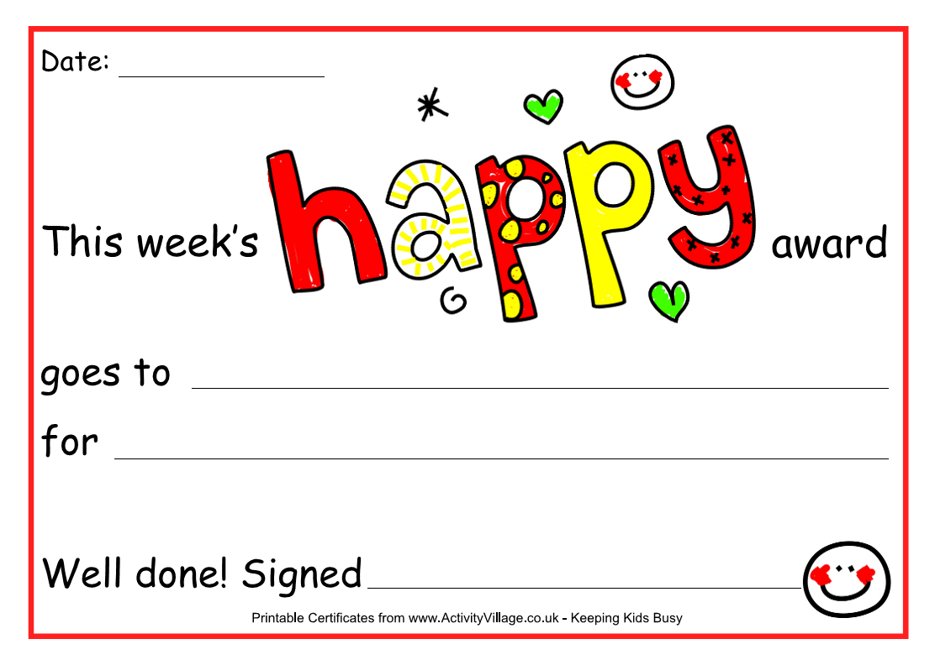

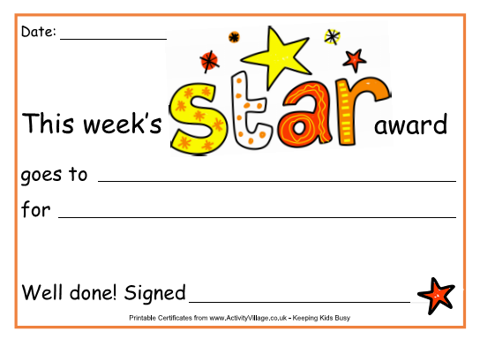


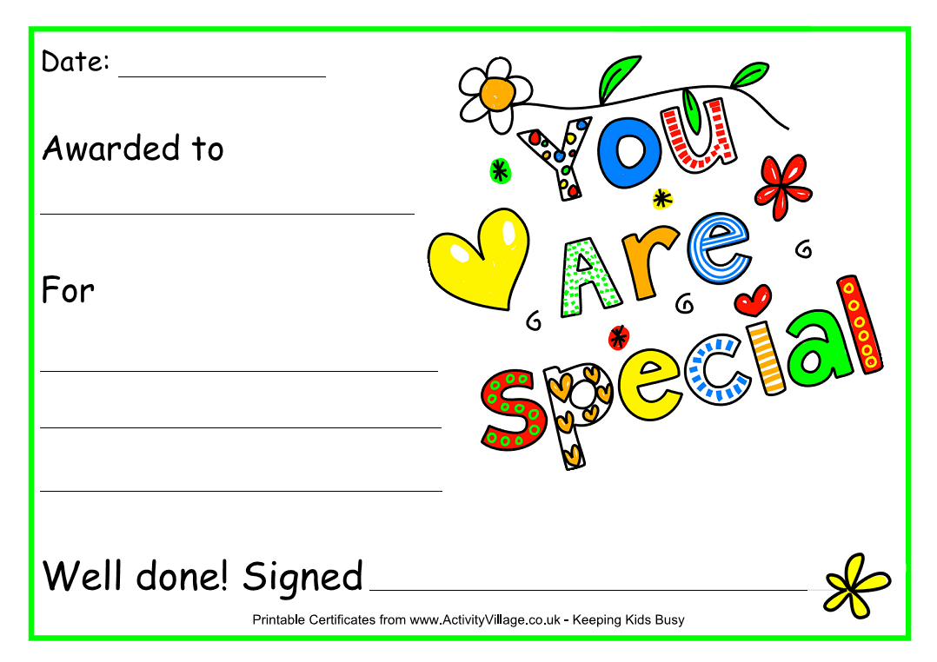
CERTIFICATES are taken from www.ActivityVillage.co.uk
- NURSERY RHYMES AND SONGS FOR KIDS

SONG №1
I AM A POLICEMAN
I am a policeman dressed in blue
Here are some things I like to do
Drag the traffic in your town
Help to keep you safe and sound
It is my job and I like it fine
No one has a better job than mine

I am a policeman dressed in blue
I want to be a friend of you
You can see me everyday
I will wave my hand and say:
It is my job and I like it fine
No one has a better job than mine
No one has a better job than mine

SONG №2

Jailhouse Rock
The warden threw a party in the county jail
The prison band was there and they began to wail
The band was jumpin' and the joint began to swing
You should've heard those knocked out jailbirds sing
Let's rock, everybody, let's rock
Everybody in the whole cellblock
Was dancing to the Jailhouse Rock

SONG №3
ANIMAL FAIR
I went to the animal fair,
The birds and the beasts were there,
The big baboon by the light of the moon
Was combing his auburn hair.
The monkey bumped the skunk,
And sat on the elephant's trunk;
The elephant sneezed and fell to his knees,
And that was the end of the monk!

SONG №4

ALPHABET SONG
'a' - you're adorable
'b' - you're so beautiful
'c' - you're so cute and full of charm
'd' - you're a darling
'e' - you're exciting
'f' - you're a feather in my arms
'g' - you're so good to me
'h' - you're so heavenly
'i' - you're the 'i' that idolize
'j' - we're like jack and jill
'k' - you're so kissable
'l' - you're the lovelife in my eye
'm','n','o','p' I could go on all day
'q','r','s','t' alphabetically speaking, you're okay
'u' - make my life complete
'v' - makes you very sweet
'w','x','y','z'
It's fun to wander through the alphabet with you
To tell you what it means to me
(repeat all)

Governmental portal of the Republic of Uzbekistan, accessed 14/12/2012
Observation of lesson in school 142 Tashkent Chilanzar, 15.12.07
УЗЛУКСИЗ ТАЪЛИМ ТИЗИМИНИНГ ЧЕТ ТИЛЛАРИ БЎЙИЧА ДАВЛАТ ТАЪЛИМ СТАНДАРТИ
Glasser, W. A. “The quality school: Managing students without coercion”, New York 1998),
“Seven proven ways to motivate children to do better in school” by The Parent Institute®, a division of NIS, Inc. reproduction rights exclusively for: Greer Middle School Greer, SC
http://www.global-english.com/tipsfromthetop.htm
Thomas A. Angelo and K. Patricia Cross “Classroom Assessment Techniques” San Francisco, 2005.
Young Learners Supplementary Activities Workshop ian.oakes@englishfirst.com.cn
Porter, L. (2009). Motivating children. www.louiseporter.com.au
Alberto, P.A. & Troutman, A.C. (2003), “Applied behavior analysis for teachers.(6th ed.)”

